Data Cleaning & Visualization Project
E-Commerce Sales — Final Report

1. Project Overview
This project takes a raw e-commerce order dataset, cleans it using Python (Pandas and NumPy), analyzes it, and produces visualizations (Matplotlib and Seaborn) to surface actionable business insights. It follows the full workflow: dataset selection, project setup, data understanding, cleaning, analysis, visualization, insight extraction, and documentation.

2. Dataset Description & Source
The dataset covers India retail orders from 2018 and is composed of two linked source files, combined on Order ID:
- List_of_Orders.csv — order metadata: Order ID, Order Date, Customer Name, State, City (560 rows)
- Order_Details.csv — order line items: Amount, Profit, Quantity, Category, Sub-Category, Payment Mode (764 rows)
Both raw files are preserved unmodified in data/raw/. The dataset contains realistic real-world data-quality issues used throughout this project: missing values, duplicate records, inconsistent text formatting, mixed data types, and outliers.

3. Data-Cleaning Process
The following steps were applied (full code in src/data_cleaning.py):
- Dropped fully blank rows (an export artifact) and rows with a missing Order ID
- Standardized column names (spaces converted to underscores)
- Parsed Order Date from text into proper datetime values
- Removed exact duplicate records from both source files
- Fixed mixed-type Quantity values (e.g. "6 units" → 6) and corrected negative quantities
- Standardized inconsistent Category, Sub-Category, and Payment Mode text (casing, spelling, whitespace)
- Imputed missing Amount and Profit values using category-level medians
- Detected and capped Amount outliers using the IQR method, flagging them in an Amount_Outlier column
- Merged the two cleaned tables into a single analysis-ready dataset (677 final rows)

4. Analysis Performed
Summary statistics, category/state groupings, and time-based trends were computed on the cleaned dataset:
Metric | Amount (₹) | Profit (₹) | Quantity
Mean | 34,467 | 3,299 | 5.0
Median | 19,832 | 1,144 | 5
Min | 524 | -20,442 | 1
Max | 123,567 | 43,577 | 9

Sales were grouped by Category, State, and Month to compare performance and identify trends over time (see Section 6).

5. Visualizations

Total Sales by Category
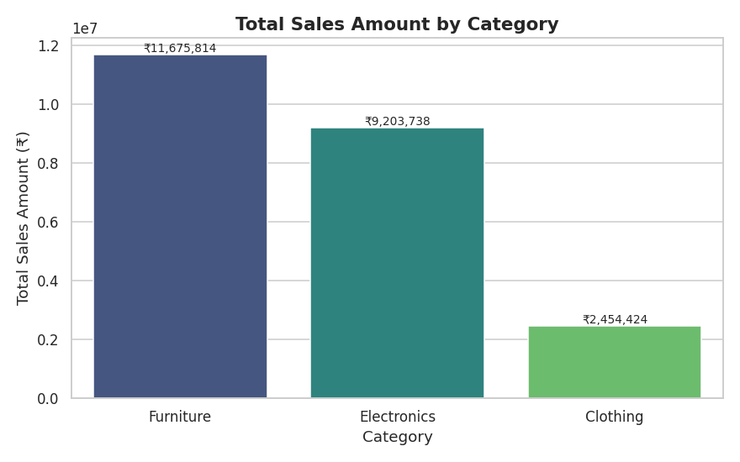
Figure 1: Furniture leads revenue, followed by Electronics; Clothing trails well behind.

Monthly Sales Trend
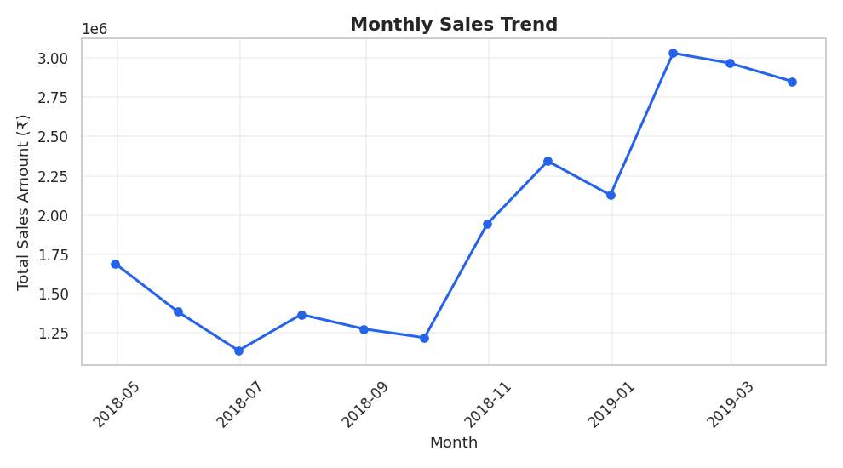
Figure 2: Month-over-month sales fluctuate, with a few notable peaks.

Top 10 States by Sales
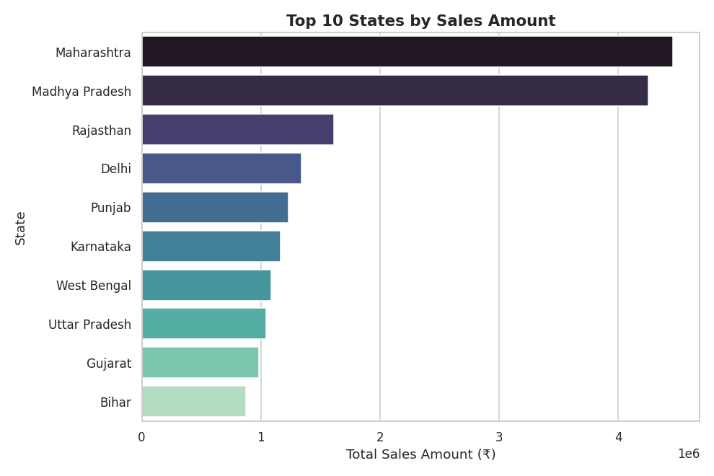
Figure 3: Maharashtra and Madhya Pradesh dominate regional sales.

Distribution of Order Amounts
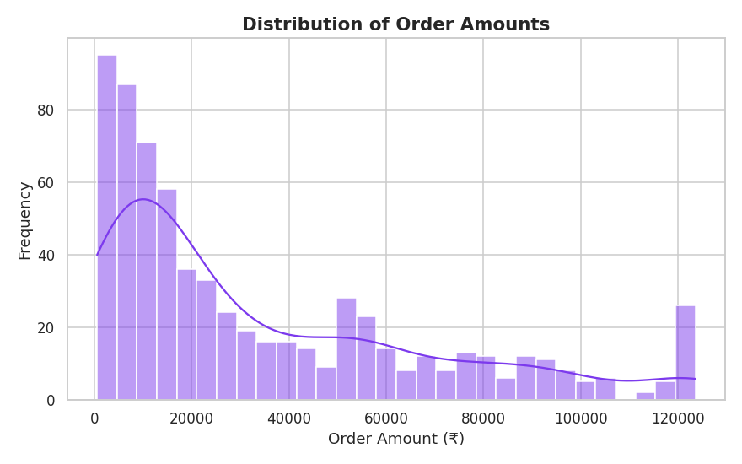
Figure 4: Order amounts are right-skewed, with most orders at the lower end.

Order Amount by Category (Outlier Detection)
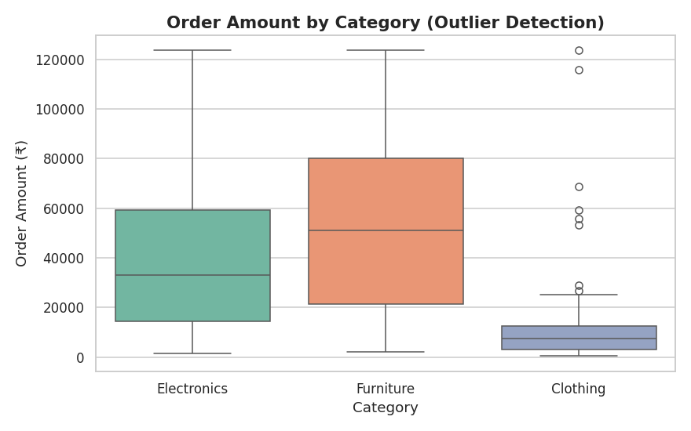
Figure 5: Furniture shows the widest spread and most high-value outliers.

Correlation Heatmap
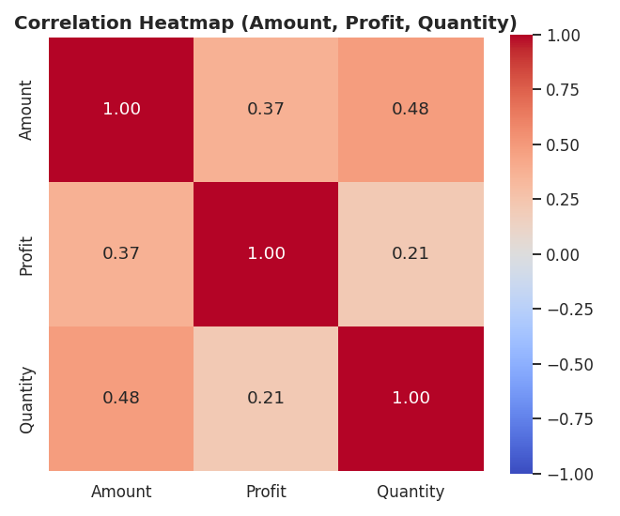
Figure 6: Amount and Profit are positively correlated; Quantity is largely independent of both.

6. Key Findings
- Furniture drives the most revenue (₹11.7M), but Electronics is the most profitable category by total profit — its margins are healthier despite lower revenue.
- Clothing underperforms on both revenue and profit and may need a pricing or promotional review.
- Maharashtra and Madhya Pradesh are the top two states by sales, together contributing a disproportionate share of revenue.
- Order amounts are right-skewed, with a long tail of high-value Furniture/Electronics purchases; a handful of clear data-entry outliers were capped during cleaning.
- Quantity shows little correlation with Profit — profitability appears driven more by product category and pricing than by order size.

7. Conclusion
Cleaning the raw order data — handling missing values, removing duplicates, standardizing inconsistent categories, and correcting outliers — was essential before any analysis could be trusted. Once cleaned, the data showed a clear story: Furniture and Electronics are the businesses' core revenue and profit drivers respectively, while Clothing lags on both fronts. Regionally, sales are concentrated in a small number of states, suggesting an opportunity to grow underrepresented regions. These insights point to concrete next steps: prioritize inventory and marketing investment in Electronics and Furniture, investigate Clothing's pricing/margin structure, and explore demand-generation in lower-performing states.

