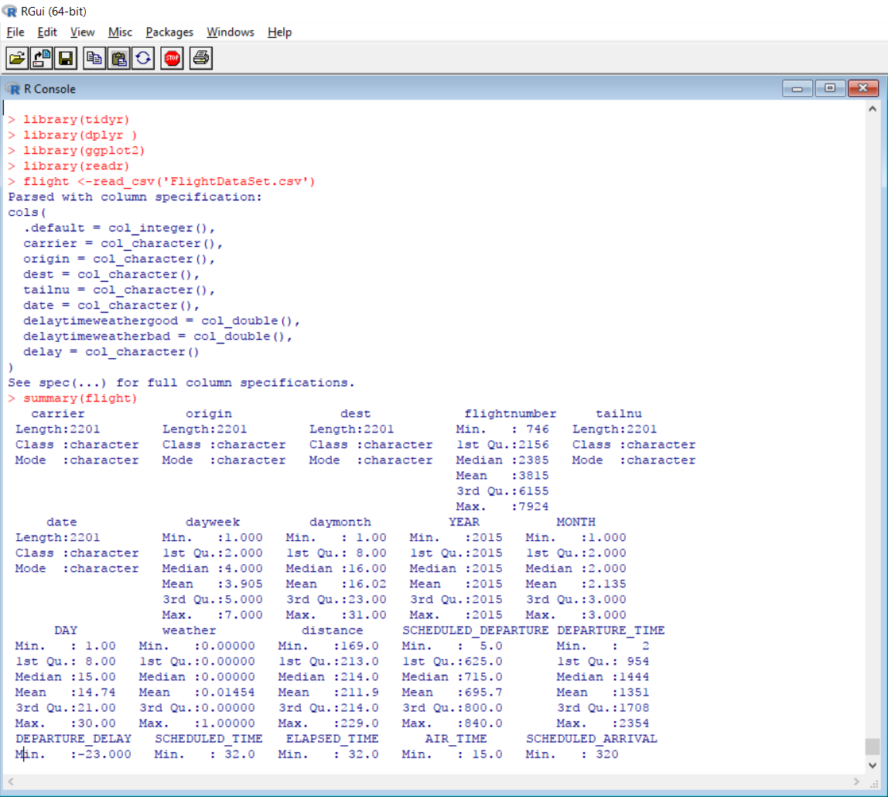

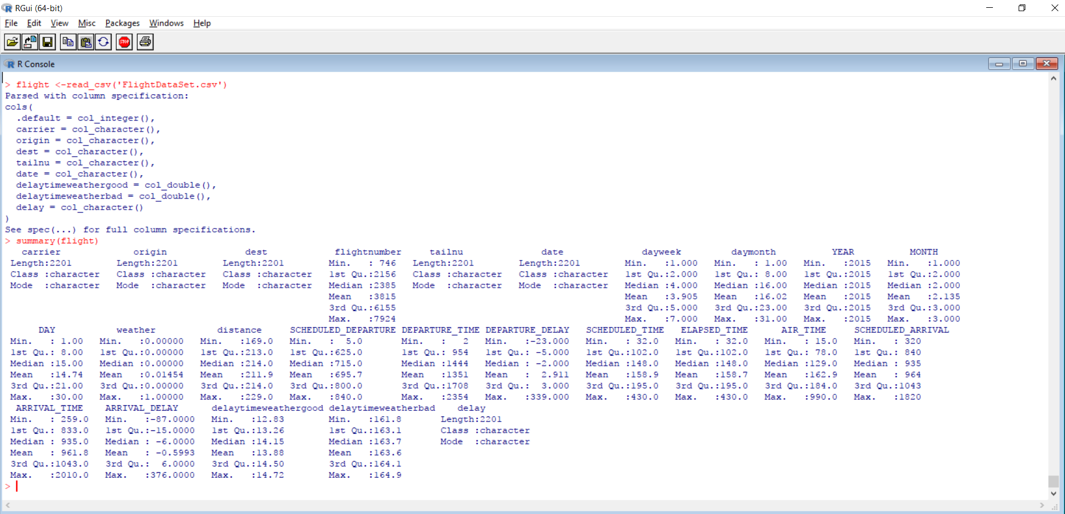

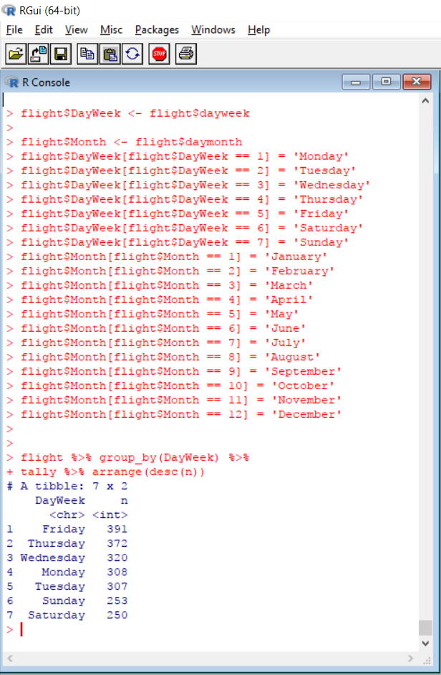

Conclusion – From R output, Friday seems to be the most common day for travelling.

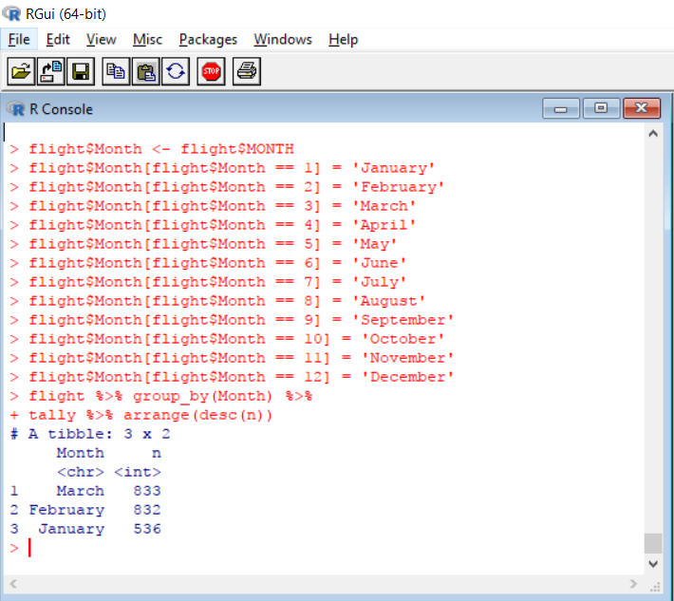

Conclusion – Our data set contains records for 1st 3 months, out of which maximum number of flights that were took of was in the month of March.

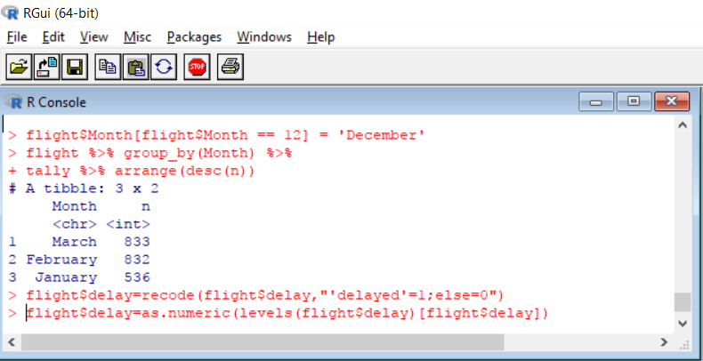

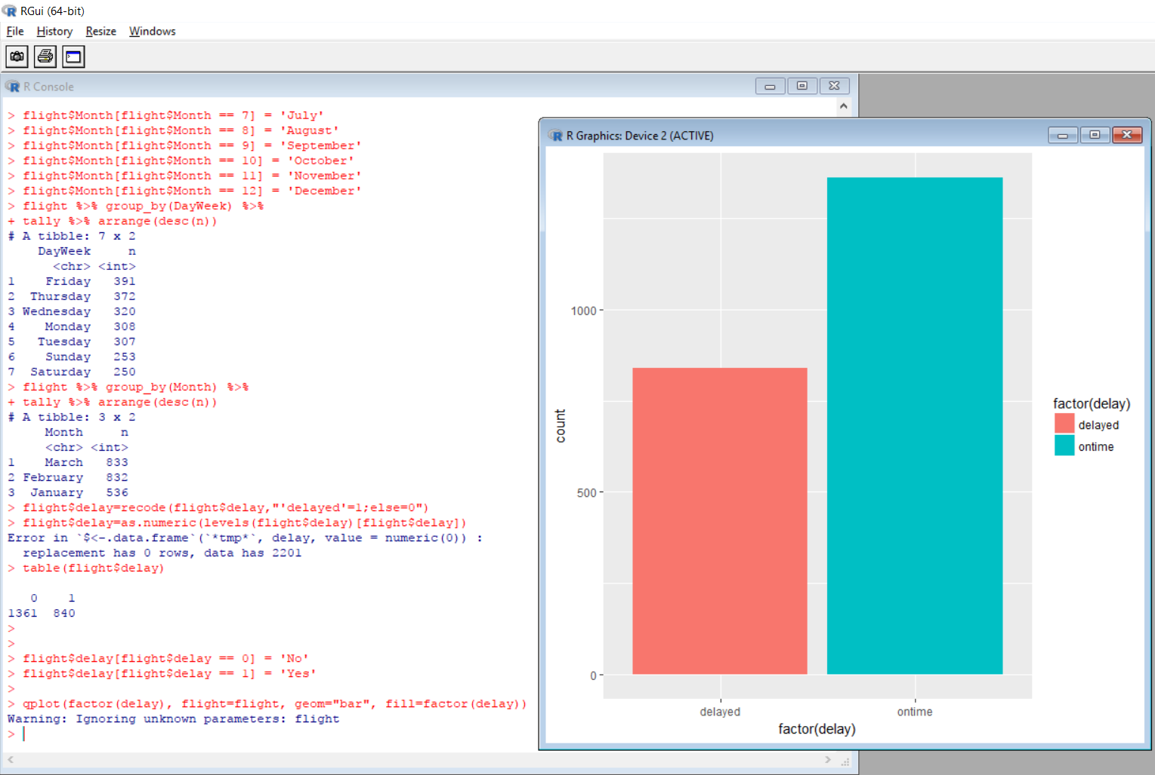

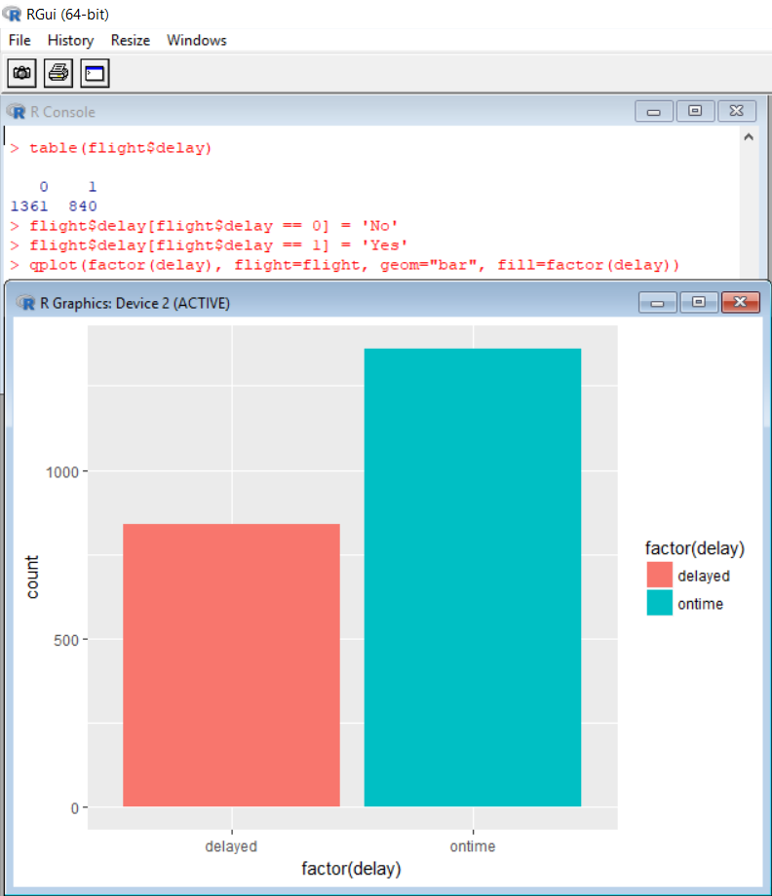

Conclusion – From our data set, flights were on-time rather than getting delayed because of any reasons.

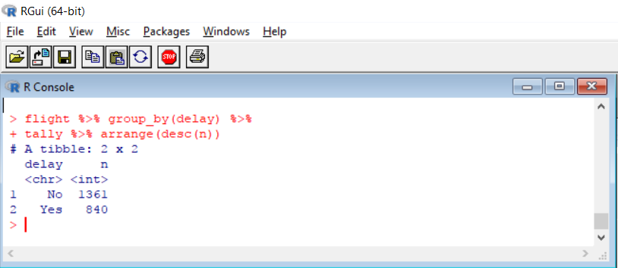

Conclusion – Out of the total data set,

**Flight On-time Count: 1361**

**Flight Delayed Count: 840**

**Arrival Delay Analysis:**

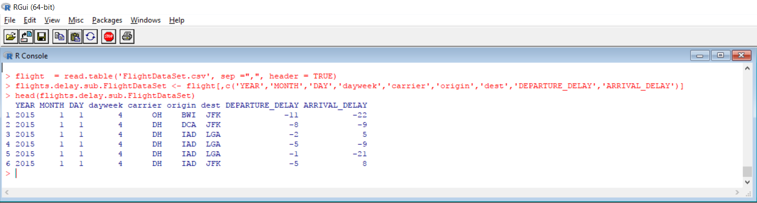

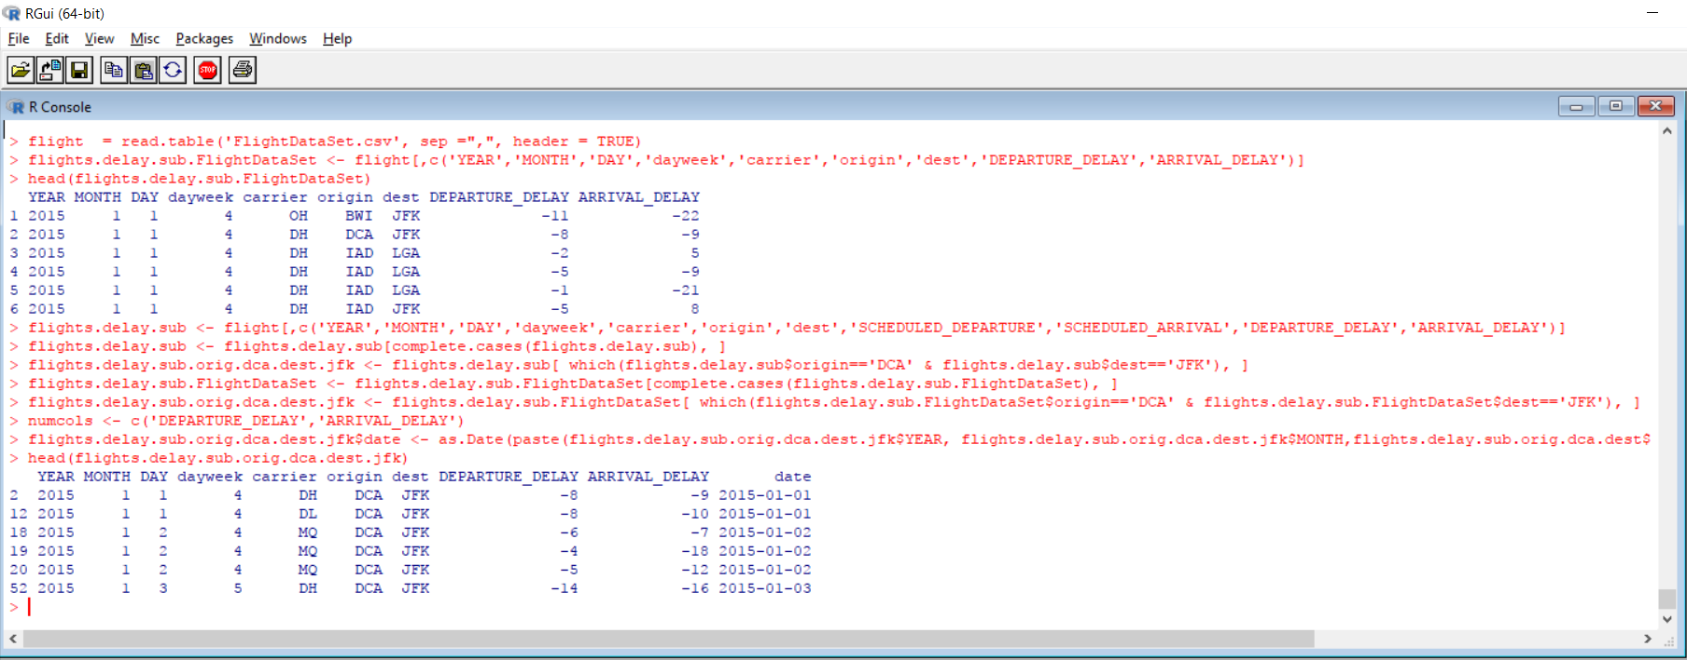

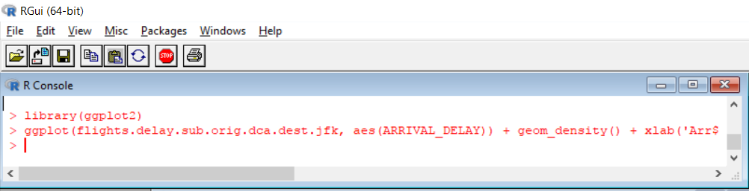

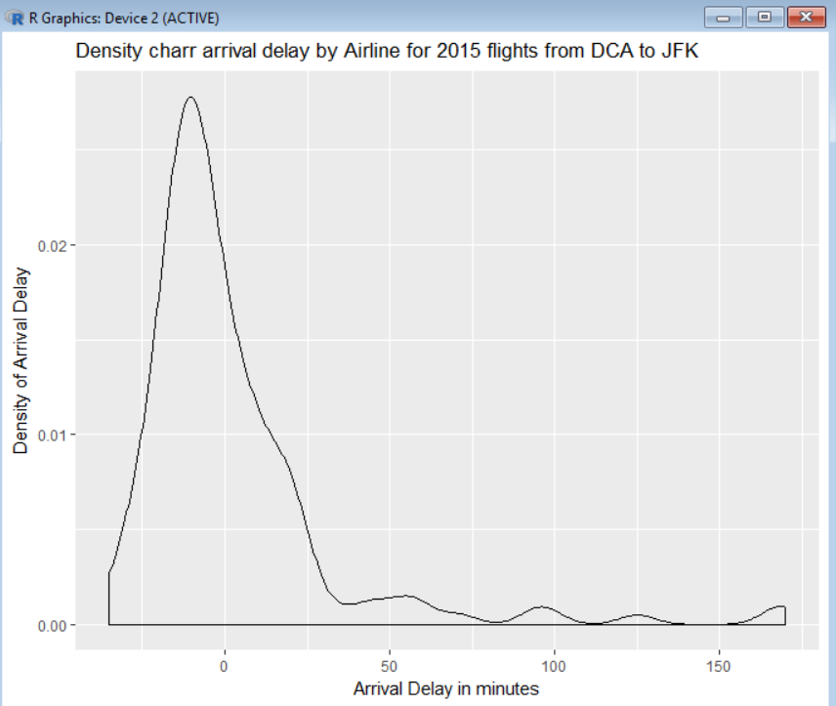

**Conclusion** - Above density chart shows me that most of the flights either reach before time or on-time. But, there are delays. Now let’s check which airlines are delayed the most.

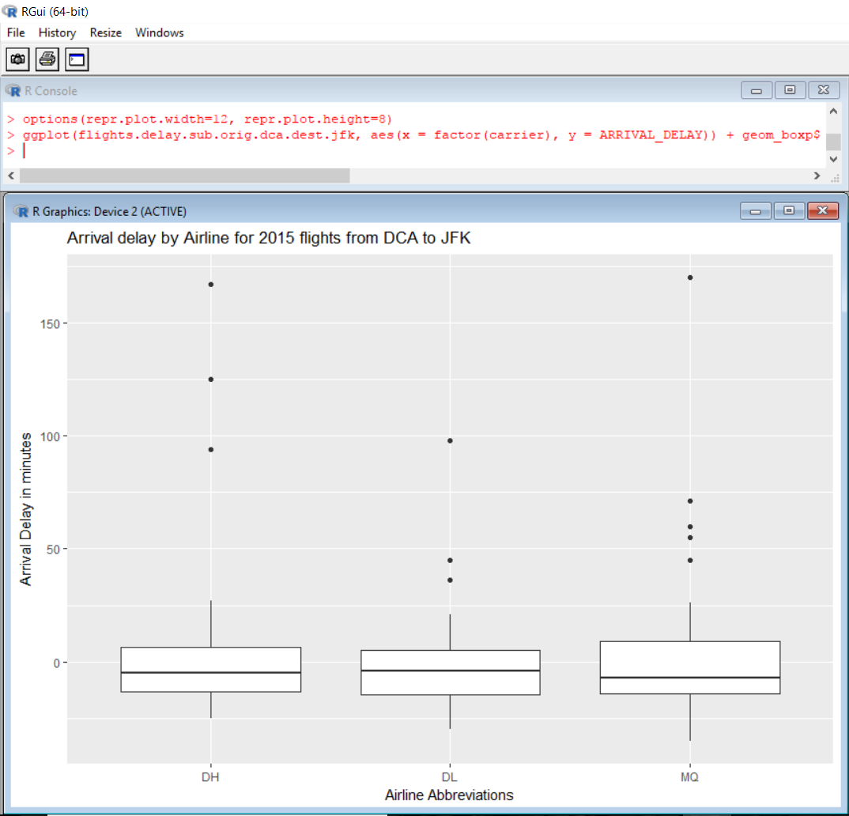

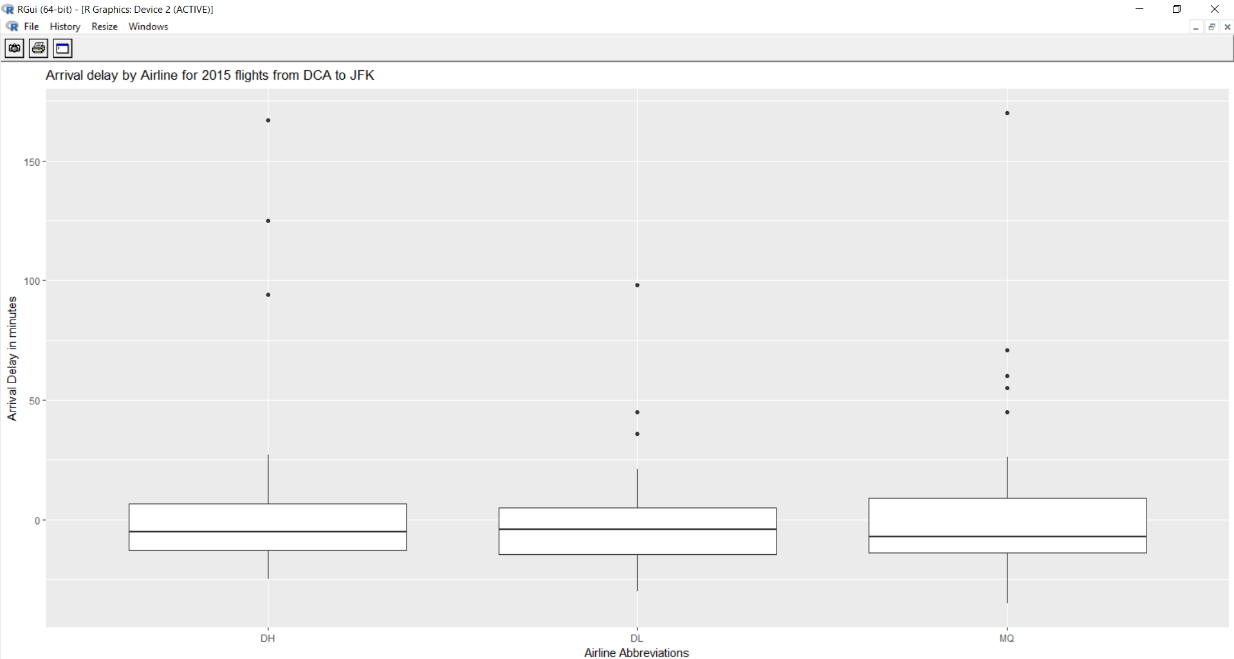

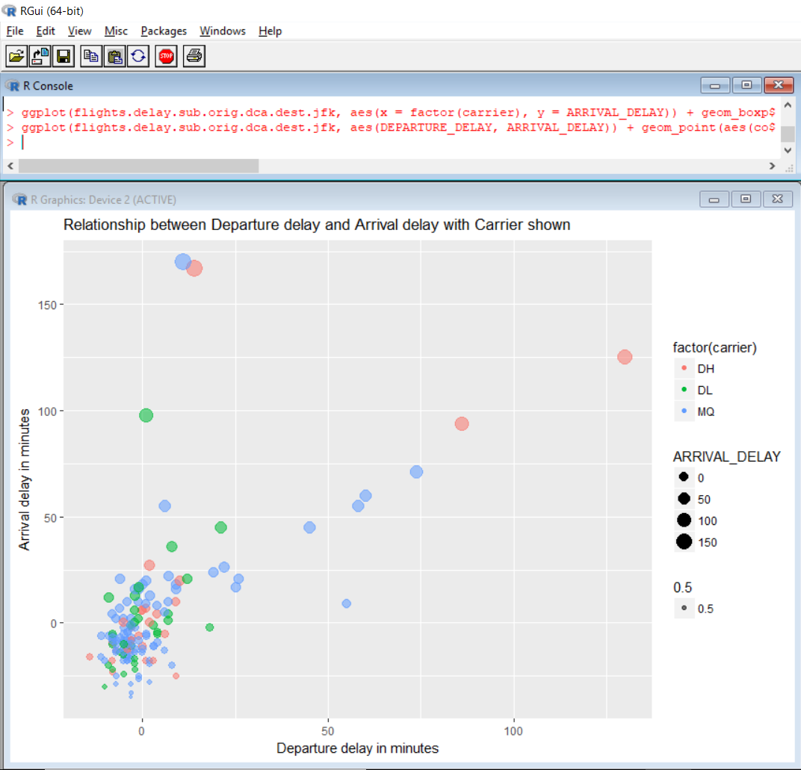

**Conclusion** - Scatter plot above provides view of density as well as distribution of departure versus arrival delay, proving the hypothesis that most of the arrival delays occurs due departure delay when flying from DCA to JFK based on flight from 2015.

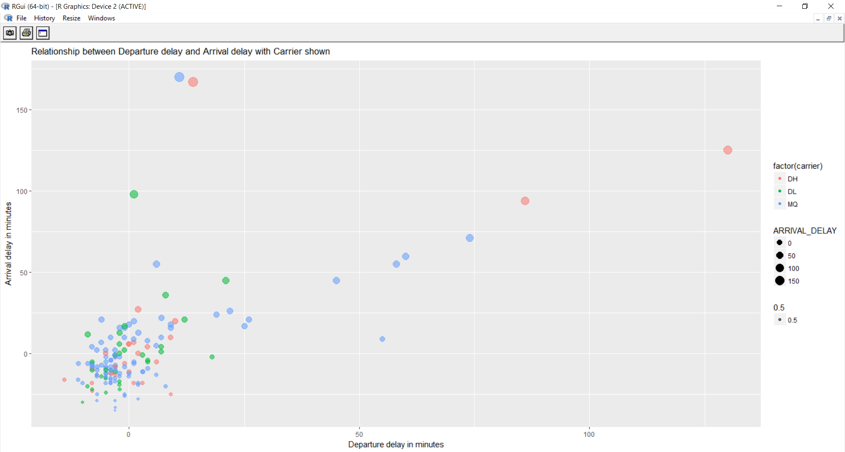

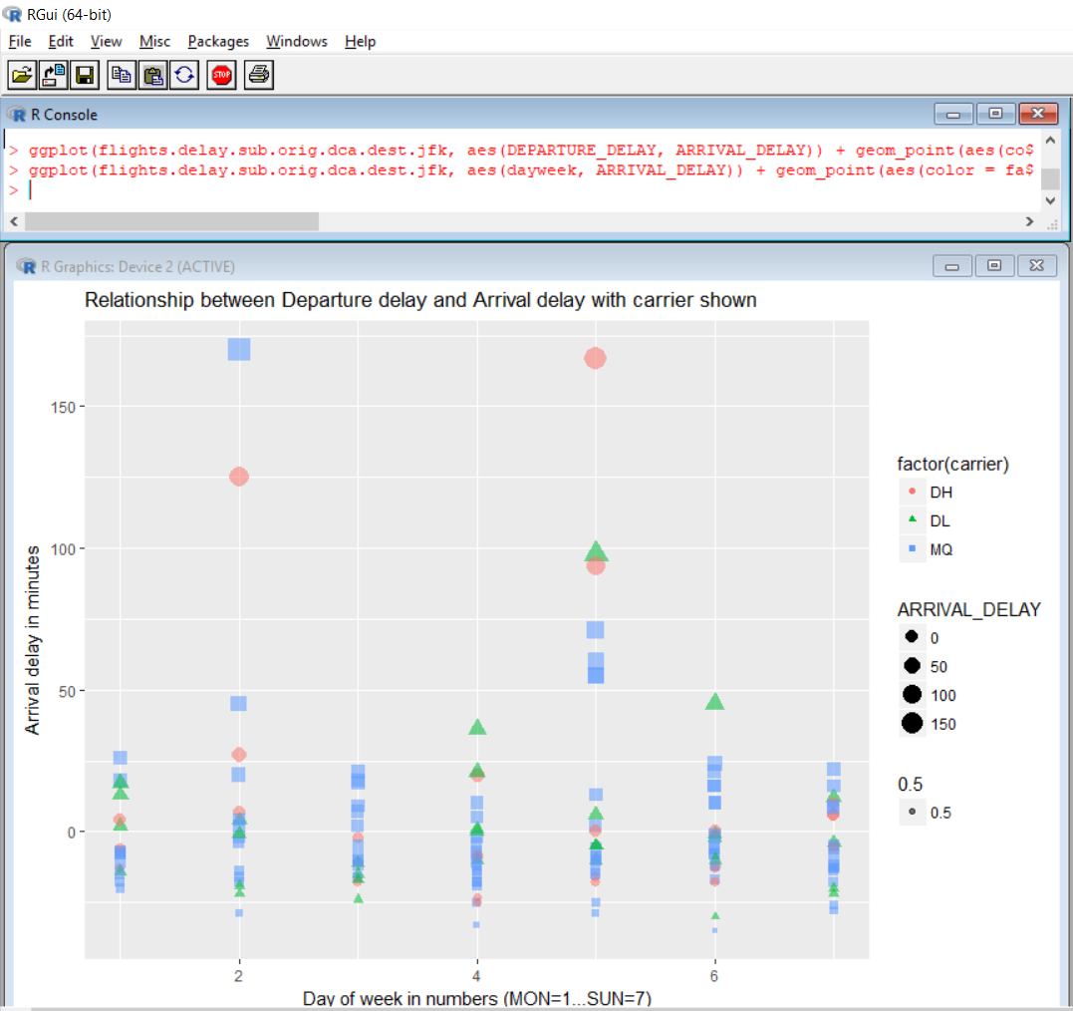

**Conclusion** - Based on above plot, least amount of delays happen on Tuesday's, Wednesday's, Thursday's and Saturday's while there is a changes flight being delayed on Monday's, Friday's and Sunday's if you fly from DCA to JFK based on 2015 Flights flight.

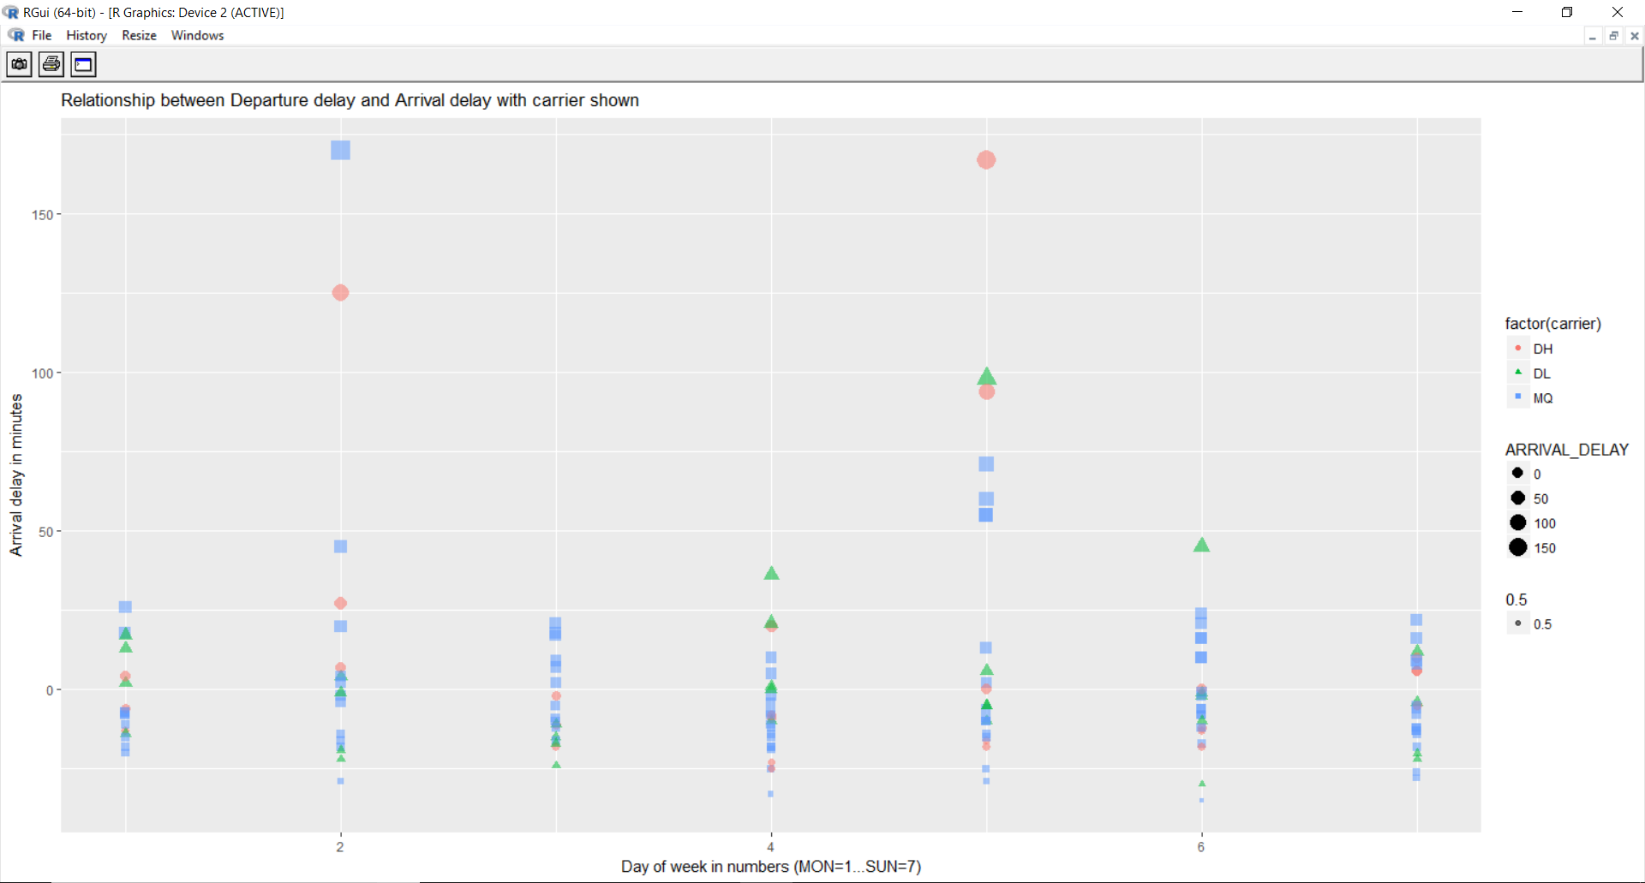

**Conclusion of Exploratory Analysis**

1. Departure delay has significant impact on Arrival delay.

2. DH and DL are least reliable and MQ airlines is most reliable in terms of arrival delay.