OneToken Supply Chain - ER Diagram (Chen Notation)
This document provides a classic Chen notation ERD representation for the OneToken Supply Chain platform.
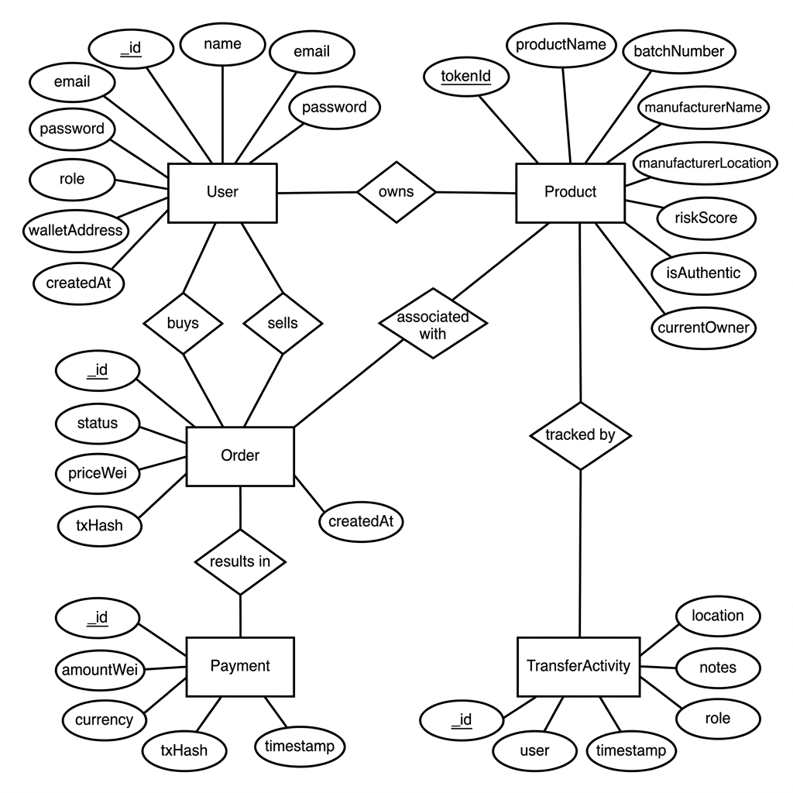

Notation Legend
- Rectangles: Entities (User, Product, Order, etc.)
- Ovals: Attributes (Name, Email, Price, etc.)
- Diamonds: Relationships (Owns, Buys, Tracks, etc.)
- Underlined Attributes: Primary Keys

