OneToken Supply Chain - Full Entity Relationship Diagram
This document provides a comprehensive Chen notation ERD including all attributes extracted from the backend database models.
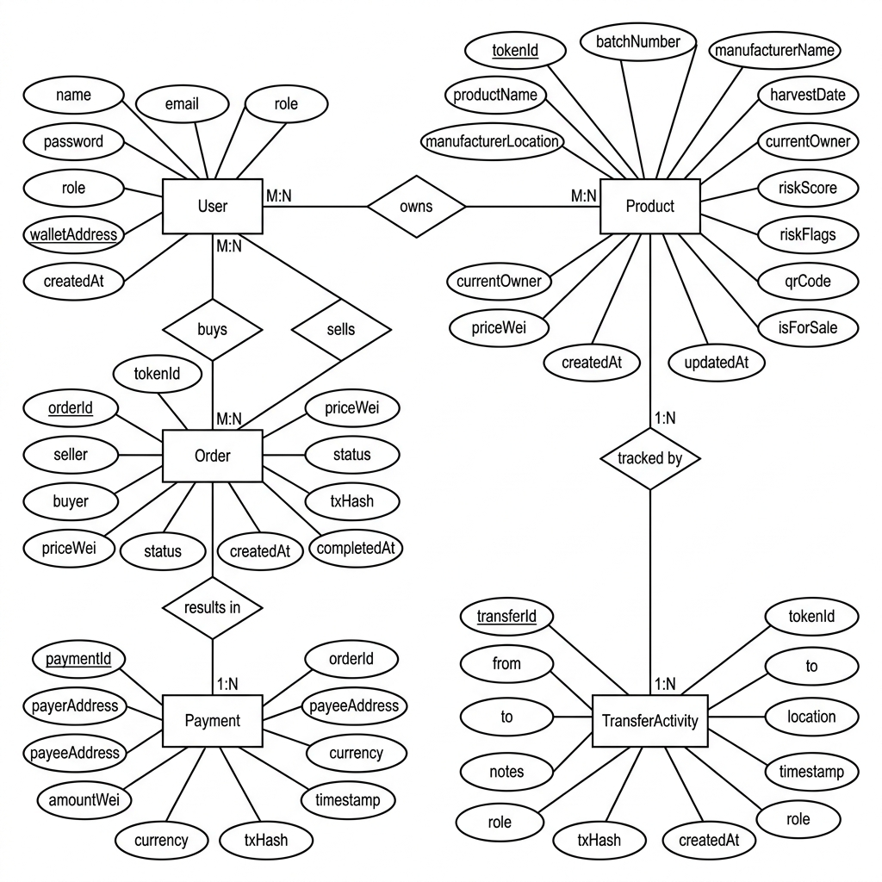

Detailed Entity & Attribute Breakdown
1. User Entity: name, email, password, role, walletAddress, createdAt
2. Product Entity: tokenId, productName, batchNumber, manufacturerName, manufacturerLocation, harvestDate, currentOwner, isAuthentic, riskScore, riskFlags, qrCode, isForSale, priceWei, createdAt, updatedAt
3. Order Entity: tokenId, seller, buyer, priceWei, status, txHash, createdAt, completedAt
4. Payment Entity: orderId, payerAddress, payeeAddress, amountWei, currency, txHash, timestamp
5. TransferActivity Entity: tokenId, from, to, location, notes, timestamp, role, txHash, createdAt

Relationships
- User 'owns' Product (1:N)
- User 'buys/sells' Order (1:N)
- Product 'tracked by' TransferActivity (1:N)
- Order 'results in' Payment (1:1)

