PEDESTRIAN DETECTION AND TRACKING

The purpose of this program is to detect and track pedestrians so as to aid in traffic management and track suspicious activities.

Here we have used OpenCV to input video and Haar cascades for full body detection as well as MOSSE for object tracking.

The haar cascade Is a pre trained model written is XML. It works on the principle of the human body ratios based on multiple data sets fed to it during the training. This model detects these rations which satisfy the human body ratio and return an positive value based on the threshold accuracy given by the user.

The code DetectMultiscale is used to detect these human figures based on the input parameters that is, rescaling the image size to fit the data set and returns a positive value and the second parameter is the number of individuals In that particular area.





We have also made a histogram using the input video. The purpose of this is to capture information about the distribution of colours or gradients in different regions of the image.

This will help us know the density of the population of the pedestrians so as to understand the migration of the public and other useful implementations.

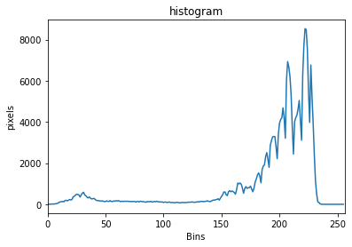

The tracker we are using here is the MOSSE tracker ( Minimum Sum of Squared Error), It is highly accurate as it works in light scale, poses, and non-rigid deformations. It is also very good at detecting occlusion's based on the pixel ratio difference from the object to the background for simplified and faster tracking.

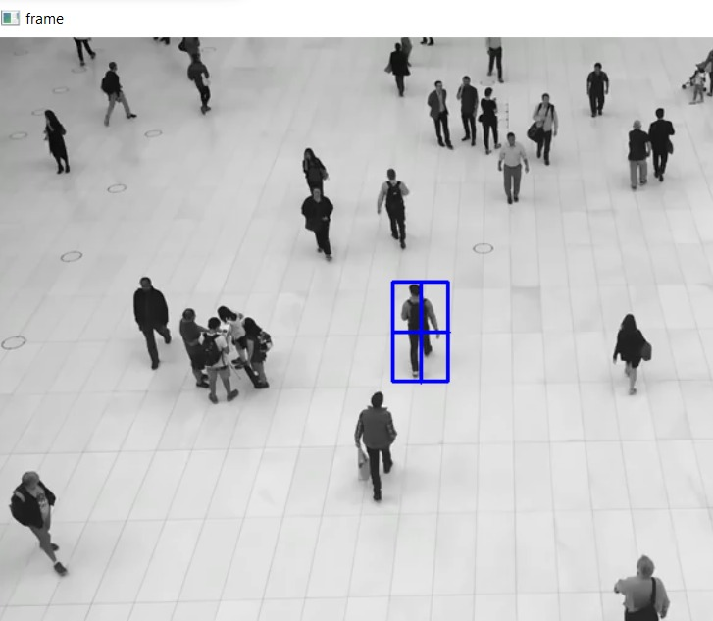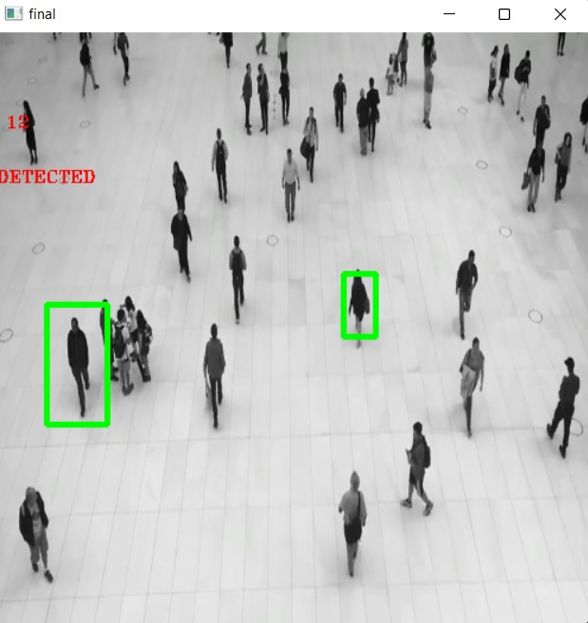

According to our output we can also track where a specific pedestrian is going as well as track multiple pedestrians for suspicious activities.

TEAM MEMBERS:

Vighnesh Bantwal Kamath-22011102121

Varshika Anand- 22011102118

S. Tejaswini-22011102085

Adhavan-22011102080