ENGINEERING DESIGN DOCUMENT
DevSecOps Pipeline for a
Password Reset Platform
TASK 3 — Requirements, Architecture & Technology Setup

Document Version | 1.0
Author | DevSecOps Lead
Target Security Standards | NIST SP 800-63B (Digital Identity Guidelines) · OWASP API Security Top 10
Classification | Internal — Engineering Design Document
Status | Draft for Architecture Review Board (ARB) Approval
✦ Zero Standing Secrets · Defense-in-Depth Segmentation · Gate-Enforced DevSecOps ✦

1. Purpose & Scope
This document defines the minimum viable product (MVP) system architecture, technology stack, functional requirements implementation strategy, and DevSecOps tooling matrix for the Password Reset Platform (PRP). The PRP is a self-service, audit-compliant workflow system that reduces IT helpdesk ticket volume for credential recovery while enforcing NIST SP 800-63B authentication assurance controls and OWASP API Security best practices across the full software delivery lifecycle (SDLC) — from local development through CI/CD to containerized deployment.
DESIGN INVARIANT
The architecture treats the pipeline itself — build tooling, dependency chain, and container artifacts — as a first-class attack surface. Security-by-design, zero standing secrets, and defense-in-depth network segmentation are non-negotiable constraints, not optional enhancements.

2. System Architecture Overview

2.1 Architecture Model
The PRP employs a containerized 3-Tier Web Architecture with hard network isolation boundaries enforced at the subnet level. Each tier is deployed as an independent container / service group, communicating only through explicitly whitelisted ports, with no tier possessing broader network reach than its function requires (principle of least network privilege).
Tier | Zone | Trust Level
Client Layer | Public Internet | Untrusted
Presentation / Proxy Layer | DMZ | Semi-Trusted (Ingress Control Point)
Application & Security Layer | Private Subnet | Trusted (Business Logic)
Data & Secrets Layer | Isolated Subnet | Highly Trusted (No Direct Ingress)

2.2 Network Isolation & Data-Flow Diagram
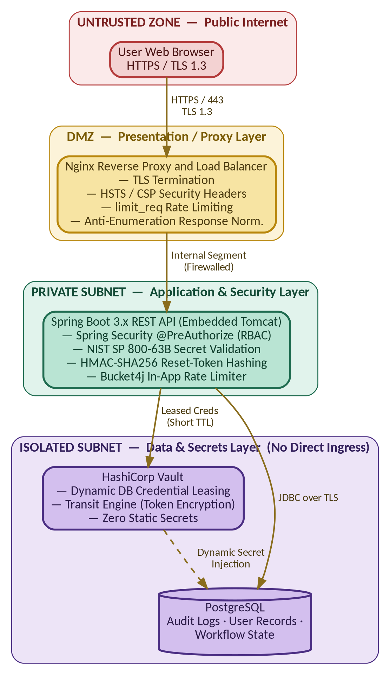
Figure 1. Four-zone network topology — traffic may only descend one tier at a time; the Data & Secrets subnet accepts no direct ingress from the DMZ or public internet.

2.3 Tier Responsibilities
- Client Layer. The user's browser retrieves the React.js SPA bundle and communicates exclusively over HTTPS/TLS 1.3, enforced via HSTS preload once issued by the proxy layer. No business logic or secrets are resident client-side beyond short-lived session tokens.
- Presentation / Proxy Layer (DMZ). Nginx acts as the sole internet-facing ingress point, terminating TLS 1.3, injecting security response headers (Strict-Transport-Security, Content-Security-Policy, X-Content-Type-Options, X-Frame-Options), and applying limit_req zones to throttle password-reset-initiation endpoints — the primary target for enumeration and credential-stuffing abuse. Nginx never holds application secrets or direct database connectivity.
- Application & Security Layer (Private Subnet). The Spring Boot 3.x service is the sole authority for business logic, authentication decisioning, and cryptographic operations. It is unreachable from the public internet — only the DMZ proxy may route to it. This layer enforces NIST SP 800-63B rules and generates HMAC-SHA256–hashed, single-use, time-bound reset tokens.
- Data & Secrets Layer (Isolated Subnet). PostgreSQL and HashiCorp Vault sit in a subnet with no direct ingress from the DMZ or internet — only the Application Layer may initiate connections inbound. Vault issues dynamic, short-TTL PostgreSQL credentials to the API service at runtime, eliminating static connection-string passwords from configuration files, environment variables, or source control entirely.

3. Technology Stack Selection & Security Rationale
Every component in the stack was selected against an explicit security criterion, not solely for developer familiarity or ecosystem popularity. The table below documents the rationale that will be defended at architecture review.
Layer | Technology | Security Rationale
Frontend | React.js (SPA) | Component-level output encoding mitigates reflected/stored XSS by default; strict separation of presentation from API trust boundary; CSP-compatible build output (no inline eval).
Backend Framework | Java 17+ / Spring Boot 3.x | LTS runtime with modern memory-safety and cryptographic library support (JCA/JCE); Spring Security provides battle-tested authN/authZ, CSRF, and session-fixation protections out of the box.
Build Tooling | Apache Maven | Deterministic, isolated dependency resolution; native plugin integration for SonarQube (SAST) and OWASP Dependency-Check (SCA) as build-gating phases.
Database | PostgreSQL | ACID-compliant relational engine required for consistent audit trails and workflow state transitions; native row-level security (RLS) and mature TLS / pg_hba.conf access controls.
Secrets Management | HashiCorp Vault | Eliminates static, long-lived credentials (“zero standing secrets”); dynamic DB credential leasing with automatic revocation; Transit engine encrypts tokens without exposing raw key material.
Reverse Proxy | Nginx | High-performance TLS termination and centralized enforcement point for security headers and rate-limiting, keeping these controls out of (and independent from) application code.
Containerization | Docker (Multi-Stage Builds) | Multi-stage builds discard build-time toolchains from the final image; Distroless/Alpine base images minimize attack surface (no shell, no package manager) and reduce CVE exposure footprint.

4. Core MVP Functional Requirements — Implementation Strategy
Requirement | Implementation Approach | Security Control
Create / View / Update / Search Records | REST endpoints backed by Spring Data JPA repositories; server-side pagination (Pageable) and parameterized queries only. | Strict input validation (Bean Validation @Valid), output encoding, and query parameterization to prevent SQLi/IDOR; field-level allow-listing on update DTOs.
Role-Based Status Workflow | Explicit finite-state machine: REQUESTED → VERIFIED → RESET_PENDING → COMPLETED / EXPIRED, enforced via Spring Security @PreAuthorize on each transition endpoint. | RBAC prevents unauthorized state jumps; every transition is written to the immutable audit log.
Summary Dashboard | Aggregation endpoints (GROUP BY / projection queries) surfacing total resets, ticket-deflection rate, active token count, and failed/suspicious attempt counters. | RBAC-gated to admin/analyst roles only; aggregate-only responses (no raw PII rows) limit sensitive-data exposure.
Rate-Limiting & Anti-Brute-Force | Dual-layer enforcement: Nginx limit_req zone at the edge + Spring Boot Bucket4j token-bucket filter in-app, capping reset requests to 3 per 5 minutes per IP/user identity. | Defense-in-depth against enumeration and brute-force; edge layer absorbs volumetric abuse before it reaches application compute.

4.1 Reset-Request State Workflow
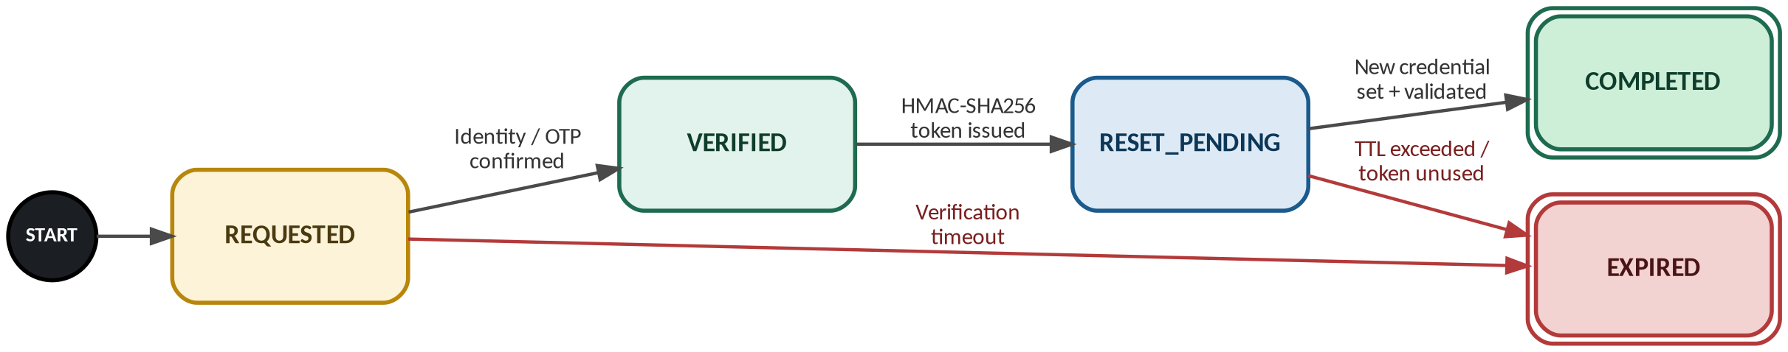
Figure 2. Finite-state machine governing every password-reset request, enforced end-to-end via Spring Security @PreAuthorize.

5. Continuous Security Integration Matrix
The pipeline treats every artifact class — source code, dependencies, container images, and configuration/secrets — as an independently scanned control point, with build-breaking gates rather than advisory-only reporting.
Stack Layer | Threat Focus | Tooling | Gate Condition
Java Application Code | Injection flaws, cryptographic misuse, OWASP API Top 10 (BOLA, broken authN, excessive data exposure) | SonarQube / Semgrep (SAST) | Build fails on Critical/High findings or new security hotspots.
Maven Dependencies | Known-vulnerable transitive/direct libraries | Trivy / Snyk (SCA) | Build blocked on any dependency with CVSS ≥ 7.0.
Dockerfile & Base Image | OS-package CVEs, insecure base layers, root-user execution | Trivy / Grype (Container Scan) | Registry push blocked on Critical CVEs; enforced non-root USER check.
Config & Git History | Hardcoded secrets, leaked API keys/tokens, committed .env files | TruffleHog (Secret Scan) | Commit blocked locally; CI gate fails on any verified secret match.

5.1 Pipeline Gate Flow
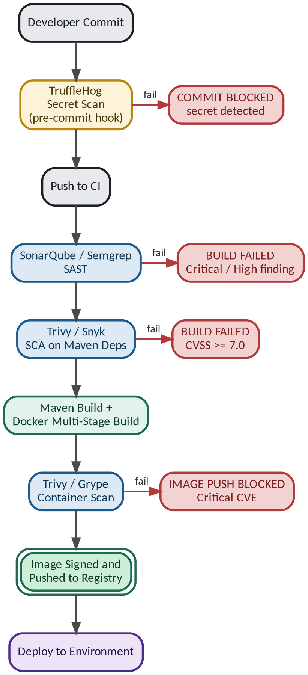
Figure 3. Every gate is a hard stop, not an advisory report — a failed scan halts progression to the next pipeline stage.

6. Local Development Setup & Orchestration
Local development mirrors the production isolation model using Docker Compose, with Vault running in -dev mode (in-memory, auto-unsealed) purely for developer convenience — this mode is explicitly forbidden beyond local use.

6.1 docker-compose.yml Reference
version: "3.9"

services:
nginx:
image: nginx:1.27-alpine
ports:
- "443:443"
volumes:
- ./nginx/nginx.conf:/etc/nginx/nginx.conf:ro
- ./nginx/certs:/etc/nginx/certs:ro
depends_on:
- backend
networks:
- dmz-net

backend:
build:
context: ./backend
dockerfile: Dockerfile
environment:
SPRING_PROFILES_ACTIVE: dev
VAULT_ADDR: http://vault:8200
VAULT_TOKEN: ${VAULT_DEV_ROOT_TOKEN}
depends_on:
- postgres
- vault
networks:
- dmz-net
- app-net
- data-net
expose:
- "8080"

postgres:
image: postgres:16-alpine
environment:
POSTGRES_DB: password_reset_platform
POSTGRES_USER: vault_managed
POSTGRES_PASSWORD: ${POSTGRES_BOOTSTRAP_PW}
volumes:
- pg-data:/var/lib/postgresql/data
networks:
- data-net
expose:
- "5432"

vault:
image: hashicorp/vault:1.17
command: server -dev -dev-root-token-id=${VAULT_DEV_ROOT_TOKEN}
cap_add:
- IPC_LOCK
environment:
VAULT_DEV_LISTEN_ADDRESS: 0.0.0.0:8200
networks:
- app-net
- data-net
expose:
- "8200"

networks:
dmz-net:
driver: bridge
app-net:
driver: bridge
internal: true
data-net:
driver: bridge
internal: true

volumes:
pg-data:

6.2 Local Orchestration Notes
- Network segmentation is preserved locally. app-net and data-net are declared internal: true, so PostgreSQL and Vault remain unreachable from the host network or DMZ, replicating the production isolated-subnet model even in development.
- Bootstrap vs. runtime credentials. POSTGRES_BOOTSTRAP_PW is used only for container initialization; the backend never reads this value — it authenticates to Vault and requests a dynamic, TTL-bound PostgreSQL credential pair at startup.
- Dev-mode Vault caveat. -dev mode auto-unseals and stores secrets in memory (non-persistent, single-node). This configuration is explicitly disallowed for staging/production, which must use a properly initialized, HA-backed Vault cluster (Raft or Consul storage).
- Startup sequence. vault and postgres must report healthy before backend completes its Vault authentication handshake; a lightweight healthcheck/wait-for-it pattern avoids race conditions on first boot.

7. Summary
This design satisfies the MVP scope by combining a network-segmented 3-tier container topology, a security-rationalized technology stack, and a gate-enforced DevSecOps pipeline that scans code, dependencies, containers, and secrets at every commit.
CORE SECURITY INVARIANT
No static credentials exist anywhere in the system. This is enforced structurally via HashiCorp Vault's dynamic secrets engine, backed by NIST SP 800-63B–compliant authentication logic and OWASP API Security–aligned request handling at every tier boundary.
— End of Document —

