1. INTRODUCTION
1.1 Background:
NSS in the college manages event participations, attendance, reports etc using Whatsapp, important reports were created by different leaders in their device which becomes difficult to manage every volunteers participations and reports etc.
VazeNSSDegreeUnit system is web application designed to simplify the management of NSS regular activities. The system provides a centralised system for Programme officers, volunteers, leaders for NSS event participation, attendance, report management.

1.2 Objectives:
The main objective of the project is to develop a web-based system that will handle volunteers, leaders, events, attendance, reports, and feedback efficiently. The system aims to reduce manual work, maintain centralized records and improve communication and event management within the NSS unit.

1.3 Purpose, Scope and Applicability:
1.3.1 Purpose: The purpose of this project is to simplify the regular activities documentation of the NSS unit using a centralized web application. The system helps programme officers, leaders, and volunteers manage and participate in events, attendance, reports, and feedback more efficiently. The system will helpful to manage volunteers data such as total hours, attended events which was difficult to check it manually.

1.3.2 Scope: The system is used by NSS Degree Unit of V. G. Vaze College. It covers NSS events through a web-based platform. The system functions include user authentication, role-based access for admin and students, event creation, event registration, attendance, report generation, and feedback forms.

1.3.3 Applicability: The system can be used by college for managing NSS activities digitally. It helps programme officers and leaders organize events and maintain volunteer records efficiently. The system also helps volunteers access event details, register for activities, and submit feedback online.

1.4 Achievements: -

SURVEY OF TECHNOLOGIES:

- Frontend:
- HTML, CSS, JAVASCRIPT - HTML (or Hypertext Markup Language) is the backbone of web development. CSS responsible for the styling, layout of a webpage. JavaScript brings interactivity to the web.
- React- It is a library for building user Interfaces. Its primary goal is to minimize the bugs that occur when developers are building UIs. It does this through the use of components - self-contained, logical pieces of code that describe a portion of the user interface
- Vuejs - It is a JavaScript framework for building user interfaces. It builds on top of standard HTML, CSS, and JavaScript and provides a declarative, component-based programming model that helps to efficiently develop user interfaces of any complexity.
- Angular -It is a comprehensive framework maintained by Google, designed for building large-scale, enterprise-level applications. It offers a robust set of tools out of the box, making it a complete solution for frontend development.
- Tailwind - A utility-first CSS framework packed with classes that can be composed to build any design, directly in markup.
- Bootstrap - Bootstrap is a free front-end framework for faster and easier web development. It includes HTML and CSS based design templates for typography, forms, buttons, tables, navigation, modals, image carousels and many other, as well as optional JavaScript plugins

HTML, CSS, JAVASCRIPT is chosen to develop interactive, responsive web applications. HTML provides structure, CSS for styling and Javascript for functionalities. Frameworks used are Tailwind for user interface design and Vuejs for interactivity of user interface.

- Backend:
- Node.js - It is open-source, cross-platform JavaScript framework that is used to build server-side and networking applications. create high-performance applications that can execute in less time.
- Ruby on Rails – It is an open-source, high level and multipurpose web application framework that is used to develop server-side applications written in the Ruby language. It has a very simple syntax and structure.
- PHP (Hypertext Preprocessor)- It is a server-side scripting language that is primarily designed for creating dynamic web pages and web applications. It provides built-in functions and libraries to handle common security issues, such as cross-site scripting (XSS) and SQL injection attacks
- Django - It is an open-source framework based on Python. It is a web framework from the server’s side. It provides high security of accounts and data with the help of a user authentication system, protection from SQL injection, etc. and precise and organized documentation divided into various sections for developers.
- Flask - Flask is a micro framework based on Python which is easy to use and provides high speed and productivity. It is lightweight and has only the required components for web development.
- Springboot - Spring Boot is an open-source web framework based on Java that allows developers to build production-grade and standalone applications.

PHP is used for this project, because it is suitable for handling features of the system such as login, attendance, event registration, and database operations.

- Database:
- MySQL - MySQL is a widely-used relational database management system (RDBMS) developed by Oracle Corporation. Known for its high performance, reliability, and ease of use, MySQL is used in many web applications
- PostgreSQL - It supports both SQL and JSON querying, making it suitable for both relational and non-relational data. PostgreSQL is highly customizable and supports a range of applications, from small single-machine applications to large internet-facing applications.
- Cassandra - Apache Cassandra is a highly scalable NoSQL database that can handle large amounts of data across many commodity servers with no single point of failure. It offers high availability and fault tolerance, making it suitable for applications that require large-scale data distribution and real-time data processing.
- MariaDB - It aims to provide a secure, high-performance alternative to MySQL, with a strong focus on compatibility and enhanced features.
- SQLite - SQLite is a self-contained, serverless, zero-configuration database engine. It can be embedded into applications, providing a lightweight and efficient way to manage local storage.
- CouchDB - CouchDB is a NoSQL database that uses JSON for documents, JavaScript for MapReduce queries, and regular HTTP for an API. It is known for its ease of use, powerful replication, and ability to synchronize databases efficiently across different devices.
- MongoDB- MongoDB is a document database. It stores data in a type of JSON format called BSON.
For the VazeNSSDegreeUnit system, the MySQL database is selected because of its fast data retrieval, easy integration with php. The system uses structured data such as user details, event details, attendance details which can be implemented using MySQL database easily.

ENTITY SETS :-
- College
- Admin
- Student
- Academic_details
- Leader
- Event
- Attendance
- Report
- Feedback_question
- Feedback_response
- FAQ

- College - This entity set stores information of college
Attributes :
- Name - name of college
Type: Simple attribute
- Password - password for credential
Type: Simple attribute

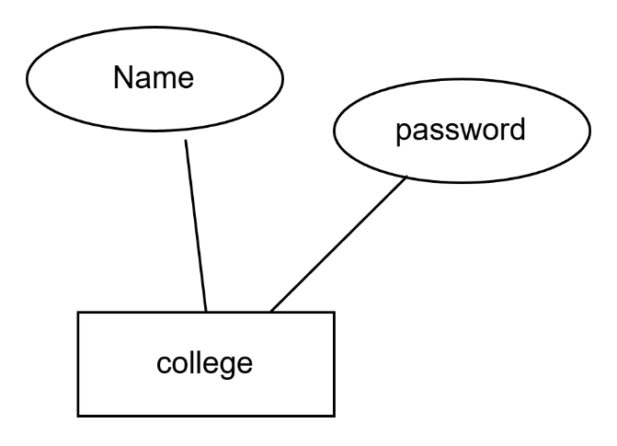

- Admin - This entity set store information of Programme Officers and NSS Committee Members. Admin will have access to all the important functionalities of the web application.
Attributes :
  - Admin_id – Unique number for each admin
Type: Simple attribute
  - Email - email of NSS Degree Unit for all Programme officers
Type: Simple attribute
  - Name(First name, Surname) - stores name of admin
Type: Composite attribute
  - Mobile - contact number of admin
Type: Simple attribute
  - Password - it will stored hashed password for authentication
Type: simple
  - Role - Role is either Programme officer or committee member
Type: simple attribute
  - Created_date - timestamp when account is created
Type: simple attribute

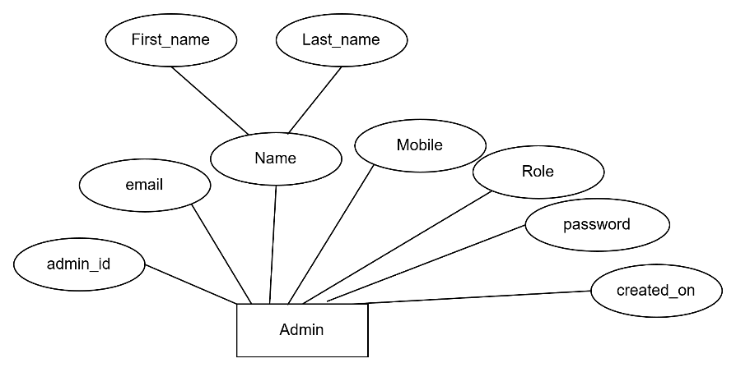
- Student - This entity set stores data of all the students who are registered as a volunteer for NSS. It stores data of assigned Leader of an academic year. It will give role-based access using Role attribute.
Attributes :
- Std_id – Unique number for each student
Type: Simple attribute
- Name(First_name, father_name,mother_name, surname) - Full name of student
Type:Composite attribute
- Email - e-mail of student always unique for each student
Type: simple attribute
- Mobile - Mobile number will also also unique for each student
Type: Simple attribute
- Password - password for login credential
Type: Simple attribute
- Blood_grp - Blood group of the student
Type: simple attribute
- Caste - Caste (SC,ST,OBC, Minor and General)
Type: Simple attribute
- DOB - Date of Birth of the student
Type: Simple attribute
- Created_on - Timestamp of when account is created
Type: simple attribute

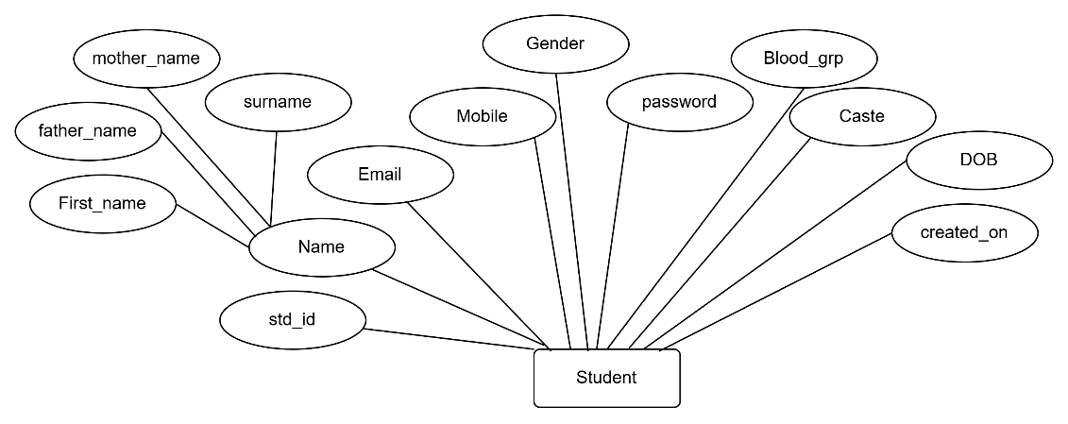

4. Academic_details - It is a weak entity set which dependent on Student entity and
stores Academic details of students.
Attribute:
  - Academic_year – current academic year
Type : Simple attribute
  - NSS_year - (First , Second, Third) year of NSS
Type: Simple attribute
  - Class - Class (FY, SY or TY)
Type: Simple attribute
  - Program - Program of student enrolled
Type: Simple attribute
  - Division - which student is learning
Type: Simple attribute
  - Roll_no - Roll Number of that student
Type: Simple attribute
  - Total_hrs - Hours completed
Type: Derived attribute

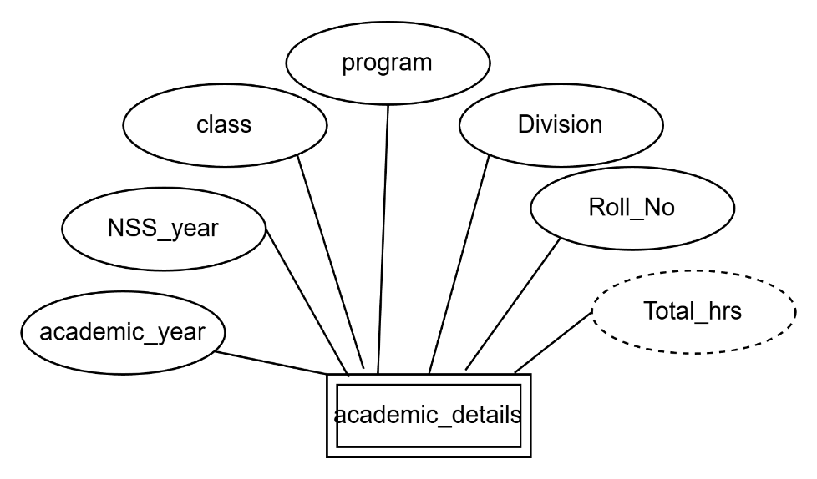

5.Leader- This entity set stores assigned leader for a academic year
Attribute:
a. Role – Stores role of leader
Type- Simple attribute

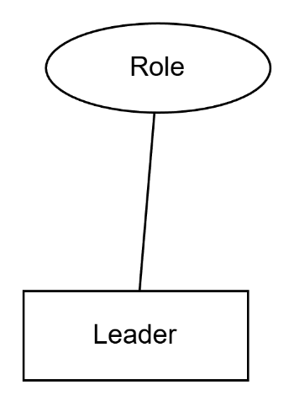

6. Event - This entity set stores all the regular events which are scheduled that created
by admin or leader.
Attribute:
  - event_id – Unique number for each event
Type : Simple attribute
  - Name - Name of Event
Type : Simple attribute
  - Date - Date of event scheduled
Type : Simple attribute
  - Organised_by - name of event organiser
Type: Simple attribute
  - Collaboration - collaborator name if event is organied with collaboration4
Type : Simple attribute
  - Description - short description of the event which includes what work have to do in the event
Type:simple attribute
  - Time - time of event begins
Type: Simple attribute
  - Reporting_time - time at which volunteers have to come
Type : Simple attribute
  - Venue - Venue of the event
  - Reporting_location - Location where all volunteers have to gather
Type: Simple attribute
  - Event_type - Type of event (CL, UL, DL, ABP-1, ABP-2)
Type : Simple attribute
  - Approx_hrs - Aproximated hrs to be given for attending event
Type: Simple attribute
  - Status - event is tentative or confirmed
Type: Simple attribute
  - Created_on - timestamp when event is created
Type: simple attribute
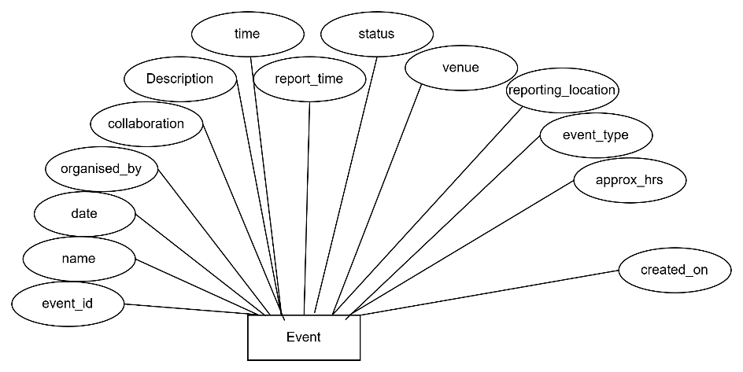

7. Attendance - This is a weak entity set stores participants of the event and who attended the event, it allows leaders to mark attendance at start and end of the event, and allot actual hours given by leaders
Attribute :
- reporting_mark -timestamp of attendance mark at the time of reporting by the leader
Type: Simple attribute
- End_mark – Timestamp of attendance mark at the end of event by the leader
Type : Simple attribute
- Hrs_alloted - actual hours alloted after event completion
Type : Simple attribute
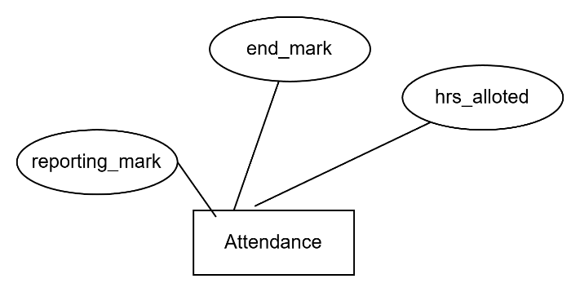
8. Report - This entity stores post-event information for reports
Attributes :
- Total_attendees(Male, Female, Total) - count of total volunteers participated
Type: Composite attribute
- Geotagged_photo - Geotagged photo of the event
- Expenditure(type,amount) - total expense of the event including travelling, breakfast etc.
Type: Composite attribute
- Exp_proof - proof of the expense
- Event_description - brief description of event importants of the event
Type: simple attribute
- Conclusion - Conclusion for the event
Type: simple attribute
- Word_report - report in given format
Type: simple attribute
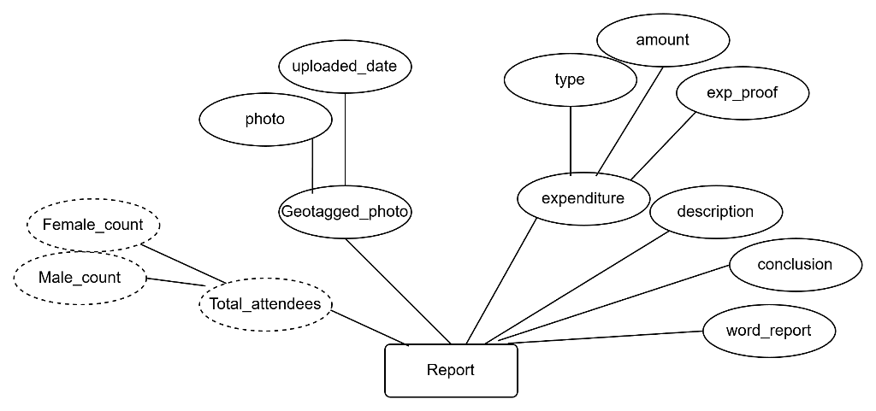
9. Feedback_question - This is weak entity set which stores Feedback questions for the event
Attributes :
- q_no - unique identifier for question
- Question - Question to get feedback
Type: Simple attribute
- Question_type - Type of question
Type: Simple attribute
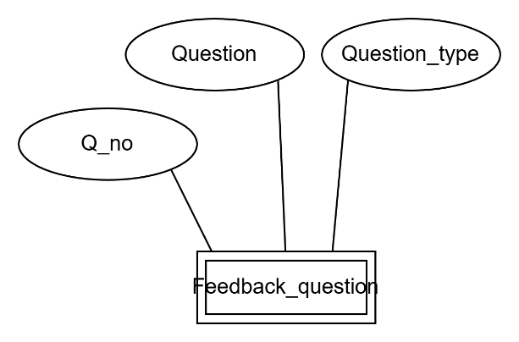
10. Feedback_response - This entity set stores feedback of the event
Attributes :
- Answer - Feedback of the question
Type: Simple attribute
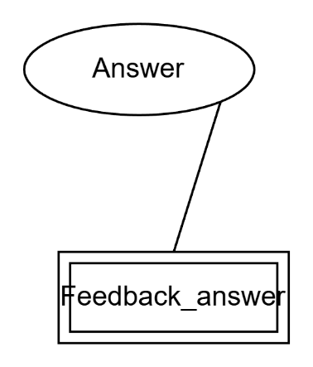
11. FAQ - this entity set stores answers of asked questions
Attributes :
- Faq_id - Unique number for each question
Type: Simple attribute
- Question - Question asked by students
Type: Simple attribute
- answer - answer given by leader for the question
Type: Simple attribute
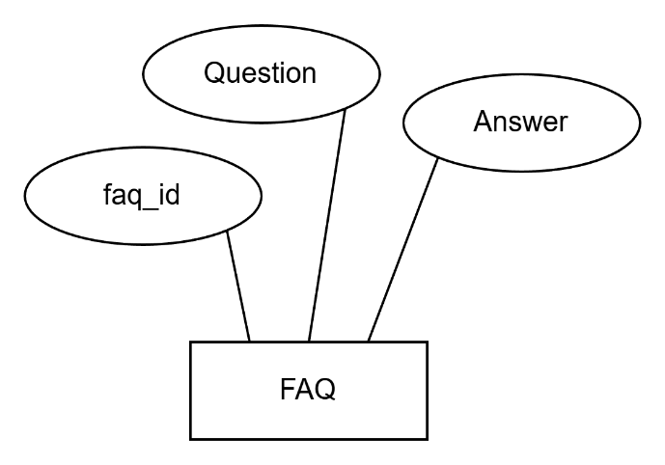

Entity-Relationship :

1.college-admin – A relationship between college and admin entity sets
Cardinality – One to many
Participation constraint- Total participation
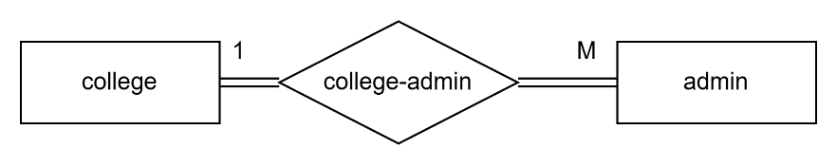
2. assigns – A relationship between admin and Leader entity set indicates leader is assigned by which admin
Cardinality- One to Many
Participation constraint – partial participation of admin and total participation of leader in relationship
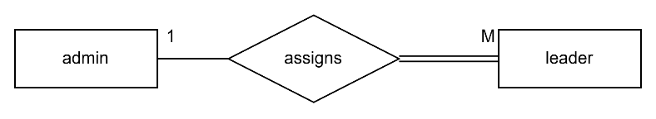
3. Approves – A relationship between leader and academic_details indicates Student’s data is approved by the leader for a academic year
Cardinality – One to Many
Participation Constraint – partial participation of leader and total participation of academic_details
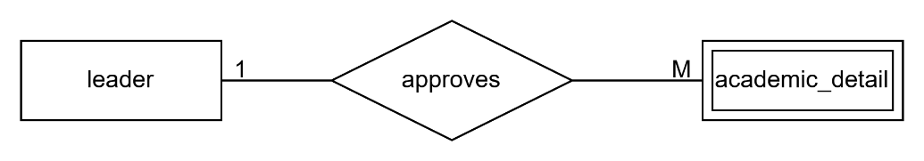
4.admin-event – A relationship between admin and event indicates event is created by the admin
Cardinality – One to Many
Participation constraint – partial participation of both entities in relationship
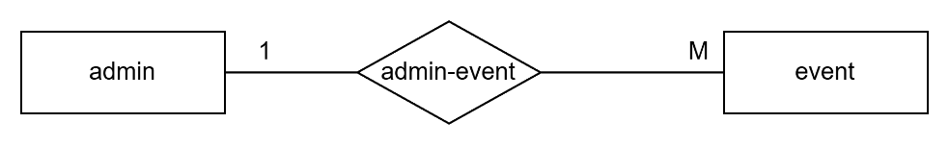

5.leader-event – a relationship between leader and event entity sets indicates leader created a event
Cardinalilty – One to Many
Participation constraint – partial participation of both entities
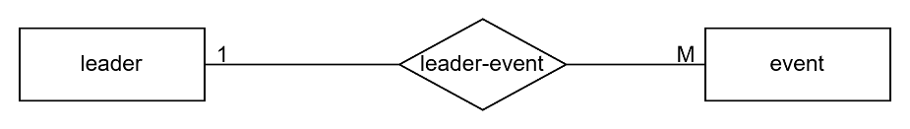

6. adds – A relationship between leader and report indicated reports are added by the leader
Cardinality – One to Many
Participation constraint – partial participation of leader and total participation of report
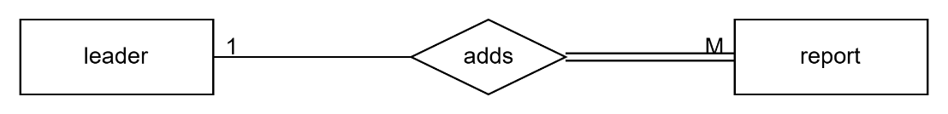

7.marked_by – A relationship between leader and attendance of event indicates attendance is marked by the leader
Cardinality – Many to One
Participation constraint – Partial participation of leader and total participation of attendance entity
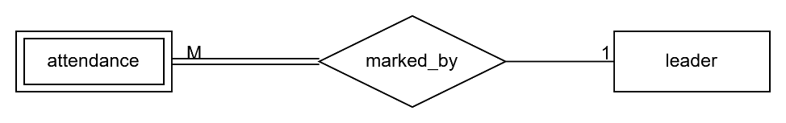
8.contains – A relationship between attendance and academic_details indicates a student attended an event for a particular academic year
Cardinality – Many to One
Participation constraint – Total participation of attendance and partial participation of academic_details
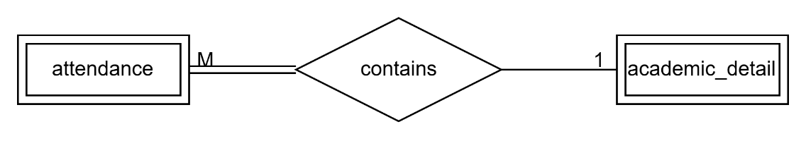

9.has – A relationship between report and attendance entity sets indicates attendance of an event
Cardinality – One to Many
Participation constraint - Total participation of both entities
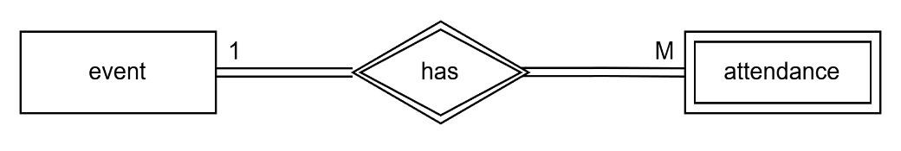
10. for – Relationship between report and event indicates report of an event
Cardinality – One to One
Participation constraint – Total participation of both entities
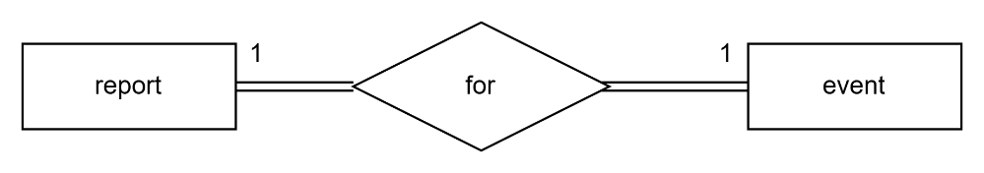
11. takes- Relationship between event and feedback_question enitity sets indicates event has feedback questions
Cardinality – One to Many
Participation constraint – Total participation of both entity
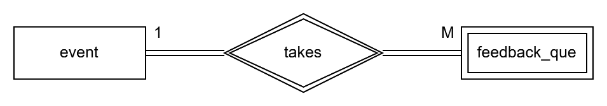

12. gets – A relationship between feedback_question and feedback_answer indicates feedback questions have answers
Cardinality – One to Many
Participation constraint – Total participation of both entity
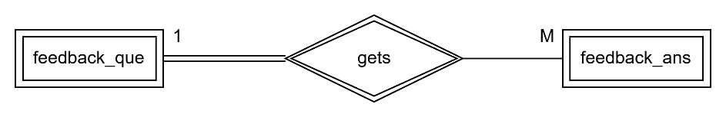
13.given_by – A relationship between feedback_answer and academic_details indicates student given feedback answer for an event of that academic year
Cardinality – One to One
Participation constraint- partial participation of both entity
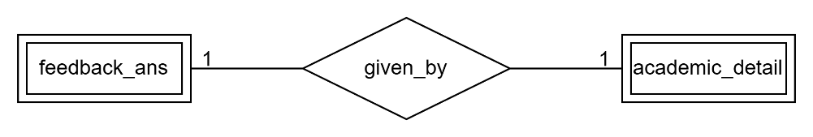
14. ans_by – A relationship between FAQ and leader indiated answer is given by the leader
Cardinality – Many to One
Participation constraint- Partial participation of leader and total participation of FAQ
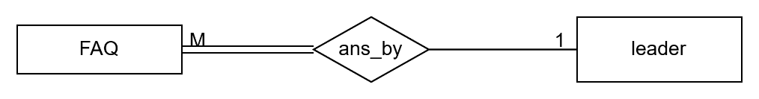
15. std-academic – A relationship between student and academic_details enitity sets indicates student’s academic details of current year
Cardinality – One to Many
Participation constraint – total participation
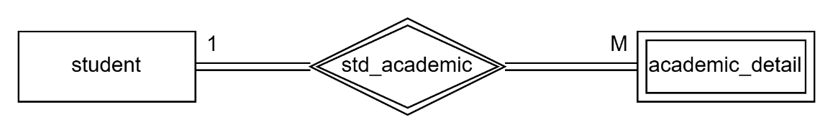

Entity-relationship Diagram :

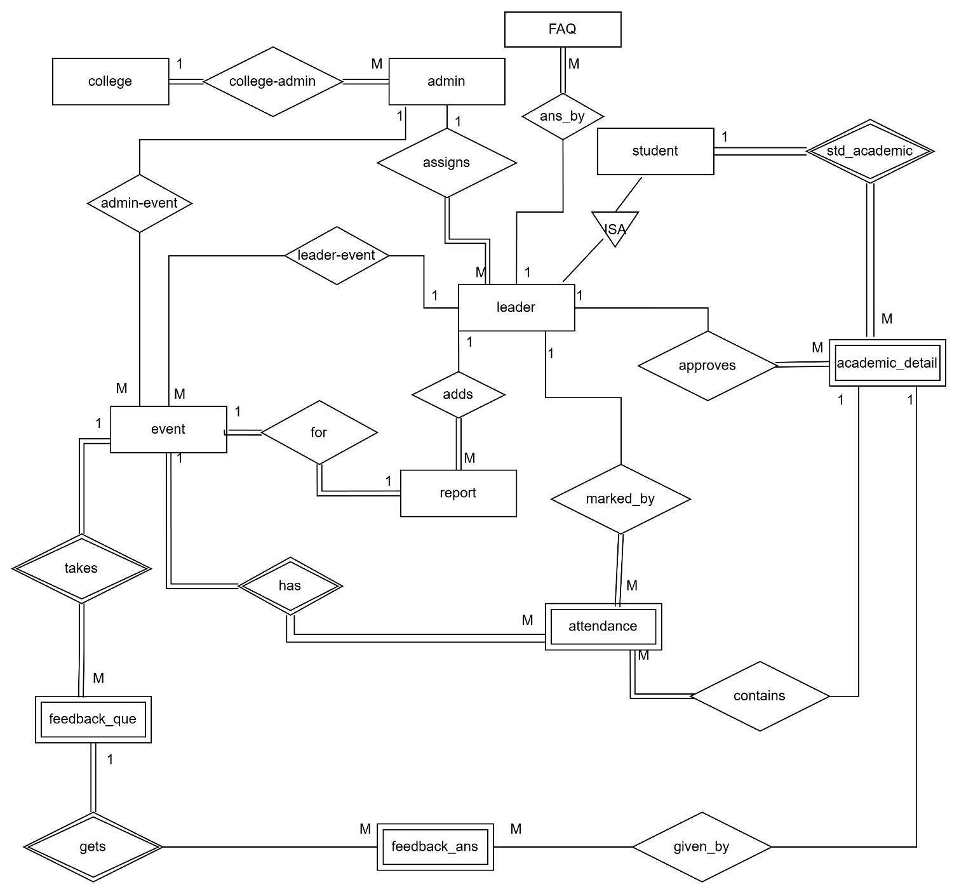

SCHEMA :

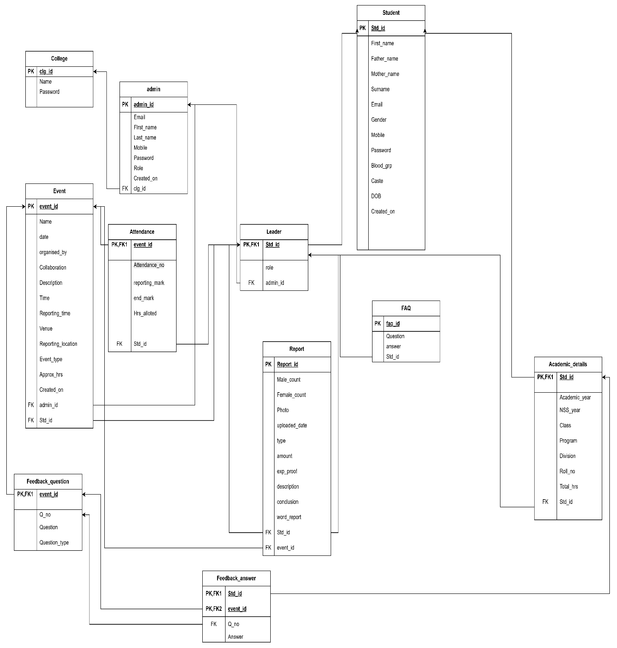

DFD:

