- ER Diagram:
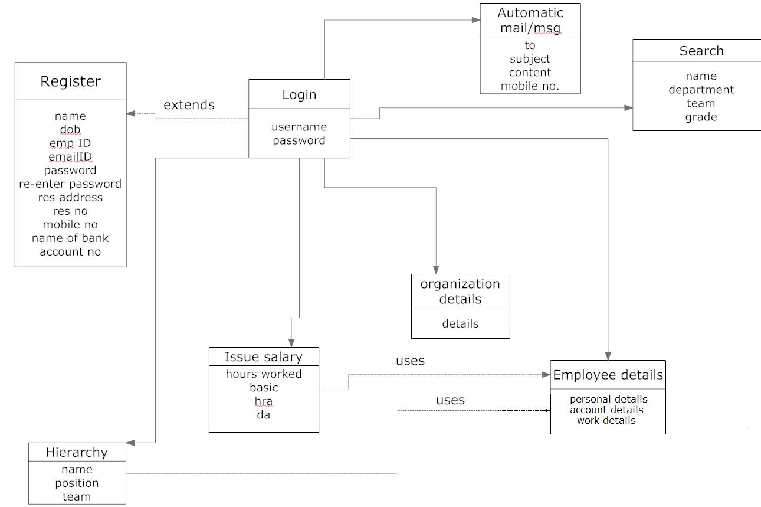

- Use Case

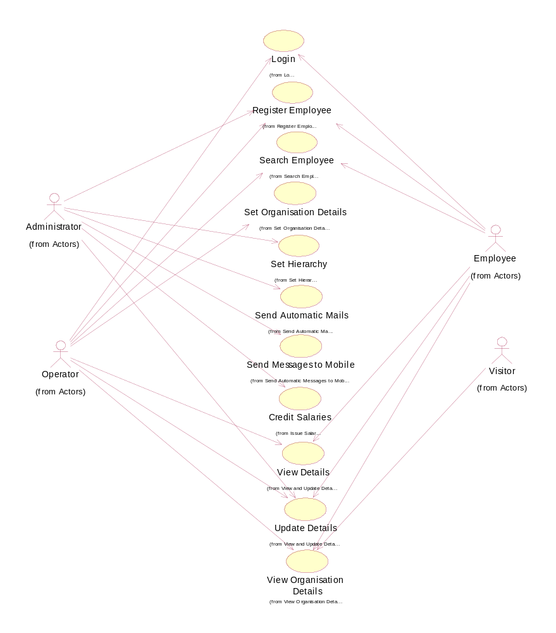

- Class Diagram
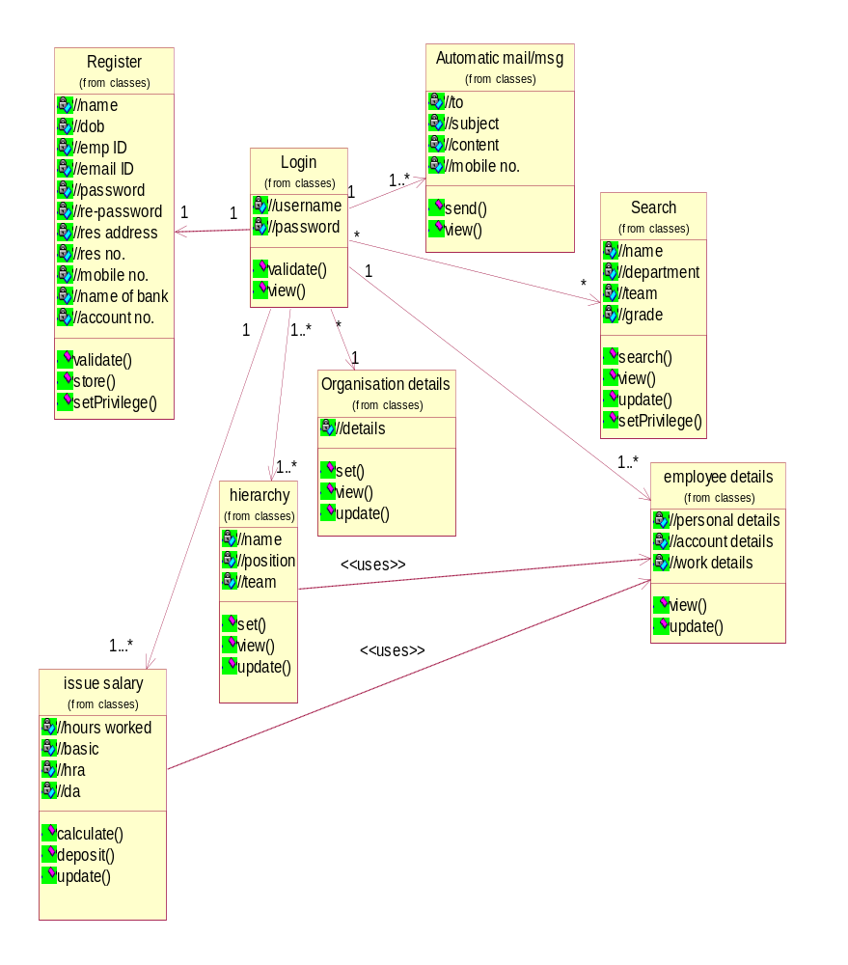

- Architecture Design

Register db
Details db
Account db

register.jsp
login.jsp
welcome.jsp
search.jsp
org_details.jsp
emp_details.jsp
send_mailmsg.jsp
update.jsp
salary.jsp

- Database Design
Register/Login db
Details db
Emp Name
Dob
Emp ID
Email ID
Username
Password
Resaddr
Res no.
Mobno.
bankname
branchname
Accno.
Sq
Sqans
Department
Grade
Team

Account db
Post1
Post2
Post3
Post4
Post5
Post6
Post7
Post8
Post9
Post10

Orgdetails
orgdet
Tag
TAGIDDISCDATEDISCTIMELASTDATELASTTIMECOUNTEEMPIDUSERNAMELASTDATE1LASTTIME1NOHRNOMIN
Emp Name
Dob
Emp ID
Email ID
Username
Password
Resaddr
Res no.
Mobno.
bankname
branchname
Accno.
Sq
sqans
- Sequence diagrams
Register:
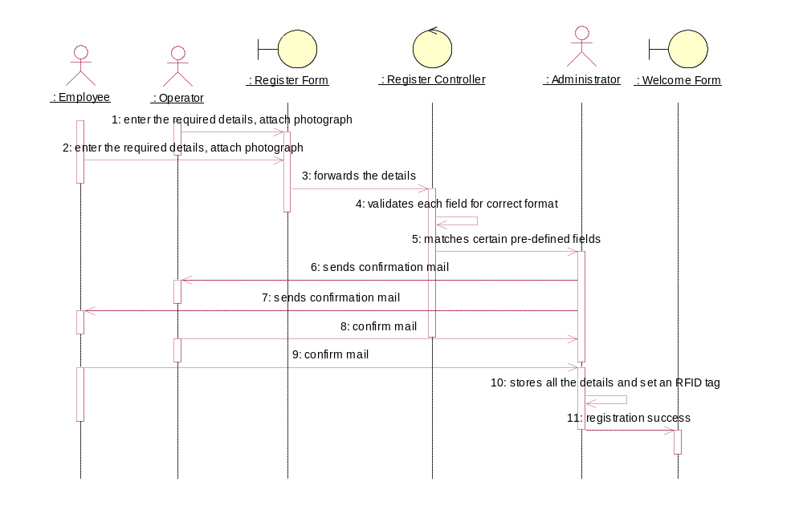

Login:
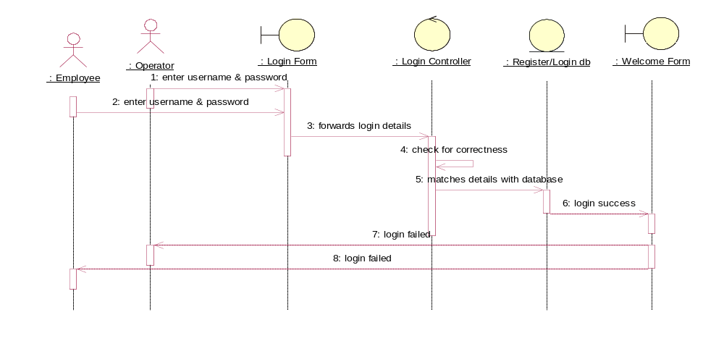
Search employee:
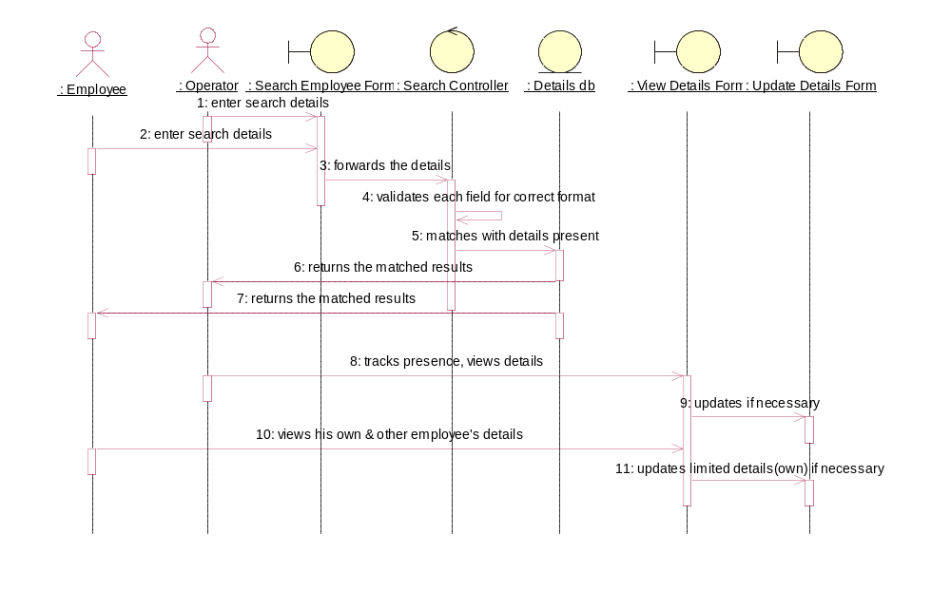

Send automatic mails/messages:
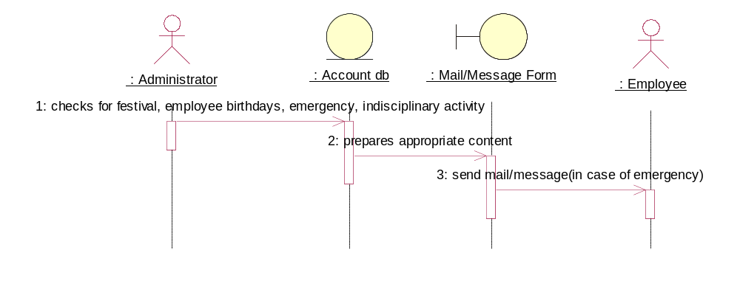

Set & view organization details:
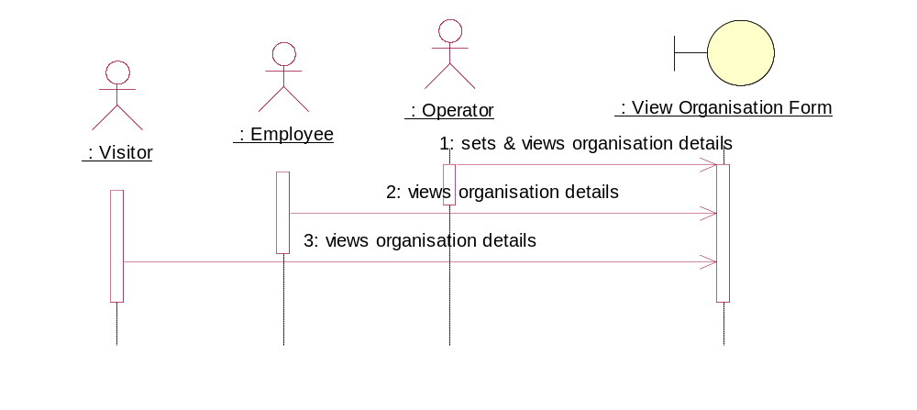

Set & view hierarchy:
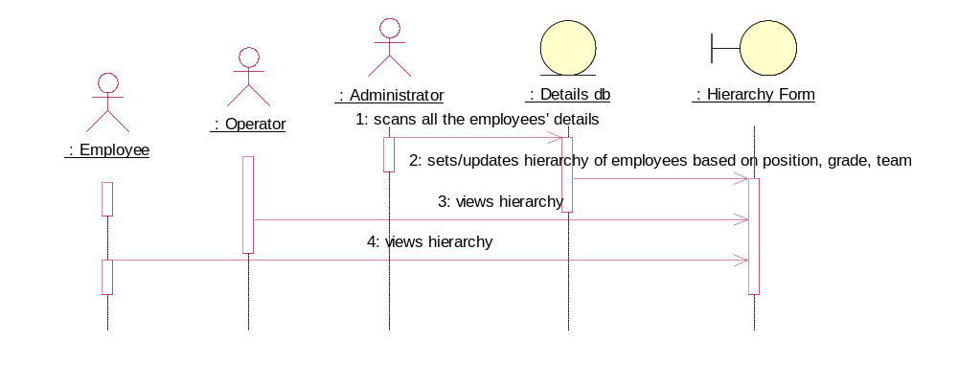

View and Update Details:
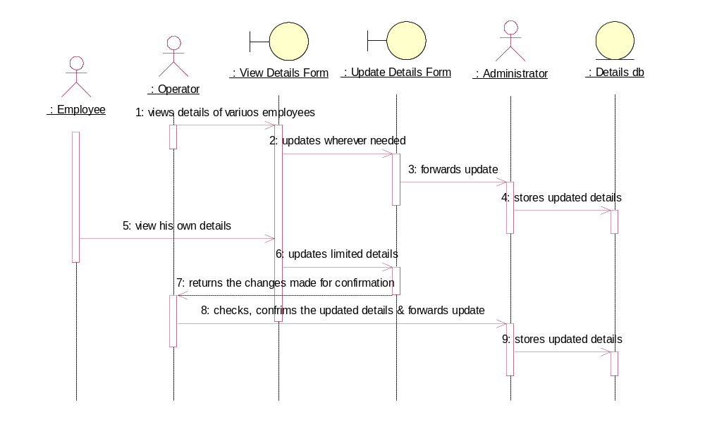

Issue salary:
