
RFID based employee tracking system

Software Requirement Specification

Easwari Engineering College
Chennai
Team members
S Viginesh
V K Siddarth
P Vijayalakshmi
S Priyankha

Project Mentor
R Radha
Department of Information Technology
Table of Contents

Description

1 Introduction 3
1.1 Purpose 3
1.2 Scope 3
1.3 Definition, Acronyms, and Abbreviations 3
1.4 References 4
1.5 Technologies to be used 4
1.6 Overview 4

2 Overall Description 5
2.1 Software Interface 5
2.2 Hardware Interface 5
2.3 Communication Interface 5
2.4 Constraints 5
2.5 ER Diagram 6
2.6 Use Case Model Survey 6
2.7 Class Diagram 8
2.8 Architecture Design 9
2.9 Database Design 10

3 Specifications 11
3.1 Use Case Reports 11
3.2 Activity diagram 18
3.3 Sequence diagrams 22
1. Introduction:
1.1 Purpose:
The purpose of the “RFID based employee tracking system” project is to detect which employee is entering and leaving the office. At the end of the month based on the attendance employee’s salary will be calculated. Apart from this, the administrator will also be able to track their employees in the campus with the help of the RFID tags the employees possess.
1.2 Scope:
  - To provide a secure registration of employees in the office
  - To search and track employees based on different criteria such as department, position etc
  - To setup the basic details of organization such as working hours, number of working days per month to calculate the salaries
  - Set the hierarchy of the organization
  - To send automatic mails to employees regarding salaries, attendance, holidays etc
  - To send messages to mobiles if employee absent or issued salaries or general messages regarding holidays, wishes etc.
  - Automated issue of salaries
  - To provide facility for employee to view and update his details, view his attendance reports
  - To provide a facility for visitor to view the organization basic details
1.3 Abbreviations:
  - Administrator:
Administrator has the overall control of the project. He can accept or reject the user of the system. He approves the registration of all employees, has the authority add, modify, update or even delete employee information based upon the present scenario.

  - Employee:
Employee is the user of this system, they register when they join the company. After approval, they can access/share their information.

  - J2EE:
Java 2 Enterprise Edition is a programming platform and it is part of the Java Platform for developing and running distributed multi-tier architecture Java applications, based largely on modular software components running on an application server.

  - DB2:
DB2 Database is the database management system that delivers a flexible and cost effective database platform to build robust, on demand business applications.

  - WAS:
WebSphere Application Server is an application server that runs business applications and supports the J2EE and web services standards.

  - WSAD:
WebSphere Studio Application Developer is a designer toolkit which is designed for develop more complex projects by providing fully dynamic web service.

  - UML:
Unified Modeling Language is a standard language for writing software blueprints. The UML may be used to visualize, specify, construct and document

  - XML:
Extensible Markup Language is a text based format that let developers describe, deliver and exchange structured data between a range of applications to client for display and manipulation.

  - HTTP:
HyperText Transfer Protocol is a transaction oriented client/server protocol between web browser and a web server.

1.4 References:
- IEEE SRS Format
- Problem Definition (Provided by IBM)

1.5 Technologies:
- J2EE: Application Architecture
- JAVA: Application architecture
- DB2: Database
- WSAD: Development Tool
- WAS: Web Server
- Rational: Design Tool

1.6 OVER VIEW:

SRS includes two sections overall description and specific requirements:
    - Overall description will describe major role of the system components and interconnections.
    - Specific requirements will describe roles & functions of the actors.

2. Overall Descriptions:
2.1 Software Interface:
- Client on Internet: Web Browser, Operating System
- Client on Intranet: Client Software, Web Browser and Operating System
- Web Server: WASCE, Operating System
- Data Base Server: DB2, Operating System
- Development End: WSAD (J2EE, Java, Java Bean, Servlets, HTML), DB2, OS (Windows), WebSphere (Web Server).

2.2 Hardware Interface:

*Client side
 | Processor | RAM | Disk space
Internet explorer  6.0 | Pentium II at 500 MHz | 64 MB | 1 GB
*Server side
Web sphere  Application server  V5.0 | Pentium III at 1 GHz | 512 MB | 2 GB
DB2 V8.1 | Pentium III at 1 GHz | 512 MB | 1GB

2.3 Communication Interface:
- Client on Internet (Employee and Visitor) will be using HTTP/HTTPS protocol.
- Client on Intranet (operator) will be using TCP/IP protocol.

2.4 Constraints
- GUI is only in English.
- Login and password is used for the identification of employee
- Each employee is provided an employee ID for unique identification.
- Only registered employees and operator will be authorized to use the services.
- It is limited to HTTP/HTTPS.

2.5 ER Diagram:
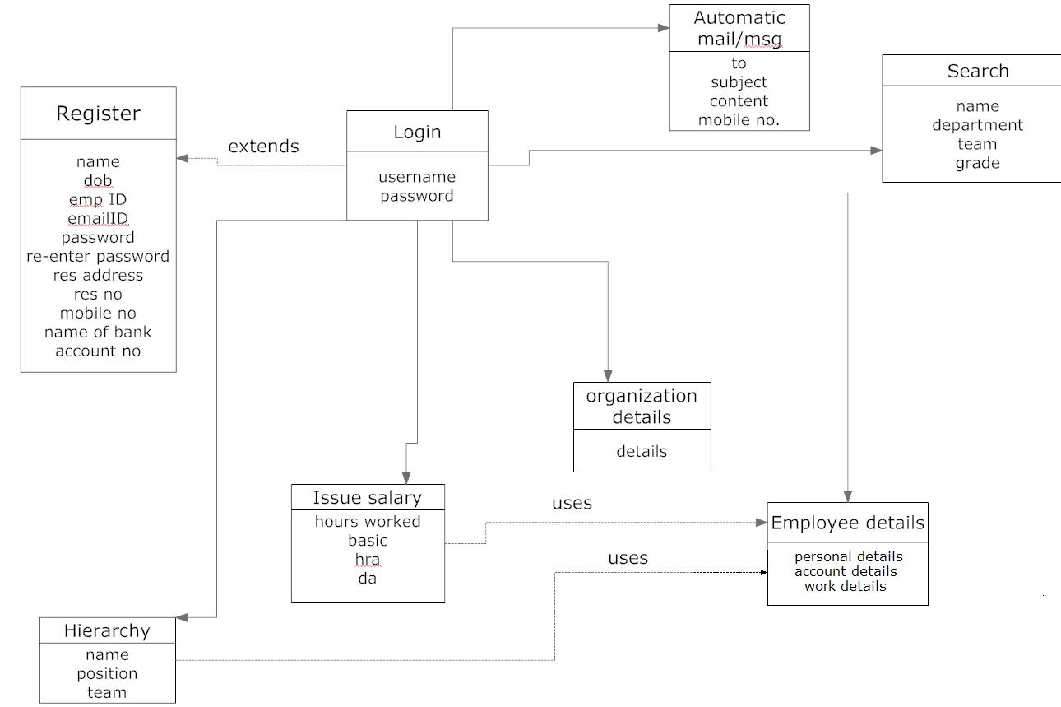

2.6 Use Case Model Survey

        - Administrator:
Administrator accepts the employees during registration; update their details, sets hierarchy of the organisation. It also sends automatic messages to employee’s mobile in case of emergency.
- Operator:
Operator registers, logs in, searches for an employee, view & update their details. He also sets and views organisation details.
- Employee:
Employee registers, logs in, searches for colleague & views basic details, organisation details, updates his details if needed.
- Visitor:
Visitor views basic organisation details.

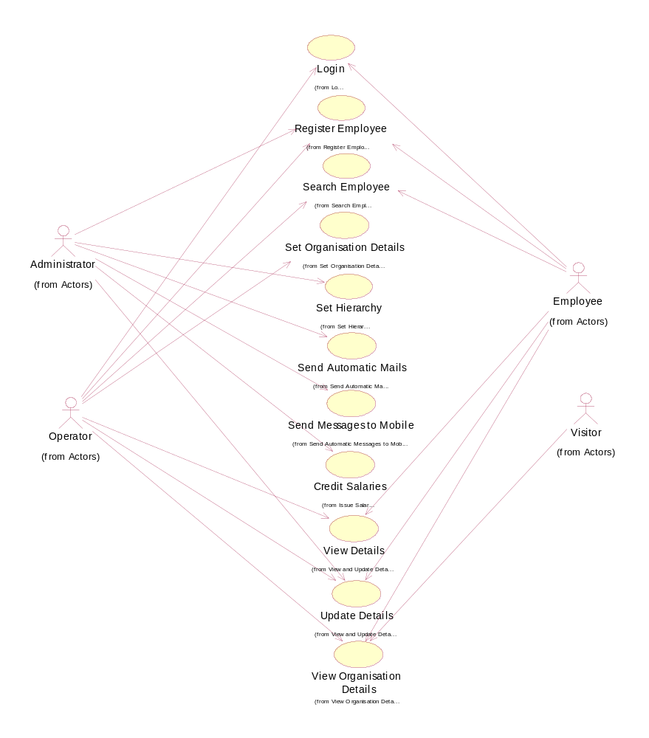

2.7 Class Diagram
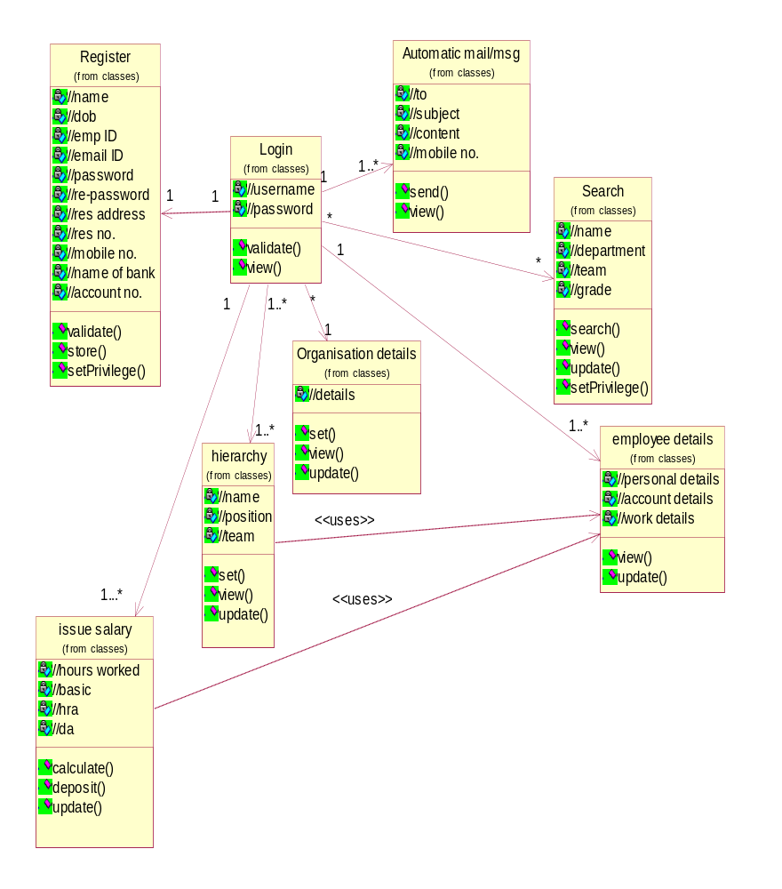

2.8 Architecture Design

Register db
Details db
Account db

register.jsp
login.jsp
welcome.jsp
search.jsp
org_details.jsp
emp_details.jsp
send_mailmsg.jsp
update.jsp
salary.jsp

2.9 Database Design
Register/Login db
Details db
Emp Name
Dob
Emp ID
Email ID
Username
Password
Resaddr
Res no.
Mobno.
bankname
branchname
Accno.
Sq
Sqans
Department
Grade
Team

Account db
Post1
Post2
Post3
Post4
Post5
Post6
Post7
Post8
Post9
Post10

Orgdetails
orgdet
Tag
TAGIDDISCDATEDISCTIMELASTDATELASTTIMECOUNTEEMPIDUSERNAMELASTDATE1LASTTIME1NOHRNOMIN
Emp Name
Dob
Emp ID
Email ID
Username
Password
Resaddr
Res no.
Mobno.
bankname
branchname
Accno.
Sq
sqans
3. Specification
3.1 Use Case Reports
3.1.1 Operator Use-Case Report:
Use case name: Login
Normal flow: The operator enters the username & password.
Pre-condition: The operator must have already registered.
Post-condition: Logs in if they match/ retries if they don’t. After logging in, the operator can access all the features which are given to him.
Alternative flow: If the credentials entered is wrong/invalid the system requests the operator to re-enter.
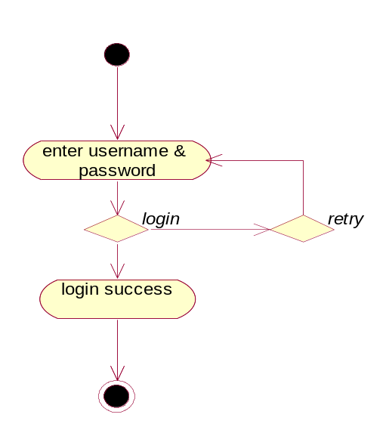

Use-case name: Search employee
Normal flow: The operator can search an employee based on various criteria like department, grade, team etc.
Pre-condition: The operator must have logged in to search details about an employee.
Post-condition: After searching, the operator views the presence of employee, his details & can also update details if necessary.
Alternative flow: If operator can’t find the employee exactly, he has to filter the search by entering proper name & criteria
`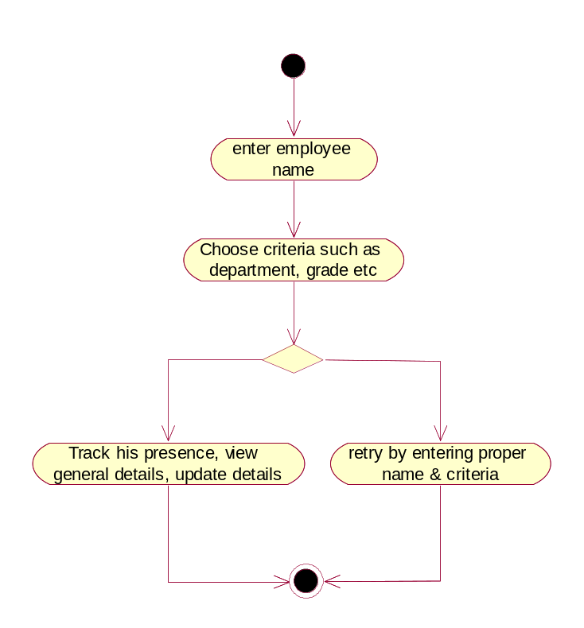

Use-case name: Set Organisation Details
Normal flow: The operator enters the various details about the organisation
Pre-condition: The operator must have logged in to set the organisation details
Post-condition: After setting the organisation details, it’ll be available for public view.
Alternative flow: No alternative flow
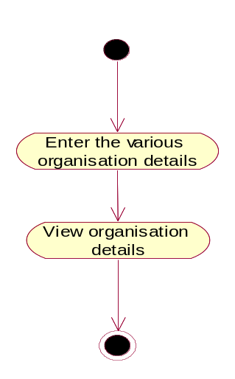
Use-case name: Credit salary
Normal flow: The operator checks whether the employee has taken extra leave or worked over-time & calculate salary based on that.
Pre-condition: The operator must have the details of total no. of hours each employee has worked.
Post-condition: Operator credits the salary for all the employees after required calculations
Alternative flow: If there problem in crediting salary, it’ll be held till the problem is resolved
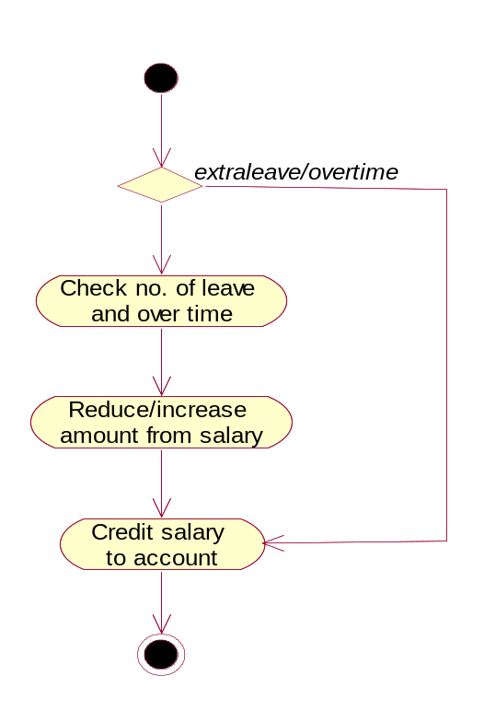
Use-case name: View & Update details
Normal flow: The operator can view the details of each employee & update it if necessary
Pre-condition: The details of all the employees must be stored in the database in order to view & update
Post-condition: The details get updated
Alternative flow: If the details are not updated, then wrong data will be present in the database.
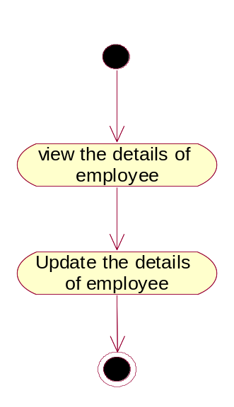

3.1.2 Administrator Use-Case Report:
Use-case name: Register employee
Normal flow: Administrator checks the various details of employee for correctness, accepts registration and allots the required RFID tag.
Pre-condition: Administrator must have the rules of registration in order to check the correctness
Post-condition: The Administrator activates employee’s profile & a tag is allotted.
Alternative flow: If the registration details have mistakes, it is resent for correction
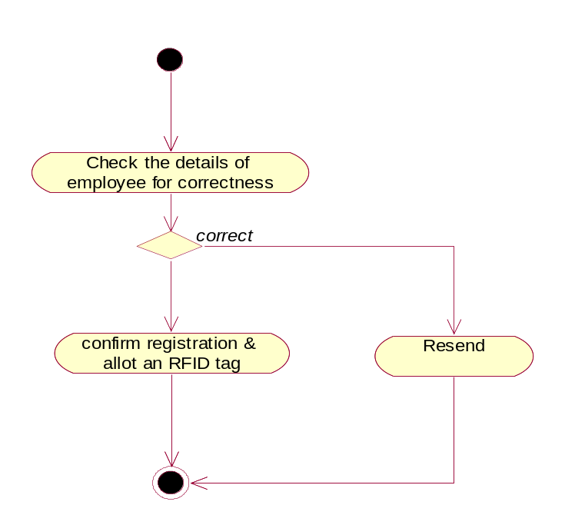
Use-case name: Set hierarchy
Normal-flow: The administrator checks the position or grades of all the employees and sets hierarchy of organisation from highest to lowest grade.
Pre-condition: The operator must have the details of all the employees in order to form hierarchy
Post-condition: After the hierarchy has been set by the administrator, it’ll be available for view by the operator & employees
Alternative flow: No alternative flow.
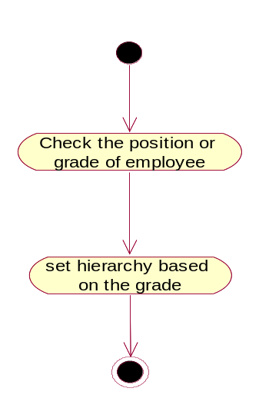
Use-case name: Send automatic mails and messages
Normal flow: When employee takes extra leave or working hours is not proper, indisplicine, for any kind of rules/proposal/circular, for festival & birthday wishes, an automatic mail is sent. In case of an emergency, matter is conveyed through message to employee’s mobile
Pre-condition: Database should contain the important dates & a threshold for indiscipline.
Post-condition: Adminitrator should check whether the particualr issue is solves, if there is any.
Alternative flow:

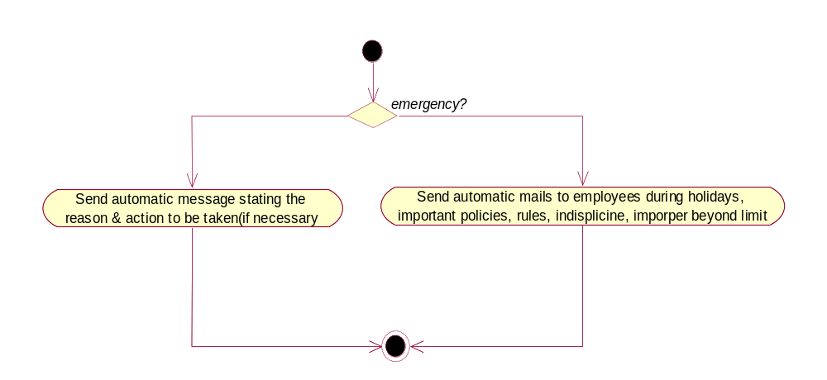
Use-case name: Update details
Normal flow: When there is an update from employee/operator, Administrator must scan thoroughly and the update must be reflected in all the required places.
Pre-condition: Administrator must scan for any update from employee/ operator.
Post-condition: The updated database must be visible to the employees and operator.
Alternative flow: If the update is not sanctioned by operator then it should not get reflected
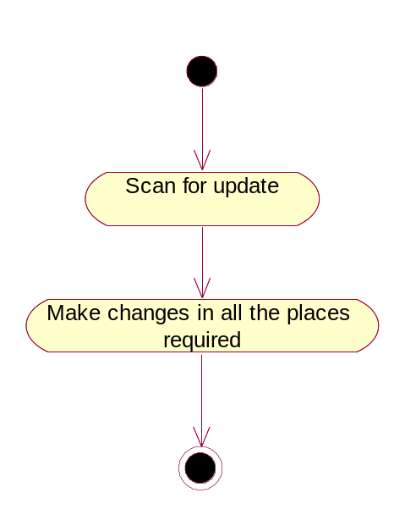

3.1.3 Employee Use-Case Report:
Use-case name: Register
Normal flow: The employee enters employee ID, required details, attach photograph and confirm mail.
Pre-condition: The person should have been appointed and he must have a valid employee ID
Post-condition: The employee’s must be registration must be accepted by Admin
Alternative flow: In case of any mistakes in the registration, employee must correct them and resend
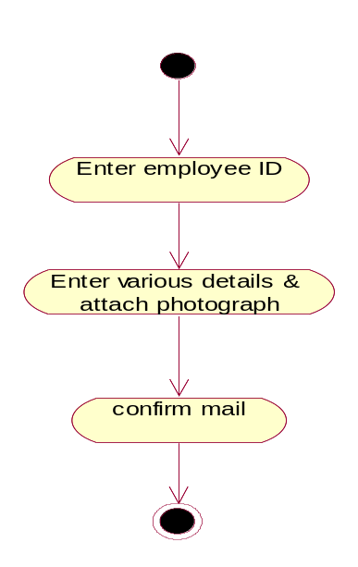
Use-case name: Login
Normal flow: The employee enters the username & password. Database verifies the details and either accepts login or throws error when the details are wrong
Pre-condition: The employee must have registered already.
Post-condition: If the credentials entered is wrong/invalid the system requests the employee to re-enter.
Alternative flow: If the credentials are wrong, employee must re-enter
Use-case name: View & Update details
Normal flow: The employee can view the his details, his colleagues & update his details if necessary
Pre-condition: The details of all the employees must be stored in the database in order to view & update
Post-condition: The details get updated in all the required places
Alternative flow: If the details entered have mistakes, then it’ll not be approved by operator . Hence, will not get updated

Use-case name: View organisation details
Normal flow: The employee can view the details about organisation
Pre-condition: The organisation details must have already been entered.
Post-condition: The employee can send the necessary changes to Administrator if necessary.
Alternative flow: After viewing the organisation details, the employee can carry on with other work.
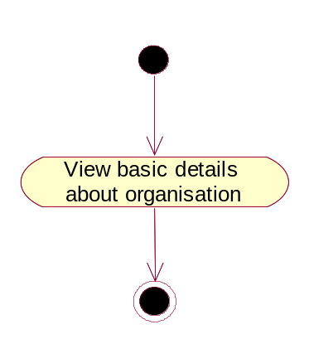

3.1.4 Visitor Use-Case report:
Use-case name: View organisation details
Normal flow: Visitor can view the certain basic details about organisation
Pre-condition: The organisation details must have already been entered.
Post-condition: The visitor cannot perform any activity after viewing
Alternative flow: There are no alternative flow

3.2 Activity Diagrams
Register:
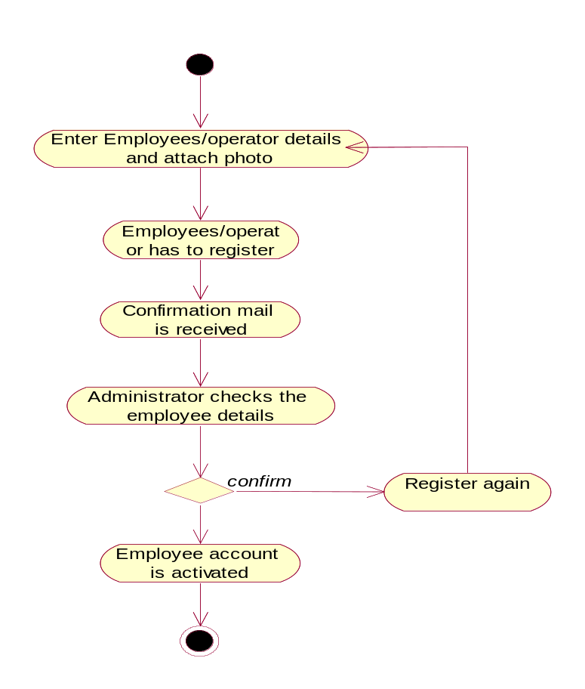

Login:
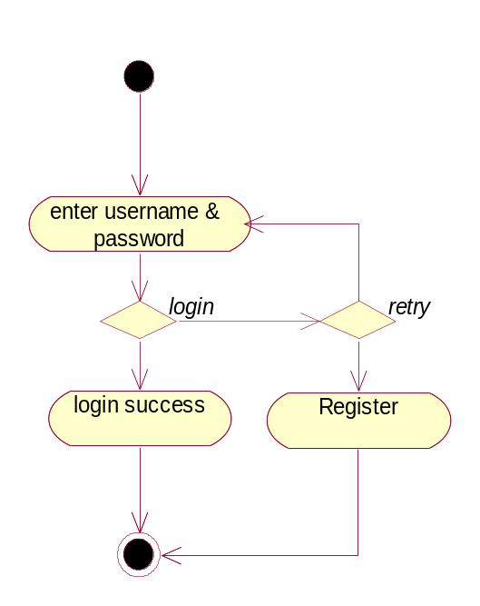

Search employee:
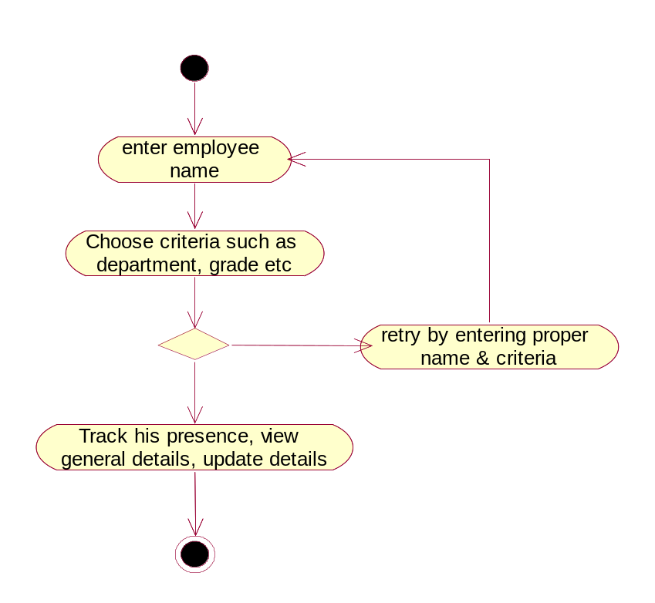

Send automatic mail/message:
Set hierarchy:
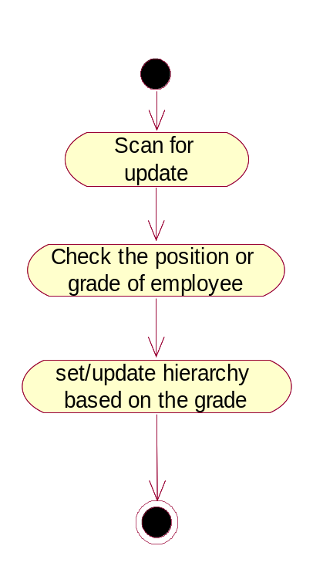

Set & view Organisation details:
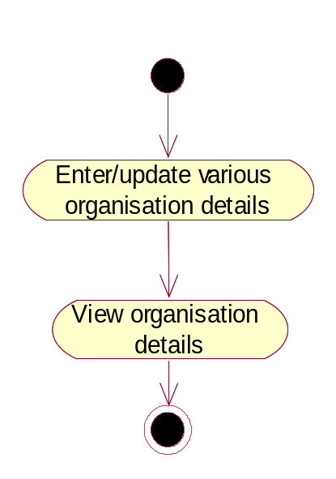

View & update details:

Issue salary:
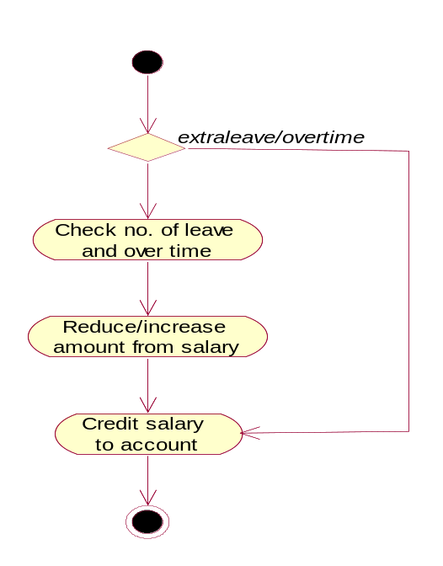
3.3Sequence diagrams:
Register:
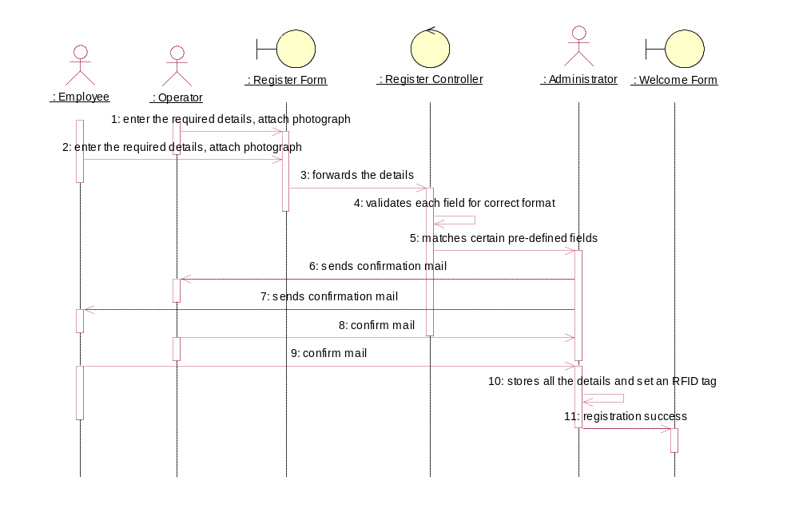

Login:
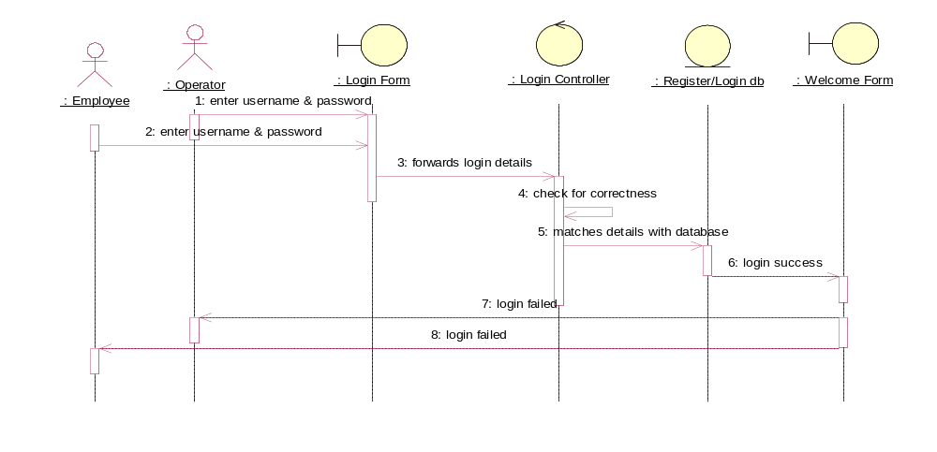
Search employee:
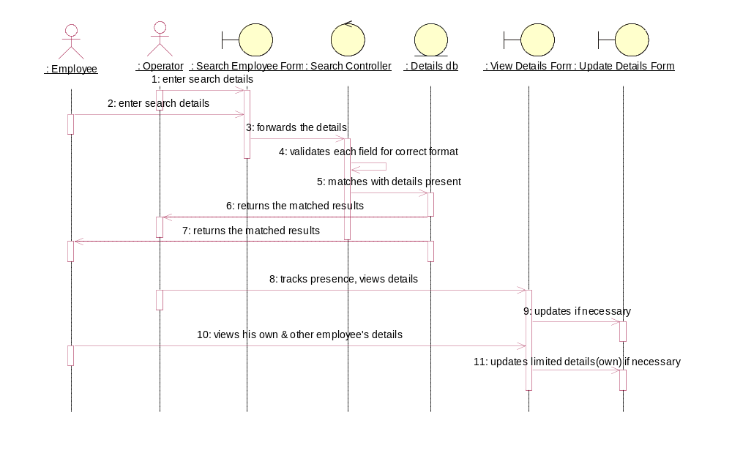

Send automatic mails/messages:
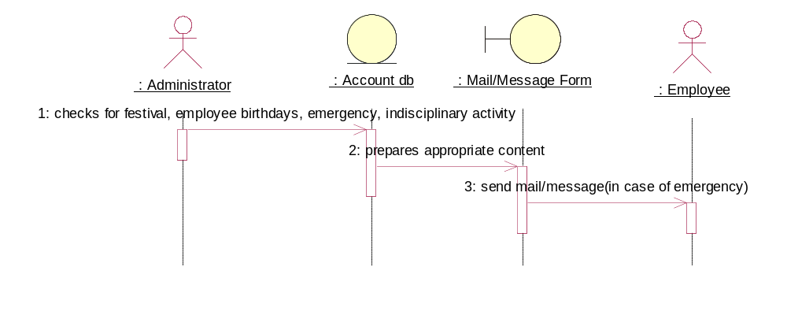

Set & view organization details:
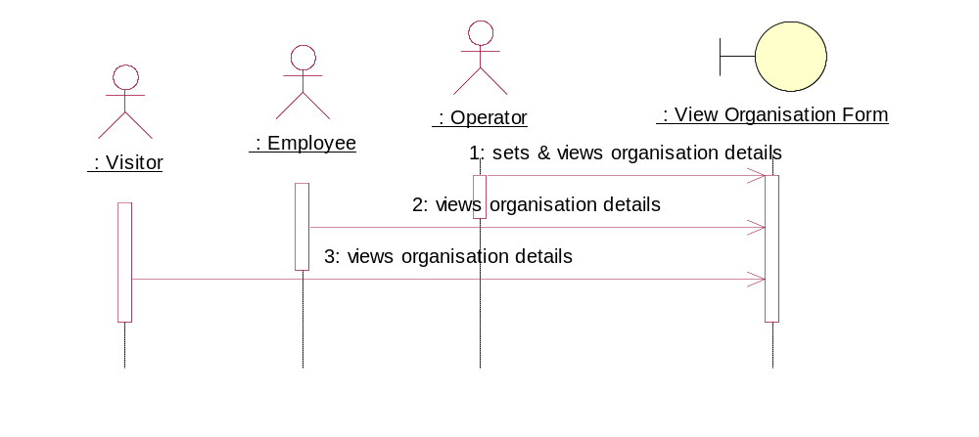

Set & view hierarchy:
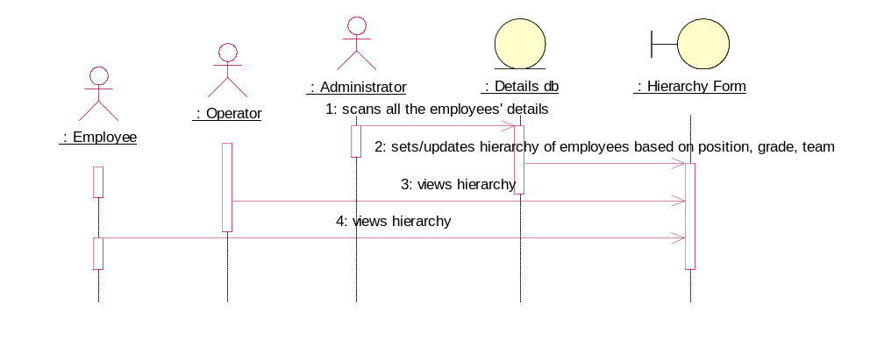

View and Update Details:
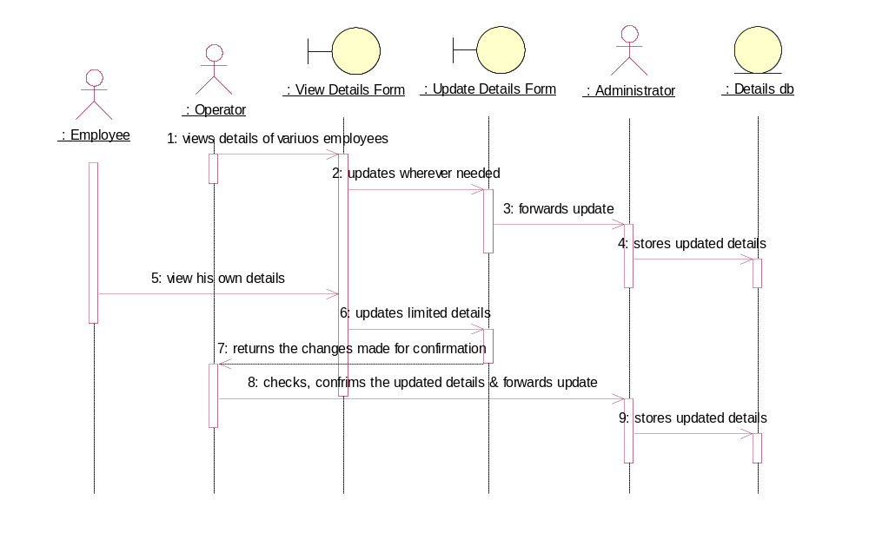

Issue salary:
