**DATE: 03-12-2024**

**Joins:**

Joins in MySQL are essential for combining records from two or more tables based on related columns. This allows us for efficient data retrieval and analysis.

Joins are used to combine rows from two or more tables based on a related column between them.

This helps in retrieving the data from a single query rather than using multiple queries

**Types of joins:**

The joins are basically divided into the following types:

* Inner join
* Outer join (left outer or left join, right outer or right join, full join)
* Self join
* Cross join

**Table creation and data insertion:**

* create table dept (dept_id int primary key, dept_name varchar(30));
* create table emps (employee_id int primary key, name varchar(30), dept_id int,foreign key(dept_id) references dept(dept_id));
* insert into dept (dept_id, dept_name) values

(1, 'HR'),

(2, 'IT'),

(3, 'Marketing');

* insert into emps (employee_id, name, dept_id) values

(1, 'vignan', 1),

(2, 'mani', 2),

(3, 'raju', null);

**Inner join:** Returns only the rows with matching values in both tables.

**Syntax:**

**Assume two tables table_1 and table_2 for all the joins**

Select columns from table_1

Inner join table_2 on table_1.common_col = table_2.common_col;

**Query:** select * from emps

Inner join dept on emps.dept_id = dept.dept_id;

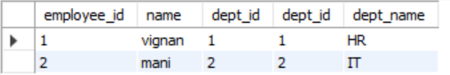

**Left outer join (or) left join:** Returns all rows from the left table and matched rows from the right table. If there is no match, NULLs are returned for columns from the right table.

**Syntax:**

select columns from table1

left join table_2 on table_1.common_col = table_2.common_col;

**Query:**

select * from emps

left join dept on emps.dept_id = dept.dept_id;

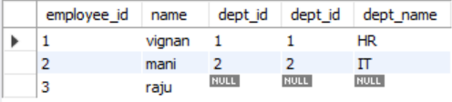

**Right outer join (or) right join:** Returns all rows from the right table and matched rows from the left table. If there is no match, NULLs are returned for columns from the left table.

**Syntax:**

select columns from table1

right join table_2 on table_1.common_col = table_2.common_col;

**Query:**

select * from emps

right join dept on emps.dept_id = dept.dept_id;

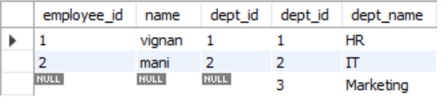

**Full outer join:** Would return all records when there is a match in either left or right table records.

Full join is not supported by MySQL

This join can be performed by using the UNION of left and right joins

**Cross join:** it is a join that returns cartesian product means every row from the first table is combined with every row from the second table.

Assume Table A has “m” rows and Table B has “N” rows then the total rows will be m x n rows

The Cartesian product of these two tables will contain m x n rows. Each row in the result is a combination of a row from Table A and a row from Table B.

**Syntax:**

select columns

from table_1

cross join table_2;

**Query:**

select * from emps

cross join dept;

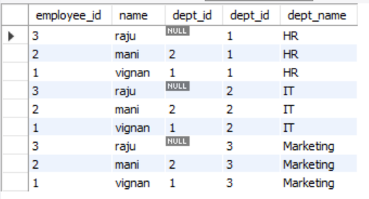

**Self join**: A join where a table is joined with itself. It is often used to compare rows within the same table

**Syntax:**

select a.columns, b.columns

from table as a

join table as b on a.common_column = b.common_column;