**Data Structures:**

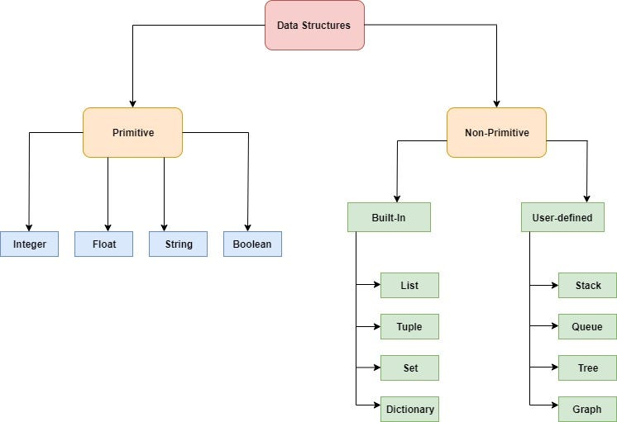

* **List** is a collection which is ordered and changeable. It Allows duplicate values.
* **Tuple** is a collection which is ordered and unchangeable. It Allows duplicate values.
* **Set** is a collection which is unordered, unchangeable, and unindexed. Not allows duplicate values.
* **Dictionary** is a collection which is ordered and changeable. Not allows duplicate values.

**Lists, Tuples, Dictionaries, and Sets**

**1. List (Mutable Ordered Collection)**

**Definition**: A list is an ordered collection of elements that can contain duplicates. The elements in a list are indexed, meaning each element has a specific position.

**Ex**:

List1 = [1, 2, 3, ‘apple’, 5.6]

customers = [‘ganesh’, ‘sai’, ‘varun’, ‘manas’]

orders = [1001, 1002, 1003]

**2. Tuple (Immutable Ordered Collection)**

**Definition**: A tuple is a collection of items that is ordered and immutable (cannot be changed once created). Tuples are useful when you want a fixed set of values.

**Ex**:

Tuple1 = (1, 2, 3, ‘apple’, 5.6)

coordinates = (10,20)

**3. Dictionary (Key-Value Pairs)**

**Definition**: A dictionary is a collection of key-value pairs, where each key is unique and used to store a value.

**Ex**:

dict1 = {‘name’: vignan, ‘age’: 23, ‘city’: ‘Hyd’}

grades = {‘1001’: ‘A’, ‘1002’: ‘B’, ‘1003’: ‘C’}

**4. Set (Unordered Collection of Unique Elements)**

**Definition**: A set is an unordered collection of unique elements. Sets are useful when you need to store unique values.

**Ex**:

Set_2 = {1, 2, 3, 4, 5}

numbers = [1, 2, 3, 4, 5, 5, 6]

unique_numbers = set(numbers) # Removes duplicates.

print(unique_numbers) # Output: {1, 2, 3, 4, 5, 6}

**Basic programs:**

**List operations:**

my_list = [1, 2, 3, 4, 5]

print(my_list[0])

print(my_list[-1])

my_list.append(6)

my_list.insert(2, 2.5)

my_list.remove(3)

popped_item = my_list.pop()

print(my_list[1:4])

print(len(my_list))

**Tuple operations:**

my_tuple = (1, 2, 3, 4)

print(my_tuple[0])

print(my_tuple[-1])

**Dict operations:**

dict1 = {‘name’: vignan, ‘age’: 23, ‘city’: ‘Hyd’}

print(my_dict["name"])

my_dict["age"] = 26

my_dict["city"] = "pune"

del my_dict["city"]

removed_value = my_dict.pop("age")

**set operations:**

my_set1= {1, 2, 3, 4}

my_set2 = {3, 4, 5, 6}

union_set = my_set1 | my_set2

intersection_set = my_set1 & my_set2

difference_set = my_set1 - my_set2