ASSIGNMENT 02

K. VIGNANAND RAO - 2303A52439(B41)

Task 1: Book Class Generation

PROMPT :
code with class book with attributes title, author, price and a summary method
CODE:
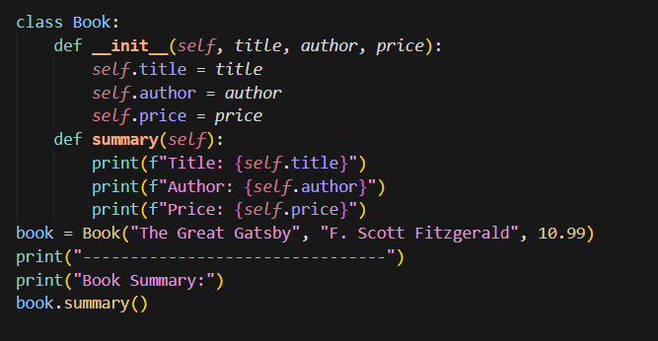
OUTPUT:
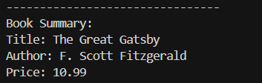
JUSTIFICATION:
By completing this task, we are able to print the book details as mentioned in the question using cursor ai, the code given is accurate and easy to understand.

Task 2: Sorting Dictionaries with AI

PROMPT:
Sort the dictionary by key values in dic{age:name} and print the names of persons in sorted manner with ages
CODE:
CURSOR AI:
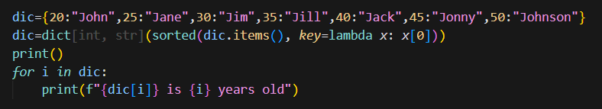
GEMINI:
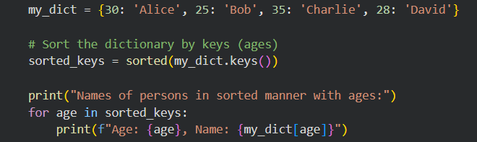
OUTPUTS:
CURSOR AI:
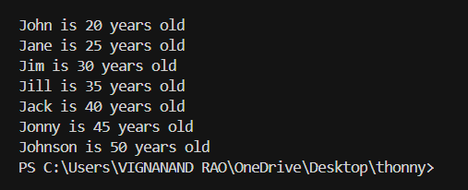
GEMINI:
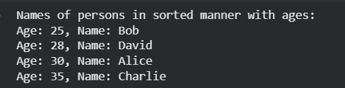

JUSTIFICATION:
In this task, although we used both different AI, we are getting the same required output, but we can clearly see the difference in approach of the code, clarity for both the codes is very fine and when comes to the representation of the output, the output given by cursor ai is neat and easy to understand by anyone.

Task 3: Calculator Using Functions
PROMPT:
simple calculator with functions addition of n numbers, subtraction of 2 numbers, multiplication of n numbers, division of 2 numbers and power of 2 numbers which chooses the operation on the user input
CODE:
CURSOR AI:
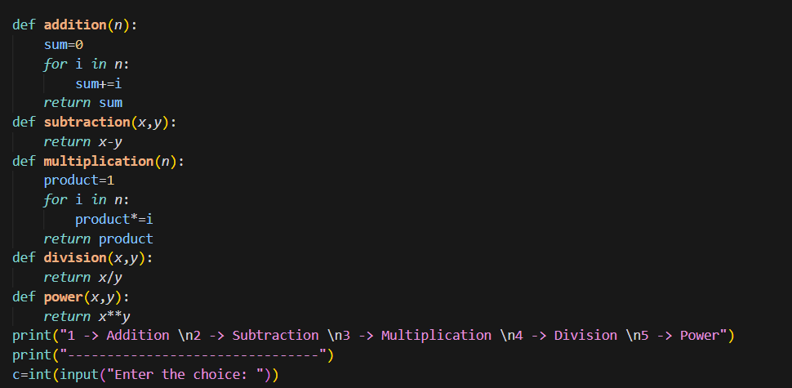
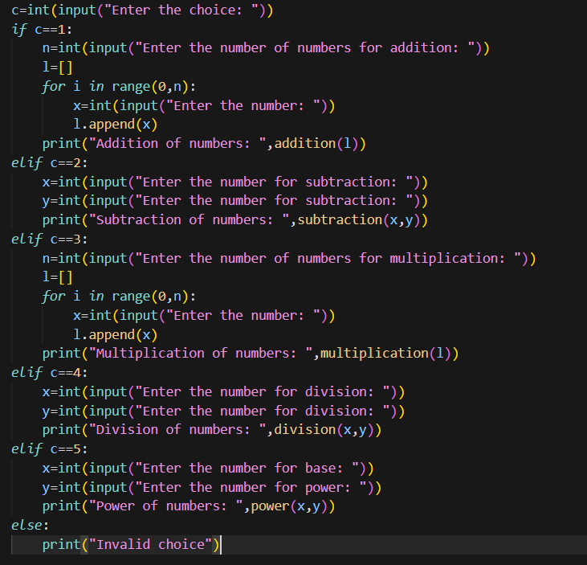
GEMINI:
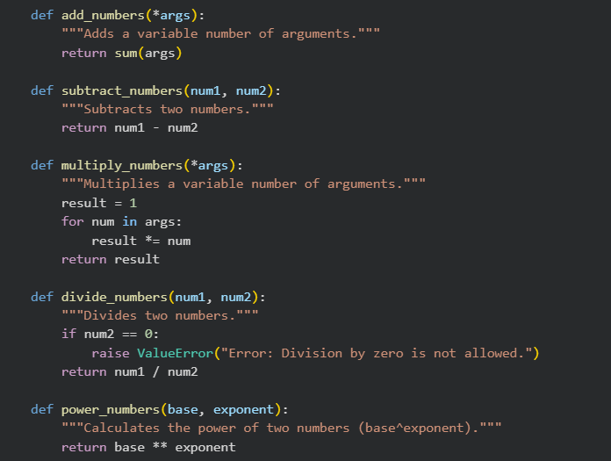
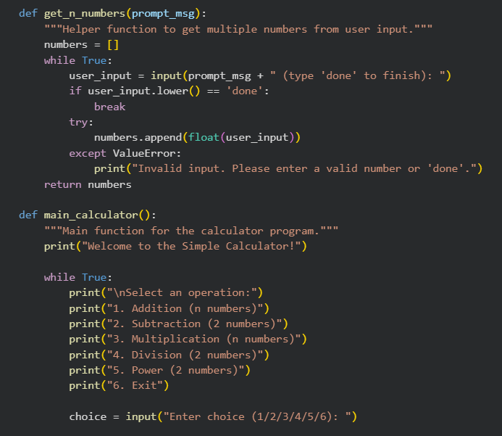
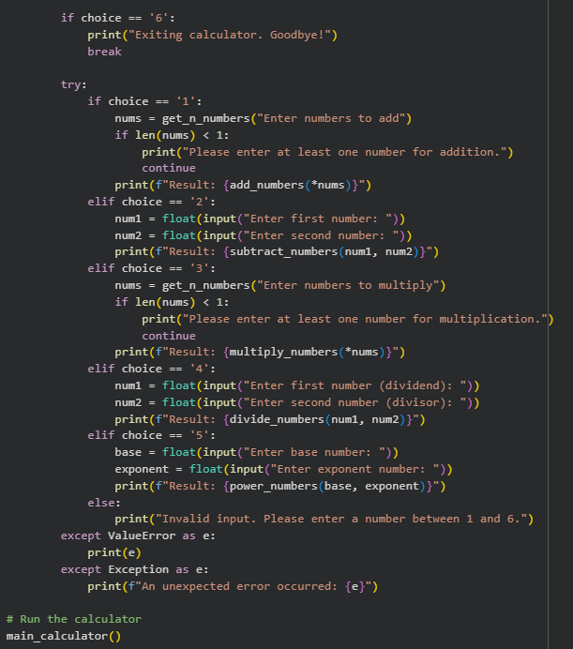
OUTPUTS:
CURSOR AI:
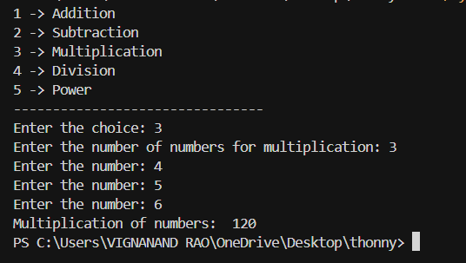

GEMINI AI:
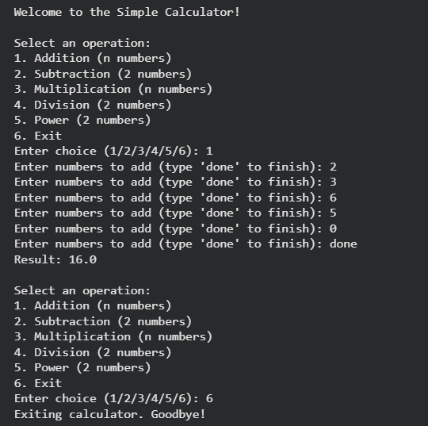
JUSTIFICATION:
Here, in this task, the main idea is same, to prepare the simple calculator, when we see the code for both cursor ai and gemini, we can see that the code is almost same but a small difference is present which brings the major change, which is, in gemini once if we run the code the calculator will run again and again until we exit it. This feature is very much important in the daily life. When we look into clarity, cursor ai output is clear and easy to understand but gemini is well in advanced for real world.

Task 4: Armstrong Number Optimization

PROMPT:
python code to check whether the given number is Armstrong or not
CODE:
GEMINI:
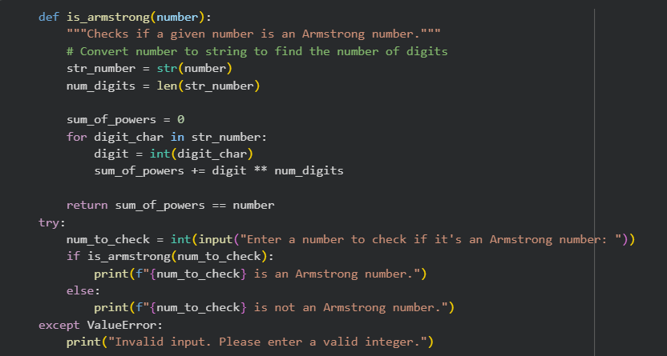
CURSOR AI:
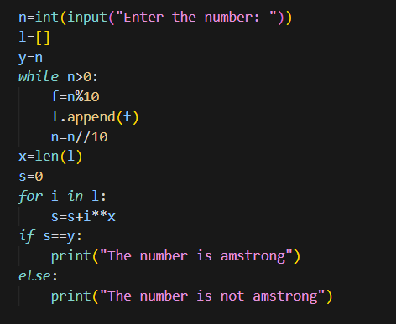
OUTPUT:
GEMINI:
CURSOR AI:
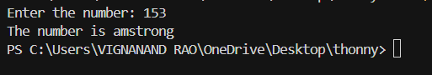
JUSTIFICATION:
In this task, we can clearly observe that, the code given by gemini is a bit complex and has more time complexity which makes code less efficient, as we have optimized it in cursor ai, the code is optimized version with only basic syntax which makes the code easy to understand for anyone. Eventhough the outputs are same, both the codes given by both gemini and cursor ai are efficient.

