Linux device driver implementation and communication with IOCTL/Procfs/Sys filesystem.

ABSTRACT

This project is divided into two parts, Linux Application and Linux Device Driver.The Linux application which will talk to the device driver using device files. The Linux application will have three parts, the communication from IOCTL calls, proc and sys file system. With the help of device file, we can read and write. The linux kernel will have new style of device registration using cdev structure which is used in developing Linux character driver. The system call from application will talk to device driver and logs will help us to verify the read/write operations by using dmesg or var/log/syslog.in userside we are writing separate 3 applications inorder to interact with driver.we are sending the values to the device driver and reading the values from the driver to application.
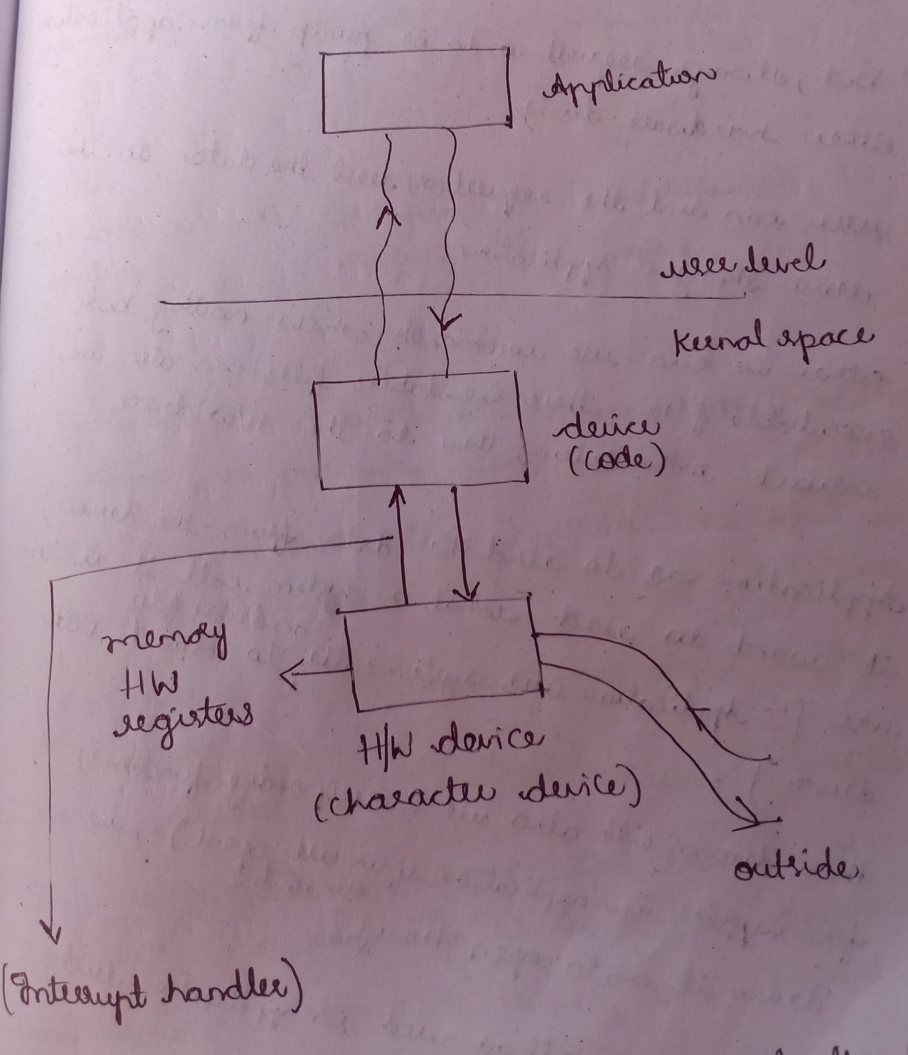

Interaction between Application and character driver

This character driver is implemented by using open(),read(),write(),close() functions.to load and unload the driver we are using initialisation and exit functions.whenever we write this functions,these functions are linked predefined structures called struct file operations.
we are building the driver by using make file with help of make command,then loading the driver,then checking the enteries of iotcl,prof and sysfs.to read the data we are using cat command and to write data we are using echo command in profs,we are using show and store commands to read and write in sysfs and copy from user &copy to user in IOTCL.application interacts with driver ,whatever the data we are writing in application it will be recieved by driver.application is using write() system call,that will automatically invoke kernal call() and corresponding write driver routine in that we are copying tha data,from sys_write() it is going to access pcb,fd table,file object,inode object,it is going to search for cdev object whose major no and minor no are same.after finding the cdev object one of its member,file opertion objects(*ofs),from there it will invoke open driver routine.driver acts as meditor to read the data from application and copy into your device,what ever the data that is recevied in external device, hardware will raise an interrupt which is responsible to revice tha data from hardware device to driver that is recevied in our hardware registers from the driver will get information from there to application.

SYNOPSIS
There are many to communicate between userspace and kernal space
1)IOCTL calls
2)Proc virtual file system entries
3)Sysfs file system entries
4)Configure file system
5)Debug file system
6)Sys control interaction(or) System call interface
7)UDP sockets
8)Netlink sockets

In this project we are using IOCTL,Profs and sysfs to talk with the Driver.Kernal is providing whatever the data activites are happening that information is providing to userspace through some interfaces like proc virtual file system,sysfs file system.

- Process related,file management related information if we want we are taking help of proc virtual file system.
- If we want to interact with hardware device we are taking help of sysfs file system.
- If we want to update the time we are using date command and we will modify the date,that command it is a exectable file,sending the request to timer,that timer sending the request that we are modifing the parameters of hardware.if we want to get the current parameter details from a particular device input and output or status or if you want to update the values or you want current values status.in such cases we are using IOCTL calls.
IOCTL as a system call in user space application and driver routine in kernal space[equivalent kernal call in kernal space]similar to read,write,close system calls.
Sysfs file system it is a RAM based file system,it is design to export the kernal data structures and its attributes from kernal to userspace.

