Criminal Identification Using ML & Face Recognition Techniques

In this paper author is employing pre-trained model for criminal faces recognition and identification. MTCNN pre-trained model will be used to detect faces and then FACENET model will be applied to extract features (embedding) from detected faces and then this features will be trained with SVM algorithm to classify weather person in image is criminal or normal person.

To train all algorithms we have used below criminal images downloaded from Google

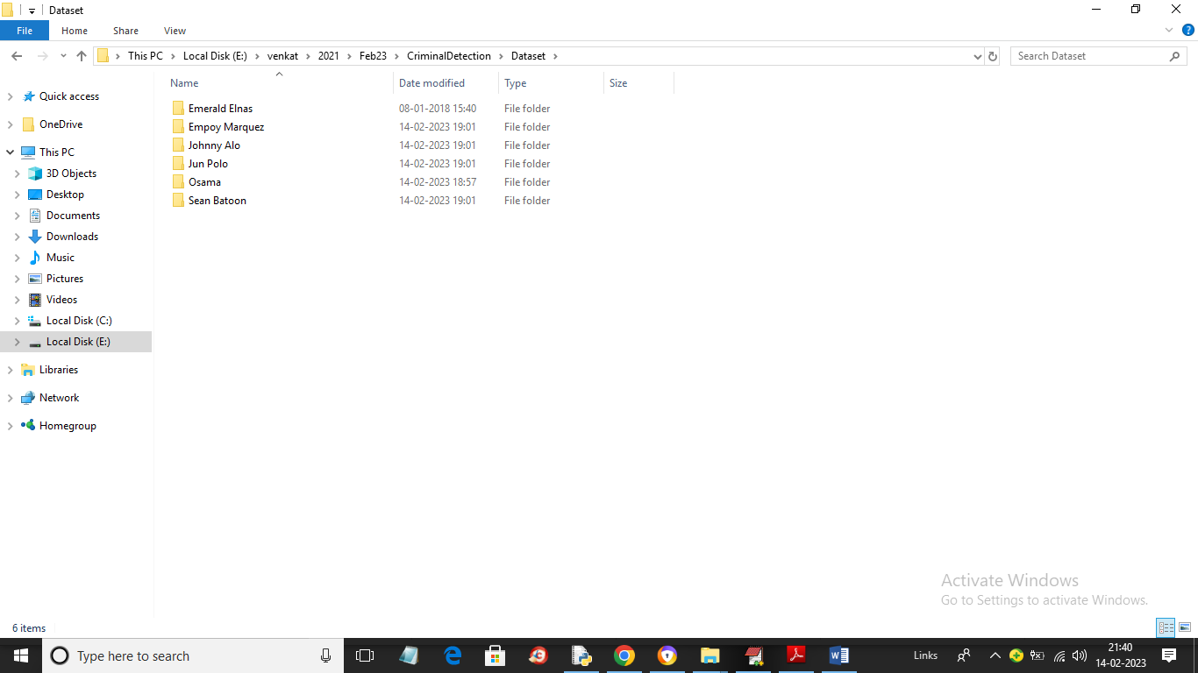

In above screen we have some criminal names and just go inside any folder to view that criminal images

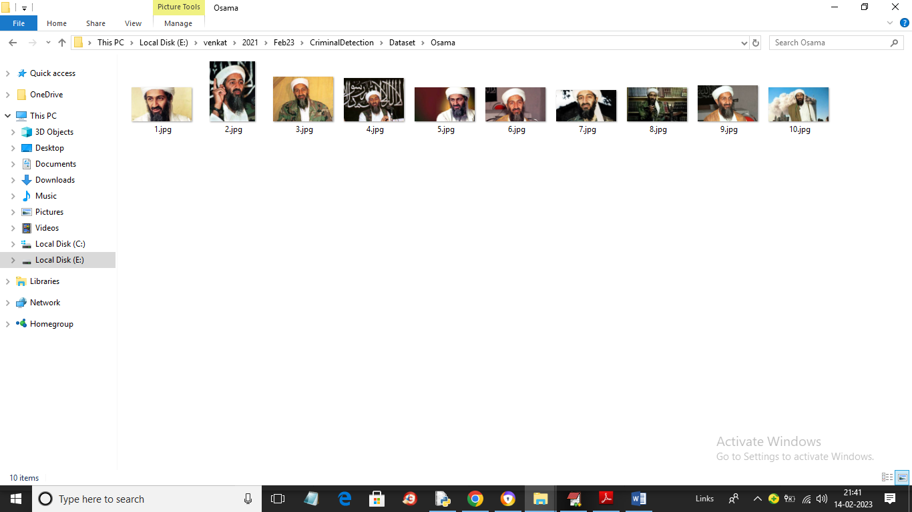

In above screen we can see images for one criminal and by using all those images we will train all algorithms and calculate accuracy. In below screen you can see loading of MTCNN and FACENET model

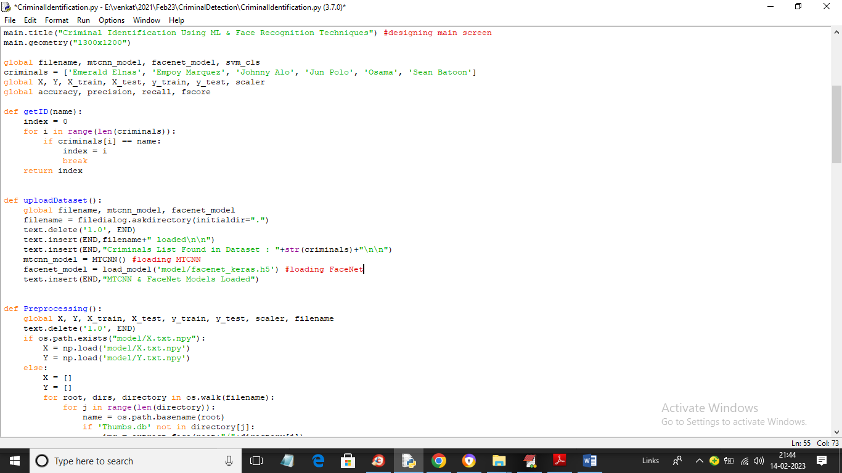

In above screen see red lines to know about both model loadings

To implement this project we have designed following modules

1. Upload Criminals Dataset: using this module we will upload dataset to application and then load both MTCNN and FACENET models
2. Preprocess Dataset: using this module we will read each image and then detect face and then extract features using FACENET and then normalize all face values and then split dataset into train and test where SVM will be using 80% dataset images for training and 20% for testing
3. Train SVM using MTCNN & FaceNet Features: using this module we will train SVM using faces and extracted features from FACENET and then train SVM using 80% dataset and then apply trained model on 20% images to calculate prediction accuracy
4. Comparison Graph: using this module we will plot accuracy, precision graph of SVM
5. Criminal Identification: using this module we will upload test image and then SVM will predict criminal and calculate matching % and if not matched then display alert messages and if any image matched with existing criminal then it will display matching %.

SCREEN SHOTS

To run project double click on run.bat file to get below screen

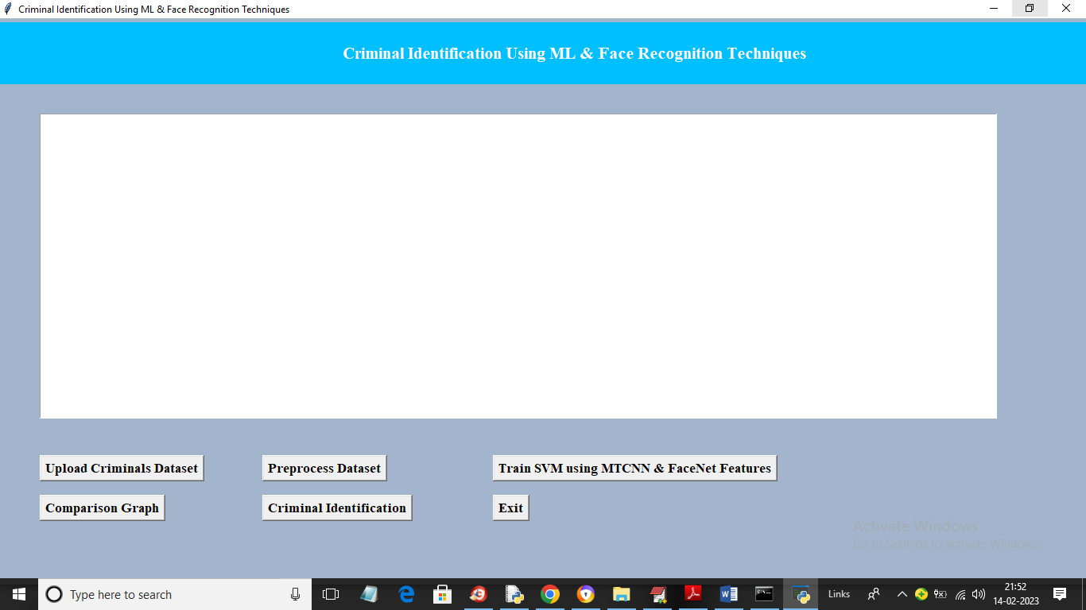

In above screen click on ‘Upload Criminals Dataset’ button to upload dataset and get below output

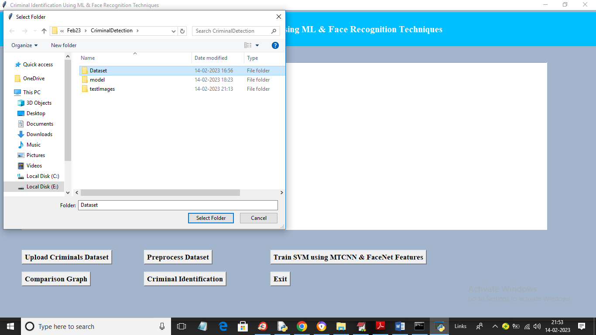

In above screen selecting and uploading entire ‘Dataset’ folder and then click on ‘Select Folder’ button to load dataset and get below output

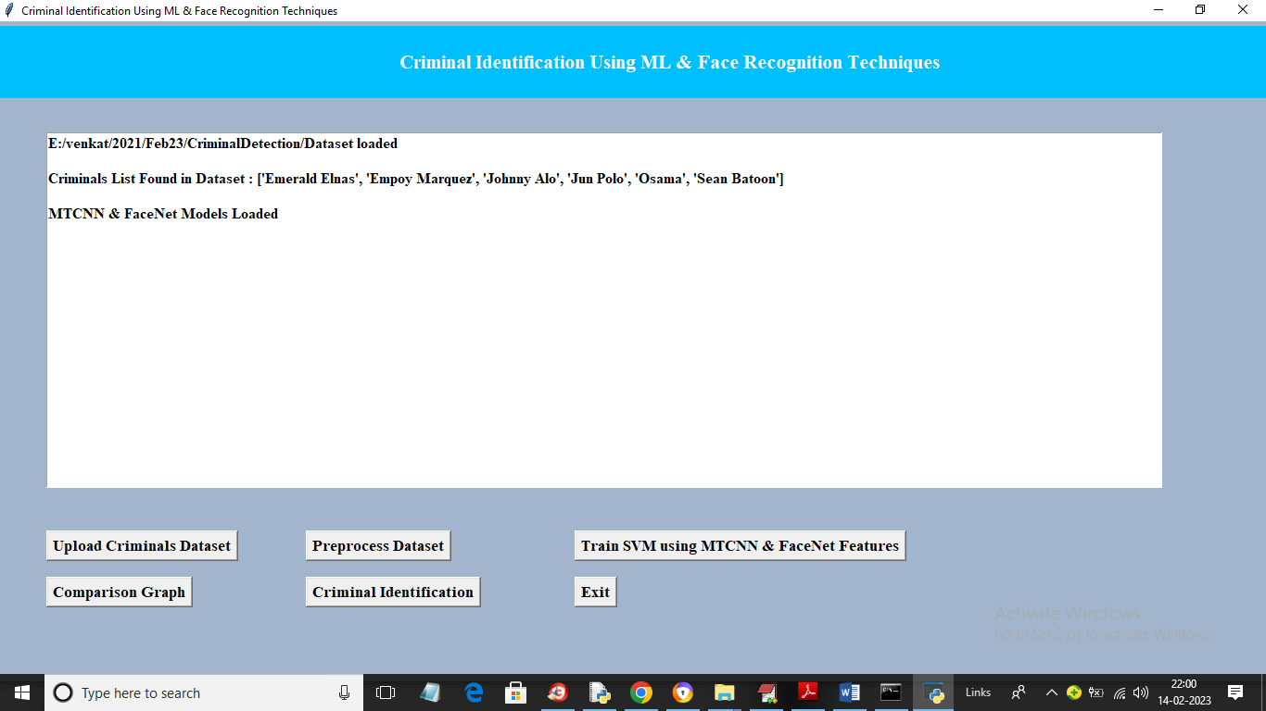

In above screen dataset loaded and we can see names of criminal’s images loaded into application and then we can see both MTCNN and FACENET model loaded and now click on ‘Preprocess Dataset’ button to process all images and split into train and test and get below output

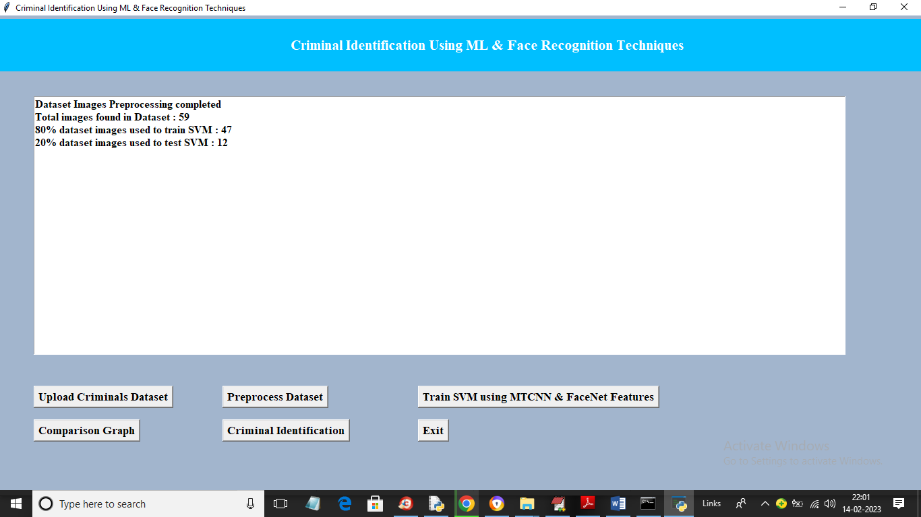

In above screen we can see dataset contains 59 images and using 47 images for training and 12 for testing and now click on ‘Train SVM using MTCNN & FaceNet Features’ button to train all faces with SVM and get below output

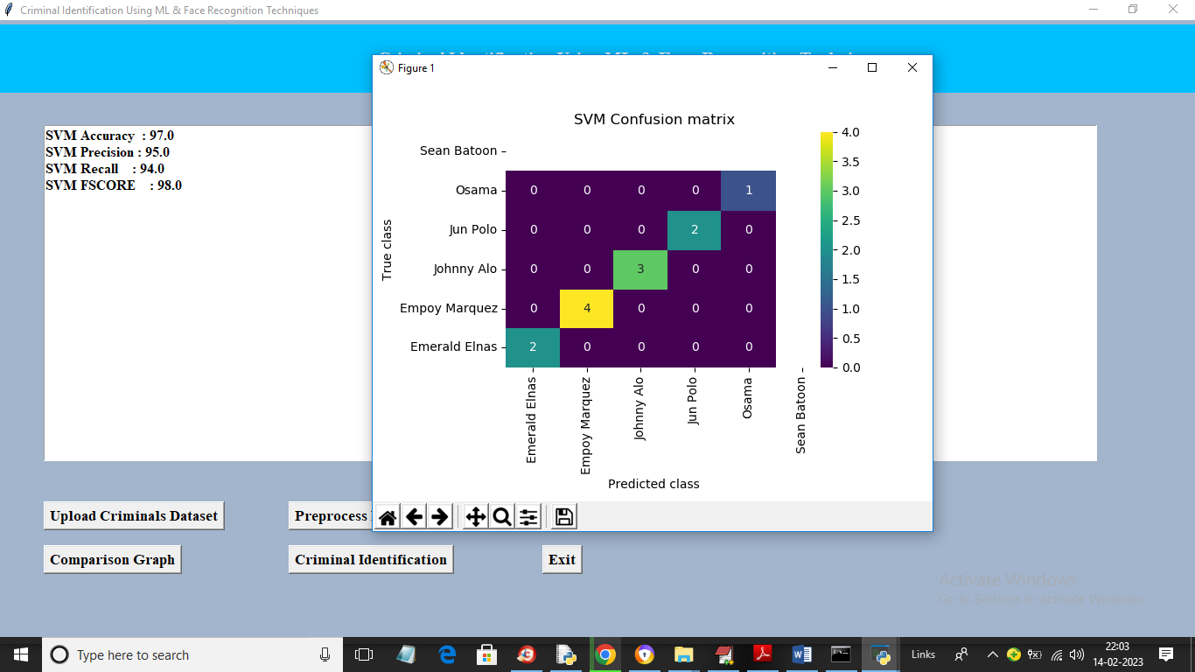

In above screen with SVM we got 97% accuracy and we can see other metrics output like precision, recall and FSCORE and in confusion matrix graph x-axis represents Predicted Labels and y-axis represents True Labels and all different colour boxes in diagnol represents Correct Prediction count and blue colour boxes contains incorrect prediction count which is 0 so SVM is accurate in criminal classification. Now close above graph and then click on ‘Comparison Graph’ button to get below output

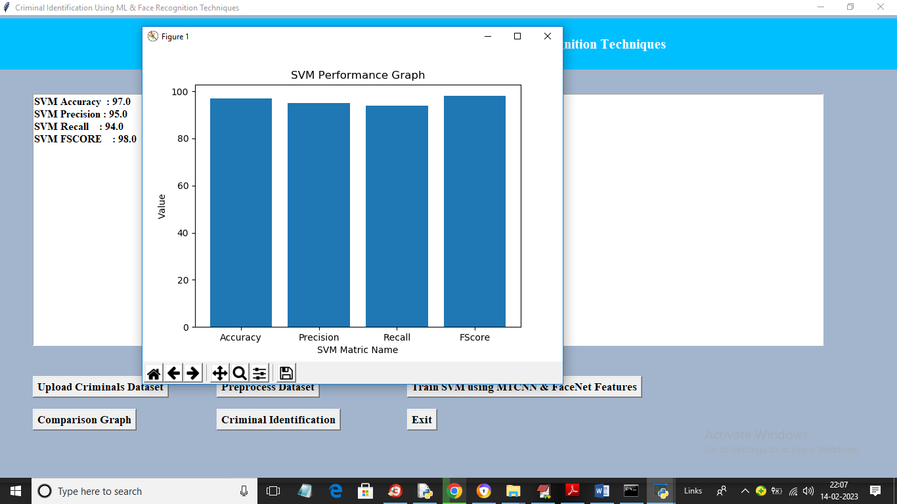

In above graph x-axis represents SVM metrics and y-axis represents performance values which is closer to 1. Now close above graph and then click on ‘Criminal Identification’ button to upload test image and get below output

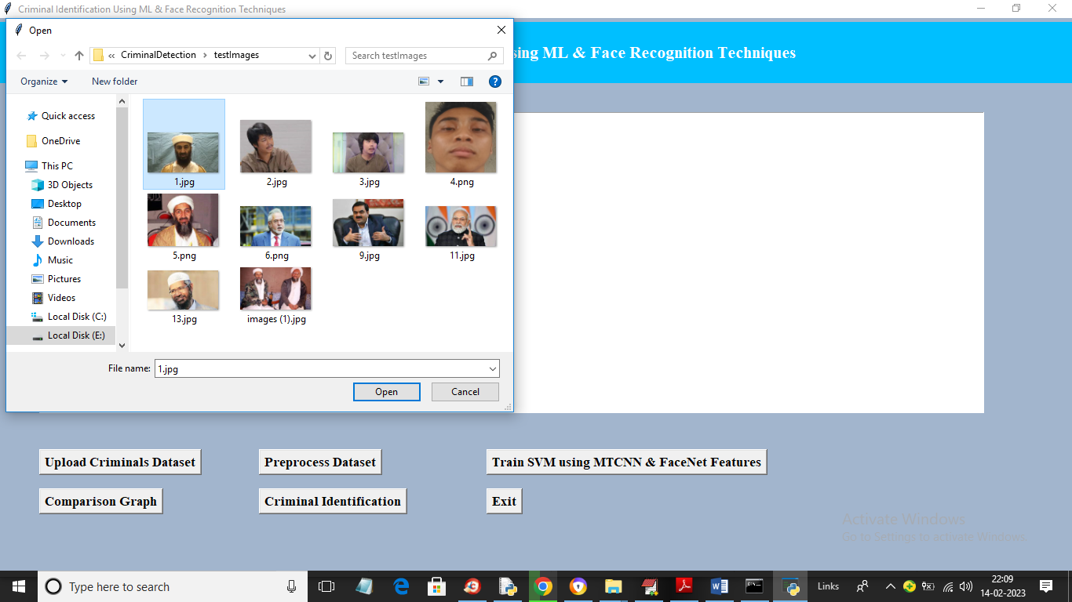

In above screen selecting and uploading 1.jpg file and then click on ‘Open’ button to get below output

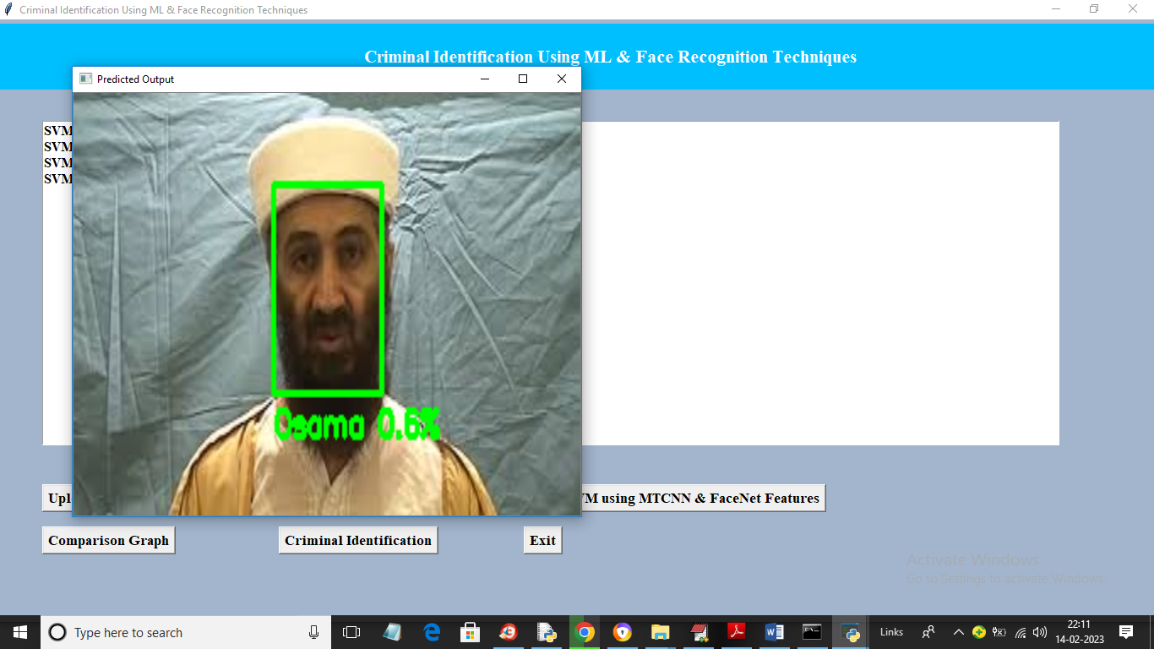

In above screen person is identified as Osama with matching percentage as 60% and similarly you can upload and test other images

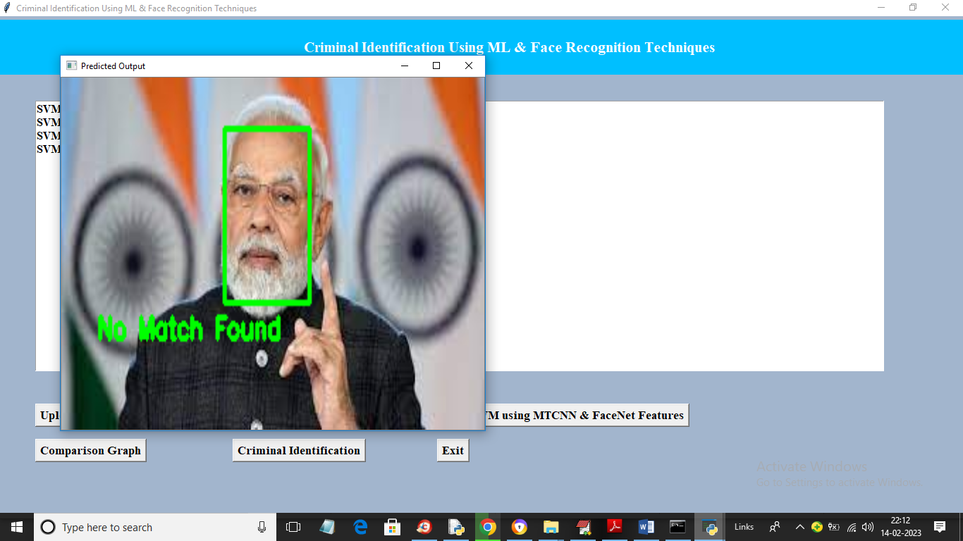

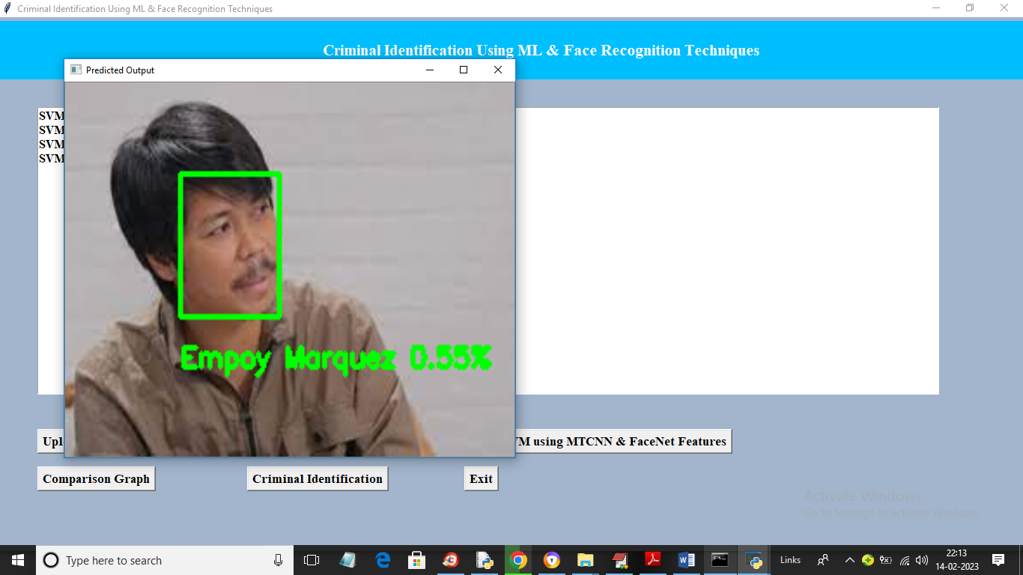

Similarly if any matches with existing criminal then it will display matching %