Ex.No.3 | Perform password extraction, cracking and recovery from target system
AIM:
- To use opensource software tools for extraction, cracking and recovery from target system.
- To implement Dictionary attack in Java/Python
THEORY:
Tool Selected: Hashcat About the Tool:
Hashcat is an open-source, advanced password recovery tool that supports a wide range of password hashing algorithms including MD5, SHA1, SHA256, bcrypt, and more. It is designed to perform high-speed password cracking using CPU or GPU. Hashcat supports several attack modes such as dictionary attack, brute-force, hybrid, mask, and rule-based attacks. It is widely used by security researchers and penetration testers for ethical hacking and password audits.
Software Requirements:
Requirement | Description
OS | Windows or linux
Hashcat | V6.2.6+
Python | 3.x (for dictionary attack implementation)
Wordlist | rockyou.txt (or any dictionary file)
GPU Drivers | NVIDIA CUDA / AMD OpenCL
Dictionary attack:
A dictionary attack is a technique used to crack passwords by systematically attempting words from a list of commonly used or likely passwords.
A dictionary-based brute-force attack is a hybrid method that enhances the basic dictionary attack by applying variations to each word. These variations may include adding numbers, changing uppercase and lowercase letters, or inserting special characters— allowing the attacker to guess passwords that are modified forms of common words.
Demonstrations (With Screen shots)
Installation Procedure / Execution:
1.Download Hashcat
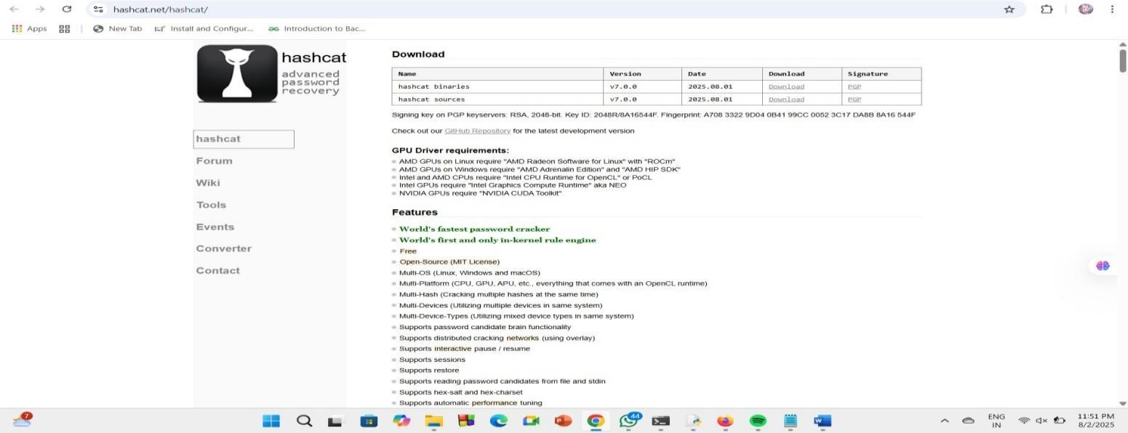

2. Extract the Zip File
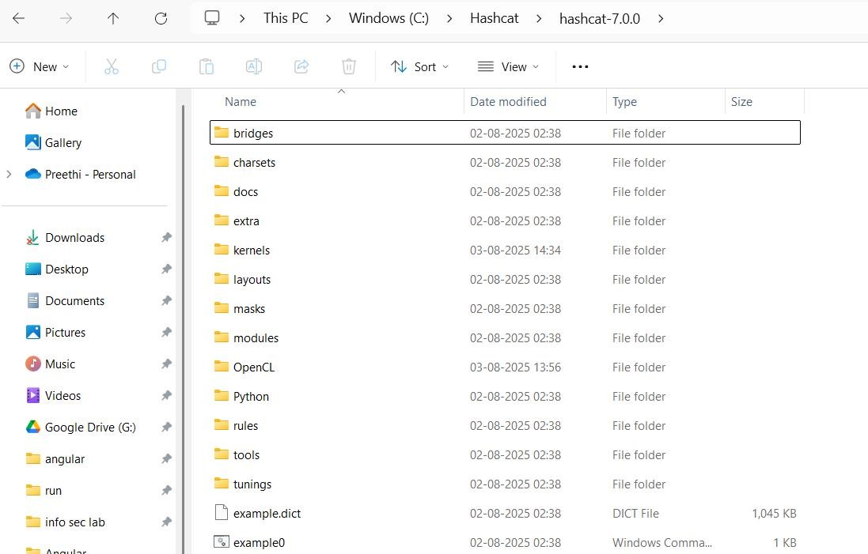
3.Prepare hash file (hash.txt)
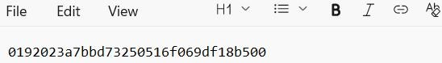
4.Prepare a wordlist (wordlist.txt)
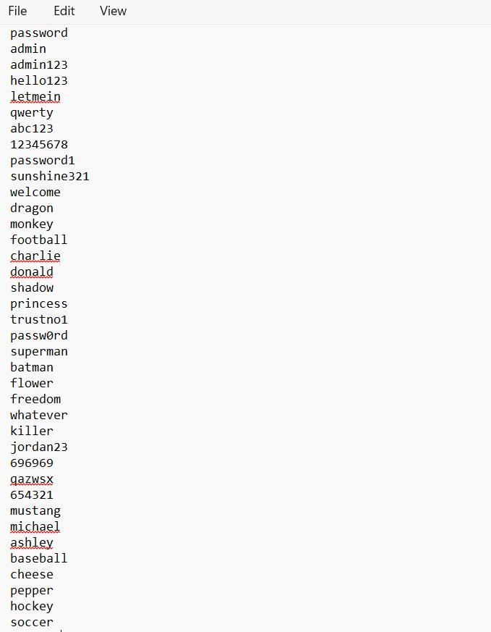
Password cracking (Dictionary attack)
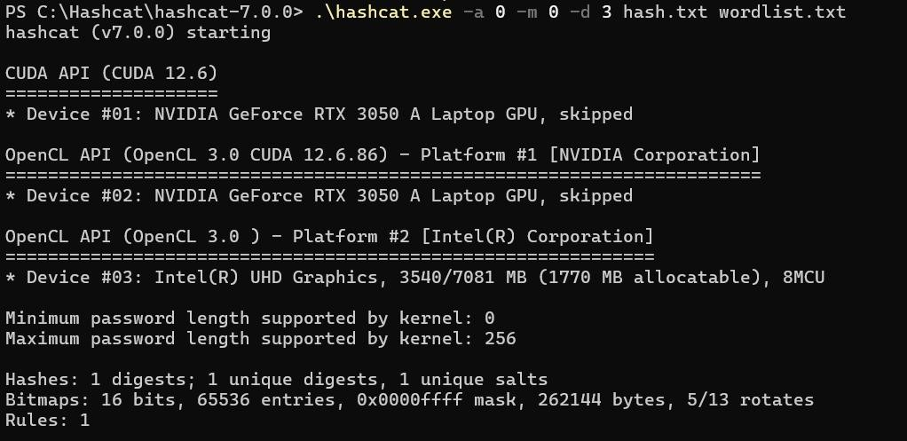
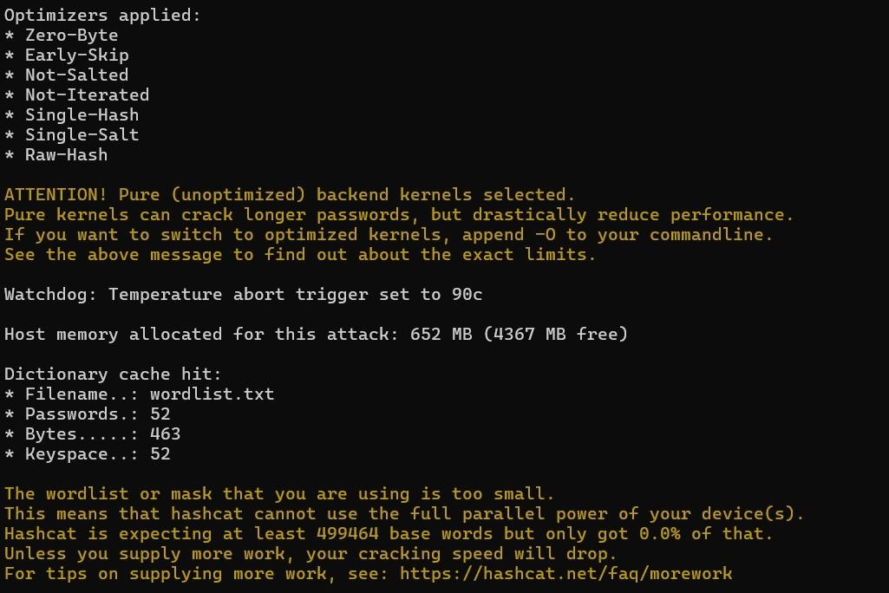
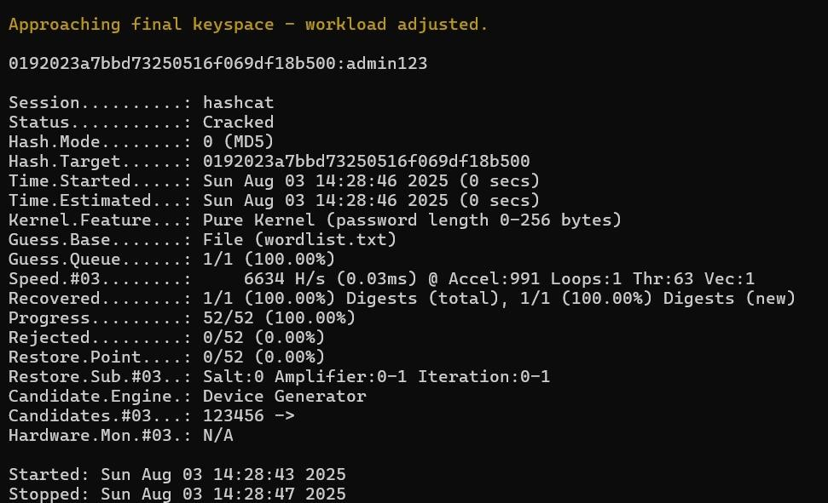
See the Cracked Password :

Algorithm for Dictionary Attack
1.Start the program and prompt the user to:
- Enter the password length.
- Enter the actual password to crack.
2.Store the inputs:
- length = desired password length.
- targetPassword = actual password to crack.
3.Define the character set (allChars) containing:
- Lowercase alphabets (a–z)
- Uppercase alphabets (A–Z)
- Numerical digits (0–9)
- Special symbols (e.g.!@#$%^&*())
4.Call generateDictionary(length) to:
- Open a file named dictionary.txt for writing.
- Use a recursive method (generateCombinations) to generate all possible combinations of characters from allChars with the given length and write each combination to dictionary.txt (one per line).
- Close the file after writing is complete.
5.Call crackPasswordFromFile(targetPassword) to:
- Open dictionary.txt for reading.
- Initialize attempts = 0.
6.Repeat for each line in the file:
- Increment attempts by 1.
- Remove newline characters from the line.
- Compare the current guess with targetPassword.
7.If a match is found:
- Display Success message,Matched password,Attempt number.
- Stop further searching.
8.If the end of the file is reached without a match:
- Display "Password not found in dictionary."
9.End the program.
Coding
import java.io.*;
import java.util.*;

public class PasswordCracker {

static String lower = "abcdefghijklmnopqrstuvwxyz";
static String upper = "ABCDEFGHIJKLMNOPQRSTUVWXYZ";
static String digits = "0123456789";
static String special = "!@#$%^&*()";
static String allChars = lower + upper + digits + special;

public static void main(String[] args) {
Scanner sc = new Scanner(System.in);
System.out.print("Enter the password length: ");
int length = sc.nextInt();
sc.nextLine(); // consume newline
System.out.print("Enter the actual password to crack: ");
String targetPassword = sc.nextLine();

try {
generateDictionary(length);
crackPasswordFromFile(targetPassword);
} catch (IOException e) {
System.out.println("Error: " + e.getMessage());
} sc.close();
}
public static void generateDictionary(int length) throws IOException {
FileWriter fw = new FileWriter("dictionary.txt");
BufferedWriter bw = new BufferedWriter(fw);
System.out.println("\nGenerating combinations of length " + length + " and writing to file...\n");
char[] chars = allChars.toCharArray();
generateCombinations(chars, "", length, bw);
bw.close();
fw.close();
}
private static void generateCombinations(char[] chars, String prefix, int length, BufferedWriter bw) throws IOException {
if (length == 0) {
bw.write(prefix);
bw.newLine();
return;
}

for (char c : chars) {
generateCombinations(chars, prefix + c, length - 1, bw);
}
}

public static void crackPasswordFromFile(String target) throws IOException {
FileReader fr = new FileReader("dictionary.txt");
BufferedReader br = new BufferedReader(fr);
String line;
int attempts = 0;
while ((line = br.readLine()) != null) {
attempts++;
if (line.equals(target)) {
System.out.println("\nYes, password found!");
System.out.println("Password matched: " + line);
System.out.println("Found on attempt number: " + attempts);
br.close();
fr.close();
return;
}
}
System.out.println("\nPassword not found in dictionary.");
br.close();
fr.close();
}
}

Output
Key takeaway from the installation and execution of password recovery tool:
- Successfully installed and executed Hashcat, an open-source password recovery tool.
- Understood and implemented both dictionary and brute-force attack strategies.
- Learned the importance of wordlists and hash formats in ethical password auditing.
Screen shots :
