1. If Sublime or VS code is not there then install VS code <https://vscode.download.prss.microsoft.com/dbazure/download/stable/ddc367ed5c8936efe395cffeec279b04ffd7db78/VSCodeUserSetup-x64-1.98.2.exe>
2. AWS Bedrock
3. Foundation models (claude-3-5-sonnet, claude-3-sonnet, amazon.titan-image-generator-v2:0, amazon.nova-reel-v1:0, amazon.titan-embed-text-v1, )
4. Text generation in Bedrock
5. Image generation in Bedrock
6. Video generation in Bedrock
7. Open the terminal, move to desktop and clone the repository
   1. git clone <https://github.com/vignes-shellkode/genai-workshop.git>
   2. Open VS code and open this folder C:\Users\hp\Desktop\genai-workshop
   3. Create a virtual environment **python -m venv myenv**
   4. Activate it **source myenv/bin/activate**
   5. pip install -r .\requirements.txt
8. Create Iam user with below permissions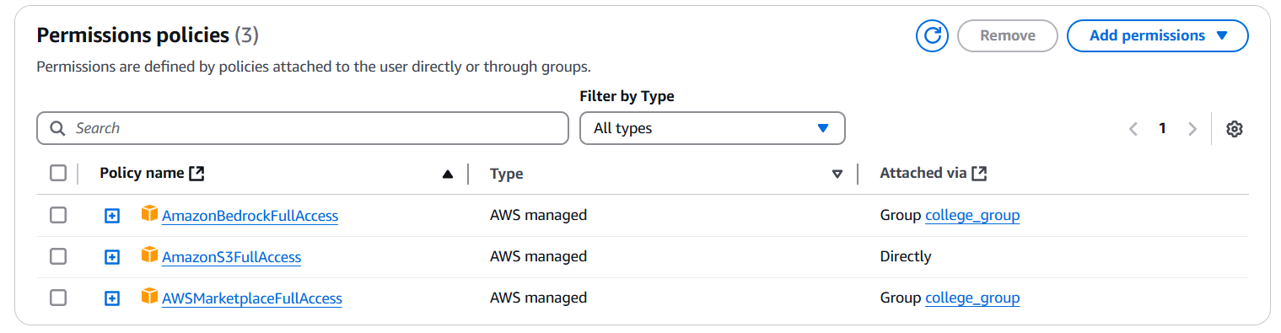
9. Create access key
10. Create an s3 bucket
11. Rename .env.sample to .env
12. Update the access key, secret key and s3 bucket name in .env file
13. Restart VS code
14. python .\1_text_generation.py
15. python .\2_image_generation.py
16. python .\3_video_generation.py
17. python .\4_chatbot.py
18. python .\5_rag.py

**Useful prompts**

**1. Creative Problem Solving & Brainstorming:**

* **Prompt:** "I'm trying to come up with ideas for my “**BE CSE**” project on how to increase student engagement in online learning. Give me 10 diverse and unexpected ideas, ranging from practical to slightly unconventional. Briefly explain the core concept behind each idea."
  + **Why it's useful:** This prompt directly addresses a common college challenge (projects, engagement) and encourages creative thinking. It asks for a variety of solutions, pushing the LLM beyond obvious answers. Students can see how the LLM can be a brainstorming partner.

**2. Understanding Complex Concepts & Summarization:**

* **Prompt:** "Explain the concept of “**GenerativeAI**” in three different ways: first, in simple terms a high school student could understand; second, using the terminology typically found in a college textbook; and third, provide a real-world example of how it might manifest in a college student's life."
  + **Why it's useful:** College involves grasping complex ideas. This prompt demonstrates the LLM's ability to tailor explanations to different levels of understanding and connect abstract concepts to real-life situations. Students can see its potential as a study aid.

**3. Research & Information Gathering (with caution about accuracy):**

* **Prompt:** "Summarize the main arguments for and against the implementation of [Specific Current Issue Relevant to College Students - e.g., universal basic income for students] in approximately 200 words. Please cite the key areas of debate and potential benefits and drawbacks."
  + **Why it's useful:** Students often need to research and synthesize information. This prompt showcases the LLM's ability to provide a concise overview of a topic. **Crucially, emphasize that the LLM's output should be a starting point and that students MUST verify information with reliable sources.** This highlights both the potential and limitations of the technology.

**4. Writing & Communication Assistance (Job-Related):**

* **Prompt:** "I'm applying for a [Specific Type of Internship or Entry-Level Job - e.g., Marketing Intern] at a company that values [Mention a key company value from their website - e.g., innovation and customer focus]. Write a concise and compelling opening paragraph for my cover letter, highlighting my relevant skills [Mention 1-2 relevant skills - e.g., experience with social media marketing and strong analytical skills] and enthusiasm for their work in [Mention a specific area of their work that interests you - e.g., developing their latest social media campaign]."
  + **Why it's useful:** College students are often navigating the job application process. This prompt demonstrates how the LLM can assist with crafting impactful introductory paragraphs for cover letters, tailored to specific roles and company values. It helps them understand how to immediately grab a recruiter's attention and connect their skills to the job requirements.