

**PHASE- 4**

**GUIDED BY :**

**Miss. ARULMOZHI R , M.E.,**

**ASSISTANT PROFESSOR,**

**DEPARTMENT OF ELECTRONICS AND COMMUNICATION ENGINEERING,**

**MRK INSTITUTE OF TECHNOLOGY,**

**KATTUMANNARKOIL,CUDDALORE DISTRICT,**

**PIN : 608 301.**

CHATBOT USING PYTHON

ABSTRACT: A Chabot is artificial intelligence (AI) computer software that can simulate a conversation using textual or audio techniques. The basis of chat bots is artificial intelligence, which analyses a customer's data and blends the response with them. AI-powered bots can take over a variety of duties since they are consider a by more powerful—and can execute numerous tasks at once. Natural language processing enables a bot to converse in the most natural manner possible. A balanced blend of innovative technology and human intervention is the optimal user-Chabot connection

INTRODUCTION:

Artificial Intelligence (ΑΙ) increasingly integrates our daily lives with the creation and analysis of intelligents oftware and hardware, called intelligent agents. Intelligent agents can do a variety of tasks ranging from lab o rwork to sophisticated operations. A chat bot is a typical example of an AI system and one of the mostele mentary and widespread examples of intelligent Human-Computer Interaction (HCI). It is a computer program, which responds like a smart entity when conversed with through text or voice and understands one or more human languages by Natural Language Processing (NLP). Chatbots are also known as smart bots,interactive agents, digital assistants, or artificial conversation entities

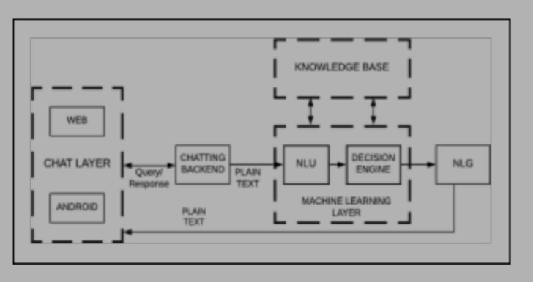

Architecture Of Chatbot

SYSTEM ARCHITECTURE

Typical chatbot architecture should consist of the following:

* Chat window/ session/ or frontend application interface.

* The deep learning model for Natural Language Processing [NLP].

* Corpus or training data for training the NLP model Application Database for processing actions to be performed by the chatbot

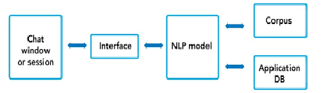

System Architecture

MODULES:

It has three python code modules.

* Intents.json:intents classification or recognization it is a type of getting a spoken or written text and then classifying it based on what the user wants to achieve.

*Trainer.py: Defines the Chatbot overall file structure and contains the intent,actions, slots, stories,domain, config and endpoint details. The code will train an NLU and dialogue model to retrieve weather from the Yahoo weather API. Model folder contains the trained models. It will also start the server with actions and also runs the chatbot on the command line. Execute only this code as it will trigger the actions and run.py.

*Run.py: triggered by trainer.py. contains the modules to run the chatbot module in the command line.

IMPLEMENTATION

*The process starts with a user’s request, for example, “What is the meaning of environment?”, to the chatbot using a messenger app like Facebook, Slack, WhatsApp, WeChat or Skype, or an app using text or speech input like Amazon Echo.

* After the chatbot receives the user request, the Language Understanding Component parses it to infe rthe user’s intention and the associated information (intent: “translate,” entities: [word: “environment”]).

* Once a chatbot reaches the best interpretation it can, it must determine how to proceed. It can act upon the new information directly, remember whatever it has understood and wait to see what happens next,require more context information or ask for clarification.

* When the request is understood, action execution and information retrieval take place. The chatbot performs the requested actions or retrieves the data of interest from its data sources, which may be a database, known as the Knowledge Base of the chatbot, or external resources that are accessed through an API call.

* Upon retrieval, the Response Generation Component uses Natural Language Generation (NLG) to prepare a natural language human-like response to the user based on the intent and context information returned from the user message analysis component. The appropriate responses are produced by one of the three models: rule-based, retrieval based, and generative model.

CONCLUSION

chatbots or smart assistants with artificial intelligence, in my opinion, are revolutionizing the world. In comparison to larger chatbots developing a simple chatbot is not a difficult effort, and developers need understand and address concerns such as reliability, scalability, and adaptability, as well as high level of intenton human language. Chatbots are more effective than people in reaching out to a big audience via messaging apps. They have the potential to become a useful information gathering tool in the near future.