VULCAN INDUSTRIES
Salesforce User Guide
Quote-to-Order Process
End-user documentation for Account, Address, Contract & Pricing,
Quote (STLE), Approvals, Order, and SyteLine integration.
Document Field | Value
Application | Vulcan Industries / Vulcan Industrial
Audience | Sales and Customer Service end users
Scope | Account → Address → Contract → Quote → Approval → Order → SyteLine
Document Type | User Guide
Version | 1.0

Table of Contents
1. Overview
2. Create an Account
3. Create an Address for the Account
4. Contract and Contract Pricing
5. Create a Quote (from Account)
6. Add Products in STLE
7. Generate and Send the Quote Document
8. Quote Approvals
9. Create an Order from a Quote
10. Order Documents and Activation
11. Quick Reference — Key Tips & Rules

1. Overview
This guide describes the end-to-end Quote-to-Order process in Salesforce for Vulcan Industries. Follow the sections in order for the standard path, or jump to a specific topic using the table of contents.
Process flow:
Account → Address → Contract + Contract Pricing → Quote (STLE) → Approval → Order → SyteLine
- Create an Account and related Address
- Create a Contract and Contract Pricing
- Create a Quote, add products in STLE, and generate documents
- Submit the quote for Approval when required
- Create and activate an Order (integrates to SyteLine)

2. Create an Account

2.1 Prerequisites
- Access to the Vulcan Industries (or Vulcan Industrial) application

2.2 Steps
- Open the Vulcan Industries application from the App Launcher.
- Navigate to Accounts and click New.
- Complete the required fields:
- Account Name
- Customer Id
- Billing Address
- Click Save.
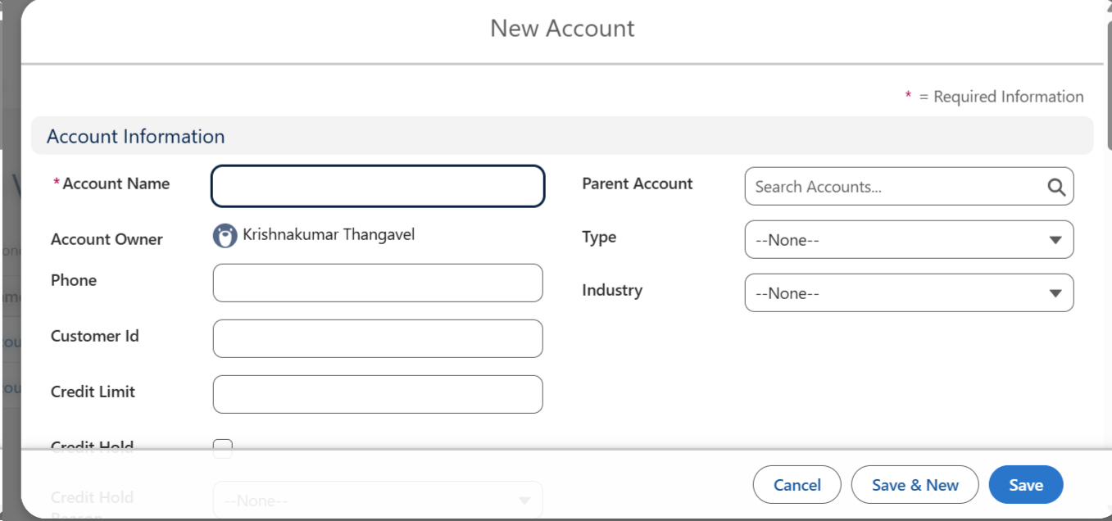
Figure 1. New Account dialog — complete required Account Information, then Save.

3. Create an Address for the Account
Addresses are managed from the Account related lists. The Parent field on an Address record is a lookup to a Location record.

3.1 Steps
- Open the Account you created.
- In Related List Quick Links, select Addresses.
- Click New.
- Complete the required fields:
- Parent — lookup to a Location. If needed, create a Location first (+ New Location), save it, then select it.
- Location Type
- Save the Address.
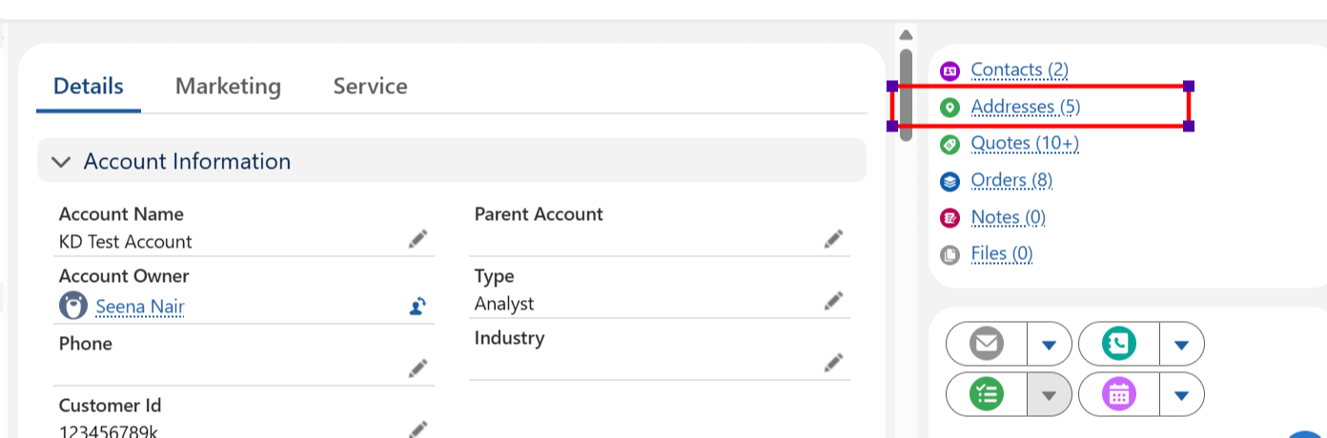
Figure 2. From the Account record, open Addresses in Related List Quick Links.
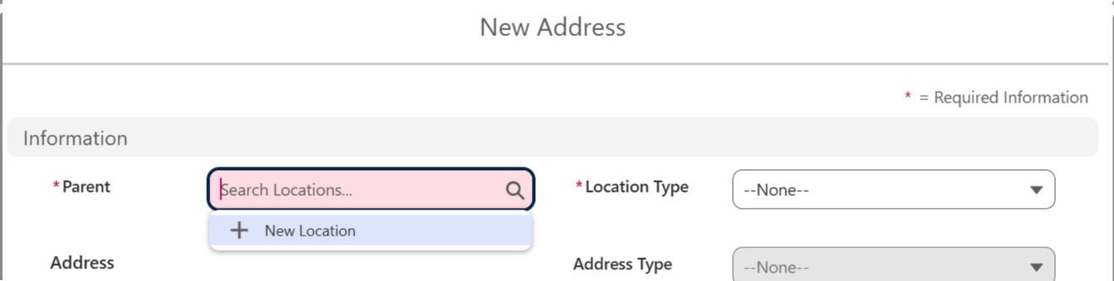
Figure 3. New Address — Parent is a Location lookup; create a Location if one does not exist.
TIP
Parent = Location. Create and save the Location before completing the Address, or use + New Location from the Parent lookup.

4. Contract and Contract Pricing
Contracted list prices appear in the Sales Transaction Line Editor (STLE) only when the contract is Activated and Contract Pricing Entries are refreshed.

4.1 Create a Contract
- Open the Contracts object.
- Click New and complete the required Contract fields.
- Click Save.

4.2 Create Contract Line / Contract Item Pricing
- On the Contract record, open the related list for contract line / pricing (for example, Contract Item Prices).
- Click New.
- Enter pricing details (for example: Item, Contract, Price, Start Date/Time, and Product Selling Model).
- Click Save.
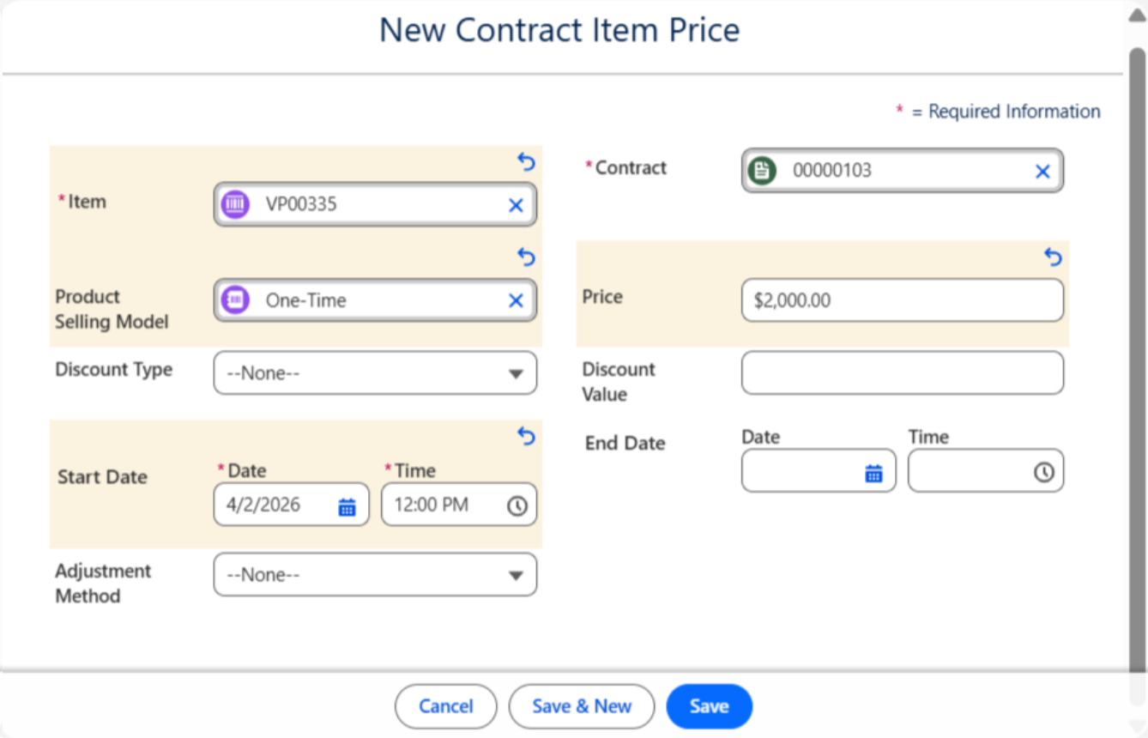
Figure 4. New Contract Item Price — set Item, Contract, Price, and Start Date.

4.3 Activate the Contract
- Activate the Contract.
IMPORTANT
Only an activated contract drives Contracted List Price in STLE. Inactive contracts will not reflect contracted pricing on quote lines.

4.4 Refresh Contract Pricing Entries
- Refresh the Contract Pricing Entries decision table so pricing is available to quotes.

4.5 Create a Quote from the Contract (optional path)
- On the Contract related list, click New Quote.
NOTE
When a quote is created from a Contract, the quote stores Contract Id. That Contract Id is what allows list price changes and contracted pricing to appear in STLE.

5. Create a Quote (from Account)

5.1 Steps
- Open the Account record.
- Click Create Quote on the record page.
- Enter Quote Name and Start Date, then save.
- On the Quote record, complete the following fields:
- Billing Term
- Shipping Term (Ship Term)
- Warehouse
- Address
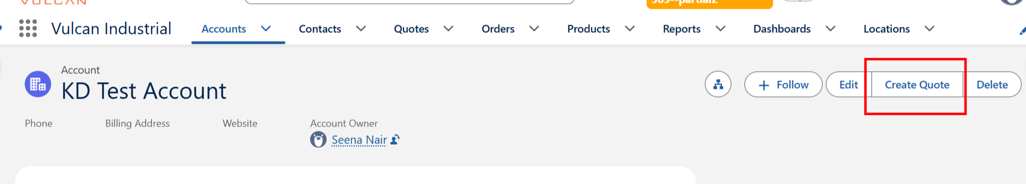
Figure 5. Account action bar — click Create Quote.
AUTOMATION
The system can populate the latest Contract Id on the Quote when contract pricing is available for the Quote’s Account.

6. Add Products in STLE
Use the Sales Transaction Line Editor (STLE) on the Quote Lines tab to browse the catalog and add products.

6.1 Steps
- On the Quote, open the Lines tab.
- In STLE, click Browse Catalogs (or use Browse Catalog / Add Product).
- Select a catalog and add products by category into STLE.
- Review list price and contracted pricing on the lines as applicable.
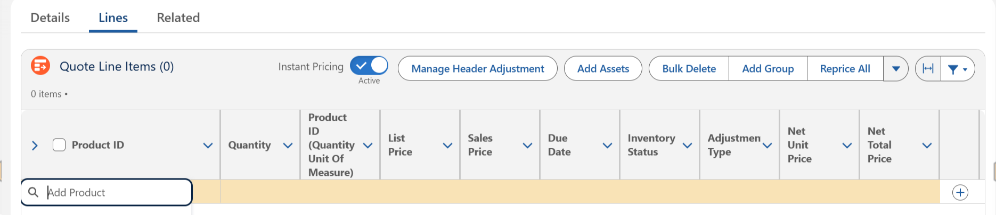
Figure 6. Quote Lines tab — add products via catalog / Add Product in STLE.

7. Generate and Send the Quote Document

7.1 Steps
- On the Quote record, click Generate Quote PDF / Generate Quote Document to preview and save the document to Files.
- Click Send Quote Doc to email the file to a user.
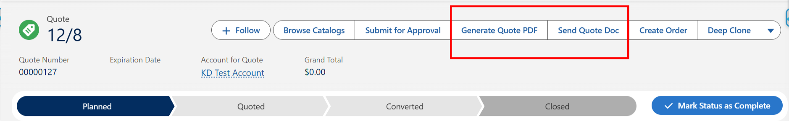
Figure 7. Quote header — Generate Quote PDF and Send Quote Doc.

8. Quote Approvals

8.1 Business rule
If the quote margin is less than 10%, clicking Submit for Approval routes the quote to a VP user for approval.
STATUS RULE
Approval Status should be updated to Needs Approval when the approval condition is met (for example, margin below the approved threshold).

8.2 Behavior after submit
- Once submitted for approval, the quote status changes to In Review.
- Approvers receive an email notification.
- After submit, the Quote Related list / Approval History provides options to Approve, Reject, or Recall.

8.3 Quote creation restriction
Quote creation is allowed only when Approval Status is not equal to any of the following:
- Needs Approval
- Rejected
- In Review

8.4 Submit for approval
- On the Quote, review Margin and Approval Status.
- Click Submit for Approval.
- On the Quote Related lists, open Approval History to track status (Submitted, Approved, Rejected, Recalled, and so on).
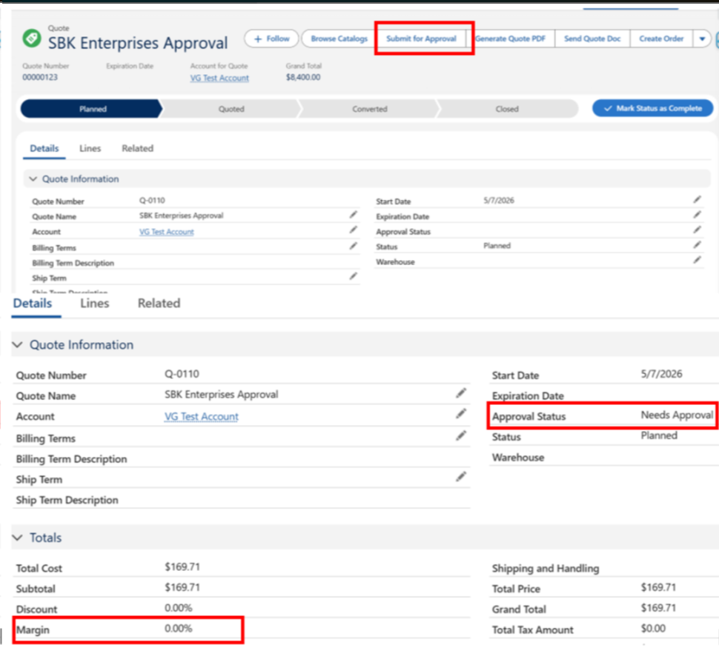
Figure 8. Submit for Approval, Approval Status, and Margin on the Quote.
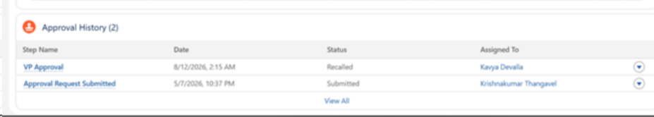
Figure 9. Approval History related list — track step status and assignee.
REMINDER
Margin less than 10% requires VP approval. After submit, status is In Review and an approval email is sent.

8.5 Approve, Reject, or Recall
After a Quote is submitted for approval, use Approval History on the Quote related list to take action:
- Approve — approve the pending approval request.
- Reject — reject the pending approval request.
- Recall — open the dropdown next to Reject and select Recall to withdraw the approval request.
RECALL STATUS
If approval is recalled, Approval Status returns to Needs Approval.

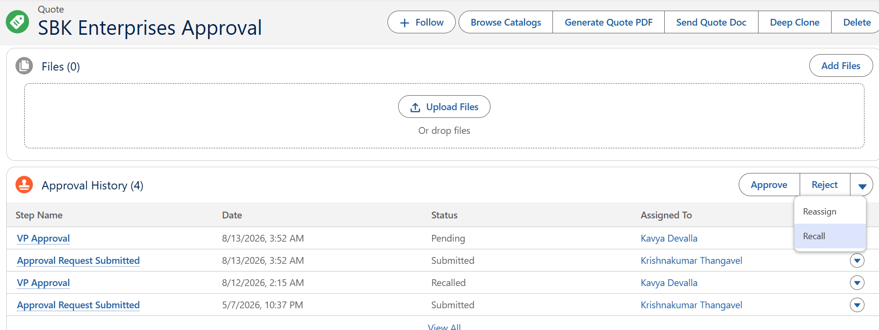
Figure 10. Approval History — Approve, Reject, and Recall actions on a submitted Quote.

8.6 Approve or Reject from email
Once a Quote is submitted for approval, Salesforce sends an email notification to the approver. Approve and Reject options are enabled directly in the email, so the approver can take action without opening Salesforce.
- The approver receives an email when a Quote requires approval (for example, when margin is below the approved threshold).
- From the email, the approver can Approve or Reject (including by reply action where enabled).
- After the decision, the submitter / team receives the appropriate email notification that the Quote was approved or rejected.
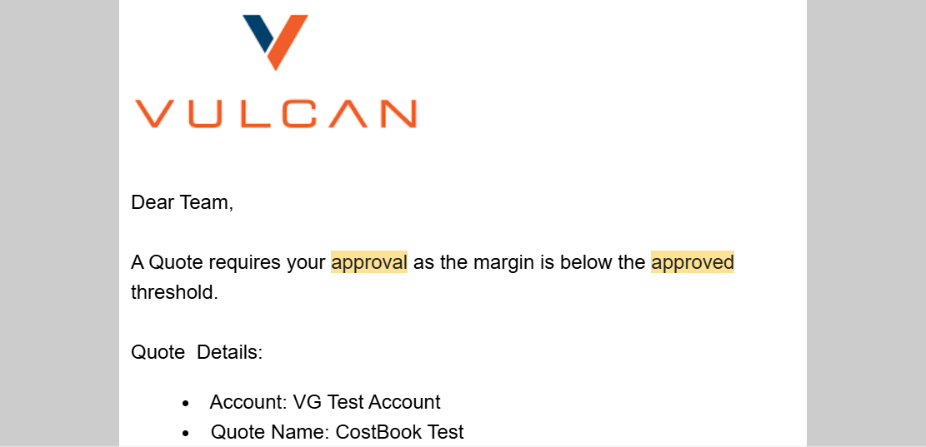
Figure 11. Approval request email — Quote requires approval when margin is below threshold.
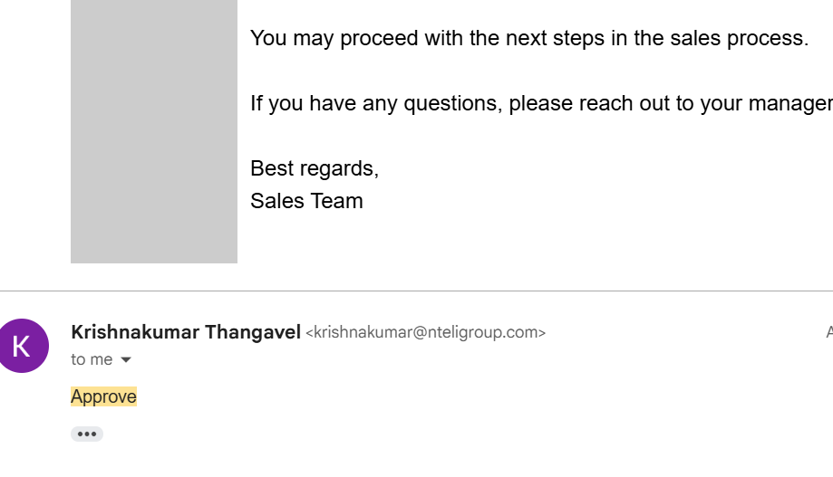
Figure 12. Email approval reply — approver can Approve (or Reject) from email.

8.7 Approval status summary
- When the approval condition is met → Approval Status = Needs Approval.
- After Submit for Approval → status = In Review.
- If approval is Recalled → status returns to Needs Approval.
- If approved or rejected → the related party receives email notification.

9. Create an Order from a Quote

9.1 Steps
- On the Quote, click Create Order.
- Select Create Single Order, then finish.
- Confirm the Order is linked to the correct Account and Contract.
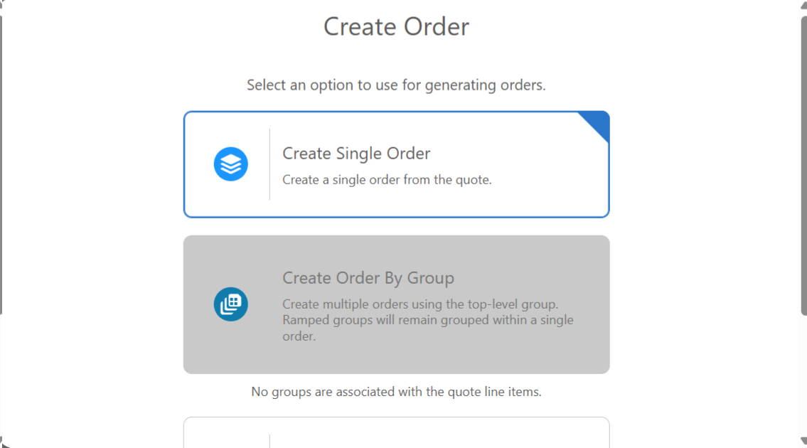
Figure 13. Create Order — select Create Single Order, then continue.
NOTE
Each order is associated with the Contract and Account record.

10. Order Documents and Activation

10.1 Generate and send order documents
- Open the Order.
- Click Generate Order Doc to view or download the document (saved to related Files).
- Click Send Order Doc to email the attached document.
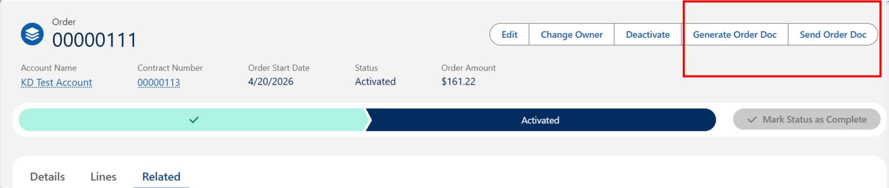
Figure 14. Order header — Generate Order Doc and Send Order Doc.

10.2 Activate the Order
- Open the Order and Activate it.
INTEGRATION
Activated Orders integrate and create orders in SyteLine for the shipping team. There are no updates back into Salesforce from SyteLine after activation.

11. Quick Reference — Key Tips & Rules
Use this table as a quick checklist. All guidance from earlier sections is summarized here.
Area | Guidance
Account | Required: Account Name, Customer Id, Billing Address
Address Parent | Lookup to Location — create Location if missing
Contract | Must be Activated for contracted list price in STLE
Pricing refresh | Refresh Contract Pricing Entries decision table after pricing changes
Quote ← Contract | Quote carries Contract Id; required for contracted pricing in STLE
Quote ← Account | Automation may set latest Contract Id when pricing exists for the Account
Quote fields | Billing Term, Shipping Term, Warehouse, Address
STLE | Lines tab → Browse Catalog / Add Product
Approval | Margin < 10% → Submit for Approval → VP; status In Review
Approve / Reject / Recall | From Approval History after submit; Recall returns status to Needs Approval
Email approval | Approver can Approve or Reject from email; notifications sent on decision
Approval statuses | Needs Approval (condition met / after recall) → In Review (submitted)
Quote gate | Do not create when Approval Status is Needs Approval, Rejected, or In Review
Order | Create Single Order from Quote
Activation | Activated Order → SyteLine; no inbound updates to Salesforce

— End of User Guide —

