SELENIUM AUTOMATION
AMAZON PRODUCT & CART AUTOMATION
TASK 2 | 06 OCTOBER 2026
STUDENT NAME | Vignesh R
REGISTER NUMBER | 212223240176
TASK | Amazon Login, Product Search & Cart Automation
DATE | 06.10.2026

01 | Objective
To automate an Amazon shopping workflow using Selenium WebDriver with Python. The task includes opening Amazon, navigating through sign-in, entering login details, searching for a WaterBottle, selecting the specified product, adding it to the cart, opening the cart, and proceeding to buy.
02 | Work Completed
- Opened Amazon India using Selenium WebDriver.
- Used WebDriverWait and Expected Conditions for dynamic elements.
- Automated navigation to the Amazon sign-in page.
- Entered the registered mobile number and continued to the password page.
- Entered the account password and completed sign-in.
- Searched for WaterBottle using the Amazon search box.
- Selected the Stoga 750 ml Protein Shaker Bottle product.
- Opened the product page and clicked Add to Cart.
- Opened the shopping cart and clicked Proceed to Buy.
- Practiced ID and XPath locators, JavaScript scrolling/clicking, and browser-window switching.
03 | Automation Flow
STEP | ACTION | TARGET
01 | Open Website | Amazon India
02 | Sign In | Account & Lists → Sign in
03 | Search | WaterBottle
04 | Select Product | Stoga 750 ml Protein Shaker Bottle
05 | Add Product | Add to Cart
06 | Cart | Go to Cart
07 | Checkout | Proceed to Buy
04 | Selenium Automation Code
from selenium import webdriver
from selenium.webdriver.common.by import By
from selenium.webdriver.support.ui import WebDriverWait
from selenium.webdriver.support import expected_conditions as EC
import time
driver=webdriver.Chrome()
driver.get("https://www.amazon.in/")
wait=WebDriverWait(driver,10)
driver.maximize_window()
time.sleep(3)
login=wait.until(
EC.element_to_be_clickable(
(By.XPATH,'//*[@id="nav-link-accountList"]/button')
)
)
time.sleep(3)
driver.execute_script(
"arguments[0].scrollIntoView({block: 'center'});",
login
)
time.sleep(3)
driver.execute_script(
"arguments[0].click();",
login
)
time.sleep(3)
print("login clicked success")
signin=wait.until(
EC.element_to_be_clickable(
(By.XPATH,'//*[@id="nav-flyout-ya-signin"]/a/span')
)
)
time.sleep(3)
driver.execute_script(
"arguments[0].scrollIntoView({block: 'center'});",
signin
)
time.sleep(3)
driver.execute_script(
"arguments[0].click();",
signin
)
time.sleep(3)
print("signin success")
mobile=wait.until(
EC.element_to_be_clickable(
(By.ID,"ap_email_login")
)
)
time.sleep(3)
mobile.click()
mobile.send_keys("9342072204")
button=wait.until(
EC.element_to_be_clickable(
(By.XPATH,'//*[@id="continue"]/span/input')
)
)
time.sleep(3)
button.click()
print("success")
password=wait.until(
EC.element_to_be_clickable(
(By.ID,'ap_password')
)
)
time.sleep(3)
password.send_keys("YOUR_PASSWORD")
signin=wait.until(
EC.element_to_be_clickable(
(By.ID,"signInSubmit")
)
)
time.sleep(3)
signin.click()
print("Login Successfully")
searchbox=wait.until(
EC.element_to_be_clickable(
(By.ID,"twotabsearchtextbox")
)
)
searchbox.send_keys("WaterBottle")
searchbox.click()
searchicon=wait.until(
EC.element_to_be_clickable(
(By.ID,"nav-search-submit-button")
)
)
searchicon.click()
print("Product Shown Success")
driver.execute_script("window.scrollBy(0,500);")
productPage = wait.until(
EC.element_to_be_clickable(
(
By.XPATH,
'//a[contains(@href, "/sspa/click")][.//h2[contains(@aria-label, "Stoga 750 ml Protein Shaker Bottle")]]'
)
)
)
driver.execute_script(
"arguments[0].scrollIntoView({block: 'center'});",
productPage
)
productPage.click()
print("Product clicked")
wait.until(lambda d: len(driver.window_handles) > 1)
driver.switch_to.window(driver.window_handles[-1])
print("Product page opened")
print("Current URL:", driver.current_url)
cartbutton=wait.until(
EC.element_to_be_clickable(
(By.XPATH,'//input[@id="add-to-cart-button"]')
)
)
print("cart added success")
cartbutton.click()
gotocart=wait.until(
EC.element_to_be_clickable(
(By.XPATH,'//*[@id="sw-gtc"]/span/a')
)
)
gotocart.click()
print("gotocart success")
proceed=wait.until(
EC.element_to_be_clickable(
(By.XPATH,'//*[@id="sc-buy-box-ptc-button"]/span/input')
)
)
time.sleep(3)
proceed.click()
time.sleep(30)
Security note: The password is represented as YOUR_PASSWORD in the submitted document. Keep real account credentials only in the local script.
05 | Output / Execution Evidence
The supplied screenshots document the Amazon automation workflow, including the Amazon home page, sign-in stages, signed-in page, and WaterBottle search results.
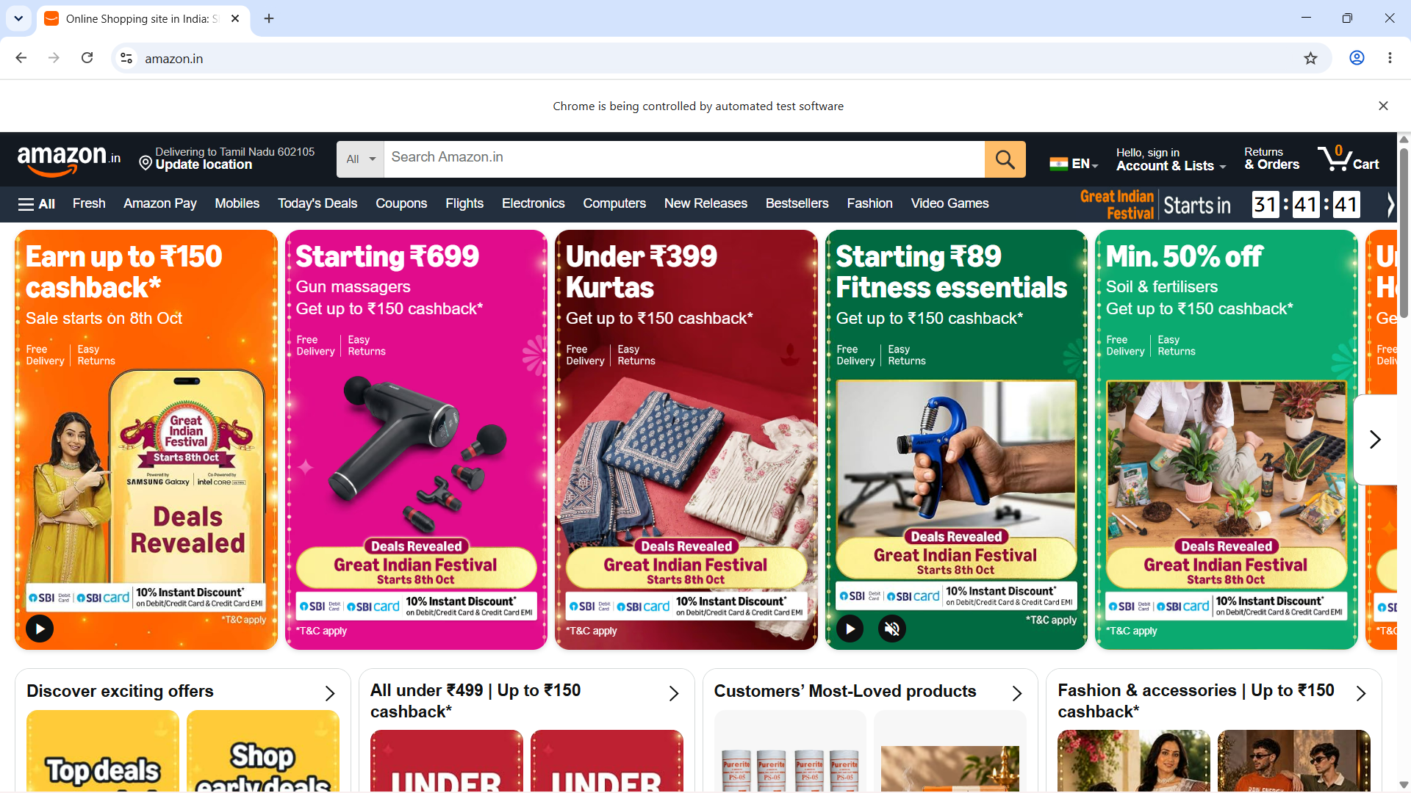
Output 1 – Amazon home page
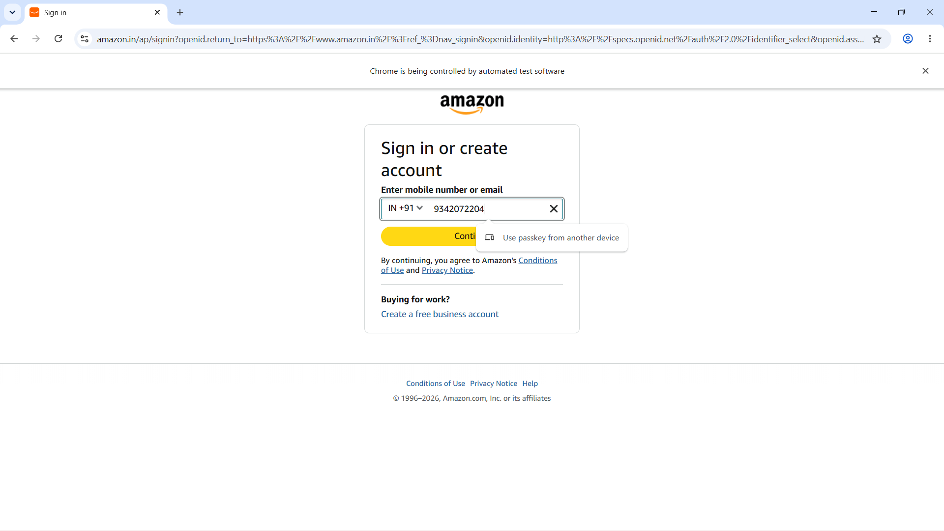
Output 2 – Amazon sign-in page
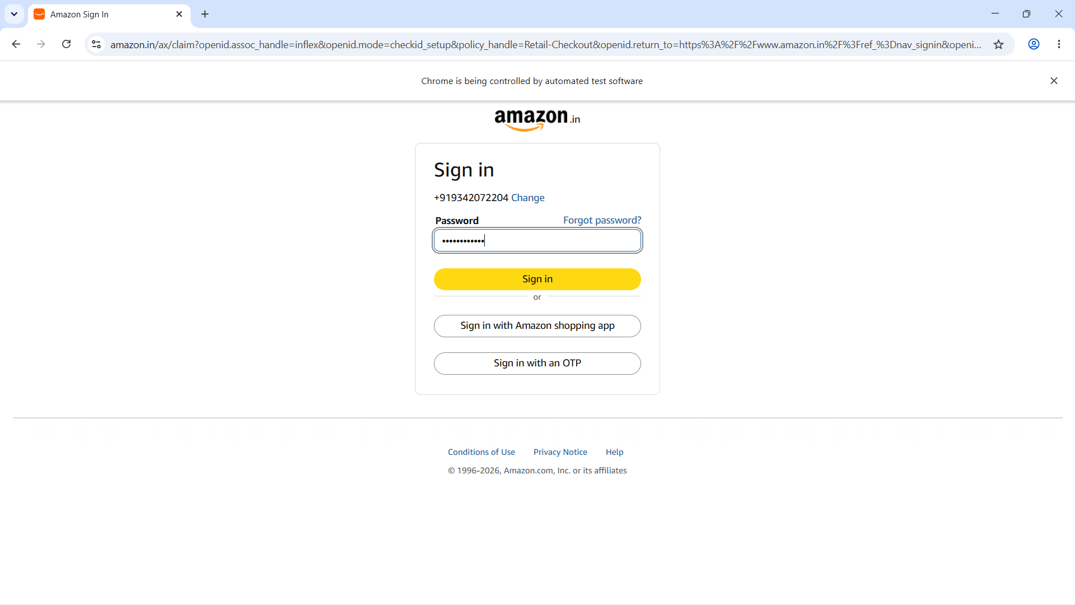
Output 3 – Password/sign-in stage
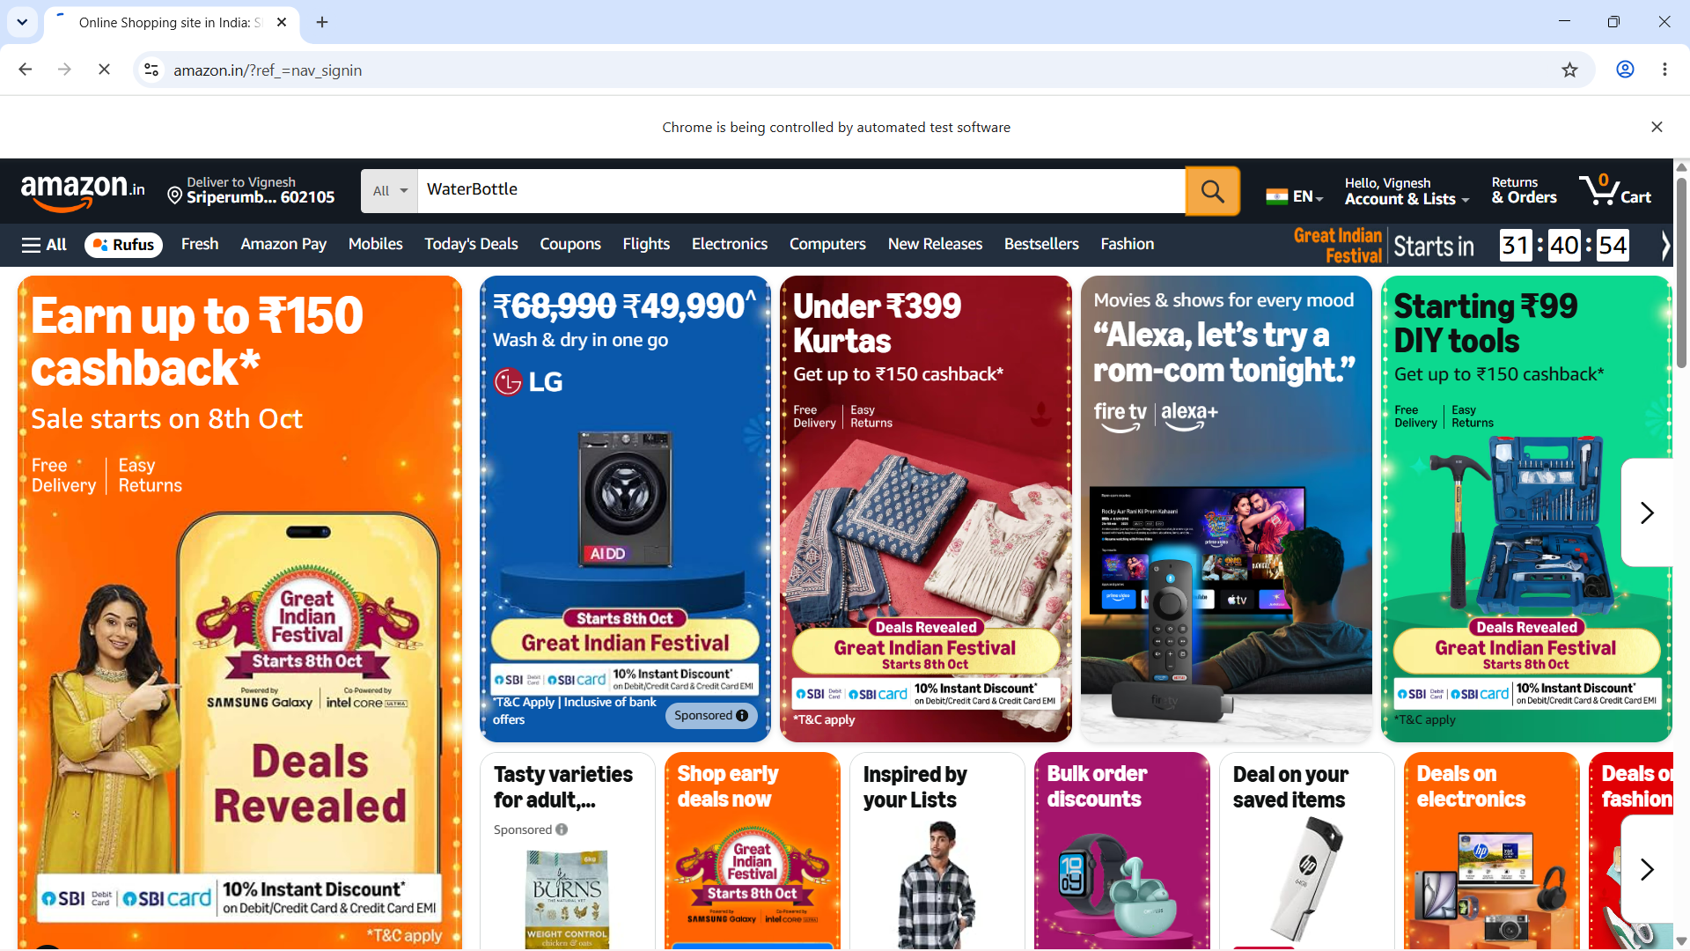
Output 4 – Signed-in Amazon page
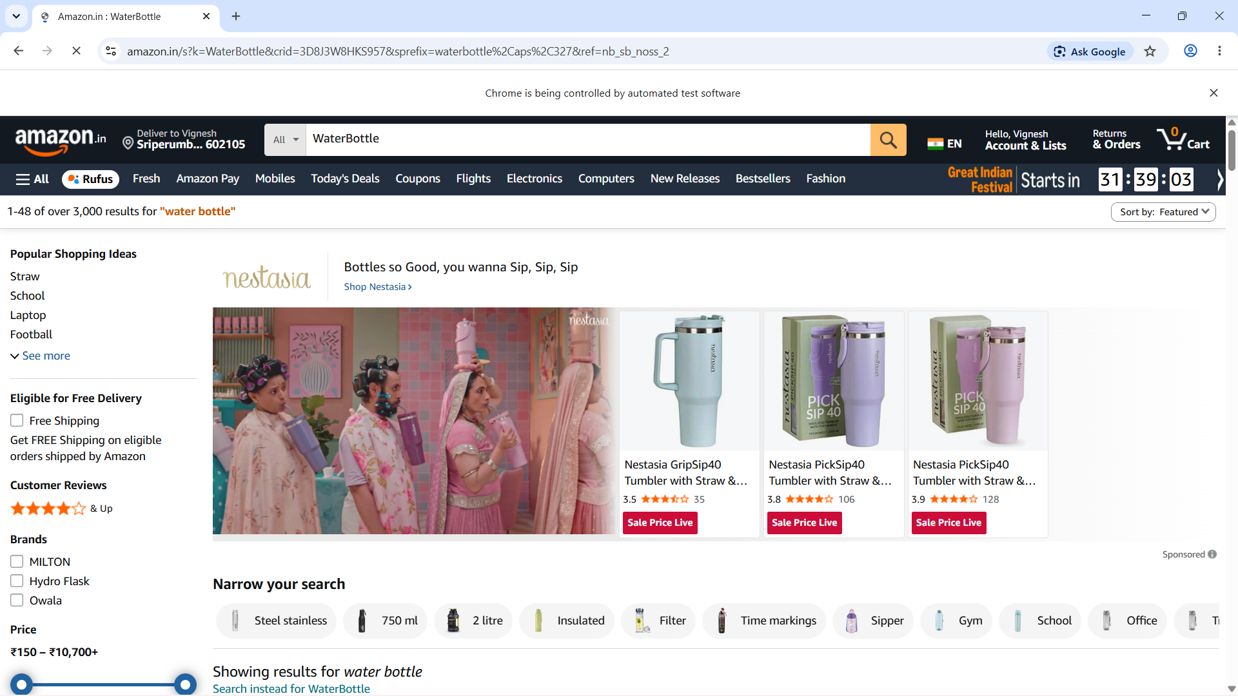
Output 5 – WaterBottle search results
06 | Expected Console Output
login clicked success
signin success
success
Login Successfully
Product Shown Success
Product clicked
Product page opened
cart added success
gotocart success
07 | Result
PASS – The supplied Selenium automation demonstrates the Amazon login, WaterBottle search, product selection, Add to Cart, cart navigation, and Proceed to Buy workflow.

