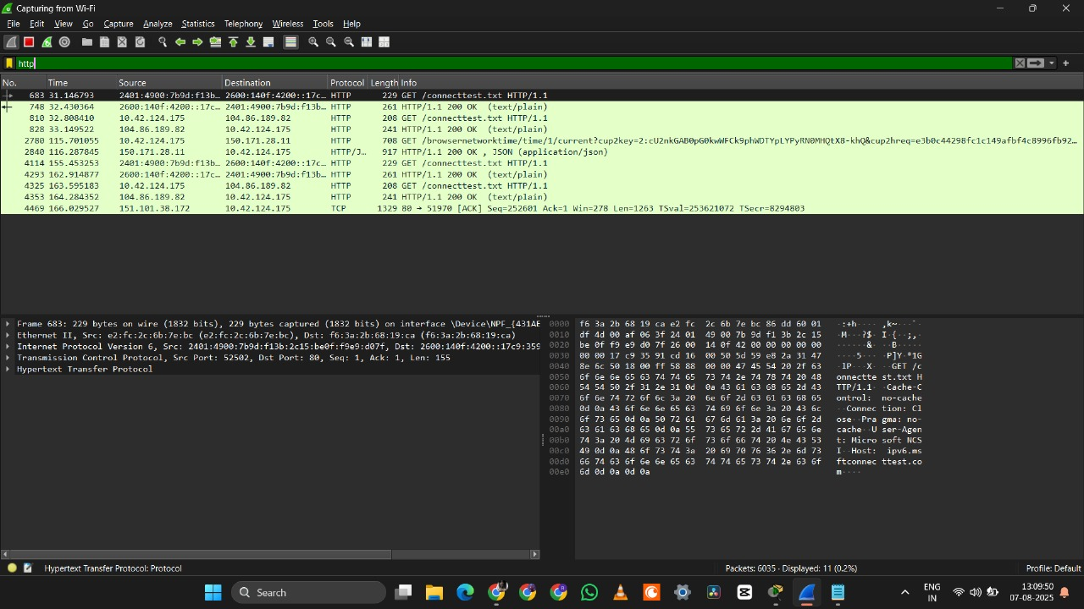Exp-27. Network layer protocol header analysis using Wire shark – SMTP