SIMATS ENGINEERING (SAVEETHA SCHOOL OF ENGINEERING)
Department of Artificial Intelligence and Data Science
ASSESSMENT TOOL 1 – APPLICATION BASED QUESTIONS

Course Code: | DSA03 | Course Title: | Natural Language Processing
CO Assessed: | CO1 – Imitation (L1) | Assessment: | Assessment Tool 1 – Application Based Questions
Weightage: | 40% of CIA
CO1 Statement: | Analyse NLP models, regular expression patterns, finite state automata, morphological processing techniques and to interpret language processing. (BL-3)
Student Name: | Gogula Vignesh | Reg. No.: | 192424153
Section / Batch: | AI & DS | Date: | 28/july/2026

Code of Conduct
I G. Vignesh-192424153 (Name / Reg No) certify that this submission is my original work and that I have adhered to the guidelines specified for this assessment. I understand that any violation of academic integrity rules will result in disciplinary action.
Signature of the Student: _________________________

Instructions
- Develop a modular and efficient Python program that satisfies all the functional requirements specified in the problem statement.
- Demonstrate the correctness of the implementation using suitable test cases and justify the output obtained.
- Follow good programming practices, including meaningful variable names, proper code indentation, comments, and error handling wherever applicable.
- Duration: 30 minutes.

Section / Topic | Focus | Q Nos
Information Extraction | Regex-Based Information Extraction | 1
Pattern Matching | Regex Pattern Matching | 2
Regular Expression Patterns | Regex-Based Input Validation | 3

Annexure A – Application Based Questions

Section 1: Regular Expressions – Resume Information Extraction
- A multinational recruitment company receives thousands of resumes every day in text format. The HR department requires an automated system to extract candidate information for shortlisting.

Design and implement a Python-based resume information extraction system using Regular Expressions that performs the following tasks:

Extract the candidate's name.
Identify email addresses.
Extract mobile numbers.
Detect technical skills (Python, Java, SQL, Machine Learning, NLP).
Extract years of experience.
Generate a structured summary of the candidate's profile.
Display candidates who satisfy the minimum eligibility criteria (minimum 2 years of experience and Python skill).

Section 2: Regular Expressions – Product Search System
- An e-commerce company plans to enhance its product search engine to improve customer experience through flexible keyword matching.

Design and implement a Python-based product search system using Regular Expressions that performs the following tasks:

Search products using an exact keyword.
Perform prefix-based searches.
Perform suffix-based searches.
Search using partial keywords.
Perform case-insensitive searches.
Display all matching product names.
Generate a report showing the total number of matching products for each search.
Section 3: Regular Expressions – University Registration System
A university is developing an automated online registration portal to verify student information before course enrollment.

Design and implement a Python-based validation system using Regular Expressions that performs the following tasks:

Validate the student register number.
Validate the institutional email address.
Validate the course code.
Validate the semester information.
Validate the student's mobile number.
Display appropriate validation messages for each field.
Generate a final registration status report indicating whether the registration is successful.

Aim
To design and implement a Python-based resume information extraction system using Regular Expressions to extract candidate details and check eligibility.
Algorithm
1. Start the program.
2. Read the resume text as input.
3. Extract the candidate's name, email, mobile number, skills, and years of experience using Regular Expressions.
4. Generate a structured candidate profile summary.
5. Check eligibility criteria (minimum 2 years of experience and Python skill).
6. Display the eligibility result.
7. Stop the program.
Python Program
import re

resume_text = input("Enter resume text: ")

name_match = re.search(r"Name:\s*([A-Za-z ]+)", resume_text)
email_match = re.findall(r"[a-zA-Z0-9._%+-]+@[a-zA-Z0-9.-]+\.[a-zA-Z]{2,}", resume_text)
mobile_match = re.findall(r"[6-9]\d{9}", resume_text)

skills_list = ["Python", "Java", "SQL", "Machine Learning", "NLP"]
skills_found = [s for s in skills_list if re.search(r"\b" + re.escape(s) + r"\b", resume_text, re.IGNORECASE)]

exp_match = re.search(r"(\d+)\+?\s*years? of experience", resume_text, re.IGNORECASE)

name = name_match.group(1).strip() if name_match else "Not Found"
email = email_match[0] if email_match else "Not Found"
mobile = mobile_match[0] if mobile_match else "Not Found"
experience = int(exp_match.group(1)) if exp_match else 0

print("Candidate Profile Summary")
print("Name:", name)
print("Email:", email)
print("Mobile Number:", mobile)
print("Skills:", ", ".join(skills_found) if skills_found else "None")
print("Years of Experience:", experience)

if experience >= 2 and "Python" in skills_found:
print("Eligibility: Shortlisted")
else:
print("Eligibility: Not Eligible")
Sample Input
Enter resume text: Name: Ananya Sharma Email: ananya.sharma@gmail.com Mobile: 9876543210 Skills: Python, SQL, Machine Learning 3 years of experience
Sample Output
Candidate Profile Summary
Name: Ananya Sharma
Email: ananya.sharma@gmail.com
Mobile Number: 9876543210
Skills: Python, SQL, Machine Learning
Years of Experience: 3
Eligibility: Shortlisted
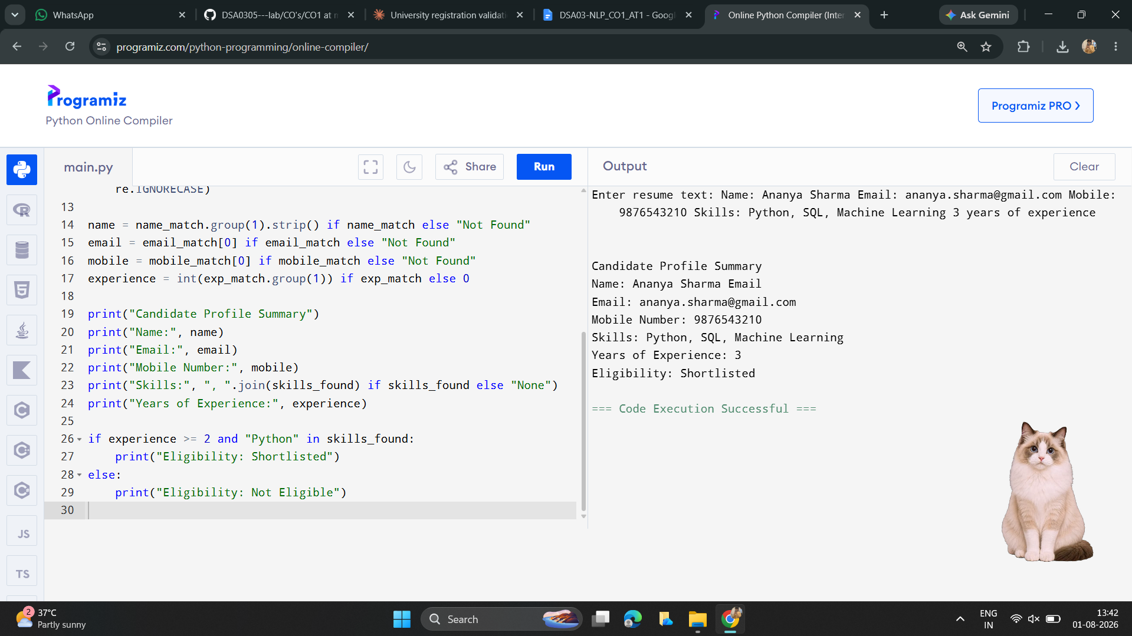

2. Title: Product Search System Using Regular Expressions
Aim
To design and implement a Python-based product search system using Regular Expressions to support exact, prefix, suffix, and partial keyword searches.
Algorithm
1. Start the program.
2. Create a list of product names.
3. Read the search keyword and search type from the user.
4. Perform exact, prefix, suffix, or partial matching using Regular Expressions based on the search type.
5. Display all matching product names.
6. Display the total number of matching products.
7. Stop the program.
Python Program
import re

products = ["Wireless Mouse", "Wireless Keyboard", "Bluetooth Speaker",
"USB Cable", "Laptop Stand", "Wireless Earbuds"]

keyword = input("Enter search keyword: ")
search_type = input("Enter search type (exact/prefix/suffix/partial): ").lower()

results = []
for product in products:
if search_type == "exact":
if re.fullmatch(keyword, product, re.IGNORECASE):
results.append(product)
elif search_type == "prefix":
if re.match(keyword, product, re.IGNORECASE):
results.append(product)
elif search_type == "suffix":
if re.search(keyword + r"$", product, re.IGNORECASE):
results.append(product)
elif search_type == "partial":
if re.search(keyword, product, re.IGNORECASE):
results.append(product)

print("Matching Products:")
for r in results:
print(r)

print("Total Matches:", len(results))
Sample Input
Enter search keyword: Wireless
Enter search type (exact/prefix/suffix/partial): prefix
Sample Output
Matching Products:
Wireless Mouse
Wireless Keyboard
Wireless Earbuds
Total Matches: 3
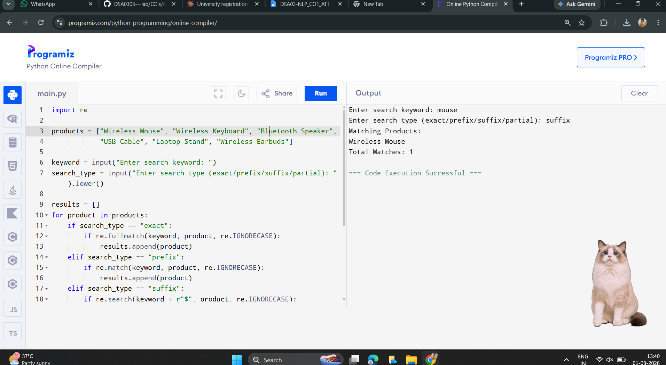
3. Title: University Registration Validation Using Regular Expressions
Aim
To design and implement a Python-based validation system using Regular Expressions to validate university registration details.
Algorithm
1. Start the program.
2. Read register number, email, course code, semester, and mobile number.
3. Validate each field using Regular Expressions.
4. Display validation messages.
5. If all validations are successful, display registration successful.
6. Stop the program.
Python Program
import re
reg = input("Register Number: ")
email = input("Institution Email: ")
course = input("Course Code: ")
semester = input("Semester: ")
mobile = input("Mobile Number: ")

reg_valid = re.fullmatch(r"\d{10}", reg)
email_valid = re.fullmatch(r"[a-zA-Z0-9._%+-]+@college\.com", email)
course_valid = re.fullmatch(r"[A-Z]{3}\d{3}", course)
semester_valid = re.fullmatch(r"[1-8]", semester)
mobile_valid = re.fullmatch(r"[6-9]\d{9}", mobile)

if reg_valid:
print("Register Number: Valid")
else:
print("Register Number: Invalid")

if email_valid:
print("Email: Valid")
else:
print("Email: Invalid")

if course_valid:
print("Course Code: Valid")
else:
print("Course Code: Invalid")

if semester_valid:
print("Semester: Valid")
else:
print("Semester: Invalid")

if mobile_valid:
print("Mobile Number: Valid")
else:
print("Mobile Number: Invalid")

if reg_valid and email_valid and course_valid and semester_valid and mobile_valid:
print("Registration Successful")
else:
print("Registration Failed")
Sample Input
Register Number: 2023001234
Institution Email: student@college.edu
Course Code: CSE101
Semester: 5
Mobile Number: 9876543210
Sample Output
Register Number: Valid
Email: Valid
Course Code: Valid
Semester: Valid
Mobile Number: Valid
Registration Successful

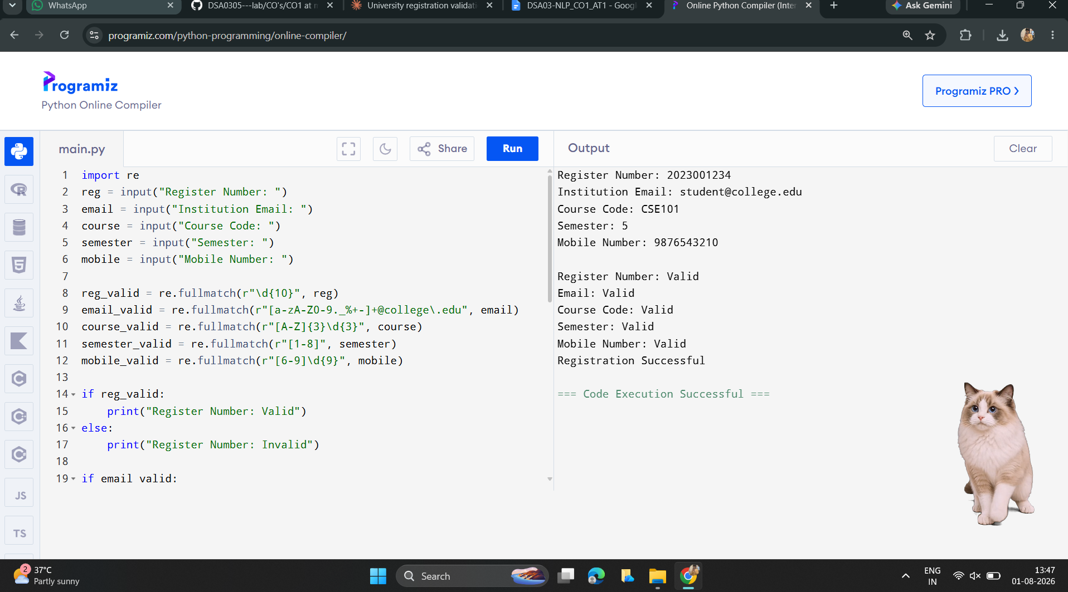

Rubrics for Calculation
Criteria | Weightage | Level 4 – Exemplary | Level 3 – Proficient | Level 2 – Developing | Level 1 – Beginning
Understanding of Problem Context | 20 | Clearly understands the problem and accurately identifies all requirements | Good understanding with minor gaps | Basic understanding; some requirements unclear | Poor understanding or misinterpretation of the problem
Application of Concepts | 30 | Accurately applies appropriate concepts to solve complex problems | Applies relevant concepts correctly with minor errors | Applies basic concepts with limited accuracy | Fails to apply appropriate concepts
Problem-Solving Approach | 20 | Logical, well-structured, and efficient approach | Mostly logical approach with minor gaps | Basic approach with some inconsistencies | Illogical or unclear approach
Accuracy of Solution | 20 | Completely correct solution with proper justification | Mostly correct with minor errors | Partially correct solution | Incorrect or incomplete solution
Clarity | 10 | Clear, well-organized, and properly explained solution | Understandable with minor clarity issues | Limited clarity and explanation | Poorly presented and difficult to understand

Q. No. / Criteria | Understanding of Problem Context | Application of Concepts | Problem-Solving Approach | Accuracy of Solution | Clarity | Sub. Total | Total %
1
2
3

Faculty In-charge | Course Coordinator | Program Director
Signature: _______________ | Signature: _______________ | Signature: _______________
Date: ___________________ | Date: ___________________ | Date: ___________________

