#include<graphics.h>

#include<conio.h>

#include<dos.h>

#include<stdlib.h>

#include<stdio.h>

void main()

{

int gd=DETECT,gm;

int x1,y1,l,i,r=50,gap=40;

initgraph(&gd,&gm,"c:\\turboc3\\bgi");

x1=getmaxx()/2;

y1=getmaxy()/2;

setbkcolor(WHITE);

for(i=0;i<=15;i+=3)

{

setcolor(BLUE);

circle(x1,y1,r+i);

setcolor(CYAN);

circle(x1+2\*r+gap,y1,r+i);

setcolor(RED);

circle(x1-2\*r-gap,y1,r+i);

setcolor(YELLOW);

circle(x1-r-gap/2,y1+r,r+i);

setcolor(GREEN);

circle(x1+r+gap/2,y1+r,r +i);

delay(100);

}

getch();

closegraph();

}

Output: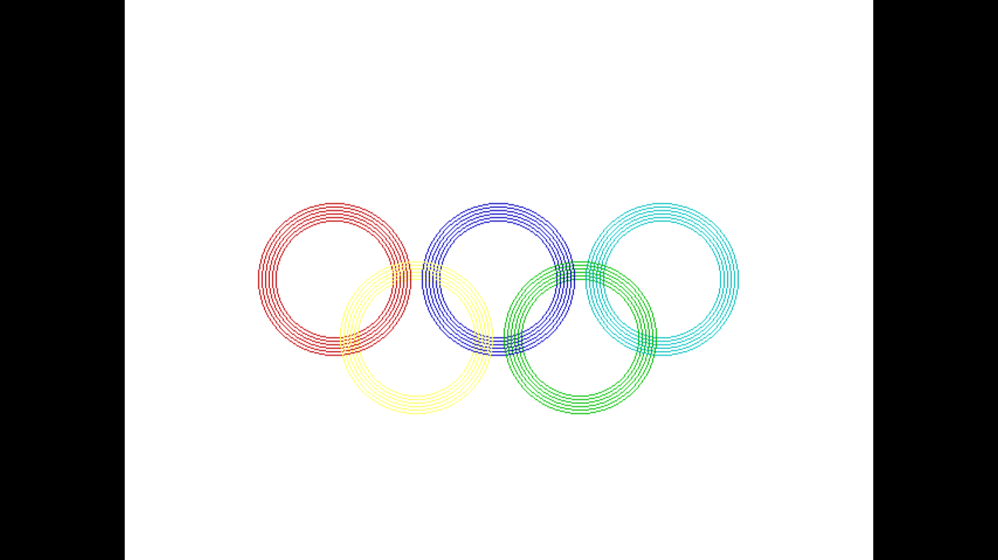

Submitted By: Vighnesha N U