*by Vigneshprabhu M, mail id: vigneshprabhuvp44@gmail.com*

**OVERVIEW:**

As IBM has discontinued its media streaming services on IBM Cloud Foundry, I have got some resources from Microsoft Azure cloud platform. Below are the complete steps that will be taken by me to put my design in my thought in previous phase into transformation, this document has some resources taken from Azure media service documentation.

**STEPS TAKEN:**

* Creating an IBM Cloud account and access the IBM Cloud Dashboard.
* Providing a high-level overview of IBM Cloud Foundry, its purpose, and its benefits.
* Creating a new application in IBM Cloud Foundry based on the application's purpose and technology stack.
* Setting up your development environment.
* Testing and developing the application.
* Providing step-by-step instructions and any important configurations.
* Explaining how to scale the application to handle more traffic.
* Discussing for the resource management and scaling options.
* Describing how to access and analyze application logs and monitoring data.
* Explaining how to create backups and restore data in case of issues.
* Describing best practices for securing the application on IBM Cloud Foundry.
* Discussing the access control and permissions.
* Explaining how to monitor and manage costs associated with your application on IBM Cloud.
* Providing a troubleshooting guide for common issues and errors.
* Discussing to provide any additional tips or recommendations.

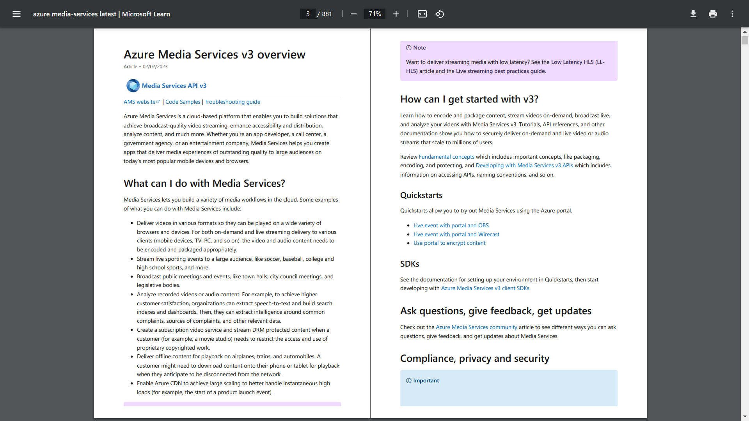

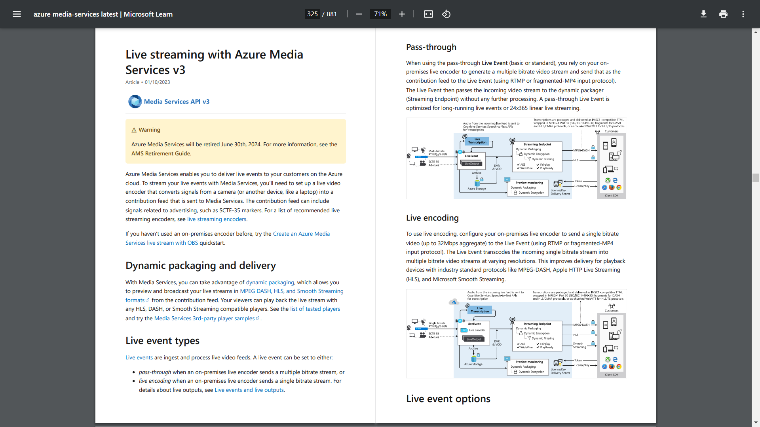

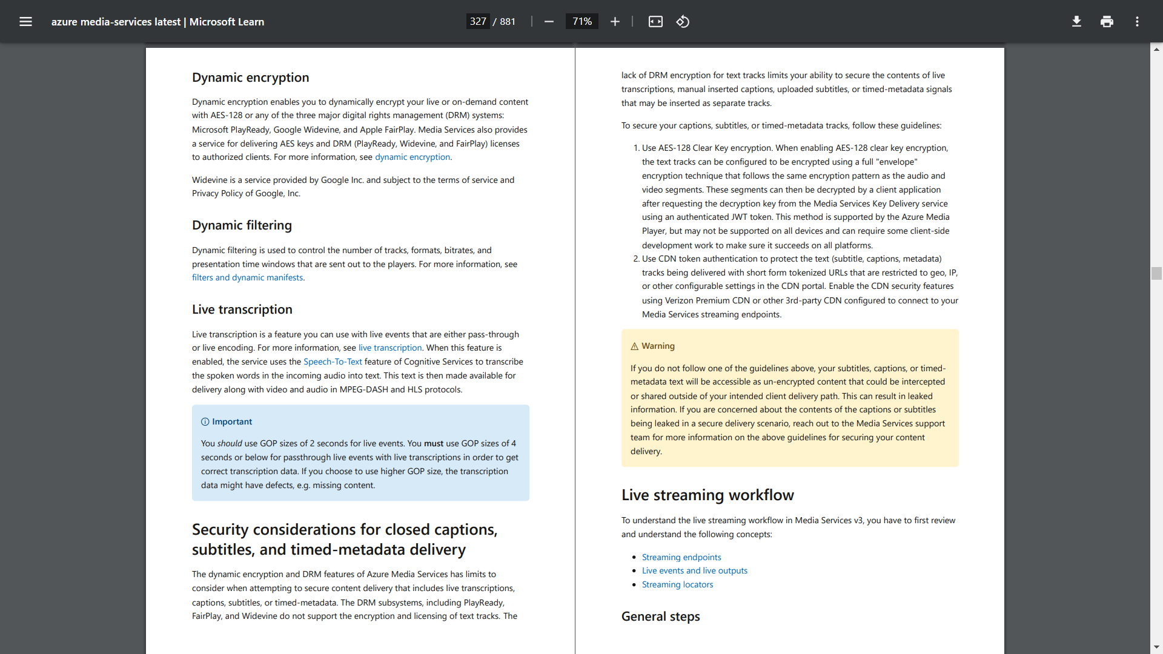

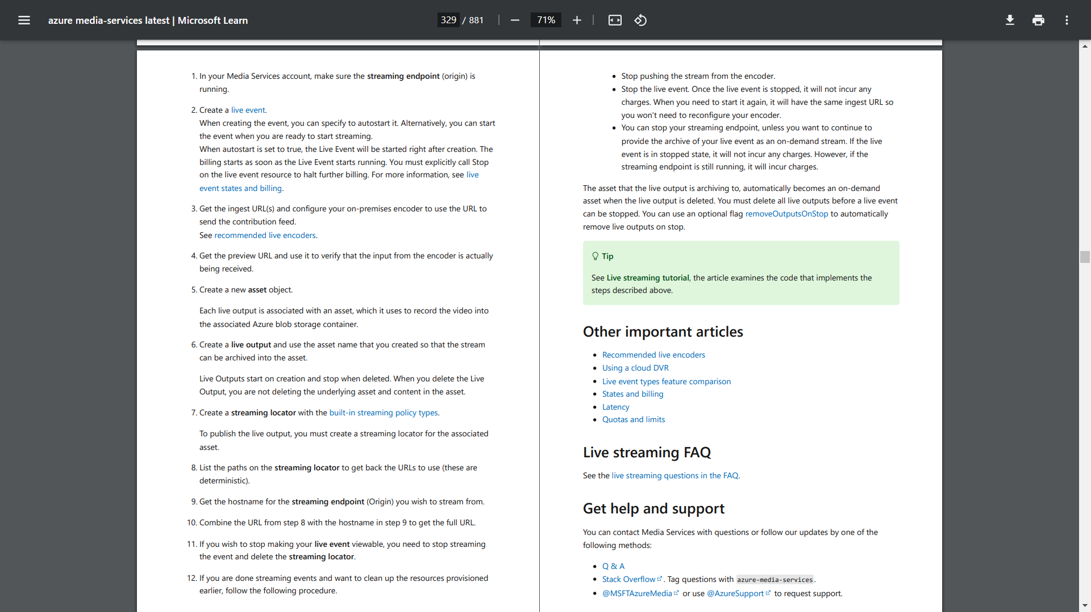

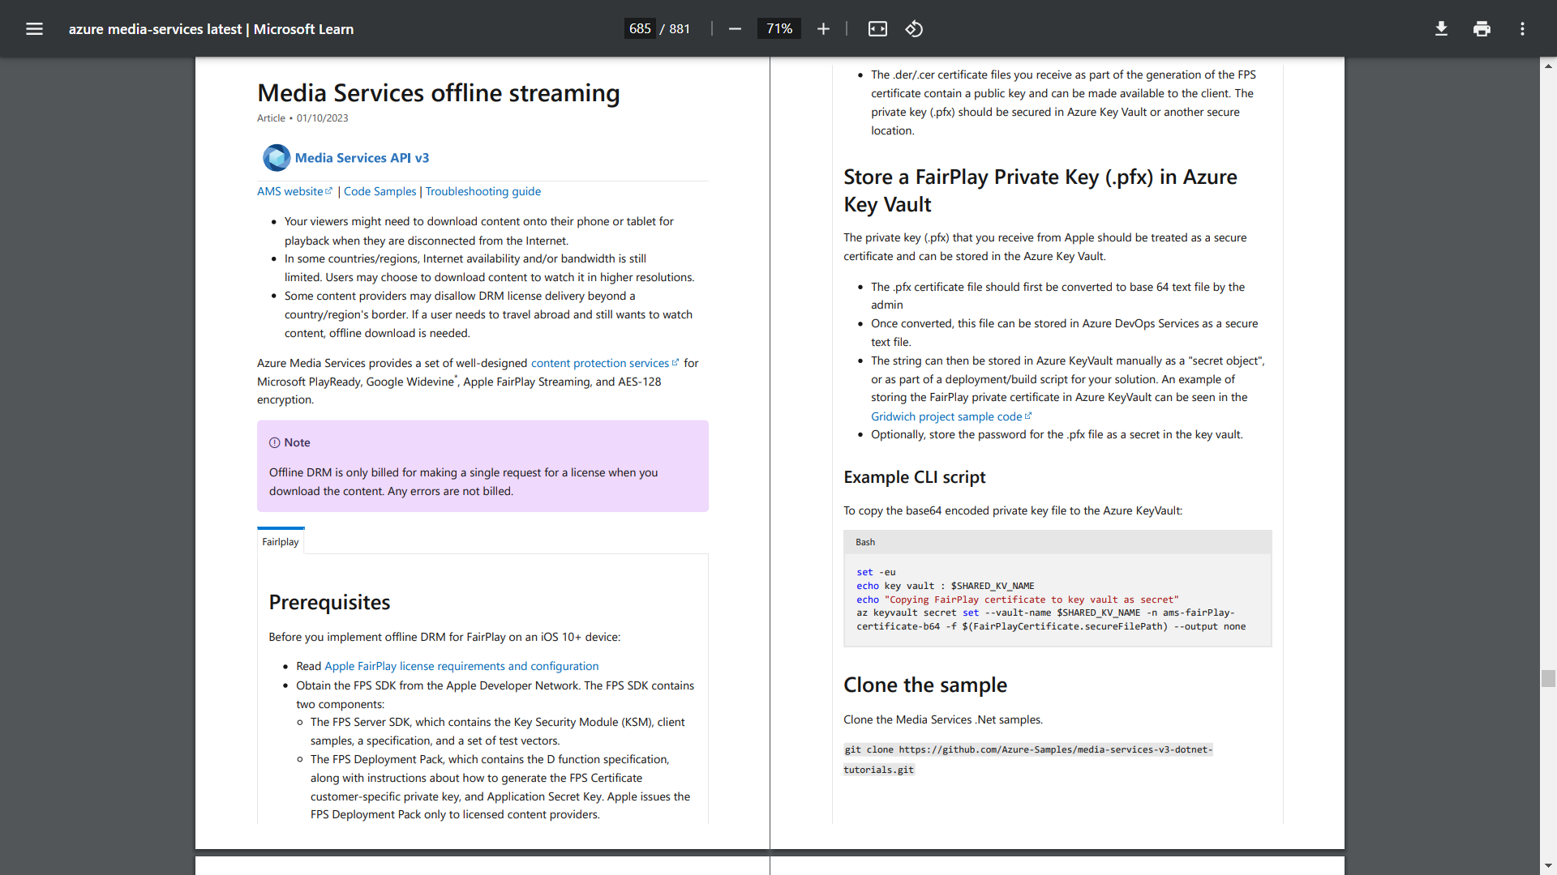

**TEAM MEMBERS:**

*VIGNESHPRABHU M*

*ABISHEK S*

*DHANUSHKUMAR K*

*MATHAN G*

*MATHANRAJ S*

*MAHENDIRAN*