Worm Propagation Modeling in Large Networks

Vignesh M. Pagadala
Department of Computer Science
Colorado State University
Vignesh.Pagadala@colostate.edu

Report for Dr Indrajit Ray

March 20th, 2018

Contents

- Introduction

- Worm propagation without applying cure
  - For 500 nodes
  - For 1000 nodes
  - For 1500 nodes
  - Influence of network type on worm propagation rate and average time

- Behavior with cure applied
  - Influence of network type on worm propagation rate and average time

- Resilience enhancement strategies

- Introduction

In this work, we shall attempt to simulate the propagation of worms in large networks. For the purpose of this study, we use three different network topologies: (1) Erdos-Renyi, (2) Barabasi-Albert, and (3) Watts-Strogatz networks. For the purpose of this simulation, we shall make use of Python for programming, and the networkx package. Initially, the networks are generated and stored in CSV files as pairs of nodes (representing an edge). These networks comprise of the three topologies, with 500, 1000, and 1500 nodes for each network type. The simulation is run for each of these networks multiple times and we record the average amount of time (here we assume that one round equals one time unit) for completing the simulation, and represent the worm propagation rate through plots.

- Worm Propagation without Applying Cure

In this section, we look into simulations where the worm’s propagation is simply observed, without the application of any cure. Simulations were performed on each of the three networks, with 500, 1000, and 1500 nodes each. For each case, the initial point of infection (1) and the probability of infection (0.01) is the same, and simulation was run for a total of 10 times. The average number of rounds taken to finish the simulation were recorded. Also, a probability of 0.01 was assigned to the worm. Which means, at each round, the node selects (to infect) each uninfected node adjacent to an infected node, with a probability of 0.01.

(a) For 500 nodes:

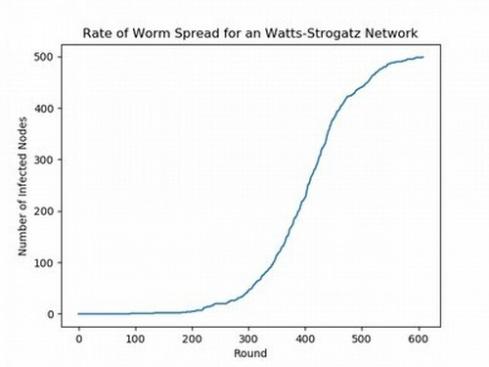
Average number of rounds: 607.3
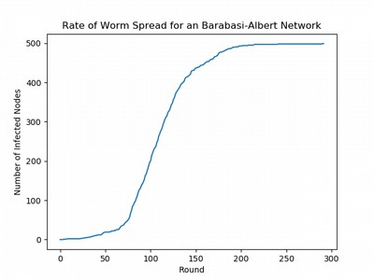
Average number of rounds: 297.3

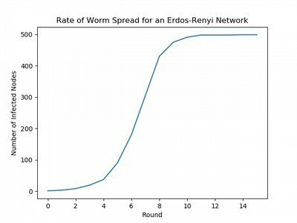
Average number of rounds: 15.6

(b) For 1000 nodes:

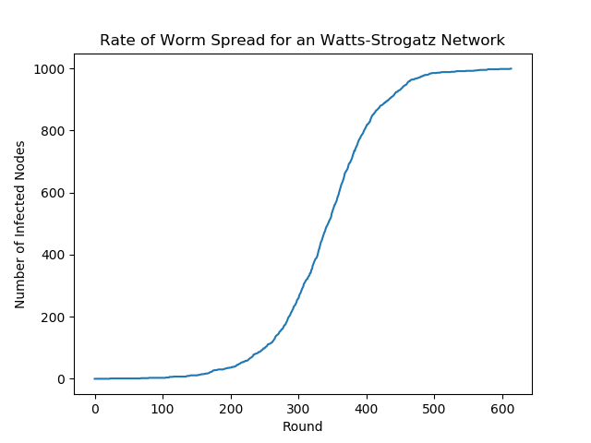
Average number of rounds: 592.4
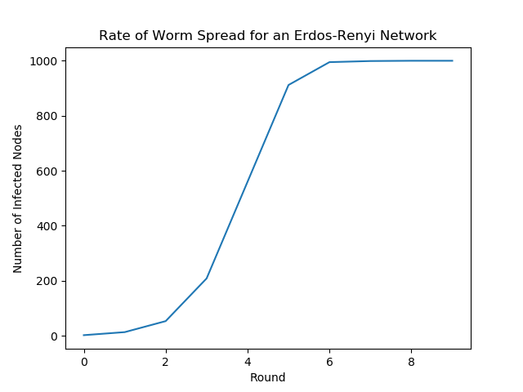
Average number of rounds: 10.3

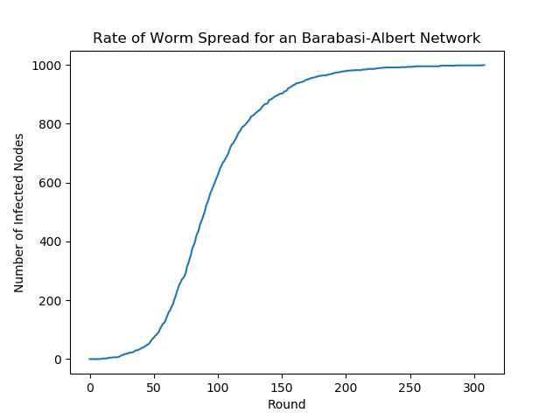
Average number of rounds: 311.1

(c) For 1500 nodes:

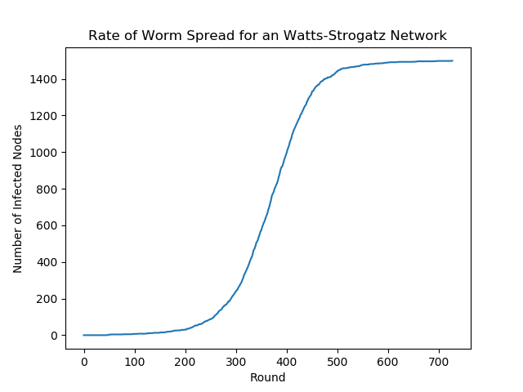
Average number of rounds: 720.4
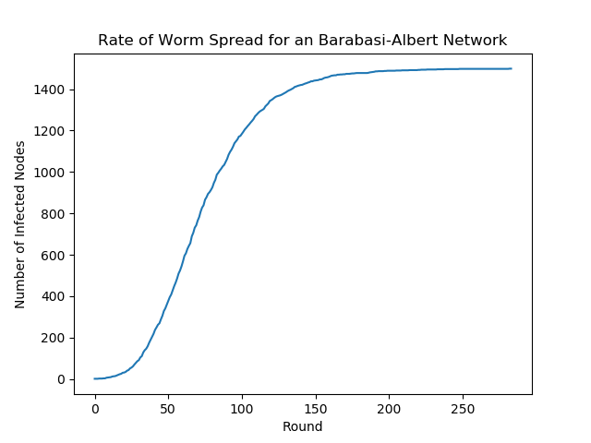
Average number of rounds: 298.7

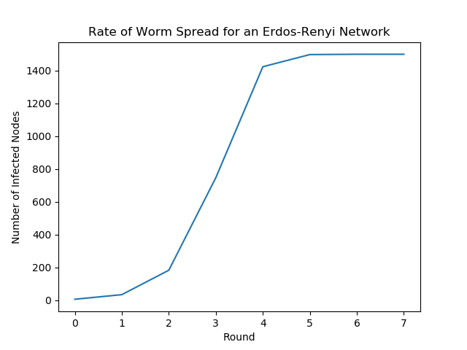
Average number of rounds: 7.24

(d) Analysis: Influence of Network Type on Worm Propagation Rate and Average Time

As can be observed, the plots of rate of worm propagation i.e. the plots of the number of nodes infected with respect to time is in all cases an ‘S’ shaped graph. This makes sense, as traditional rate of spread of a worm in a network follows as ‘S’ shape. In all instances, the number of infected nodes starts off increasing slowly and eventually making a steep climb, and leveling off gradually.

Now let us examine how the plots vary with the different network types. For all the network types, increasing the number of nodes seems to result in more or less similar behavior. For example, let’s look at the Barabasi-Albert network. For 500, 1000 and 1500 nodes, the rate of infection increases at around the 25 – 50 round mark. And also, all the nodes get infected at around 250 – 300th round. This behavior can be seen for the other two network types as well.

However, there is a distinct difference in the rate of infection with the different network types. For 500 nodes, Erdos-Renyi is completely overwhelmed in an average of 15.6 rounds. On the other hand, Barabasi-Albert is taken over completely in an average of 297.3 rounds. Watts-Strogatz is taken over after 607.3 average number of rounds. This evidently means that Watts-Strogatz has performed the best (in terms of resilience), Barabasi-Albert is next best, and Erdos-Renyi has performed the worst.

For 1000 nodes, similar characteristics can be taken note of. Erdos-Renyi, Barabasi-Albert and Watts-Strogatz are completely infected by 10.3, 311.1 and 592.4 average number of rounds respectively, which implies that Watts-Strogatz has done better than Barabasi-Albert, which has done better than Erdos-Renyi.

For 1500 nodes, again, the same pattern is observable. Erdos-Renyi has done the worst, getting completely infected at just 7.24 rounds. Watts-Strogatz has performed the best, being taken over only by 720.4 rounds, and Barabasi-Albert with 298.7 rounds, takes the middle position. Once again, the same pattern follows:

Watts-Strogatz > Barabasi-Albert > Erdos-Renyi

The rate of infection appears to be the highest in Erdos-Renyi networks and lowest in Watts-Strogatz networks. Barabasi-Albert networks have an infection rate which is lower than Erdos-Renyi networks, but higher than Watts-Strogatz networks.

- Behavior with Cure Applied

In this section, we look into simulating the spread of a worm in a network, but this time we enforce a defense mechanism. Similar to the worm’s behavior, we shall have a defense mechanism spread throughout the network in the same manner. Each node which it encounters, it shall ‘inoculate’, thereby making it immune to the worm, and, if the node is infected, it will disinfect and inoculate the same. In this simulation, both the defense mechanism and the worm propagate simultaneously.

(a) Influence of network type on worm propagation rate and average time

The plots below show the number of infected nodes with respect to time (rounds), when a cure is applied, for 500 nodes in all three network types. To perform these experiments, a probability value of 0.01 was used for the worm propagation, and 0.01 for the cure to propagate. As can be seen, the number of infected nodes increases initially for all the network types, and then the cure eventually gets the upper hand, thereby decreasing the number of infected nodes in the system, till the network is completely inoculated and cured. Upon observation of each of the plots, we can notice the evident variations which exist in the rate of infection, inoculation and the average time taken for the maximum number of nodes to get infected.

Firstly, in the case for the Watts-Strogatz, with 500 nodes and 1000 edges, the number of infected nodes gets to the maximum value (close to 70), and gradually decreases till no nodes are infected. It can be seen that, to reach the maximum infected state, it took an average of 298.7 rounds. In the Barabasi-Albert, and Erdos-Renyi, it took a mean time of 189.3 and 8.27 rounds respectively.
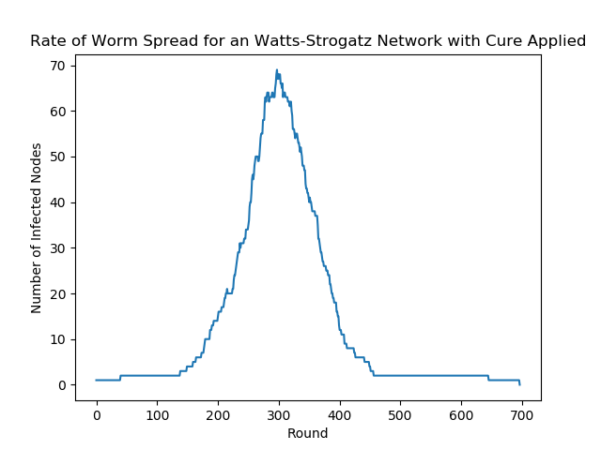
Average time (for max infection): 298.7
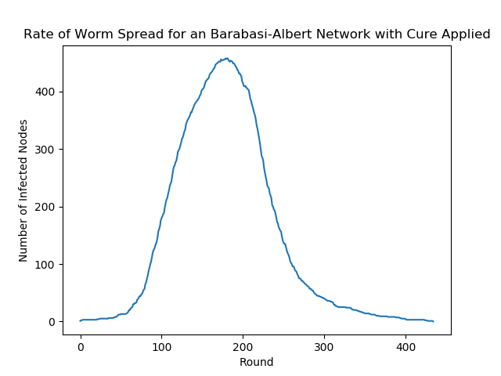
Average time (for max infection): 189.3

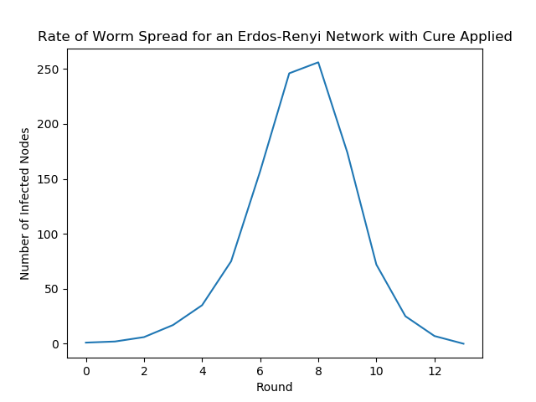
Average time (for max infection): 8.27

When a cure was not applied, the infected nodes increased gradually till the entire network was infected. The plot of the infection rate was an ‘S’ shaped graph. However, when a cure is applied, there are distinct changes. In all the networks, the defense mechanism seems to prevent the entire network from being taken over. In the case of Watts-Strogatz, the number of infected nodes reaches a ceiling of around 70, at round 298.7 and then decreases. The same happens for Barabasi-Albert, and Erdos-Renyi, where the maximum number of nodes infected are around 480 and 250, at round 189.3 and 8.27 respectively.

There is clearly a noticeable difference in the average time to infect the maximum number of nodes. In Watts-Strogatz, it takes 298.7 rounds just to infect around 70 nodes. However, 400+ nodes are infected in Barabasi-Albert, in just 189.3 rounds. Erdos-Renyi displays the least ability to resist the worms spread by having 250+ nodes infected in just 8.27 rounds. This behavior is quite similar to when no cure was applied. In any case, we can infer from these observations that, once again, even with the application of a cure, the average time taken to infect most of the nodes seem to follow the same order for each of the three networks, which would be:

Erdos-Renyi < Barabasi-Albert < Watts-Strogatz

Also, we can observe that, to fully finish inoculating the network, it takes an average of 698.6 rounds, in the case of Watts-Strogatz. For performing the same on the Barabasi-Albert network takes just a mean of 464.87 rounds. The process of inoculation happens the fastest in the Erdos-Renyi network, taking just 13.21 rounds to complete the entire process.

- Resilience Enhancement Strategies

We can infer from this experiment that, the type of network indeed does have an effect upon the behavior of the worm. We could observe that, an Erdos-Renyi network could be overwhelmed by a worm in very less time. On the other hand, a Watts-Strogatz seemed to be very resilient as it took a lot more time to completely engulf the network. Therefore, for networks to exhibit more resilience to network worms, we would need networks with low average path lengths, and higher clustering coefficients. The Watts-Strogatz network has certain nodes with a high degree value i.e. nodes with a high number of connections. These nodes are well connected with other nodes.

Due to this reason, selecting one of these ‘hub’ nodes as the initial point for the cure to spread from would provide more resilience to the network, since the defense mechanism, from this node, would be in a position to reach more nodes in the network faster. On the other hand, choosing a node which lies in the periphery may not have such a profound effect.

The following strategies could be considered:

1. Design the network such that the clustering coefficient is high. That is, there are plenty of nodes with a large number of connections with other nodes.
2. The network should also have a low average-path length.
3. The node from which the defense mechanism is activated should be a ‘hub’ node, that is, a node with a high degree of connections.

