STAT 512 – Assignment 6

Vignesh M. Pagadala
Vignesh.Pagadala@ColoState.Edu

1. A study was done to investigate the effectiveness of five methods for the irrigation of
blueberry shrubs. Ten farms were included in the study. Each of the five treatments was
evaluated at each of the ten farms (with irrigation treatments randomly assigned to plots).
The response variable is weight of the harvested fruit. The data is available from Canvas as “Irrigation.csv”. Note: Be sure to define Farm as.factor!

A. Calculate the sample size, simple mean and SE for each method (averaging over farms).
Include the resulting summary table in your assignment.
ANSWER:

# A tibble: 5 x 5
Method n mean sd se
<fct> <int> <dbl> <dbl> <dbl>
1 CenterPoint 10 464. 48.2 15.3
2 Lateral 10 498. 52.0 16.4
3 SubIrrigation 10 390. 52.7 16.7
4 Surface 10 616. 52.8 16.7

B. Create a bar chart (with SE bars) to summarize the data. Include the resulting graph in
your assignment. Assuming your summary table from above is called SumStats (with
columns Method, mean and se), you can use code something like this:
Library(ggplot2)
ggplot(SumStats, aes(x = Method, y = mean)) +
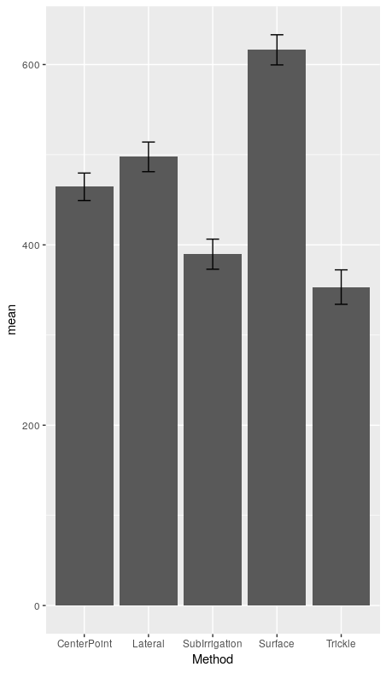
geom_bar(stat = "identity") + geom_errorbar(aes(ymin =
mean-se, ymax = mean+se), width = 0.2)
ANSWER:

C. Fit the RCB model. Inspect the diagnostic plots (Resids vs Fitted and Normal QQplot of Resids), and comment on what you see. Do the assumptions appear to be satisfied?
Note: You do not have to include the diagnostic plot in your assignment, just comment on
each graph. (4 pts)
ANSWER:

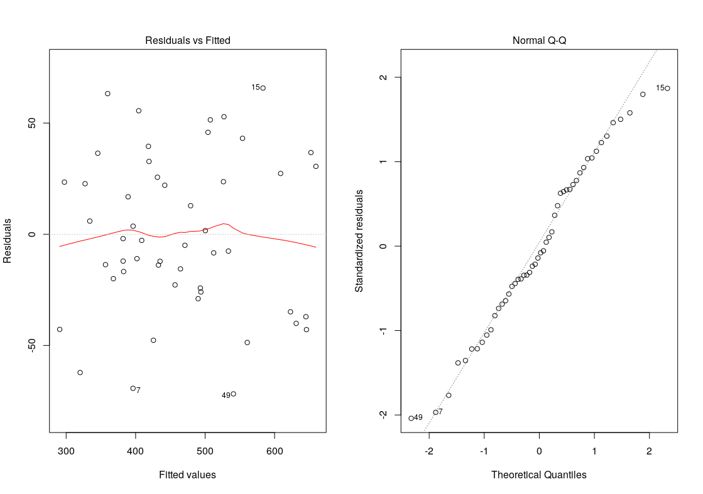
From the above plots, we can conclude that the assumptions are indeed satisfied. The Resid vs Fitted has around equal scatter, and the Q-Q plot is a clear straight line.

D. Continuing with the RCB model from the previous question, include the Type3 ANOVA
table in your assignment.
ANSWER:
Anova Table (Type III tests)

Response: Weight
Sum Sq Df F value Pr(>F)
(Intercept) 577042 1 335.7767 < 2.2e-16 ***
Method 421213 4 61.2751 1.434e-15 ***
Farm 66312 9 4.2874 0.0007685 ***
Residuals 61867 36
---
Signif. codes: 0 ‘***’ 0.001 ‘**’ 0.01 ‘*’ 0.05 ‘.’ 0.1 ‘ ’ 1

Analysis of Variance Table

Response: Weight
Df Sum Sq Mean Sq F value Pr(>F)
Method 4 421213 105303 61.2751 1.434e-15 ***
Farm 9 66312 7368 4.2874 0.0007685 ***
Residuals 36 61867 1719
---
Signif. codes: 0 ‘***’ 0.001 ‘**’ 0.01 ‘*’ 0.05 ‘.’ 0.1 ‘ ’ 1

E. Can we conclude that there is a difference between the irrigation methods? Justify your
response with a test statistic and p-value.
ANSWER:
Yes, we have a test statistic of 61.2751 and a very significant p-value.

F. Make a conclusion about the effectiveness of the blocking in this example. Justify your
response with a test statistic and p-value.
ANSWER:
Yes, the blocking was effective, since we have a p-value of 0.0007685 (significant) and test statistic 4.2874.

G. The investigators are interested in which irrigation methods are significantly different
from each other. Use emmeans() function from the emmeans package to get Tukey-
adjusted p-values for comparing treatments. Then use this information to create a “cld”
display, where methods that are NOT significantly different from each other are given the
same number grouping. Hint: Use code something like this:
library(emmeans)
library(multcompView)
emout <- emmeans(Model1, pairwise ~ Method)
emout
cld(emout)
ANSWER:

$emmeans
Method emmean SE df lower.CL upper.CL
CenterPoint 464 13.1 36 438 491
Lateral 498 13.1 36 471 524
SubIrrigation 390 13.1 36 363 416
Surface 616 13.1 36 590 643
Trickle 353 13.1 36 327 380

Results are averaged over the levels of: Farm
Confidence level used: 0.95

$contrasts
contrast estimate SE df t.ratio p.value
CenterPoint - Lateral -33.2 18.5 36 -1.791 0.3944
CenterPoint - SubIrrigation 74.7 18.5 36 4.029 0.0024
CenterPoint - Surface -151.9 18.5 36 -8.193 <.0001
CenterPoint - Trickle 111.2 18.5 36 5.998 <.0001
Lateral - SubIrrigation 107.9 18.5 36 5.820 <.0001
Lateral - Surface -118.7 18.5 36 -6.403 <.0001
Lateral - Trickle 144.4 18.5 36 7.789 <.0001
SubIrrigation - Surface -226.6 18.5 36 -12.223 <.0001
SubIrrigation - Trickle 36.5 18.5 36 1.969 0.3014
Surface - Trickle 263.1 18.5 36 14.191 <.0001

Results are averaged over the levels of: Farm
P value adjustment: tukey method for comparing a family of 5 estimates

Method emmean SE df lower.CL upper.CL .group
Trickle 353 13.1 36 327 380 1
SubIrrigation 390 13.1 36 363 416 1
CenterPoint 464 13.1 36 438 491 2
Lateral 498 13.1 36 471 524 2
Surface 616 13.1 36 590 643 3

Results are averaged over the levels of: Farm
Confidence level used: 0.95
P value adjustment: tukey method for comparing a family of 5 estimates
significance level used: alpha = 0.05

H. Are the simple means (part A) and emmeans (part G) the same for this analysis? What
about the simple SE’s (part A) versus SE’s returned by emmeans (part G)?
ANSWER:
Yes they are the same. The simple SEs and the SEs returned by emmeans are not the same.

I. Run the analysis as a one-way ANOVA using just Method in the model. (In practice I
would not do this, but try it here for illustration.) Include the ANOVA table in your
assignment. How does dfResid compare to the RCB model? How does MSResid
compare to the RCB model? (4 pts) Hint: Recall that MSResid = SSResid/dfResid.
ANSWER:

Analysis of Variance Table

Response: Weight
Df Sum Sq Mean Sq F value Pr(>F)
Method 4 421213 105303 36.969 1.096e-13 ***
Residuals 45 128179 2848
---
Signif. codes: 0 ‘***’ 0.001 ‘**’ 0.01 ‘*’ 0.05 ‘.’ 0.1 ‘ ’ 1

Both DFResid and MSResid are higher compared to the RCB model.

2.
A fertilizer trial on a range grass (blue grama) was conducted in a randomized complete
block design. Five fertilizer treatments were randomly assigned to the plots in each of five
blocks, but two observations have missing values. The response variable (Y) represents
phosphorous. The data is available from Canvas as “GrassMiss.csv”. Note: Be sure to
define Block as.factor!

A. Calculate the simple mean for each trt (averaging over blocks). Include the resulting
summary table in your assignment. Hint: Because of the NA values, it is easiest to use
aggregate() here.
ANSWER:
Trt Y
1 Ctrl 2.0450
2 N100 1.8780
3 N100wP 2.3340
4 N50 2.0420
5 N50wP 2.4525

B. Fit the RCB model and include the Type3 ANOVA table in your assignment.
ANSWER:
Anova Table (Type III tests)

Response: Y
Sum Sq Df F value Pr(>F)
(Intercept) 10.1078 1 1566.5568 8.996e-16 ***
Trt 0.9651 4 37.3924 2.490e-07 ***
Block 0.0333 4 1.2911 0.3204
Residuals 0.0903 14
---
Signif. codes: 0 ‘***’ 0.001 ‘**’ 0.01 ‘*’ 0.05 ‘.’ 0.1 ‘ ’ 1

C. Calculate the emmeans and corresponding confidence intervals for each trt and include
them in your assignment. Note that the SE is larger (and CIs are wider) for trts that have
missing values.
ANSWER:
Trt emmean SE df lower.CL upper.CL
Ctrl 2.053647 0.04117405 14 1.965337 2.141957
N100 1.878000 0.03592289 14 1.800953 1.955047
N100wP 2.334000 0.03592289 14 2.256953 2.411047
N50 2.042000 0.03592289 14 1.964953 2.119047
N50wP 2.447647 0.04117405 14 2.359338 2.535957

Results are averaged over the levels of: Block
Confidence level used: 0.95

D. Are the simple means (part A) and emmeans (part C) the same for this analysis?
ANSWER:
No the simple and emmeans are not the same.

E. Use the coefficient estimates (from the summary() output) to compute predicted values
for the two missing observations. Show your work for full credit. (Note that you can
verify these using the predict() function.) (4 pts)
ANSWER:

Block 3, N50wP:
2.02059 + 0.394 + 0.01365 = 2.428

Block 5, Ctrl:
2.02059 + 0 + 0.06765 = 2.0882

F. Verify that the lsmean for N50wP is the average of the five predicted values (one from
each block) for N50wP. Show your work for full credit.
ANSWER:

For N50wP:
(2.414588 + 2.410588 + 2.428235 + 2.502588 + 2.482235)/5 = 2.4476, which is the same value as the computed lsmean.

