STAT 512 – Assignment 8

Vignesh M. Pagadala
Vignesh.Pagadala@ColoState.Edu

1. Create two-way interaction plots separately for each plant type (Grass/Forb). (4 pts) This can
be done by first calculating treatment means (using aggregate or dplyr), then using code
something like this:
library(ggplot2) qplot(x = Herb, y = Biomass, colour = Water, group = Water, data = SumStats) + geom_line() + facet_grid(. ~ Type)
ANSWER:

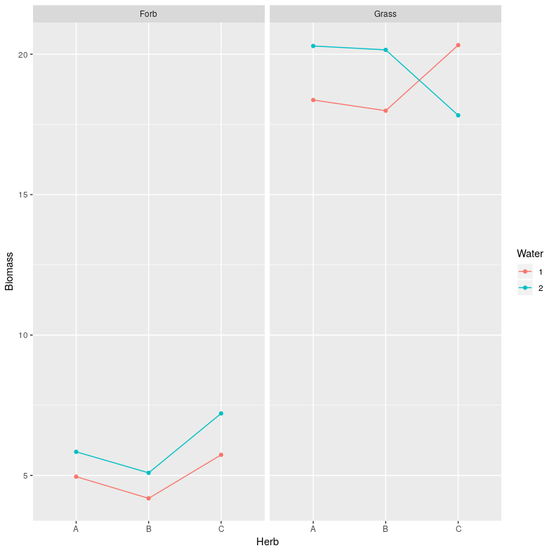

2. Fit the three-way model with all interactions. Include the Type 3 ANOVA table in your
assignment. You should find evidence of a 3 way interaction.
ANSWER:
Anova Table (Type III tests)

Response: Biomass
Sum Sq Df F value Pr(>F)
(Intercept) 5473.8 1 5539.1323 < 2.2e-16 ***
Type 1678.7 1 1698.7721 < 2.2e-16 ***
Herb 5.1 2 2.5644 0.097872 .
Water 5.9 1 5.9711 0.022271 *
Type:Herb 5.4 2 2.7185 0.086259 .
Type:Water 0.7 1 0.7092 0.408021
Herb:Water 7.9 2 3.9973 0.031742 *
Type:Herb:Water 13.1 2 6.6440 0.005055 **
Residuals 23.7 24
---
Signif. codes: 0 ‘***’ 0.001 ‘**’ 0.01 ‘*’ 0.05 ‘.’ 0.1 ‘ ’ 1
3. Consider the diagnostics plots and discuss whether model assumptions are satisfied.
ANSWER:

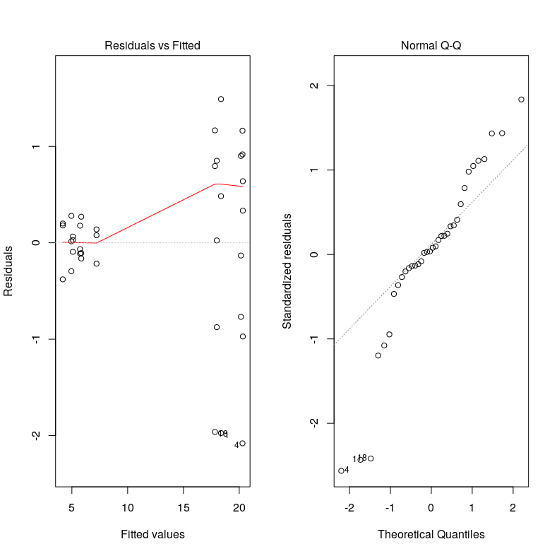

The Resid vs Fitted plot does not look good, as there is unequal scatter. So the model assumptions may not be satisfied.

4. Use emmeans to calculate pairwise comparisons of Water (1 vs 2) for each level of Herb and
Type. You can use code something like this:
emmeans(Model1, pairwise ~ Water|Herb*Type)
ANSWER:

Herb = A, Type = Forb:
contrast estimate SE df t.ratio p.value
1 - 2 -0.885 0.812 24 -1.090 0.2865

Herb = B, Type = Forb:
contrast estimate SE df t.ratio p.value
1 - 2 -0.908 0.812 24 -1.119 0.2741

Herb = C, Type = Forb:
contrast estimate SE df t.ratio p.value
1 - 2 -1.473 0.812 24 -1.815 0.0821

Herb = A, Type = Grass:
contrast estimate SE df t.ratio p.value
1 - 2 -1.924 0.812 24 -2.371 0.0261

Herb = B, Type = Grass:
contrast estimate SE df t.ratio p.value
1 - 2 -2.167 0.812 24 -2.669 0.0134

Herb = C, Type = Grass:
contrast estimate SE df t.ratio p.value
1 - 2 2.499 0.812 24 3.079 0.0051

5. Include the Type 3 ANOVA table in your assignment.
ANSWER:

Anova Table (Type III tests)

Response: Biomass
Sum Sq Df F value Pr(>F)
(Intercept) 544.92 1 10432.1562 < 2.2e-16 ***
Herb 10.17 2 97.3895 3.820e-08 ***
Water 5.33 1 102.1229 3.197e-07 ***
Herb:Water 0.33 2 3.1846 0.07772 .
Residuals 0.63 12
---
Signif. codes: 0 ‘***’ 0.001 ‘**’ 0.01 ‘*’ 0.05 ‘.’ 0.1 ‘ ’ 1

6. Consider the diagnostics plots and discuss whether model assumptions are satisfied.
ANSWER:
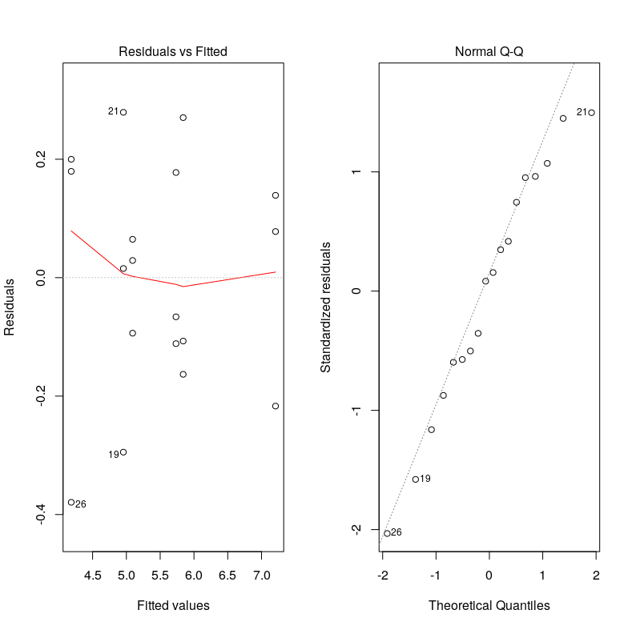

The scatter seems okay in the Resid vs Fitted plot. The Q-Q plot looks good too. These plot are better than the earlier ones.

7. Use emmeans to calculate pairwise comparisons of Water (1 vs 2) for each level of Herb.
ANSWER:
$emmeans
Herb = A:
Water emmean SE df lower.CL upper.CL
1 4.96 0.132 12 4.67 5.24
2 5.84 0.132 12 5.55 6.13

Herb = B:
Water emmean SE df lower.CL upper.CL
1 4.18 0.132 12 3.90 4.47
2 5.09 0.132 12 4.80 5.38

Herb = C:
Water emmean SE df lower.CL upper.CL
1 5.73 0.132 12 5.45 6.02
2 7.21 0.132 12 6.92 7.49

Confidence level used: 0.95

$contrasts
Herb = A:
contrast estimate SE df t.ratio p.value
1 - 2 -0.885 0.187 12 -4.742 0.0005

Herb = B:
contrast estimate SE df t.ratio p.value
1 - 2 -0.908 0.187 12 -4.868 0.0004

Herb = C:
contrast estimate SE df t.ratio p.value
1 - 2 -1.473 0.187 12 -7.894 <.0001

8. Calculate the LSD value (ME for difference between means) corresponding to the comparisons
from the previous question. Show your work for full credit. Hint: See ExpDesign2 slide 81.
Recall that you can check your calculation using the SE value given in the output from the
previous question.
ANSWER:

> qt(0.975, df = 12)*sqrt(2*(0.63/12)/3)
[1] 0.4076186

9. Use emmeans to calculate the comparison of Water (1 vs 2) averaging over the levels of Herb.
ANSWER:

> emout3$contrasts
contrast estimate SE df t.ratio p.value
1 - 2 -1.09 0.108 12 -10.106 <.0001

Results are averaged over the levels of: Herb

10. Calculate the LSD value (ME for difference between means) corresponding to the comparisons from the previous question. Show your work for full credit. See hints from #8.
ANSWER:

qt(0.975, df = 12)*sqrt(2*(0.63/12)/9)
[1] 0.2353387

11. Comparing your LSD values from questions #8 (interaction comparison) and #10 (main effect
comparison), which comparison has higher power? Briefly discuss.
ANSWER:
The LSD value for the Main Effect comparison is lesser, hence, the power is higher for the main effect comparison than the interaction comparison.

12. Include the Type 3 ANOVA table in your assignment.
ANSWER:
Anova Table (Type III tests)

Response: Biomass
Sum Sq Df F value Pr(>F)
(Intercept) 6607.6 1 3433.9972 4.029e-16 ***
Herb 0.3 2 0.0694 0.9333
Water 1.3 1 0.6586 0.4329
Herb:Water 20.7 2 5.3786 0.0215 *
Residuals 23.1 12
---
Signif. codes: 0 ‘***’ 0.001 ‘**’ 0.01 ‘*’ 0.05 ‘.’ 0.1 ‘ ’ 1

13. Consider the diagnostics plots and discuss whether model assumptions are satisfied.
ANSWER:
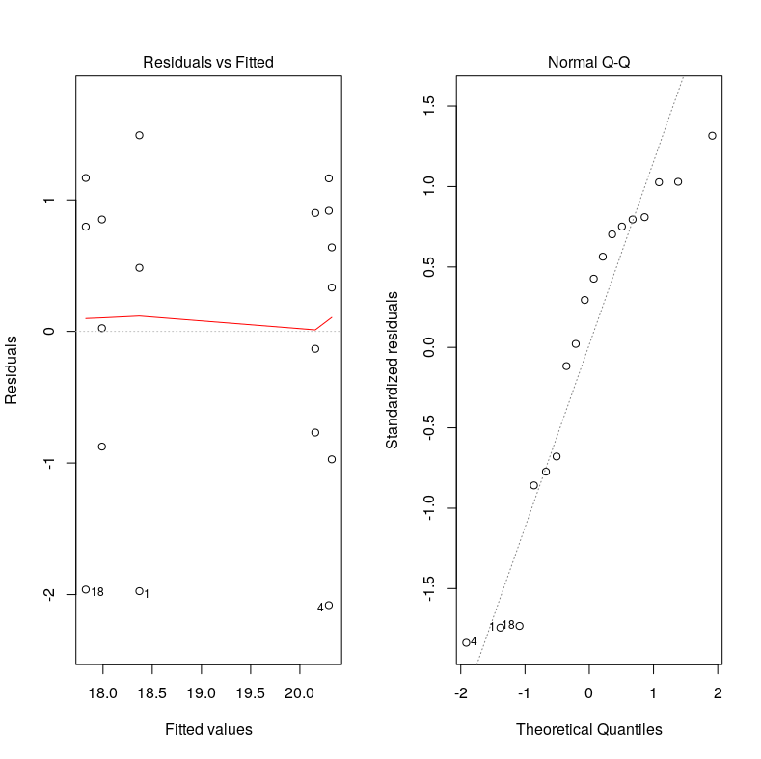

From the plots, the scatter seems more or less equal in the Resid vs Fitted plot, and the Q-Q plot looks good as well indicating a good chance that the model assumptions are satisfied.

14. Use emmeans to calculate pairwise comparisons of Water (1 vs 2) for each level of Herb.
ANSWER:

Herb = A:
contrast estimate SE df t.ratio p.value
1 - 2 -1.92 1.13 12 -1.699 0.1150

Herb = B:
contrast estimate SE df t.ratio p.value
1 - 2 -2.17 1.13 12 -1.913 0.0799

Herb = C:
contrast estimate SE df t.ratio p.value
1 - 2 2.50 1.13 12 2.207 0.0476

15. Would it be appropriate to calculate the comparison of Water (1 vs 2) averaging over the levels of Herb? Briefly discuss.
ANSWER:

No. Because, there is significant interaction between Water and Herb.

16. The comparisons from #7 and #14 were also considered in #4. Considering the corresponding
results from the combined analysis (#4) versus the split analysis (#7, #14), briefly discuss what is
the same and what is different. Specifically, consider the estimated difference, corresponding SE
and df. (4 pts)
ANSWER:
From the results, we can see that the estimated difference is the same, but the SE and DF are quite different.

17. Give (at least) one reason why we might prefer to split the analysis by Type (running separate
2way ANOVAs for Grass and Forb). Your answer should be based on the output.
ANSWER:
From looking at the Resid vs Fitted and Q-Q plot for the analysis where we do not split by Type, the model assumptions are clearly not satisfied. But when we do the splitting, the assumptions are satisfied.

18. Give (at least) one weakness of splitting the analysis “by type” as compared to the full 3way
ANOVA model.
ANSWER:
By splitting the analysis by Type, we are unable to observe and analyze the behavior of Forb against Grass, which could be quite useful.

