|  |  |
| --- | --- |
| **NAME** | **VIGNESH SARAN T** |
| **NM ID** | **A93D463B6018B34AB164E3FDB1B0A993** |
| **COLLEGE NAME** | **SARANATHAN COLLEGE OF ENGINEERING** |
| **PROJECT TITLE** | **How to Create a Google Ads Campaign for your brand** |
| **CATEGORY** | **DIGITAL MARKETING** |
| **DEPARTMENT** | **ELECTRONICS AND COMMUNICATION ENGINEERING** |

**Email:** [**vigsaraclothing@gmail.com**](mailto:vigsaraclothing@gmail.com)

**DOCUMENTATION:**

**Sample product for Google Ads:**

**Brand website:** [**https://vigsara.blogspot.com/**](https://vigsara.blogspot.com/)

**Brand Name: Vigsara Clothing**

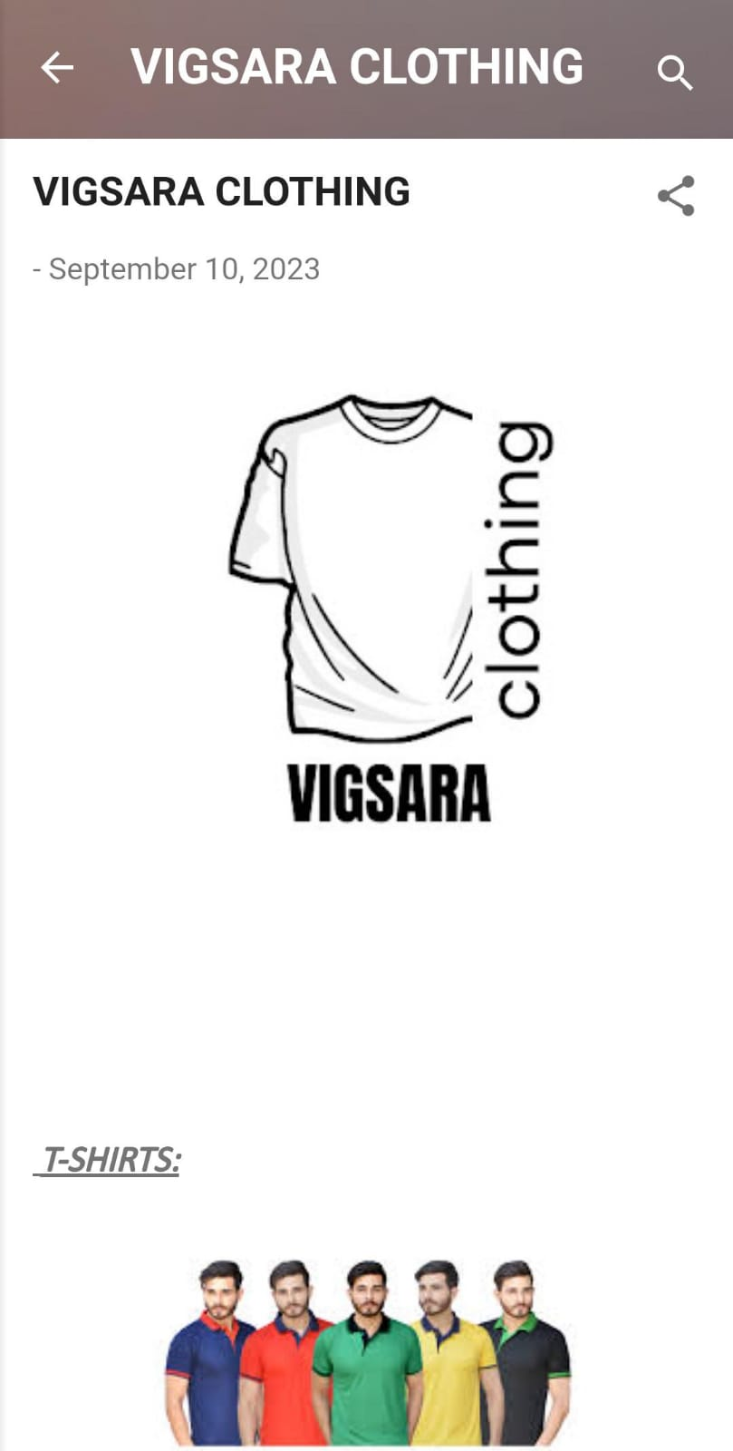

**Google Ads Campaign:**

**Navigation:**

[**https://ads.google.com/**](https://ads.google.com/)

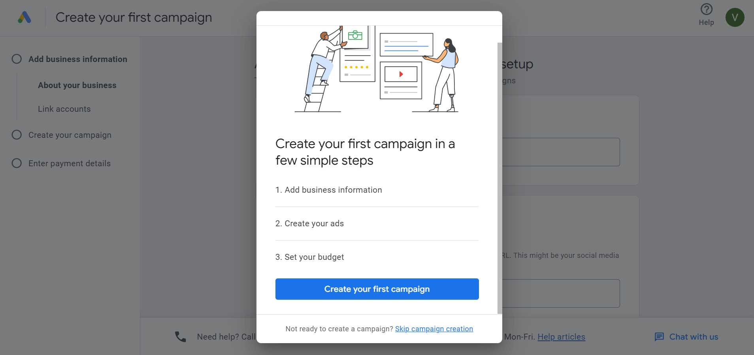

**Add business information:**

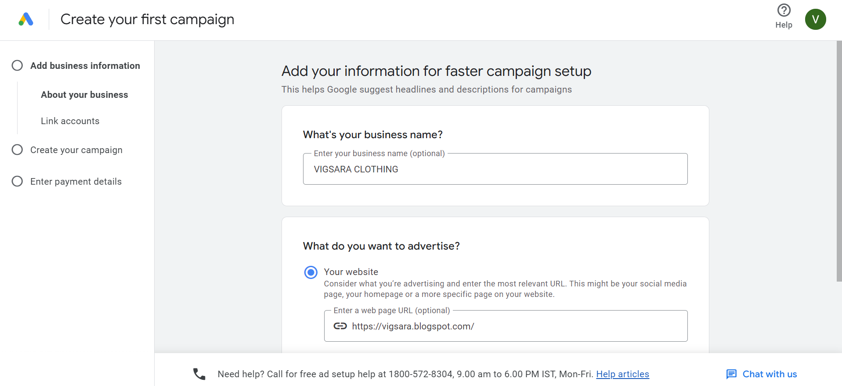

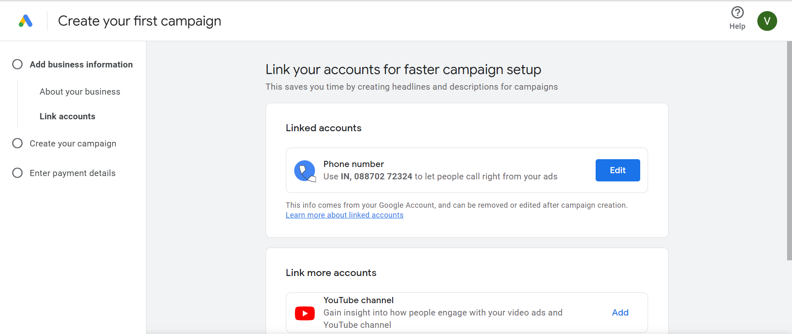

**Create your campaign:**

**Campaign goal: page views**

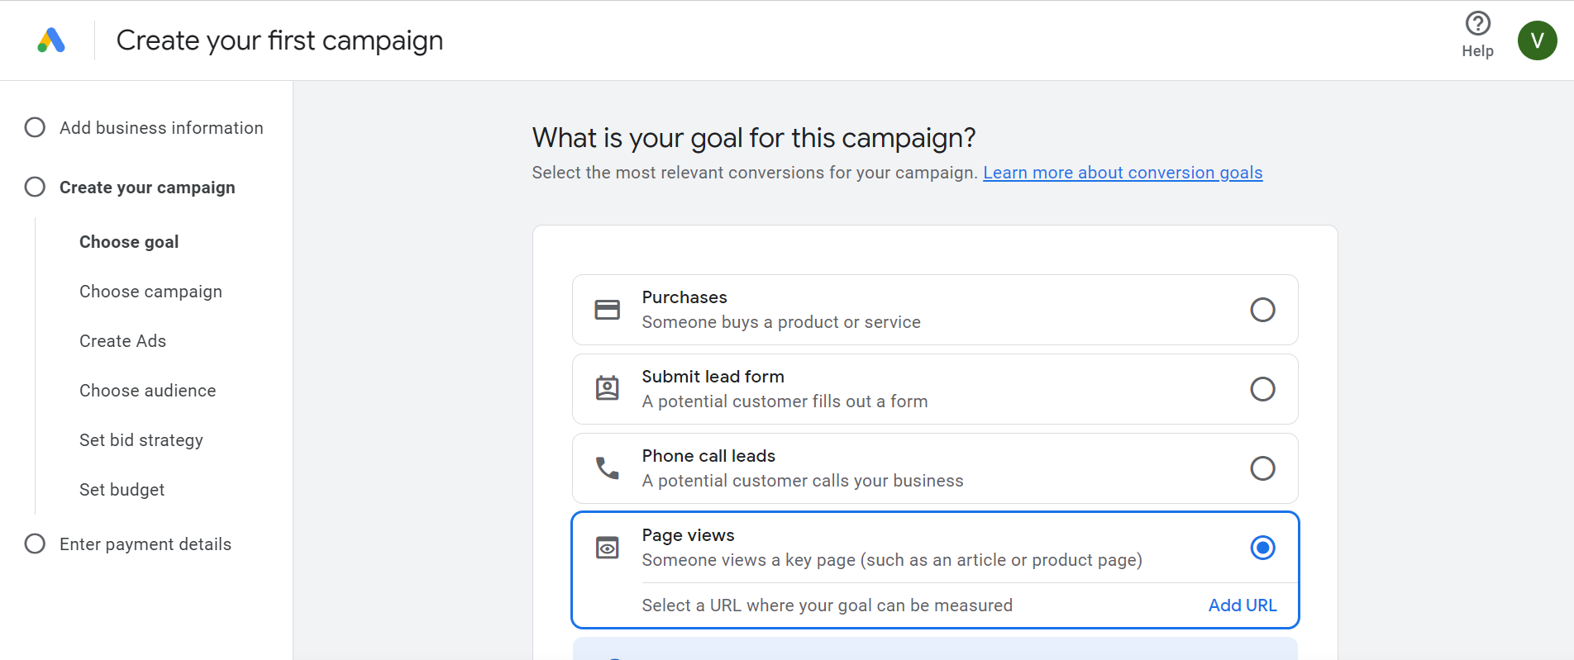

**Campaign type: Performance max**

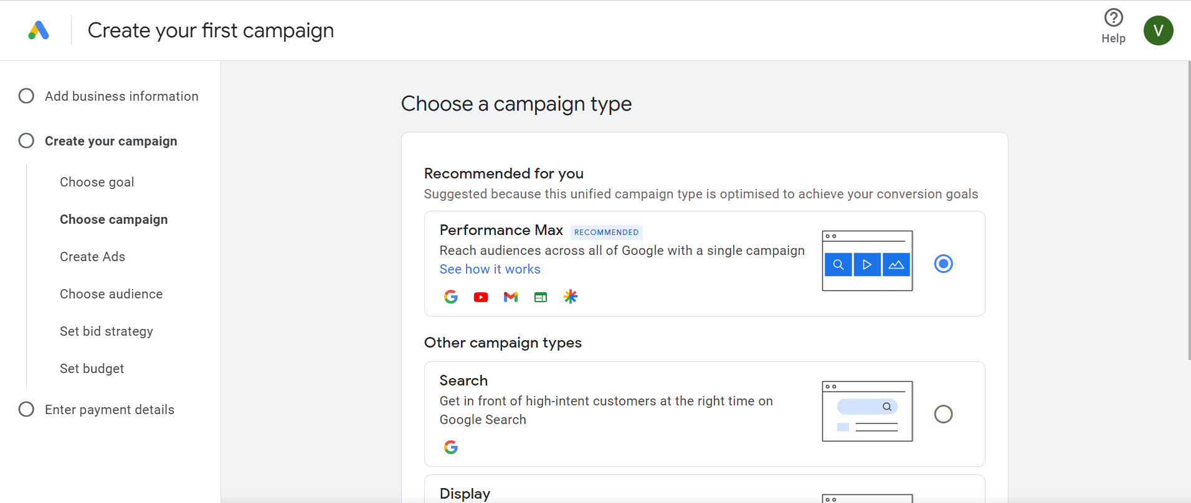

**Create ads:**

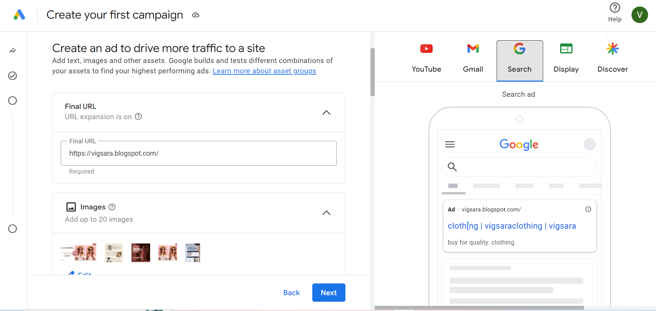

**Create ads: Google ad in You tube**

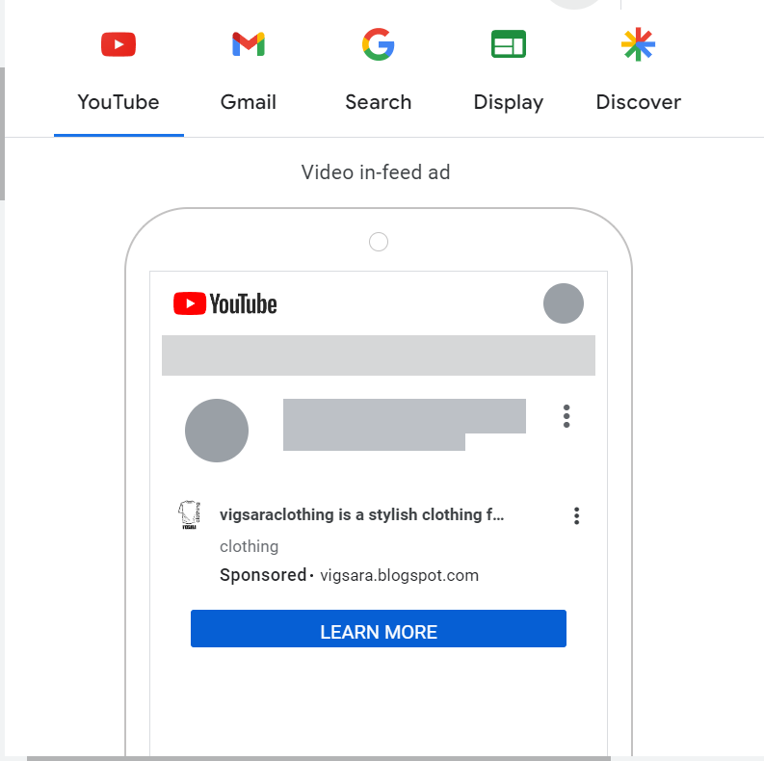

**Create ads: Google ad in Gmail**

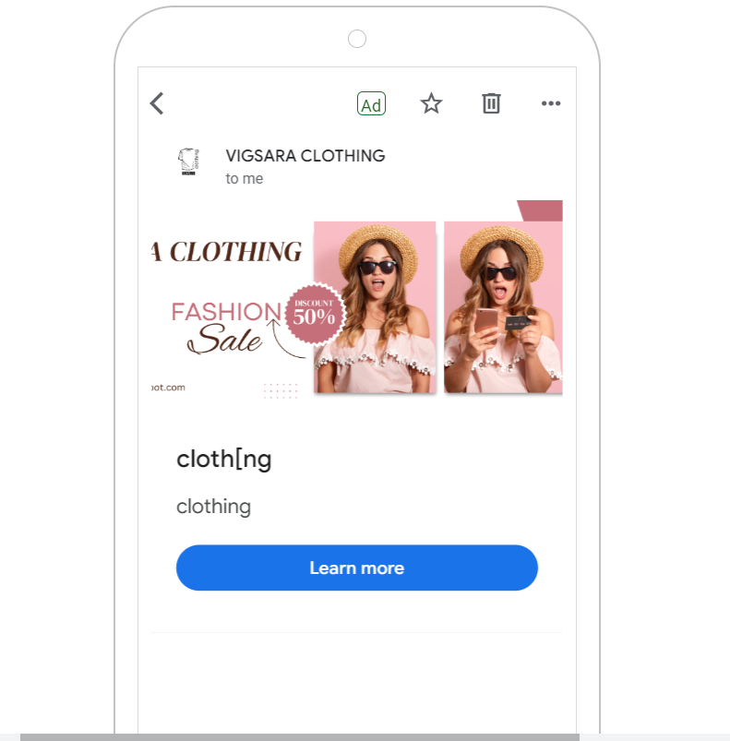

**Create ads: Google ad in Google Search**

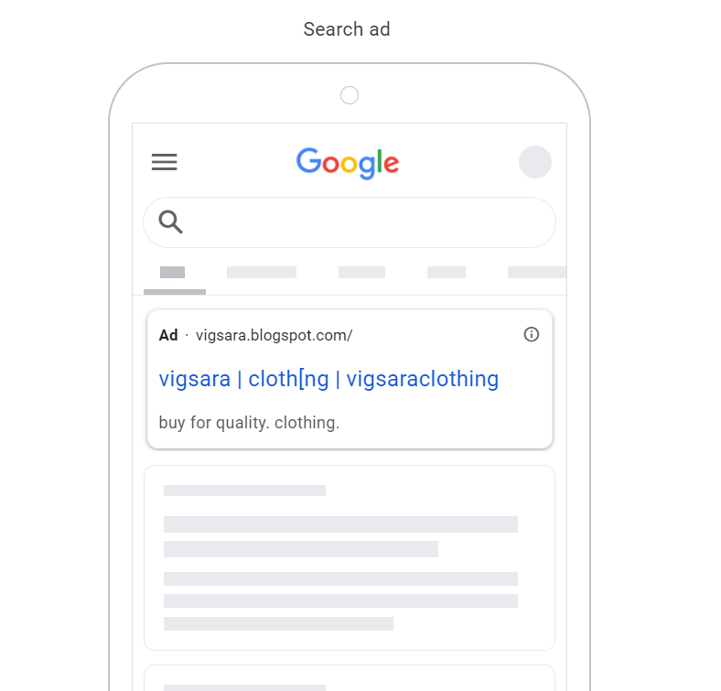

**Signals Selection: Adding Keyword**

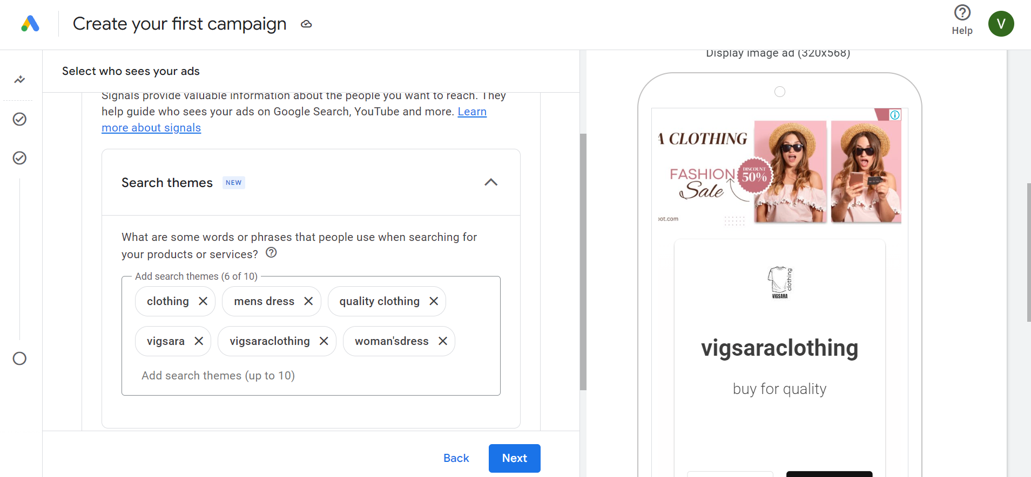

**Images and logo:**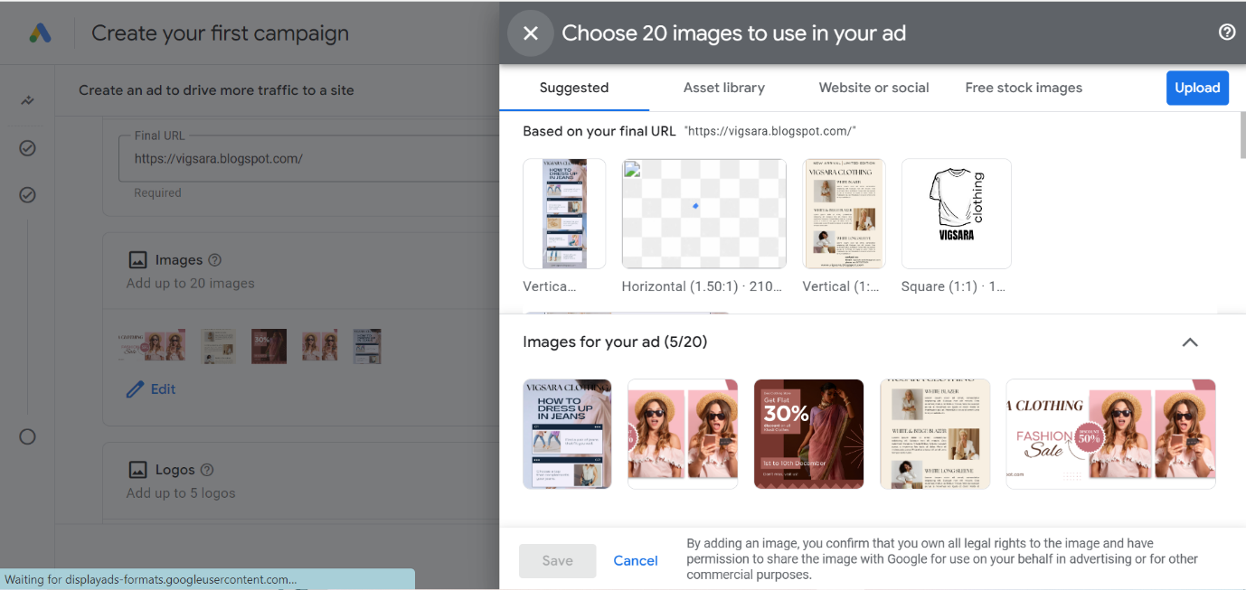

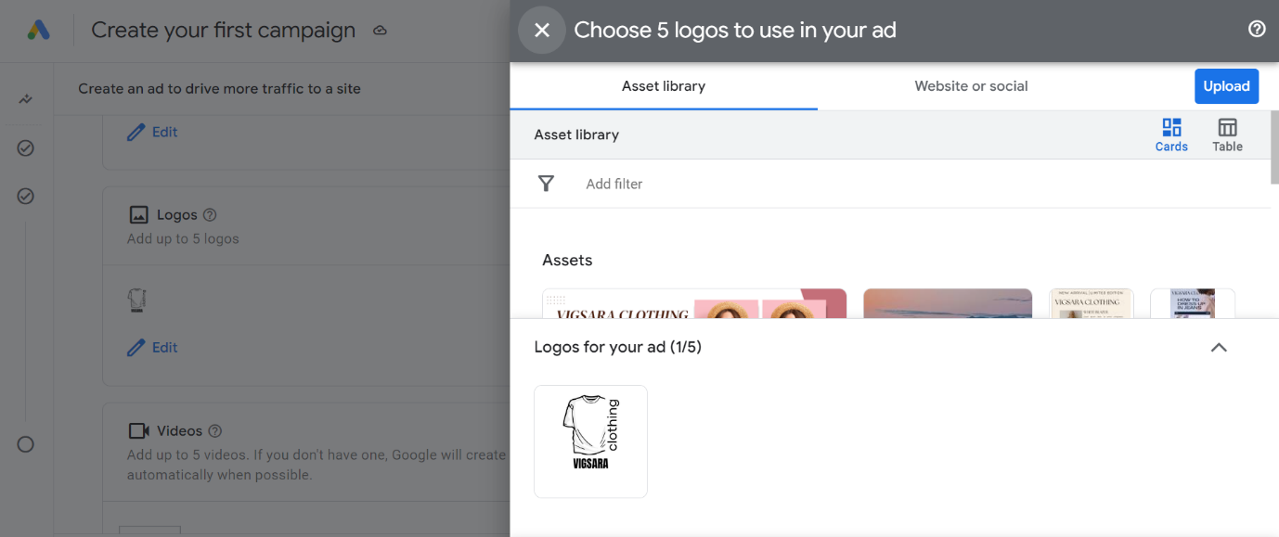

**Location and Languages:**

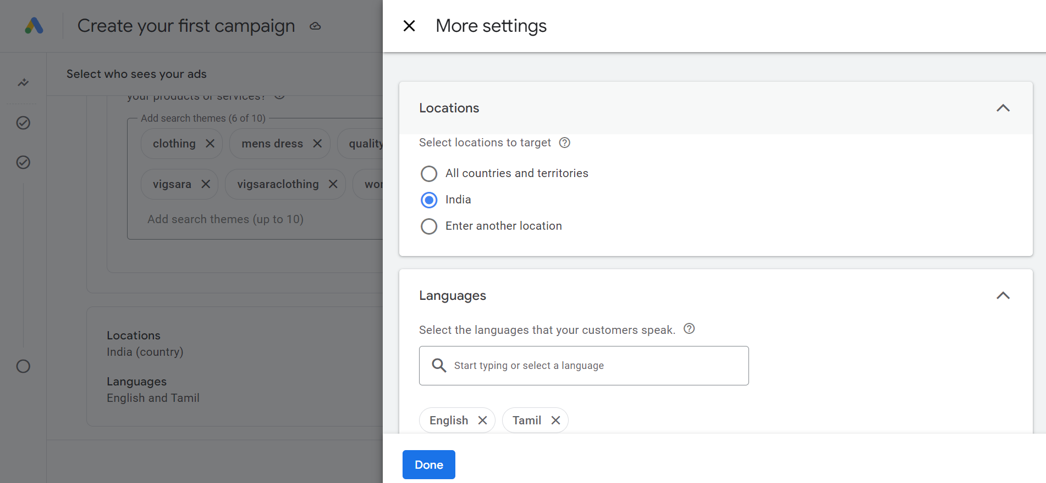

**Set bid strategy:** **Conversion value**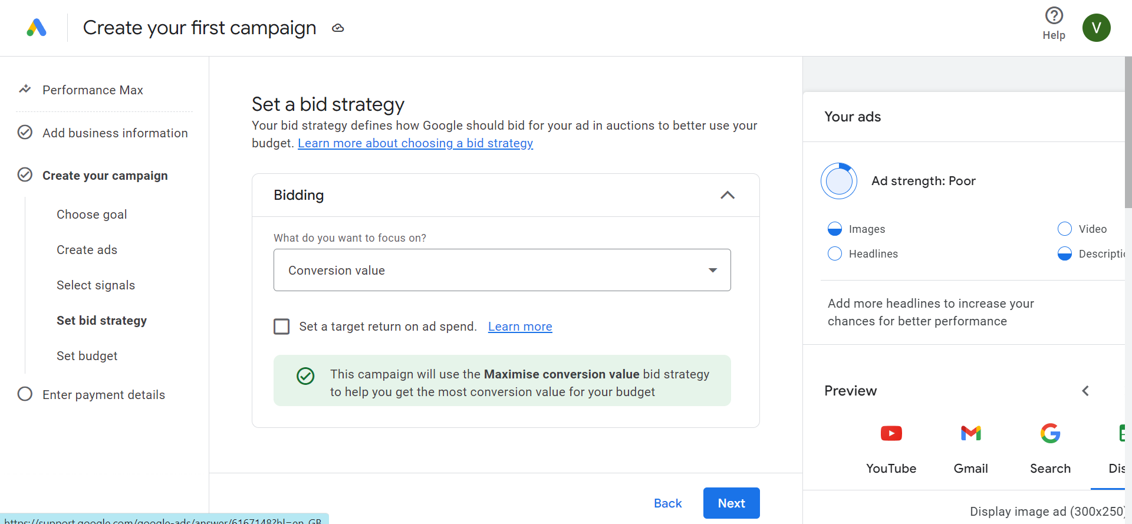

**Set budget:**

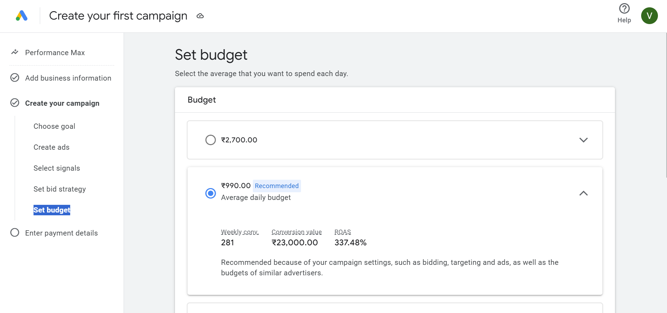

**Demo Link :**

[**https://youtu.be/Fx6mBIpMbDE**](https://youtu.be/Fx6mBIpMbDE)