**Goal:**

To calculate the ‘co-medication rate’ of two drugs, Insulin (In) and Byetta (By). Co-medication means patient taking both drugs at the same time.

**Data:**

We are given a list of patientID's, dates, and drug purchases. See diagram below.

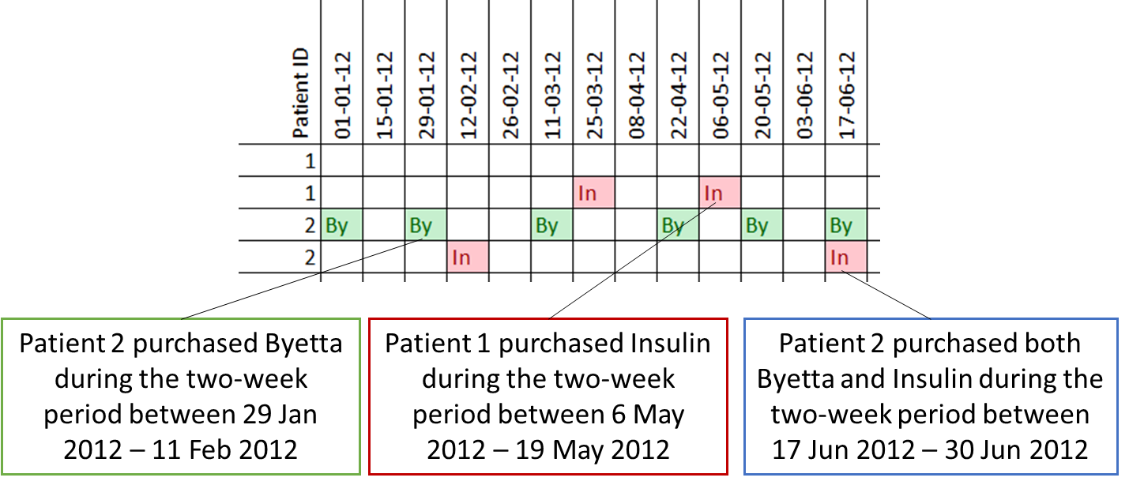

**Assumptions:**

* Each date represents the two-week period in which the purchase took place. We do not know the exact date of purchase.
* Insulin lasts for approximately **90 days** for each purchase.
* Byetta lasts for approximately **30 days** for each purchase.

**Tasks:**

1. Design an algorithm to calculate co-medication rate (assume all records must be used in this algorithm)
   1. What is your definition of co-medication rate?

Number of instances of consuming both the drugs over the treatment period

i.e. Co-Medication rate = (#both drug days count/total treatment days)

My assumptions:

1. If the drug is available for the patient based on purchase time point, then it is assumed to be consumed.

2. Each day one unit of drug consumed every day from the date of purchase until they run out.

* 1. How do you calculate this co-medication rate based on your definition? Please provide one of the following:
     1. Code design flow chart or diagram
     2. Pseudo code (please check excel detailed solution)
        1. Import data into tabular form
        2. Pivot the table to create patient ID wise + datewise vertical table with Byetta and Insulin purchase as its own column heads (as mentioned in the excel)
        3. Since each time point is fortnightly, assign
           1. “By”= 2 (30days= approx. 2 fortnight time points)
           2. “In”=6 (90days= approx. 2 fortnight time points)

This will convert By and In purchase data columns into numericals. And make the empty values 0.

* + - 1. Create availability data by Looping through columns to cumulatively express the available counts of each drug per day per patient.
      2. Create co-medication column by looking for drug availability across both the drugs.
      3. Perform patient wise and date wise summary tables to find respective average co-medication rate
    1. Actual code in R, python, or SAS
    2. Excel file

Please check the excel file attached named ‘co-medication rate’

1. How would you visualize the results of your measurement?
   1. What charts or graphs would be useful?
      1. Time series line plot showing the trend of co-medication across time. This can help to understand if the co-medication rate varies over treatment time if so which period of treatment is most/less likely to occur.
      2. Histogram plot with co-medication rate across patients can help the understand the magnitude and frequency of co-medication.
      3. Time series unstacked area plot for magnitude of availability of each drugs providing visual representation of overlapping areas which corresponds to co-medication rate.
2. How can your algorithm or definition be improved?
   1. What real life patient behavior need to be catered for?
   2. What are the potential issues from this data set?
   3. If you could exclude certain records from your definition or algorithm, what kind of records would be excluded? Why?
   4. Do you believe you are over-estimating or under-estimating co-medication rate? Why?