**COVID – 19**

**VACCINE**

**DATA ANALYSIS**

**PROJECT**

abstract

This project is all about carefully looking at information about Covid-19 vaccines. We're mainly interested in how well the vaccines work, how they are distributed, and if there are any negative effects. The big goal is to find useful insights that can help leaders and health groups make better plans for giving out vaccines. To do this, we go through steps like collecting data, cleaning it up, exploring what it tells us, doing some math to understand it better, and making visuals to explain it clearly. The hope is that by doing this, we can give a good picture of how the vaccines are doing and help in the fight against Covid-19.

objective

The project aims to thoroughly analyze Covid-19 vaccine data with key objectives: evaluating vaccine efficacy, scrutinizing distribution strategies, investigating adverse effects, and providing actionable insights. By achieving these goals, the project seeks to enhance decision-making for policymakers and health organizations, fostering optimized deployment strategies in the ongoing battle against the Covid-19 pandemic.

Design & thinking

* Data Collection
* Data Preprocesing
* Exploratory Data Analysis(EDA)
* Statistical Analysis
* Virtualization
* Insights and Recommendation

Data collection

* The dataset used for the covid-19 vaccine analysis project is a csv file with 15 columns representing country,ISO code,Date,total vaccination , people vaccinated, people fully vaccinated, daily vaccinated raw, daily vaccination,total vaccinations per 100,people vaccinated per 100, people fully vaccinated per 100, daily vaccinations per million, vaccines, source name,source website
* Identify reputable sources such as health organizations (e.g., WHO, CDC), government agencies, and trusted research studies to ensure the accuracy and reliability of the data.
* Explore public health databases for comprehensive datasets related to

Covid-19 vaccines. Prioritize sources that provide detailed and up-to-date

* Establish contact with health departments at various levels (local, regional, national) to obtain detailed and granular data on vaccination campaigns, distribution strategies, and adverse reaction reports.

Data preprocessing

* Implement strategies to handle missing values, such as imputation techniques or, if necessary, consult domain experts to determine appropriate approaches for filling missing data.
* Utilize statistical methods to identify and manage outliers. Decide whether outliers should be corrected, removed, or retained based on their impact on the analysis.
* Ensure consistency in data formats by standardizing units, date formats, and any other variables that may have diverse representations across the dataset.
* Develop procedures to identify and handle any duplicate entries in the dataset, ensuring that each data point is unique and contributes meaningfully of the analysis

Exploratory data analysis

* Identify key variables for exploration, focusing on aspects such as vaccine efficacy rates, distribution patterns, adverse reaction frequencies, and demographic characteristics.
* Generate statistical summaries (mean, median, standard deviation, etc.) for numerical variables and frequency distributions for categorical variables. Complement these summaries with visualizations such as histograms, bar charts, and pie charts for a comprehensive overview.
* Analyze temporal trends in vaccine distribution and adverse reactions. Use time series plots and trend analyses to identify patterns and potential seasonality.
* Use exploratory techniques to identify potential outliers or anomalies in the data.
* 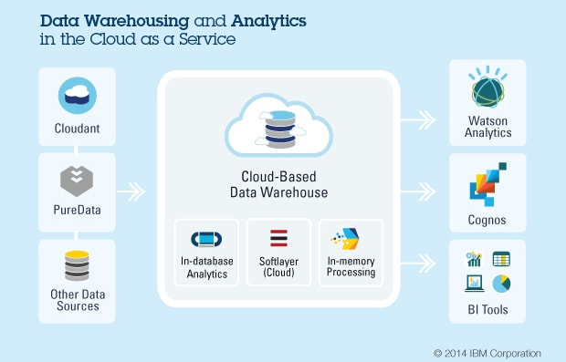

Statistical analysis

* Use exploratory techniques to identify potential outliers or anomalies in the data. Employ box plots and scatter plots, particularly useful in detecting data points that deviate significantly from the norm
* Formulate clear hypotheses related to vaccine efficacy, distribution, and adverse effects. Define null and alternative hypotheses to guide the statistical analyses.
* Conduct comparative analyses to compare vaccine efficacy rates between different groups (e.g., age groups, regions) using appropriate statistical tests (t-tests, ANOVA, etc.).
* Investigate relationships between variables using correlation analyses. Perform regression analyses to model and predict factors influencing vaccine efficacy, distribution, or adverse effects.
* Calculate descriptive statistics (mean, median, standard deviation, etc.) for key variables.

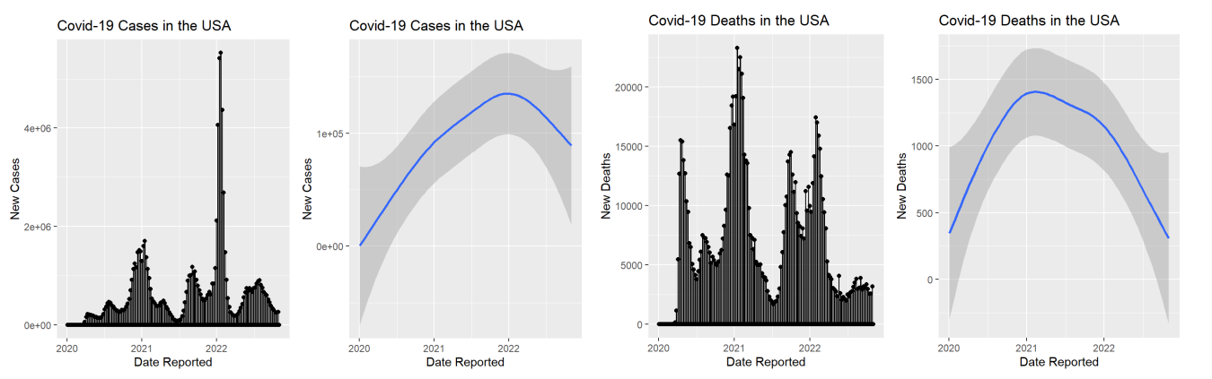

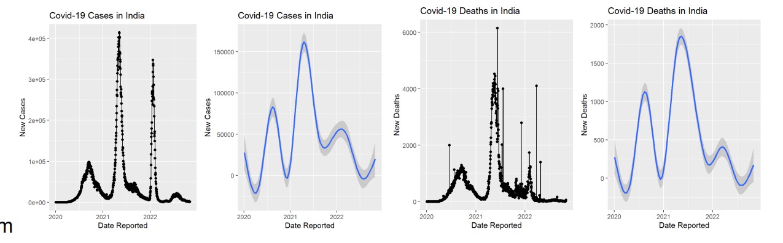

visualization

* Data Exploration Visualization:

Line charts, histograms, pie charts for basic trends and distributions.

* Vaccine Efficacy Visualizations:

Bar charts, line charts, heatmaps for variations across vaccine types, age groups, or regions.

* Distribution Pattern Visualizations:

Time series plots, stacked area charts, animated maps for temporal trends and geographic variations.

* Adverse Effects Representation:

Bar charts, donut charts, treemaps for clear representation of adverse reaction profiles.

Insights & Recommendation

* Summarize key findings from statistical analyses, exploratory data analysis (EDA), and visualizations. Highlight significant trends, patterns, and correlations.
* Identify key factors influencing vaccine efficacy, distribution, and adverse effects. Consider demographic factors, regional variations, and temporal trends.
* Understand the implications of the identified patterns and trends. Evaluate how vaccine efficacy, distribution, and adverse effects impact overall public
* Derive insights from comparative analyses, such as differences in vaccine efficacy rates between age groups or regions. Understand the implications of these variations.

# conclusion

In this dataset we came to know that the vaccination process in every country was going in good pace that indicates we can have control of this disease very soon all over the world