Task 3: SD Card Data Logger (Temperature + Light)
Timestamped CSV Logging with Optional RTC

1. Objective
Sample a temperature sensor (LM35) and a light sensor (LDR voltage divider) at a fixed interval, timestamp each reading (using a DS3231 RTC if available, or elapsed time otherwise), and append the readings as CSV rows to a file on an SD card for later analysis.

2. Components Used
- Arduino UNO
- SD card module (SPI)
- DS3231 RTC module (optional - for real-world timestamps)
- LM35 analog temperature sensor
- LDR (light-dependent resistor) + 10kΩ resistor (voltage divider)
- MicroSD card (formatted FAT16/FAT32), breadboard, jumper wires

3. Wiring Diagram
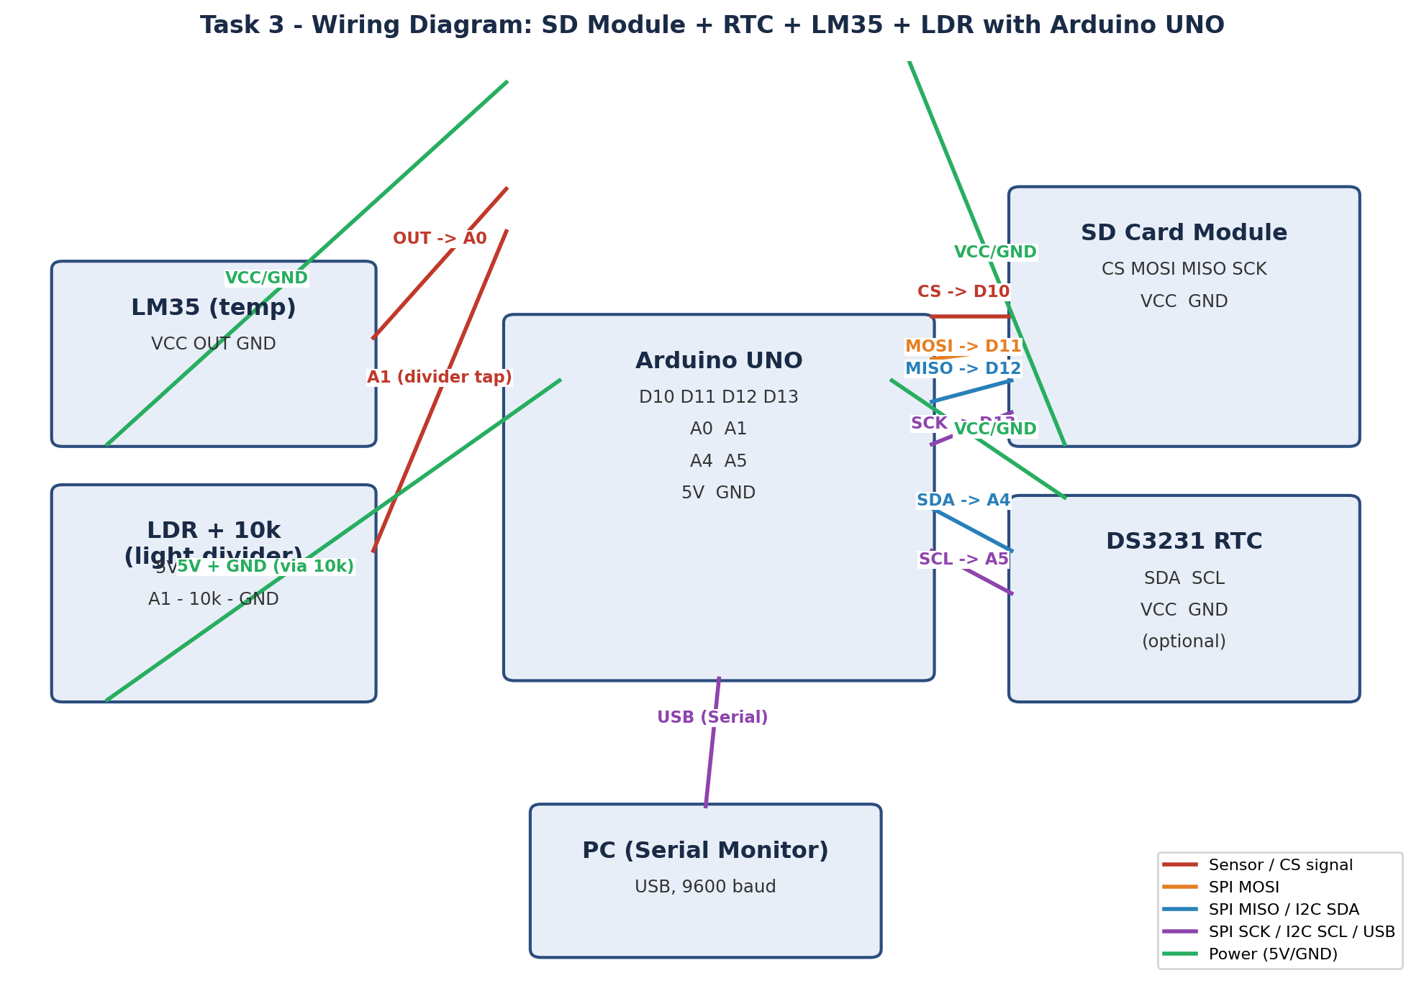

3.1 Pin Connections
Module | Pin | Arduino UNO | Notes
SD Module | CS | D10 | Chip select
SD Module | MOSI | D11 | SPI data out
SD Module | MISO | D12 | SPI data in
SD Module | SCK | D13 | SPI clock
SD Module | VCC / GND | 5V / GND | Power
DS3231 RTC | SDA | A4 | I2C data (optional)
DS3231 RTC | SCL | A5 | I2C clock (optional)
DS3231 RTC | VCC / GND | 5V / GND | Power (optional)
LM35 | OUT | A0 | Analog temp output
LM35 | VCC / GND | 5V / GND | Power
LDR divider | Tap | A1 | Between LDR and 10k to GND

4. How It Works
- Every SAMPLE_INTERVAL_MS (default 5000 ms), the sketch reads LM35 on A0 and converts it to °C, and reads the LDR divider on A1 as a raw ADC value (0-1023, higher = brighter with this wiring).
- If a DS3231 is present, each row is timestamped with a real date/time string; otherwise the sketch logs elapsed seconds since power-on.
- Each reading is appended to datalog.csv on the SD card as: timestamp,tempC,light_raw, and mirrored to Serial for live viewing.
- A header row is written only once, the first time the file is created, so re-running the sketch keeps appending rather than duplicating headers.
- logFile.flush() is called after every write so that data already logged survives a sudden power loss, rather than sitting in a buffer that's lost if the card/board loses power before a normal file close.

5. Sampling Rate & Power Considerations
- Sampling rate (5 s default): a balance between resolution and card wear/power draw. Temperature and ambient light both change slowly, so 5 s gives smooth trends without generating excessive write cycles. Reduce the interval (e.g. 1 s) only if you need finer-grained data - it proportionally increases SD card writes and average current draw.
- SD card power draw: SD cards briefly spike in current during write/erase operations (often 50-200 mA), which is the single largest transient load in this circuit. This is more relevant on battery power than on USB, where the extra current is negligible.
- Open/close per sample vs. keeping the file open: this sketch opens and closes datalog.csv on every write. That costs a small amount of extra time and flash wear on the SD controller, but ensures each row is safely committed - important since there's no graceful shutdown when power is cut in the field.
- RTC battery: a DS3231 module keeps time across power cycles using a small coin cell; without it (or without an RTC at all), timestamps reset to elapsed-seconds-since-boot on every restart, so absolute time is only meaningful within a single power-on session.
- For longer deployments on battery power, consider: increasing the sample interval, putting the Arduino into a low-power sleep mode between samples (e.g. via the LowPower library) and waking on a timer/RTC alarm, and only powering the SD module during the brief write window if using a MOSFET power-switch.

6. Example Output CSV
datalog_example.csv (submitted alongside this document) is a synthetic example showing the expected format and structure with 120 rows - it illustrates what the real datalog.csv pulled from your SD card should look like once you run the sketch on hardware. Replace it with your actual logged file (100+ real samples) before submitting.
timestamp,tempC,light_raw
2026-08-20 09:00:00,27.04,605
2026-08-20 09:00:05,27.11,597
2026-08-20 09:00:10,27.03,605
2026-08-20 09:00:15,26.91,613
2026-08-20 09:00:20,27.03,600
2026-08-20 09:00:25,27.06,586
2026-08-20 09:00:30,26.92,577
2026-08-20 09:00:35,26.84,581
2026-08-20 09:00:40,26.69,572
2026-08-20 09:00:45,26.76,579
...
(120 rows total in datalog_example.csv)

7. Arduino Sketch
Full source: sd_temp_light_logger.ino (submitted alongside this document).
/*
Task 3: SD Card Data Logger (Temperature + Light, Timestamped)
------------------------------------------------------------------
Hardware : Arduino UNO, SD card module (SPI), DS3231 RTC (I2C, optional),
LM35 temperature sensor, LDR (light-dependent resistor)
Software : SD.h, SPI.h, Wire.h, RTClib (optional - only if RTC is used)

Wiring:
SD card module (SPI bus - fixed on UNO):
MOSI -> D11
MISO -> D12
SCK -> D13
CS -> D10
VCC -> 5V
GND -> GND

DS3231 RTC (optional, I2C):
VCC -> 5V
GND -> GND
SDA -> A4
SCL -> A5

LM35 (temperature):
VCC -> 5V
GND -> GND
OUT -> A0

LDR (light, voltage divider):
5V -> LDR -> A1 -> 10k resistor -> GND

Behavior:
- Samples temperature + light once every SAMPLE_INTERVAL_MS.
- Timestamps each row using the RTC if present, otherwise falls back
to millis()-based elapsed time.
- Appends each reading as a CSV row to datalog.csv on the SD card,
and mirrors it to Serial for live monitoring.
- Writes a header row only if the file is new/empty.
- Calls file.flush() after every write so data already on the card
survives a power loss, at the cost of slightly higher write overhead.

NOTE: If you don't have a DS3231, set USE_RTC to false below - the
sketch will log elapsed milliseconds instead of a wall-clock timestamp.
*/

#include <SPI.h>
#include <SD.h>
#include <Wire.h>

#define USE_RTC true // set to false if no DS3231 is connected

#if USE_RTC
#include "RTClib.h"
RTC_DS3231 rtc;
#endif

const int CHIP_SELECT = 10; // SD module CS pin
const int TEMP_PIN = A0; // LM35 analog pin
const int LIGHT_PIN = A1; // LDR analog pin
const unsigned long SAMPLE_INTERVAL_MS = 5000; // 1 sample every 5 seconds

File logFile;
unsigned long lastSampleTime = 0;
unsigned long sampleCount = 0;

void setup() {
Serial.begin(9600);
while (!Serial) { ; }

Serial.println("Task 3: SD Card Data Logger");

if (!SD.begin(CHIP_SELECT)) {
Serial.println("ERROR: SD card initialization failed. Check wiring/card.");
while (1) { delay(1000); } // halt - nothing useful to do without SD
}
Serial.println("SD card initialized.");

#if USE_RTC
if (!rtc.begin()) {
Serial.println("ERROR: RTC not found. Check wiring.");
while (1) { delay(1000); }
}
if (rtc.lostPower()) {
Serial.println("RTC lost power, setting time to compile time.");
rtc.adjust(DateTime(F(__DATE__), F(__TIME__)));
}
#endif

bool needsHeader = !SD.exists("datalog.csv");
logFile = SD.open("datalog.csv", FILE_WRITE);
if (logFile) {
if (needsHeader) {
logFile.println("timestamp,tempC,light_raw");
logFile.flush();
}
logFile.close();
Serial.println("Log file ready: datalog.csv");
} else {
Serial.println("ERROR: could not open datalog.csv");
}

Serial.println("timestamp,tempC,light_raw");
}

String getTimestamp() {
#if USE_RTC
DateTime now = rtc.now();
char buf[20];
snprintf(buf, sizeof(buf), "%04d-%02d-%02d %02d:%02d:%02d",
now.year(), now.month(), now.day(),
now.hour(), now.minute(), now.second());
return String(buf);
#else
return String(millis() / 1000) + "s"; // elapsed seconds since power-on
#endif
}

void loop() {
unsigned long now = millis();
if (now - lastSampleTime < SAMPLE_INTERVAL_MS) return;
lastSampleTime = now;

int tempRaw = analogRead(TEMP_PIN);
float tempC = (tempRaw * 5.0 / 1023.0) * 100.0; // LM35: 10mV/°C
int lightRaw = analogRead(LIGHT_PIN);

String timestamp = getTimestamp();
String row = timestamp + "," + String(tempC, 2) + "," + String(lightRaw);

logFile = SD.open("datalog.csv", FILE_WRITE);
if (logFile) {
logFile.println(row);
logFile.flush(); // ensure this row survives an unexpected power loss
logFile.close();
sampleCount++;
} else {
Serial.println("ERROR: could not open datalog.csv for append");
}

Serial.println(row);

if (sampleCount == 100) {
Serial.println("100 samples logged. Logging will continue - "
"remove/pull the card once you have enough data.");
}
}

8. Notes
- If SD.begin() fails, double-check the CS pin matches your module's wiring and that the card is formatted FAT16/FAT32.
- If you don't have a DS3231, set USE_RTC to false at the top of the sketch - no RTClib install needed in that case.
- To pull data off the card for submission, remove the microSD card and open datalog.csv directly on a PC, or read it back over Serial with a small companion sketch.

