S.VIGNESH

(192512378)

SIMATS ENGINEERING

ASSESSMENT TOOL 2

COURSE NAME: Artificial Intelligence COURSE CODE: CSA1715

COURSE OUTCOME COVERED

CO3: Analyze knowledge representation and reasoning using propositional logic, FOL, inference, resolution, chaining methods, knowledge representation to perform logical reasoning for drawing valid conclusions and decision making. (BL4)

Assessment Tool Weightage: 10%

Duration : 30 Mins
QUESTIONS: 30 Total Marks:30

Annexure A

MCQ Test

Code of Conduct:

I S.VIGNESH(192512378) certify that this submission is my original work and that I have adhered to the guidelines specified for this assessment.
I understand that any violation of academic integrity rules will result in disciplinary action.

Signature of the student:

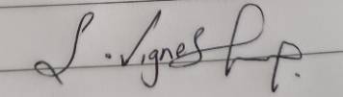

Annexure A
a) P ∧ ¬Q | c) ¬Q → ¬P only
b) ¬P ∨ Q | d) Both b and c

a) A disjunction of conjunctions | c) A conjunction of literals only
b) A conjunction of disjunctions (clauses) | d) A sequence of implications

a) Some students pass | c) If something passes, it is a student
b) Every entity that is a student passes | d) There exists at least one student who passes

a) Convert clauses to CNF | c) Prove a goal using backward chaining
b) Make two logical expressions syntactically identical | d) Derive facts using Modus Ponens

a) The knowledge base is consistent | c) A contradiction — the original goal is proven
b) The negated goal is satisfiable | d) More clauses need to be added

a) Goal-driven / top-down | c) Heuristic-based depth-first
b) Data-driven / bottom-up | d) Probabilistic inference

Circle the most appropriate option for each question.
a) An agent that reacts randomly to the environment | c) An agent that only follows pre-defined scripts
b) An agent that uses a knowledge base and logical inference to decide actions | d) An agent that learns from rewards

Q1. Which of the following best describes a Logical Agent in AI?

Q2. In Propositional Logic, 'P → Q' is logically equivalent to:

Q3. Conjunctive Normal Form (CNF) requires the formula to be expressed as:

Q4. In FOL, the sentence ∀x: Student(x) → Passes(x) means:

Q5. Unification in FOL is the process of finding substitutions that:

Q6. In the Resolution algorithm, deriving the empty clause □ indicates:

Q7. Forward Chaining is best described as a strategy.

Q8. Backward Chaining begins reasoning from:
a) All known facts toward a conclusion | c) A random clause in the knowledge base
b) The goal and works backward to verify supporting facts | d) The resolution refutation tree

a) Eliminate biconditionals (↔) | c) Apply Skolemization to remove existential quantifiers
b) Move negations inward using De Morgan’s laws | d) Distribute AND over OR

a) Training a neural network on domain-specific data | c) Writing heuristic search strategies
b) Defining domain concepts, relations, and axioms formally in FOL | d) Encoding reward functions for reinforcement learning

a) ¬Q is true | c) P is uncertain
b) Q must be true | d) The KB is inconsistent

a) Is the most specific possible match | c) Eliminates all variables from a clause
b) Makes two terms identical with minimal variable binding | d) Applies resolution to produce CNF

a) Forward Chaining | c) Backward Chaining
b) Truth Table method | d) A* search

a) Supports probabilistic reasoning | c) Is always more expressive
b) Cannot represent objects, relations, or quantifiers — only truth values of atomic propositions | d) Handles uncertainty better

Q9. Which step is NOT part of converting a sentence to CNF?

Q10. Knowledge Engineering in FOL involves:

Q11. Modus Ponens states: If P → Q is known and P is true, then:

Q12. The Most General Unifier (MGU) is the substitution that:

Q13. Which inference method is more appropriate when a specific goal is known?

Q14. Propositional Logic differs from First Order Logic because it:

Q15. Resolution Refutation proves a goal G by:
a) Directly deriving G from the KB using forward chaining | c) Checking G in the truth table
b) Adding ¬G to the KB and deriving a contradiction (empty clause □) | d) Applying Modus Tollens repeatedly

a) An agent receiving numerical rewards from the  environment | c) Acquiring knowledge by following explicit symbolic  rules
b) Improving performance by examining examples or experience from the environment | d) Memorizing a fixed dataset without generalization

a) Deriving specific conclusions from general rules | c) Memorizing training data exactly
b) Generalizing a hypothesis from specific training examples | d) Applying search algorithms to find optimal policies

a) A class label / output decision | c) A test on an attribute / feature
b) A probability distribution over outcomes | d) A training data sample

a) Requires large amounts of training data to generalize | c) Uses prior domain knowledge to explain and generalize  a single example
b) Learns only from numeric data using regression | d) Applies unsupervised clustering to find hidden patterns

a) All features are conditionally dependent on each other  given the class | c) All features are conditionally independent given the  class label
b) The data must follow a uniform distribution | d) Labels are determined by a reward function

Q16. Learning from observation in AI refers to:

Q17. Inductive learning is best described as:

Q18. In a Decision Tree, what does each internal node represent?

Q19. Explanation-Based Learning (EBL) differs from inductive learning because it:

Q20. In statistical learning, a Naive Bayes classifier assumes:

Q21. Learning with complete data (no hidden variables) in a Bayesian network involves:
a) Using the EM algorithm to estimate missing values c) Directly computing maximum likelihood estimates from
observed data

a) Training data is fully labeled and no variables are  hidden | c) The dataset contains hidden (latent) variables that  cannot be directly observed
b) An agent explores an unknown environment using trial and error | d) Backpropagation fails to converge in a neural network

a) Initialize the weights of each neuron to zero | c) Introduce non-linearity to enable learning of complex  patterns
b) Normalize the input dataset before training | d) Store previously learned examples in memory

a) Weights are updated in the forward pass using input  gradients | c) The error is propagated backward from output to input  layers to adjust weights
b) Outputs of each layer are stored and reused in later epochs | d) A separate model is trained for each hidden layer independently

a) Minimizing the number of training examples used | c) Finding the maximum-margin hyperplane that  separates classes
b) Grouping similar data points into clusters using centroids | d) Updating weights using Q-values from an environment

a) Reducing the number of support vectors needed | c) Operating in a high-dimensional feature space without  explicitly computing coordinates
b) Accelerating gradient descent convergence | d) Replacing hidden layers in a deep neural network

a) Classification accuracy on a fixed test set | c) Cumulative reward received over time through  interaction with the environment
b) The number of features selected from the training data | d) The size of the neural network hidden layer

b) Training a deep neural network with dropout
regularization
d) Applying reinforcement signals to update weights

Q22. The Expectation-Maximization (EM) algorithm is used when:

Q23. In a Neural Network, the activation function serves to:

Q24. Which of the following correctly describes backpropagation in a neural network?

Q25. A Support Vector Machine (SVM) — a type of kernel machine — classifies data by:

Q26. The kernel trick in kernel machines (SVMs) allows:

Q27. In Reinforcement Learning, the agent aims to maximize:

a) A supervised learning algorithm requiring labeled  datasets | c) A model-free, off-policy temporal difference learning  method
b) An unsupervised clustering technique using centroids | d) A decision-tree-based ensemble classifier

a) The model performs poorly on both training and test  data | c) The model fits training data too closely and generalizes  poorly to new data
b) The learning rate is set too low during gradient descent | d) The training set has more features than training examples

a) RL uses labeled input-output pairs; SL uses reward  signals | c) RL learns via trial-and-error with reward feedback; SL  learns from labeled examples
b) Both RL and SL require explicit reward functions | d) RL is always faster to converge than SL on any dataset

Q28. The Q-Learning algorithm in Reinforcement Learning is classified as:

Q29. Overfitting in machine learning occurs when:

Q30. Which of the following best distinguishes Reinforcement Learning from Supervised Learning?

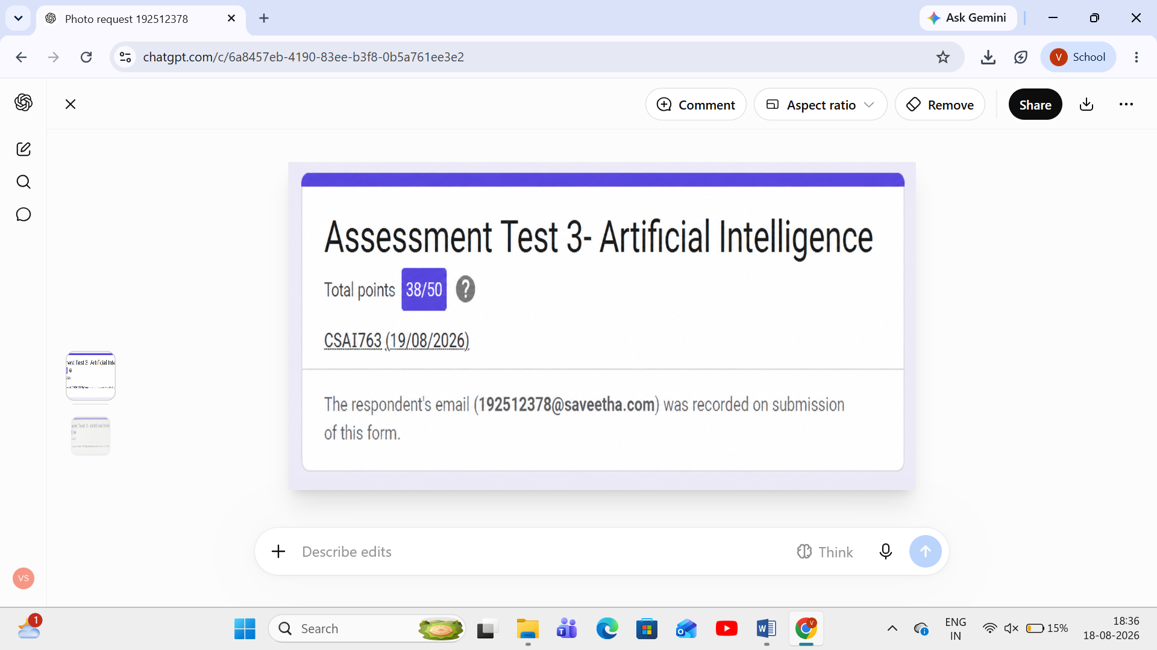

RUBRICS FOR CALCULATION

Criteria | Weightag e (%) | Level 4 (Exemplary) | Level 3 (Proficient) | Level 2 (Developing) | Level 1 (Beginning)
Conceptual Understanding | 30% | Demonstrates thorough understanding; answers all questions accurately | Shows good understanding with few errors | Partial understanding; several incorrect responses | Lacks understanding; majority of answers incorrect
Accuracy of Answers | 25% | All answers are correct | Most answers are correct with minor mistakes | Some correct answers; frequent errors | Mostly incorrect answers
Application of Knowledge | 20% | Correctly applies concepts to problem-based questions | Applies concepts with minor errors | Limited ability to apply concepts | Unable to apply concepts
Time Management | 15% | Completes quiz well within time efficiently | Completes on time with minor delays | Requires extra time or rushes through questions | Unable to complete within given time
Question Interpretation | 10% | Interprets all questions correctly and  responds appropriately | Misinterprets a few questions | Often misinterprets questions | Unable to understand questions

