Name:S.VIGNESH
Reg.No:192512378

25. Prolog Program for Diet Suggestion Based on Disease
Aim
To write and execute a Prolog program that suggests recommended foods and foods to avoid for a given disease.
Algorithm
- Start the program.
- Define diseases such as diabetes, hypertension, and anemia.
- Define recommended foods for each disease.
- Define foods that should be avoided for each disease.
- Create a rule to retrieve recommended foods.
- Create another rule to retrieve foods to avoid.
- Enter the disease as a query.
- Prolog searches the database for matching facts.
- Display the recommended foods and foods to avoid.
- Stop the program.
PROGRAM:
% Prolog Program to Suggest Diet Based on Disease

% Diabetes
recommended(diabetes, vegetables).
recommended(diabetes, fruits).
recommended(diabetes, whole_grains).

avoid(diabetes, sweets).
avoid(diabetes, sugary_drinks).
avoid(diabetes, junk_food).

% Hypertension
recommended(hypertension, vegetables).
recommended(hypertension, fruits).
recommended(hypertension, whole_grains).

avoid(hypertension, salty_foods).
avoid(hypertension, processed_foods).
avoid(hypertension, junk_food).

% Anemia
recommended(anemia, spinach).
recommended(anemia, beans).
recommended(anemia, lentils).

avoid(anemia, excess_tea).
avoid(anemia, excess_coffee).
avoid(anemia, processed_foods).

% Rule to suggest recommended food
suggest_diet(Disease, Food) :-
recommended(Disease, Food).

% Rule to suggest food to avoid
suggest_avoid(Disease, Food) :-
avoid(Disease, Food).
INPUT:
suggest_diet(diabetes, Food).
OUTPUT:
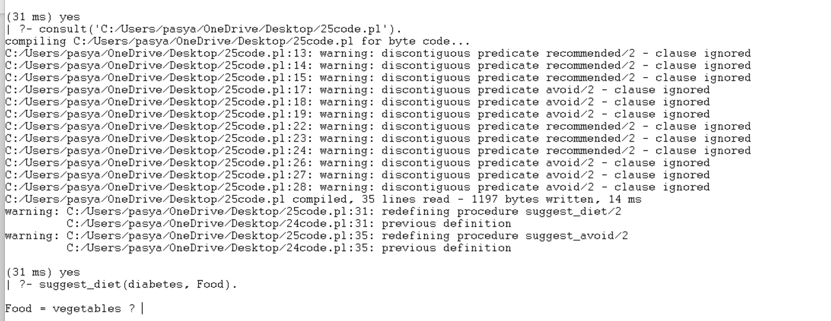

Result:
Thus, the Prolog program for suggesting a diet based on disease was successfully implemented and executed, and the recommended foods and foods to avoid were successfully retrieved using Prolog queries.

