28. Prolog Program to Implement Best First Search Algorithm
Name:S.VIGNESH
Reg.No:192512378

Aim
To write and execute a Prolog program to implement the Best First Search algorithm and find a path from a start node to a goal node using heuristic values.
Algorithm
- Start the program.
- Define the graph using connected nodes.
- Assign a heuristic value to each node.
- Start the search from the initial node.
- Select the node having the lowest heuristic value.
- Expand the selected node and find its neighboring nodes.
- Add the neighboring nodes to the list of nodes to be explored.
- Repeat the process by selecting the node with the lowest heuristic value.
- Stop when the goal node is reached.
- Display the path from the start node to the goal node.

PROGRAM:
% Best First Search Algorithm

% Graph
edge(a, b).
edge(a, c).
edge(b, d).
edge(b, e).
edge(c, f).
edge(c, g).
edge(d, h).
edge(e, h).
edge(f, h).
edge(g, h).

% Heuristic values
heuristic(a, 7).
heuristic(b, 6).
heuristic(c, 5).
heuristic(d, 4).
heuristic(e, 3).
heuristic(f, 2).
heuristic(g, 4).
heuristic(h, 0).

% Best First Search
best_first(Start, Goal) :-
write('Start Node: '),
write(Start),
nl,
search([Start], Goal, [Start]).

% Goal reached
search([Goal|_], Goal, Path) :-
write('Goal Node Reached: '),
write(Goal),
nl,
write('Final Path: '),
write(Path),
nl.

% Search process
search([Current|Rest], Goal, Path) :-
Current \= Goal,

write('Current Node: '),
write(Current),
nl,

findall(
Next,
(
edge(Current, Next),
\+ member(Next, Path)
),
Children
),

write('Children: '),
write(Children),
nl,

add_children(Children, Rest, NewOpen),

write('Open List: '),
write(NewOpen),
nl,

select_best(NewOpen, NextNode, Remaining),

write('Selected Node: '),
write(NextNode),
nl,
nl,

search([NextNode|Remaining], Goal, [NextNode|Path]).

% Add children to open list
add_children([], Open, Open).

add_children([H|T], Open, NewOpen) :-
add_children(T, [H|Open], NewOpen).

% Select node with minimum heuristic value
select_best([H|T], Best, Remaining) :-
select_best_node(T, H, Best),
remove(Best, [H|T], Remaining).

select_best_node([], Best, Best).

select_best_node([H|T], CurrentBest, Best) :-
heuristic(H, H1),
heuristic(CurrentBest, H2),
(
H1 < H2
->
select_best_node(T, H, Best)
;
select_best_node(T, CurrentBest, Best)
).

% Remove selected node
remove(X, [X|T], T).

remove(X, [H|T], [H|R]) :-
X \= H,
remove(X, T, R).
INPUT:
?- best_first(a, h).
OUTPUT:
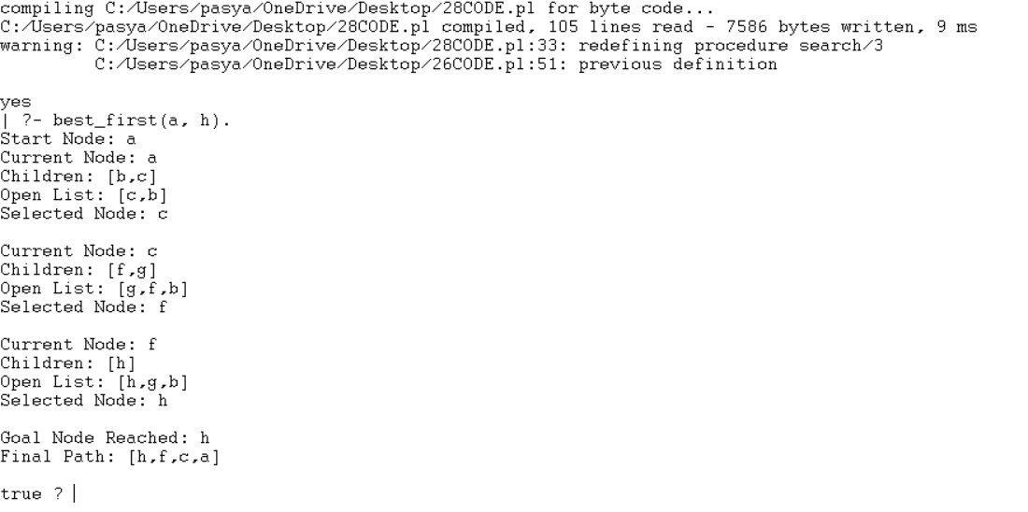

RESULT:
Thus, the Best First Search algorithm was successfully implemented in Prolog, and the optimal heuristic-based path from the starting node to the goal node was obtained successfully.

