Name:S.VIGNESH
Reg.No:192512378

29. Prolog Program for Medical Diagnosis
Aim
To write and execute a Prolog program to diagnose a disease based on the symptoms given by the user using facts and rules.
Algorithm
- Start the program.
- Define common symptoms in the knowledge base.
- Define rules for different diseases based on their symptoms.
- Accept symptoms as input through a query.
- Compare the given symptoms with the disease rules.
- If the symptoms match, identify the corresponding disease.
- Display the diagnosed disease.
- If no disease matches, display that the disease could not be identified.
- Stop the program.
PROGRAM:
% Medical Diagnosis System

% Disease and symptoms

disease(flu, fever, cough, body_pain).
disease(cold, cough, sneezing, runny_nose).
disease(malaria, fever, chills, sweating).
disease(diabetes, frequent_urination, excessive_thirst, weight_loss).

% Diagnosis rule

diagnose(Disease, S1, S2, S3) :-
disease(Disease, S1, S2, S3).
INPUT:
?- diagnose(Disease, fever, cough, body_pain).
OUTPUT:
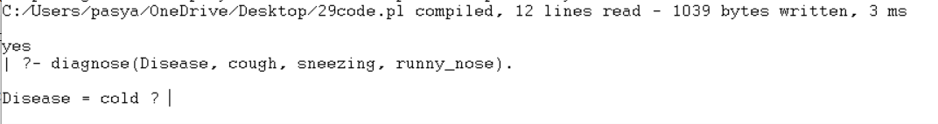
Result
The Prolog medical diagnosis system successfully identifies flu, cold, malaria, and diabetes based on the symptoms provided.

