32. Prolog Program to Implement Pattern Matching
Name:S.VIGNESH
Reg.No:192512378

Aim
To write and execute a Prolog program to implement pattern matching by comparing a given pattern with a list of elements.
Algorithm
- Start the program.
- Define a predicate to compare two patterns.
- Compare the elements of both patterns one by one.
- If the elements match, continue with the next elements.
- If all elements match, return true.
- If any element does not match, return false.
- Display the result.
- Stop the program.
Code:
% Facts
student(rahul, cse, 85).
student(priya, aids, 90).
student(anu, cse, 78).
student(kiran, ece, 88).
student(rohan, aids, 95).

% Rule to find students with marks above 80
above80(Name) :-
student(Name, _, Marks),
Marks > 80.

% Rule to find students from a department
department(Name, Dept) :-
student(Name, Dept, _).
INPUT:
?- ?- student(Name, Dept, Marks).
OUTPUT:
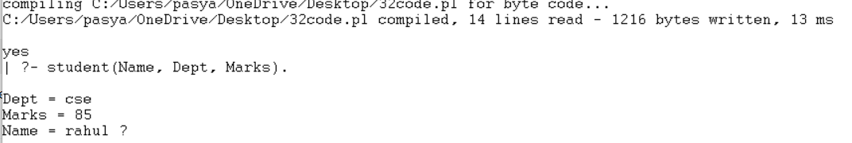
Result:
Thus, the pattern matching program was successfully implemented in Prolog, and matching and non-matching patterns were correctly identified.

