**Web Programming(BCSE203E)**

**Lab-3**

**Name:** N Vignesh

**Reg No:** 23BCE1156

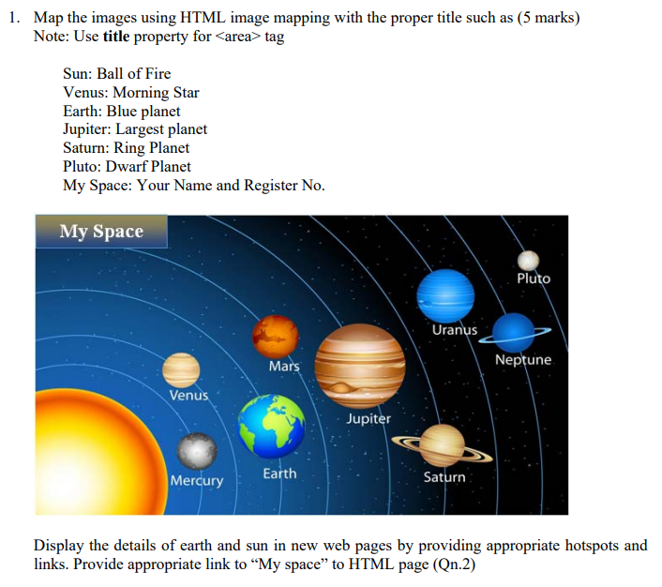

**Code:**

*Space.html:*

<!DOCTYPE html>

<html>

    <head>

        <title>

            Image Map

        </title>

    </head>

    <body background="https://th.bing.com/th?id=OIP.mTmQ_6luirHAoiVJNjfnvwHaFj&w=288&h=216&c=8&rs=1&qlt=90&o=6&pid=3.1&rm=2" style="background-size: cover;">

        <font size="10">

            <map name="space">

                <area title="Vignesh N 23BCE1156" shape="rectangle" coords="2,19,288,97" href="MySpace.html">

                <area title="Sun" shape="poly" coords="1,171,132,453,136,764,1,1045" href="https://www.bing.com/ck/a?!&&p=ff0d0463757214cfe9abe5b62ff6851e5209cd7352a44c4029ed036fa72d2afcJmltdHM9MTczNDMwNzIwMA&ptn=3&ver=2&hsh=4&fclid=0af6c96a-5312-68df-1768-db2852bf6942&psq=sun&u=a1aHR0cHM6Ly93d3cuYnJpdGFubmljYS5jb20vcGxhY2UvU3Vu&ntb=1">

                <area title="Mercury" shape="circle" coords="272,584,11" href="https://www.bing.com/ck/a?!&&p=459c21e5b1562a15da7c5675b01b6a25b0e8031147fc19e83f11693f4dc42780JmltdHM9MTczNDMwNzIwMA&ptn=3&ver=2&hsh=4&fclid=0af6c96a-5312-68df-1768-db2852bf6942&psq=mercury&u=a1aHR0cHM6Ly9zY2llbmNlLm5hc2EuZ292L21lcmN1cnkv&ntb=1">

                <area title="Venus" shape="circle" coords="332,568,18" href="https://www.bing.com/ck/a?!&&p=9c2218b8972eed5b8caeb4151b92d52619b32ef06f2ea7b839a9e10586e3efdcJmltdHM9MTczNDMwNzIwMA&ptn=3&ver=2&hsh=4&fclid=0af6c96a-5312-68df-1768-db2852bf6942&psq=venus&u=a1aHR0cHM6Ly9zY2llbmNlLm5hc2EuZ292L3ZlbnVz&ntb=1">

                <area title="Mars" shape="circle" coords="403,551,21" href="https://www.bing.com/ck/a?!&&p=78aa68224ac96a3f458b71724dcd5f484244f3b5556298f9639949390c8e6ffeJmltdHM9MTczNDMwNzIwMA&ptn=3&ver=2&hsh=4&fclid=0af6c96a-5312-68df-1768-db2852bf6942&psq=EARTH+britannica&u=a1aHR0cHM6Ly93d3cuYnJpdGFubmljYS5jb20vcGxhY2UvRWFydGg&ntb=1">

                <area title="Earth" shape="circle" coords="481,538,16" href="https://www.bing.com/ck/a?!&&p=5a33e71d2b18285d57b9b022cb9e34e47e5c6ec38092a3b6199d0398b7e706f0JmltdHM9MTczNDMwNzIwMA&ptn=3&ver=2&hsh=4&fclid=0af6c96a-5312-68df-1768-db2852bf6942&psq=mars&u=a1aHR0cHM6Ly9zY2llbmNlLm5hc2EuZ292L21hcnMv&ntb=1">

                <area title="Jupiter" shape="circle" coords="823,458,113" href="https://www.bing.com/ck/a?!&&p=b2a25c085aab74fa31141d7da19b979f861a0232f4282e78e5c093d9bacf8336JmltdHM9MTczNDMwNzIwMA&ptn=3&ver=2&hsh=4&fclid=0af6c96a-5312-68df-1768-db2852bf6942&psq=jupiter&u=a1aHR0cHM6Ly9zY2llbmNlLm5hc2EuZ292L2p1cGl0ZXI&ntb=10">

                <area title="Saturn" shape="circle" coords="1150,407,74" href="https://www.bing.com/ck/a?!&&p=3a46e641e0690135174182ea99840cfb361893e550f7a1c8ee80f979b3a03a26JmltdHM9MTczNDMwNzIwMA&ptn=3&ver=2&hsh=4&fclid=0af6c96a-5312-68df-1768-db2852bf6942&psq=saturn&u=a1aHR0cHM6Ly9zY2llbmNlLm5hc2EuZ292L3NhdHVybg&ntb=1">

                <area title="Uranus" shape="circle" coords="1408,332,51" href="https://www.bing.com/ck/a?!&&p=7d30491c71bec771ab5536970103de8ed4c11540e55efb78d3178e2308e8f01aJmltdHM9MTczNDMwNzIwMA&ptn=3&ver=2&hsh=4&fclid=0af6c96a-5312-68df-1768-db2852bf6942&psq=uranus&u=a1aHR0cHM6Ly9zY2llbmNlLm5hc2EuZ292L3VyYW51cy8&ntb=1">

                <area title="Neptune" shape="circle" coords="1620,268,44" href="https://www.bing.com/ck/a?!&&p=d6bc3420fd640e8df3c30787c55d638a2c11101a0f44b726dd73a2b04ae52a66JmltdHM9MTczNDMwNzIwMA&ptn=3&ver=2&hsh=4&fclid=0af6c96a-5312-68df-1768-db2852bf6942&psq=neptune&u=a1aHR0cHM6Ly9zY2llbmNlLm5hc2EuZ292L25lcHR1bmUv&ntb=1">

            </map>

            <img src="Space.png" usemap="#space"></img>

        </font>

    </body>

</html>

**Output:**

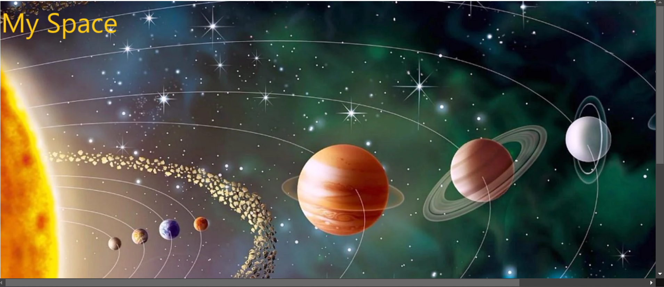

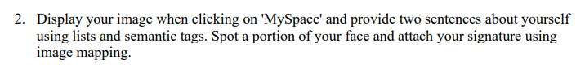

**Code:**

*MySpace.html:*

<!DOCTYPE html>

<html>

    <head>

        <title>

            Welcome to my page - 23BCE1156

        </title>

        <h1 align="center">

            My Space

        </h1>

    </head>

    <header>

        <h1>About Myself</h1>

    </header>

    <body background="https://th.bing.com/th?id=OIP.mTmQ_6luirHAoiVJNjfnvwHaFj&w=288&h=216&c=8&rs=1&qlt=90&o=6&pid=3.1&rm=2" style="background-size: cover;">

        <map name="sign">

            <area title="Vignesh" shape="circle" coords="56,86,50" href="Sign.png">

        </map>

        <img src="Vignesh.png" usemap="#sign">

        <font size="5">

            <ul>

                <li>I am Vignesh N. I am studying CSE in VIT Chennai.</li>

                <li>My hobbies include playing Chess, coding and listening to music.</li>

            </ul>

        </font>

    </body>

</html>

**Output:**



