**Web Programming(BCSE203E)**

**Lab-7**

**Name:** N Vignesh

**Reg No:** 23BCE1156

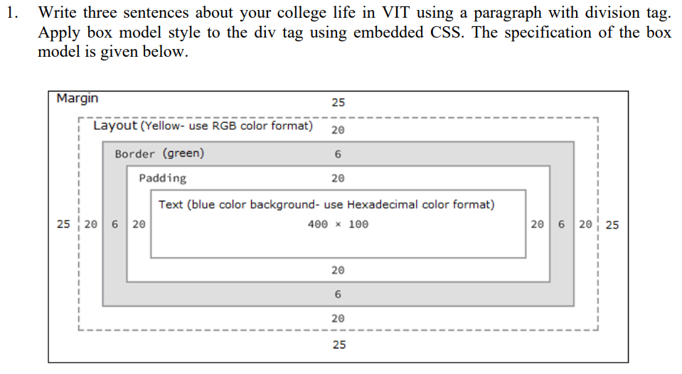

**Code:**

*VIT.html:*

<!DOCTYPE html>

<html>

    <head>

        <title>

            Welcome to my page-23BCE1156

        </title>

        <style>

            .div1 {

                display: flex;

                justify-content: center;

                align-items: center;

                height: 100vh;

            }

            .div2{

                height: 100px;

                width: 400px;

                color: white;

                background-color: #0000ff;

                padding: 20px;

                border: 6px solid green;

                outline: 20px solid rgb(255, 255, 0);

                margin: 25px;

                text-align: center;

            }

        </style>

    </head>

    <body>

        <div class="div1">

            <div class="div2">

                <p>Life at VIT,Chennai is vibrant, with a mix of academics, cultural events, and cutting-edge projects that foster growth. The diverse community and well-equipped campus create a dynamic environment for learning and collaboration.</p>

            </div>

        </div>

    </body>

</html>

**Output:**

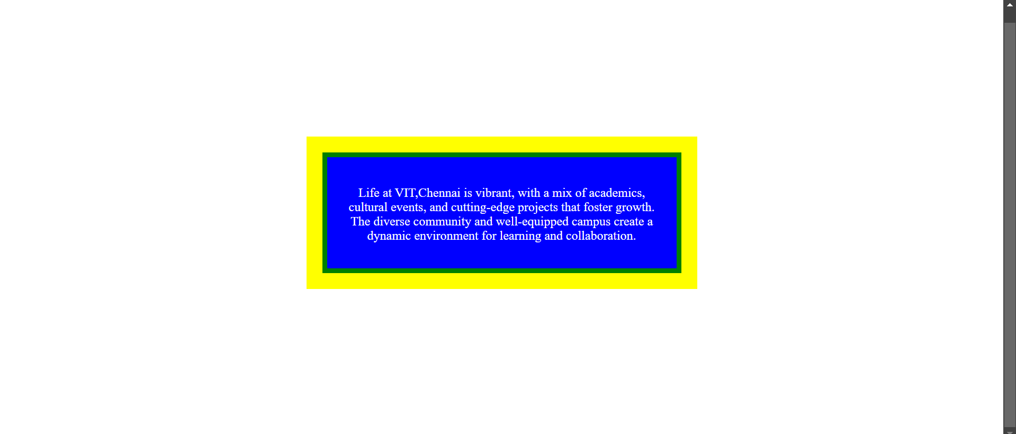

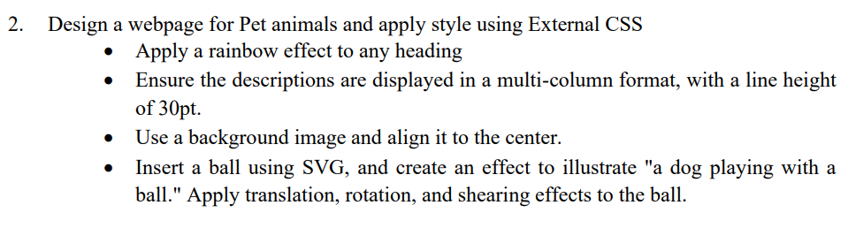

**Code:**

*Pet.html:*

<!DOCTYPE html>

<html>

    <head>

        <title>

            Welcome to my page-23BCE1156

        </title>

        <link rel="stylesheet" href="Pet.css">

        <h1 class="rainbow">Pet Animals</h1>

    </head>

    <body>

        <h2 class="rainbow">Cats</h2>

        <p class="desc">

            Cats make wonderful pets due to their independent yet affectionate nature.

            They are low-maintenance, requiring minimal grooming and generally being capable of self-care.

            Cats are known for their playful and curious personalities, often entertaining themselves and their owners with their antics.

            Their ability to adapt to small living spaces makes them ideal for apartments and urban settings.

            With their soothing purrs and calming presence, cats bring comfort and companionship to their owners, making them beloved members of the family.

        </p>

        <h2 class="rainbow">Dogs</h2>

        <p class="desc">

            Dogs are loyal, loving, and energetic companions, making them one of the most popular choices for pets.

            They thrive on human interaction and are known for their ability to form deep emotional bonds with their owners.

            Dogs come in various breeds, each with unique traits, making it easy to find one that fits your lifestyle.

            They provide protection, companionship, and endless joy with their playful and affectionate nature.

            With proper care, training, and attention, dogs become devoted family members and bring immense happiness to any home.

        </p>

        <h2 class="rainbow">Hamsters</h2>

        <p class="desc">

            Hamsters are adorable, low-maintenance pets, perfect for small spaces and first-time pet owners.

            These tiny, nocturnal creatures are fun to watch as they scurry, burrow, and explore their surroundings.

            Hamsters require a clean, safe cage with ample bedding, an exercise wheel, and hiding spots to stay happy and healthy.

            They are generally independent but enjoy gentle handling and occasional treats.

            With their charming personalities and minimal care needs, hamsters make delightful companions for both kids and adults.

        </p>

        <svg width="800" height="500">

            <style>

                .ball{

                    animation: ellipseAnimation 5s infinite ease-in-out;

                }

                @keyframes bounce{

                    0%, 100%{

                        transform: translateX(0);

                    }

                    50%{

                        transform: translateX(100px);

                    }

                }

                @keyframes ellipseAnimation {

                    0% {

                        transform: translateX(-200px) translateY(100px);

                    }

                    25% {

                        transform: translateX(0px) translateY(0px);

                    }

                    50% {

                        transform: translateX(200px) translateY(100px);

                    }

                    60%{

                        transform: translateX(300px) translateY(100px) skewX(45deg) rotate(100deg);

                    }

                    75%{

                        transform: translateX(100px) translateY(100px) skewX(45deg) rotate(100deg);

                    }

                    100% {

                        transform: translateX(-200px) translateY(100px);

                    }

                  }

            </style>

            <circle class="ball" cx="550" cy="150" r="50" style="fill:red" />

        </svg>

    </body>

</html>

*Pet.css:*

h1{

    text-align: center;

}

.rainbow{

    background-image: linear-gradient(45deg, red, orange, yellow, green, blue, indigo, violet, red);

    -webkit-background-clip: text;

    -webkit-text-fill-color: transparent;

}

.desc{

    line-height: 30pt;

    column-count: 3;

    column-gap: 20px;

    column-rule-style: solid;

}

body{

    background-image: url("Pets.png");

    background-position: center;

    background-attachment: fixed;

    background-repeat: no-repeat;

    background-size: cover;

}

.dog {

    font-size: 50px;

    position: absolute;

    bottom: 10px;

    left: 20px;

}

**Output:**

