**Code: MECQ01**

**RATIO, PROPORTION & VARIATION**

1. If a/b = 1/3, b/c = 2, c/d = 1/2, d/e = 3, e/f = 1/4, find the value of abc/def.

**a) 3/8 b) 27/8 c) 3/4 d) 27/4**

1. p:q = 1:3, q:r = 2:3, r:s = 5:2, find p:q:r:s.

**a) 5:15:20:8 b) 10:30:45:18 c) 1:3:5:2 d) None of the above**

1. The ratio of the population of country A to B is 3:2, country B to C is also 3:2 and country C to D is also 3:2. If the population of all the countries together is 195 million, find the population (in millions) of country C.

**a) 30 b) 36 c) 42 d) 48**

1. Consider a sequence where the nth  term is given by n/n+2 (n = 1, 2,3 ....)

Find t3 * t4 * ....... *t53

**a) 2/495 b) 2/477 c) 12/55 d) 1/1485**

1. If a/(b+c) = b/(c+a) =c/(a+b) =k, then k cannot take any value except

a**) 1/2 b) -1 c) 1/2or -1 d) 1/2 or 0**

1. Let a, b, c, d and e be integers such that a= 6b= 12c, and 2b= 9d= 12e. Then which of the following pairs contains a number that is not an integer?

**a) (a/27, b/e) b) (a/36, c/e) c) (a/12, bd/18) d) (a/6, c/d)**

1. A teacher distributes “n” chocolates among four children such that the 1st child gets half the chocolates. Of the remaining, the 2nd child gets 2/3 of it. Of the remaining the 3rd child gets 3/4 of it. The last child gets the remaining 5 chocolates. Find “n”.

a**) n<20 b) Between 20 and 50 c) Between 50 and 80 d) n>80**

1. Four children have 60 chocolates with them. The 1st child has half the number of chocolates as the others put together. The 2nd child has 1/3rd the number of chocolates as the others put together. The 3rd child has 1/4th the number of chocolates as the others put together. How many chocolates are with the 4th child?

**a) 7 b) 11 c) 13 d) 17**

1. The current ratio of the ages of a husband to the wife is 5:4. Which of the following CAN NOT represent the ratio of their ages 10 years ago?

**a) 2:1 b) 3:2 c) 4:3 d) 6:5**

1. An alloy A is formed by mixing copper and iron in the ratio 1:2 by weight, and another alloy B is formed by mixing iron and zinc in the ratio 3:4, by weight. If a third alloy C is formed by mixing alloys A and B completely, such that the ratio of copper and zinc in the alloy C is 5:6, by weight, then what fraction of the alloy C is iron?

**a) 13/23 b) 17/31 c) 23/41 d) 29/51**

1. A shop sold only small and large cups of juice. 3/5 of the cups sold were small and the rest were large. If the large cups were sold for 7/6 as much as the small cups, what fraction of the total revenue was from the sale of large cups?

**a) 3/16 b) 5/16 c) 7/16 d) 9/16**

1. The ratio of the number of chocolates with B to D is 8 to 5, and the ratio of the number of chocolates with A to B is 3 to 4. If the ratio of the number of chocolates with C to D is 3 to 2, what is the ratio of the number of chocolates with A to C?

**a) 5/16 b) 5/4 c) 9/16 d) 4/5**

1. The present ratio of chocolates to cakes with a child is 30 to 1. If the numbers of chocolates were to increase by 50 and the numbers of cakes were to increase by 5, the ratio of chocolates to cakes would then be 25 to 1. What is the present number of cakes?

**a) 5 b) 10 c) 15 d) None of the above**

1. A satellite is composed of 30 units, each of which is equipped with a set of sensors, some of which have been upgraded. Each unit contains the same number of non-upgraded sensors. If the number of non-upgraded sensors on one unit is 1/5 the total number of upgraded sensors on the entire satellite, what fraction of the sensors on the satellite have been upgraded?

**a) 1/5 b) 1/6 c) 1/7 d) None of the above**

1. Three friends, returning from a movie, stopped to eat at a restaurant. After dinner, they paid their bill and noticed mints at the front counter. A took 1/3 of the mints, but returned four. B then took 1/4 of what was left but returned three. C then took half of the reminder but threw two back into the bowl. The bowl had only 17 mints left when the raid was over. How many mints were originally in the bowl?

**a) 36 b) 48 c) 60 d) None of the above**

1. Two liquids are in the ratio 5:3. If 16 litres of the first liquid is removed, the ratio now becomes 3:5. Find the original combined volume (in litres) of the two liquids.

**a) 32 b) 36 c) 40 d) Cannot be determined**

1. The ratio of the incomes of A and B is 4:3 while the ratio of their expenses is also 4:3. Which of the following is definitely true about their savings SA and SB respectively?(Assume their savings to be positive values only)

**a) SA > SB b) SA ≥ SB c) SA = SB d) None of the above**

1. A shopkeeper stores “x” kgs of rice. The first customer buys half this amount plus half a kg of rice. The second customer buys half the remaining amount plus half a kg of rice. The third customer does the same. Thereafter, there is no rice left in the shop. Find the value of “x”.

**a) 2<x<6 b) 6<x<10 c) 10<x<14 d) 14<x<18**

1. This year, Ram will save a certain amount of his income, and he will spend the rest. Next year, he will have no income, but for each dollar he saves this year, he will have (1+r) dollars available to spend. In terms of r, what fraction of his income should Ram save this year, so that next year the amount he has available to spend will be equal to half the amount that he spends this year?

**a) 1/ (r+2) b) 1/(3r+2) c) 1/(r+3) d) 1/(2r+3)**

1. The value of a stone varies with the square of its weight. If a 10kg stone worth Rs 1000, is broken into 4 parts in the ratio 1:2:3:4 by weight, find the loss in the value of the stone.

**a) Rs 100 b) Rs 300 c) Rs 500 d) Rs 700**

1. In a bag containing only green, red, blue and white balls, the number of green balls is half the total number of balls. Half the number of red balls equals one third the number of blue balls. Twice the sum of red and blue balls is 4 more than thrice the number of blue balls. Also, half the number of white balls equals one third the number of green balls. Find the total number of balls in the bag.

**a) 80 b) 100 c) 120 d) 150**

1. The velocity of a train inversely proportional to the square root of the number of passengers on the train. When there are 900 passengers on the train, the velocity of the train is 100 km/hr. If the speed of the train is 150km/hr, find the number of passengers on the train.

**a) 1350 b) 625 c) 2025 d) 400**

1. A bag contains only 1,2 and 5 Rs coins. The ratio of the number of 1 Re to 2Rs coins in a bag is 1:4 while the ratio of the number of 2 Rs to 5 Rs coins in the bag is 7:2. If the total number of coins in the bag is between 200 and 250, then find the total value of the coins in the bag.

**a) Rs. 480 b) Rs. 515 c) Rs. 535 d) Cannot be determined**

1. The time taken to cover a certain distance varies directly with the distance travelled and inversely with the speed. The speed varies directly with the square root of the weight of the vehicle and inversely with the length of the vehicle. For a 50 mile journey completed in half an hour in a 18 feet vehicle, the weight of the vehicle is 100 pounds. What is the weight (in pounds) of a 16 foot vehicle, if the vehicle can cover 42 miles in 28 minutes?

a**) 36 b) 49 c) 64 d) None of the above**

1. The value of a stone varies directly with the thickness and varies directly with the square of the radius. If the radii of two stones are in the ratio 4:3, what should be the ratio of the thickness of the stones, if the value of the first stone is 4 times the other?

**a) 4:9 b) 9:4 c) 9:16 d) 16:9**

**Code: MECQ02**

**PERCENTAGE, PROFIT & LOSS**

1. If the price of rice increased by 50%, by what % should the rice consumption reduce, so that the expenditure on rice increases by only 20%?

**a) 15 b) 20 c) 25 d) None of the above**

1. If x is k% of y, then y is what % of x? (in terms of k)

**a) 100k b) 100/k c) 10000k d) 10000/k**

1. If the radius of the circle is increased by 20%, the area of the circle is increased by what percentage?

**a) 20 b) 40 c) 44 d) 48**

1. In town X, 64 percent of the population are employed, and 48 percent of the population are employed males. What percent of the employed people in Town X are females?

**a) 16% b) 25% c) 32% d) 40%**

**Directions for questions 5 to 7:**

The ratio of males to females in country A is 3:2, country B is 4:3 and country C is 5:4 respectively. Also, the number of females in country A is the same as the number of males in country B while the number of males in country C is 25% more than the number of males in country B.

1. By what % does the number of males in country C exceed the females in country B?

**a) 33.33 b) 50 c) 66.66 d) Cannot be determined**

1. What is the ratio of number of males in A to number of males in C?

**a) 1:1 b) 5:4 c) 6:5 d) Cannot be determined**

1. By what % is the number of females in C lesser than the number of males in A?

**a) 25 b) 33.33 c) 50 d) Cannot be determined**

1. A factory has 500 workers, 15 percent of whom are women. If 50 additional workers are to be hired and all of the present workers remain, how many of the additional workers must be women in order to raise the percent of women employees to 20 percent?

**a) 10 b) 20 c) 30 d) 35**

1. The length, breadth and height of a room are in the ratio 3:2:1. If the breadth and height are halved and the length is doubled, find the percentage decrease in the area of the four walls of the room.

**a) 25 b) 30 c) 35 d) 40**

1. The ratio of the population of 3 cities currently is 3:2:1. In the next 2 years, these cities show an increase of 10%, 20 % and 25% respectively, in each of the years as compared to the previous year. Which of the following represents the ratio of their populations after the 2 year period?

**a) 1432: 1184: 625**

**b) 1452: 1152: 625**

**c) 1436: 1184: 625**

**d) 1436: 1152: 625**

**Directions for questions 11 to 13:**

There are 6 cities A, B, C, D, E, F. The population of B is 25 % less than C, which in turn is 100% more than A. The population of E is 400% of the population of A while the population of B is 75% lesser than the population of F.

1. If the population of D is 33.33% lesser than the population of F, then the population of A is what % lesser than the population of D?

**a) 25 b) 50 c) 75 d) None of the above**

1. If the population of F is 1800 million, what is the combined population of A and B in millions?

**a) 900 b) 750 c) 600 d) Cannot be determined**

1. If the population of E increased by 25%, while the population of A increased to 4 times its current value, then the combined population of A and E is what % more than the combined population of C and F?

**a) 10% b) 12.5% c) 16.66% d) 20%**

1. The population of a city rose by 4%, 5% and 6% and then fell by 10%. Find the approximate overall percentage increase.

**a) 3.5% b) 4.1% c) 4.5% d) 5.1%**

1. If the cost price of 25 mangoes equals the selling price of 20 mangoes, find the profit/loss percentage per mango.

**a) 20% profit b) 20%loss c) 25%profit d) 25%loss**

1. If the selling price of 2 items is the same, and on 1 item a profit of 10 % was made and on the other, a loss of 10 %, find the overall profit or loss percentage.

**a) No profit no loss b) 1%profit c) 1%loss d) Cannot be determined**

1. A shopkeeper makes a 44% profit after allowing a 20% discount on the marked price. What will be the profit percentage if a 40% discount is given?

**a) 4% b) 8% c) 12% d) Cannot be determined**

1. The magnitude of profit is one third of the discount offered. If the discount is 37.5%, find the profit percent.

**a) 20 b )25 c) 33.33 d) None of the above**

1. The cost of one helmet, two pairs of gloves, three pairs of pads, four bats and five balls increased by 11%, 22%, 33%, 44% and 55% respectively over that of the previous year. Last year, if I had spent equal amounts purchasing each of the given varieties of items (ie, helmets, gloves, pads, bats and balls), by what percentage would the total cost of all items I purchased increase this year, over that in the previous year?

**a) 22% b) 33% c) 44% d) Cannot be determined**

1. Fresh grapes contain 90% water by weight while dried grapes contain 20% water by weight. What is the weight of dry grapes available from 20 kg of fresh grapes?

**a) 2 kgs b) 2.5 kgs c) 4 kgs d) 5 kgs**

1. A man purchased goods for Rs 6000. He sold 2/5th of it at 30% profit. If he wants to make an overall profit of 20%, at what profit percentage should the remaining goods be sold?

**a) 10 b) 13.33 c) 15 d) 16.66**

1. The ratio of the population of 4 cities A, B, C, D is 3: 4: 5: 6. During 2 successive years, the cities showed a 40%, 30%, 20% and 10% growth in population in each of the years respectively. If at the end of this period, there are 6000 more people in city D as compared to city C, how many more people are there in city B as compared to city A?

**a) 66000 b) 77000 c) 88000 d) Cannot be determined**

1. A team is defined as the pairing of exactly 1 adult with 1 child. If 40% of all the adults and 20% of all the children in a city are part of teams, then what % of the population is part of teams? (The population only comprises of adults and children. Also each adult can only pair up with one child and vice versa)

**a) 25 b) 26.66 c) 30 d) 33.33**

1. In a group, 80% of the people are literates and 40% of them are male. Find the ratio of the number of literate females to the total number of illiterates in the group.

**a) 12:5 b) 5:3 c) 4:1 d) 8:3**

1. The sales of a company in 1998 is x% more than the sales in 1997 while the sales in 1999 is y% less than the sales in 1998. If the sales in 1999 is lesser than 1997, then which of the following must be true?

**a) x < y b) x-y < xy/100 c) x-y > xy/100 d) None of the above**

1. The marks scored by a student in 5 subjects A,B,C,D,E is in the ratio 4:5:6:7:8. The total marks of the 5 exams are in the ratio 1:1:2:2:2. If he scores an overall of 60%, in how many subjects individually did he score more than 60%?

**a) 1 b) 2 c) 3 d) 4**

1. A salesman sells two kinds of trousers: cotton and woollen. A pair of cotton trousers is sold at 30% profit and a pair of woollen trousers is sold at 50% profit. The salesman has calculated that if he sells 100% more woollen trousers than cotton trousers, his overall profit will be 45%. However he ends up selling 50% more cotton trousers than woollen trousers. What will be his overall profit?

**a) 35 b) 40 c) 45 d) 50**

1. A shopkeeper sells a radio at 10% discount and yet manages a 10% profit. Find the profit/loss percentage, if he were to sell the radio at a discount of 20%?

**a) 1% profit b) 2%loss c) 3%profit d) 4%loss**

1. The marked price and the cost price of a watch are in the ratio 4:3. The discount percentage offered before it was sold and the profit/loss percentage made on it is in the ratio 3:4. Find the profit/loss percentage.

**a) 10 b) 16.66 c) 20 d) 33.33**

1. A person wants to invest money to guarantee maximum returns on investment. There are 3 options, each of which can be utilised fully or partially in conjunction with the other options.

**Option A:** Invest in a bank. It promises a return of 0.1 %.

**Option B:** Invest in mutual funds of company X. A rise in the stock market will result in a return of +5%, while a fall in the stock market will result in a return of -3%.

**Option C:** Invest in mutual funds of company Y. A rise in the stock market will result in a return of -2.5% , while a fall in the stock market will result in a return of +2%.

Which strategy will maximize the guaranteed return to the person?

1. **Invest 100% in option A**
2. **Invest 36% in option B and 64% in option C**
3. **Invest 64% in option B and 36% in option C**
4. **Invest 1/3rd in each of the options**

**Code: MECQ03  GEOMETRY**

1. A 25 m ladder is placed against a wall such that its base is 7m from the wall. The base is drawn out such that the top comes down by half the distance that the base is drawn out. Find the distance that the base is drawn out by.

**a) 2 b) 4 c) 8 d) None of the above**

1. In equilateral triangle ABC of side 3 each, D is a point on BC such that BD =1/2 CD. Find length of AD.

**a) √5 b) √6 c) √7 d) √8**

1. If BE ||CD*,* BC *=* AB *=* 3*,* AE *=* 4*,* CD *=* 10*,* what is the area of trapezoid BEDC?

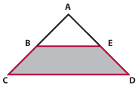

**a) 24 b) 16 c) 30 d) 18**

1. Triangle PQR is right angled at Q and line segment QS is perpendicular to PR. If line segment PS has a length of 16 and line segment SR has a length of 9, what is the area of 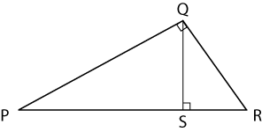triangle PQR?

**a) 100 b) 200 c) 75 d) None of the above**

1. The perimeter of an equilateral triangle equals the perimeter of a rectangle. If one of the dimensions of the rectangle is the same as the side of the triangle, find the ratio of the areas of the triangle and rectangle.

**a) √3: 2 b) 2: √3 c) 1: 2 d) None of the above**

1. Consider a square ABCD. P is a point on side BC and Q is a point on side CD. If the area of triangle PCQ is 24 cm2 and PC is 2 cm longer than CQ, find the length of PQ.
2. **5<PQ<8 b)8<PQ<11 c)11<PQ<14 d)None of the above**
3. How many right triangles with integer sides can be constructed, with 15 being one of the sides of the right triangle?

**a) 2 b) 3 c) 4 d) 5**

1. In triangle ABC, angle A is 30 degrees, angle C is 105 degrees and a = 8. Find b.

**a) 4√2 b) 6√2 c) 8√2 d) 10√2**

1. Triangle AOB is constructed such that A and B are points on the circumference of a unit circle while O is the centre. Triangle AOB has the maximum possible area. Find the area of sector AOB.

**a) π/2 b) π/3 c) π/4 d) π/6**

1. A ladder leans against a vertical wall. The top of the ladder is 8m above the ground. When the bottom of the ladder is moved 2m farther away from the wall, the top of the ladder rests against the foot of the wall. What is the length of the ladder?

**a) 15 b) 17 c) 5 d) None of the above**

1. How many differently shaped triangles exist, in which no 2 sides are of the same length, each side is of integral length and perimeter of the triangle is less than 14 units?

**a) 3 b) 4 c) 5 d) 6**

1. 8, 13 and x are three sides of an obtuse angled triangle. How many integer values can x take?

**a) 5 b) 10 c) 15 d) Infinite**

1. If 7 and 9 are 2 sides of a triangle, then which of the following is not a possible value of the area of the triangle?

**a) 20 b) 25 c) 35 d) 5**

1. How many right triangles with integer sides can be formed with 25 being one of the sides of the triangle?

**a) 2 b) 3 c) 4 d) 5**

1. Triangle ABC is an equilateral triangle inscribed inside a circle. K is any point on arc AB. Which of the following is true?

**a) KC < KA + KB b) KC = KA + KB c) KC ≤ KA + KB d) KC ≥ KA + KB**

1. (3)(47) and 48 are the 2 smaller sides of a right angled triangle. Find the hypotenuse.

**a) 49 b) (40)46 c) (80)45 d) None of the above**

1. In triangle PQR, PQ=PR=11 and S is a point on QR such that PS=10 cm. If the lengths of QS and SR are integers, find the length of QR.

**a) 5 b) 10 c) 15 d) None of the above**

1. How many triangles with perimeter 14 cms are possible, if each side is an integer.

**a) 3 b) 4 c) 5 d) More than 5**

1. 7 cm and 8 cm are two sides of a triangle. Which of the following cannot represent the ratio of the circum radius to the in radius of this triangle?

**a) 7:3 b) 5:3 c) 11:3 d) Depends on the third side**

1. Consider the figure shown in which BC= 12 cm, DB= 9 cm, CD= 6 cm and angle BCD= angle BAC.

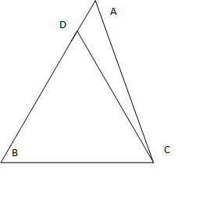

What is the ratio of the perimeter of the triangle ADC to that of the triangle BDC?

**a) 7/9 b) 8/9 c) 6/9 d) 5/9**

1. In triangle ABC, M is the midpoint of side AB and N is the midpoint of side AC. P is the midpoint of AM and Q is the midpoint of AN. Find the area of triangle APQ if the area of triangle BCM is 32 square units.

**a) 2 b) 4 c) 8 d) None of the above**

1. A 10 feet ladder is standing vertical to the ground along a wall. If its foot is moved 6 feet away from the wall, by how many feet does the top of the ladder move down?

**a) 1 b) 2 c) 3 d) 4**

1. ABC is a triangle. D is a point on BC,E is a point on AB and F is a point on AC such that DE is perpendicular to AB and DF is perpendicular to AC.DE: EB = 8: 5 and AF: FC = 5: 4. Find (area of triangle AED)(area of triangle AFD)/(area of triangle EBD)(area of triangle FCD).

**a) 3:1 b) 2:1 c) 1:2 d) Cannot be determined**

1. The ratio of the perimeters of two similar triangles is 3:1. Find the ratio of their areas.

**a) 3:1 b) 6:1 c) 9:1 d) Cannot be determined**

1. Find the area of the largest square that can fit into a semicircle of area 50π square units.

**a) 100 b) 80 c) 60 d) None of the above**

1. Two poles of height 2m and 3m are 5m apart. Find the height of the point of intersection of the lines joining the top of each pole to the foot of the opposite pole.

**a) 3 b) 2 c) 1.2 d) None of the above**

1. If a circle is drawn inside a square which is drawn inside a circle which is drawn inside a square which is drawn inside a circle, find the ratio of the areas of the outermost circle to the inner most circle.

**a) 2:1 b) 3:1 c) 4:1 d) 8:1**

1. C is a circle with centre C0. Let PQ be a diameter of C. C1 is the midpoint of C0Q, C2 is the midpoint of C1Q and so on. Certain number of circles are now constructed with diameters as C0Q, C1Q, C2Q and so on. If the sum of the areas of the constructed circles is 341 sq cm and the area of the circle with centre C0 is 1024 sq.cm, how many circles are constructed?

**a) 4 b) 5 c) 6 d) 7**

1. P, Q, R, S are points on the circumference of a circle such that PSR is an equilateral triangle and PQ is the diameter. Find the perimeter of the quadrilateral PQRS if PQ= 8cms.

**a) 8√3 b) 8(√3 + 1) c) 16√3 d) None of the above**

1. Two circles are placed against a right angle as shown. Given that R=2 cms , find r

**a) 3 - 2√2 b) 4 - 2√2 c) 7 - 4√2 d) 6 – 4√2**

1. The difference in the circum circle and in circle area of an equilateral triangle is 144 π units. Find the perimeter of the triangle.

**a) 24 b) 72 c) 48 d) 96**

1. 2 equal circles intersect each other at 2 points P (0, 2) and Q (0,-2). The tangent to circle 1 passes through P and the centre of circle 2 while the tangent to circle 2 passes through P and the centre of circle 1. Find the area of either circle.

**a) 4π b) 8π c) 1 2π d) 16π**

1. In a semicircle with diameter AD=8 a chord BC parallel to AD is placed such that AB=CD=2. Find the length of BC.

**a) 7 b) 7.5 c) 7.75 d) 8**

1. 2 equal circles of radius r each and centres X and Y cut each other at points G and H. If angle GXY is 45 degrees, and area of the triangle HXY = 18 cm2, find the radius r.

**a) 6 b) 9 c) 12 d) None of the above**

1. An equilateral triangle, a square and a circle all have the same area. If t , s and c denote their perimeters respectively , then

**a) t>s>c b) t<s<c c) t>c>s d) s>t>c**

1. A tangent PT is drawn to a circle from an external point P, with T as the point of tangency O is the centre of the circle and PO intersects the circle at M. If OP/PT>2, find the least possible integer value of OM/MP?

**a) 7 b) 6 c) 5 d) 4**

1. Find the maximum number of 4 cm chords that can fit into a circle of radius 4 cm, given that no two chords should intersect inside the circle.

**a) 2 b) 4 c) 6 d) More than 6**

1. ABCD is a square that circumscribes a circle of radius R. E is a point on side AB such that AE= 10 units. G is a point on AD such that AG is 20 units. F is a point on the circumference of the circle such that AEFG is a rectangle lying outside the circle but inside the square. Find the radius of the circle.

**a) 40 b) 50 c) 60 d) 70**

1. A circle is inscribed in a right triangle whose smaller sides are 50 and 120. Find the radius of the circle.

**a) 10 b) 20 c) 30 d) 40**

1. The number of diagonals in a regular polygon exceeds the number of sides by 250%. Find the measure of each angle in the regular polygon (in degrees).

**a) 108 b) 135 c) 144 d) None of the above**

1. ABCD is a square of sides of length 10 units. OCD is an isosceles triangle with base CD.OC cuts AB at a point Q and OD cuts AB at point P. The area of trapezoid PQCD is 80 square units. Find the altitude from O in triangle OCD.

**a) 10 b) 25 c) 20 d) cannot be determined**

1. Find the length of the side of the largest square that can be inscribed in an equilateral triangle of side 1 unit.(approx)

**a) 0.35 b) 0.4 c) 0.45 d) 0.5**

1. Let S1, S2 ..........Sn be squares such that for each n ≥ 1, the length of the diagonal of Sn equals the length of the side of Sn+1. If the length of the side of S3 = 4 cm, find the length of the side of Sn .

**a) 2(n-1) b)2(n-1) c)2(n+1)/2 d)2(2n+1)/2**

1. Find the sum of all the internal angles in a 5 pointed star

**a) 180 b) 240 c) 360 d) Cannot be determined**

1. A rectangular pool 20 meters wide and 60 metres long is surrounded by a walkway of uniform width. If the total area of the walkway is 516 square meters, how wide, in metres, is the walkway?

**a) 2 b) 3 c) 4 d) 5**

1. Two sides of a plot measure 32 meters and 24 meters and the angle between them is a right angle. The other two sides measure 25 meters each and the other three angles are not right angles. What is the area of the plot?

**a) 684 b) 192 c) 576 d) 784**

1. The number of diagonals in a regular polygon is 250% greater than the number of sides. Find the measure of each angle (in degrees) of the polygon

**a) 120 b) 135 c) 140 d) 144**

1. ABCD is a square with AC and BD the diagonals. With AC now as one of the sides, another square ACFE is constructed, with B being a point inside this square. Find the ratio of the areas of pentagon AEFCB and triangle ACD.

**a) 3:1 b) 4:1 c) 5:1 d) 6:1**

1. The length, breadth and diagonal of a rectangle are distinct integers. The length increased by 87.5%, while the breadth increased by 33.33% resulting in an “x” % increase in the diagonal. If the length, breadth and diagonal of the new rectangle are distinct integers as well, find the value of x.

**a) 56.25 b) 60.41 c) 66.66 d) 70**

1. ABCD is a parallelogram with ∠ABC = 60°. If the longer diagonal is of length 7 cm and the area of the parallelogram ABCD is 15 √3/2 sq.cm, then the perimeter of the parallelogram (in cm) is:

**a) 14 b) 15 c) 16 d) None of the above**

1. A rectangular sheet of paper, when halved by folding it at the midpoint of its longer side, results in a rectangle whose longer and shorter sides are in the same proportion as the longer and shorter sides of the original rectangle. If the shorter side of the original rectangle is 2, find the area of the original rectangle.

**a) 8 b) 4√2 c) 4 d) 2√2**

1. ABCDEF is a regular hexagon. Triangle ABD forms what portion of the area of the hexagon?

**a) 1/2 b) 2/5 c) 1/3 d) ¼**

1. Rectangular tiles each of size 70cm by 30 cm must be laid horizontally on a rectangular floor of size 130cm by 110 cm such that the tiles should not overlap. Also the tiles must not overshoot any edge of the floor. A tile can be placed in any orientation as long as its sides are parallel to the side of the floor. Find the maximum tiles that can be fit into the floor.

**a) 4 b) 5 c) 6 d) 7**

1. The angles of a polygon are all distinct integers. If the largest angle is 144 degrees, find the maximum number of sides the polygon can have.

**a) 8 b) 9 c) 10 d) Cannot be determined**

1. A square tin sheet of side 12 inches is converted into a box with open top in the following steps: The sheet is placed horizontally; Then, equal sized squares, each of size *x* inches, are cut from the four corners of the sheet; Finally, the four resulting sides are bent upwards in the shape of a box. If *x* is an integer, then what value of *x* maximizes the volume of the box?

**a) 3 b) 4 c) 1 d) 2**

1. A car is being driven, in a straight line and at a uniform speed, towards the base of a vertical tower. The top of the tower is observed from the car and, in this process, it takes 10 minutes for the angle of elevation to change from 45° to 60°. After how much more time will this car reach the base of the tower?

**a) 5(√3 + 1) b) 6(√3 + √2) c) 7(√3 - 1) d) 8(√3 - 2)**

1. ABCDEFGH is a regular octagon with side 1 cm with the vertices in that order. Find AF.

**a) √2 + 1 b) √3 + 1 c) 2.5 d) √7**

1. Find the maximum possible value of 21Sin x + 72Cos x.

**a) 57 b) 63 c) 72 d) 75**

1. Regular hexagon ABCDEF has a perimeter of 36. *O* is the center of the hexagon and of circle *O.*Circles A, B, C, D, E, and F have centers at A, B, C, D, E, and F, respectively. If each circle is tangent to the two circles adjacent to it and to circle *O*, what is the area of the shaded region (inside the hexagon but outside the circles)?

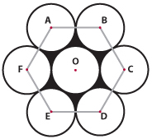

**a) 54√2 -27π b) 36√3 - 18π c) 54√3 - 27π d) None of the above**

1. Identify the correct relationship:

**a) 3 Sin12 =Sin36 +4 Sin312 b) 3 Sin12 =Sin36 -4 Sin312**

**c) 4 Sin12 =Sin 36 +3 Sin312 d) 4 Sin12 =Sin 36 –3 Sin312**

1. A person starts from A, and travels 50 meters to the east, and then 50 meters north-east at exactly 45° to his earlier direction to reach B. If the shortest distance between A and B is in the form of a √(b+ √c) meters, find the value of a + b + c.

**a) 52 b) 54 c) 56 d) None of the above**

1. ABCD is a quadrilateral with angle B being 60 degrees. AD = 5 cm and CD = 12 cm. Diagonal AC is also the diameter of a circle. AB = BC. What can be said about the following statements with respect to the quadrilateral and circle mentioned above?

Statement 1: The vertex B lies inside the circle

Statement 2: The area of the quadrilateral ABCD is greater than 100 cm2

**a) Statement 1 is true & statement 2 is false**

**b) Statement 2 is true & statement 1 is false**

**c) Both the statements are true**

**d) Both the statements are false**

1. A property dealer brought a rectangular piece of land at Rs. 100/sq. ft. The length of the plot is less than twice its breadth. Due to its size there were no buyers for the full plot. Hence he decided to sell it in smaller size pieces as given below. The largest square from one end was sold at Rs. 120/sq ft. From the remaining rectangle the largest square was sold at Rs. 115/sq. ft. Due to crash in the property prices, the dealer found it difficult to make profit from the sale of the remaining land. The ratio of the perimeter of the remaining land to the perimeter of the original land is 3:8, at what price the remaining part of the land has to be sold such that the dealer makes an overall profit of 10%?

**a) 50/sq. ft. b) 55/sq. ft. c) 60/sq. ft. d) 65/sq. ft**.

1. Ram draws a triangle on a paper and then Shyam draws a circle on the same paper. If “a” represents the minimum points of intersection of the triangle and the circle and “b” represents the maximum points of intersection of the triangle and the circle, how many values are there between “a” and “b” (exclude a and b)?

**a) 4 b) 5 c) 6 d) 7**

1. Consider a right circular cone of radius 2 and height 5. A right circular cylinder needs to be placed inside the cone with one of the flat surfaces resting on the base of the cone. Find the largest possible total surface area of the cylinder.

**a) 20*3.14/3 b) 25*3.14/3 c) 30*3.14/3 d) None of the above**

1. AB is a line segment with O being its mid point. X is any point on line segment AB. P is a point such that PX is perpendicular to AB. Also PX2 = (AX)(BX).Then,

**a) PO = AB/2 b) PO=AB/3 c) PO = 2(AB)/3 d) Nothing can be concluded**

1. A piece of paper is in the shape of a right angled triangle and is cut along a line that is parallel to the hypotenuse, leaving a smaller triangle. There was a 35% reduction in the length of the hypotenuse of the triangle. If the area of the original triangle was 34 square inches before the cut, what is the area (in square inches) of the smaller triangle?

**a) 16.665 b) 16.565 c) 15.465 d) 14.365**

1. There is a lizard on the top right vertex of a cubicle room of side 10 feet. It has to move to a stationary insect which is at the bottom left vertex (diagonally opposite vertex). Find the minimum distance to be travelled by the lizard.

**a) 10√3 b) 10√5 c) 10(√2+1) d) 30**

1. ABCD is a rectangle with AB=12 and AD=20. E and F are points on BC and CD such that EF=17. The midpoint of line EF is joined to the midpoint of line AF. This line measures 6.5.Find the area of triangle AEF.

**a)100 b)110 c)120 d)130**

1. AD is a diameter of the circle of radius 10. BC is a chord that measures 10 units and is parallel to AD. AB = 10 units. Find the area of the trapezium ABCD.

**a) 50√3 b) 75 c) 75√3 d) None of the above**

**Code: MECQ04**

**NUMBER THEORY**

1. The number of employees in a firm is a prime number less than 300. The ratio of the number of employees who are graduates , to that of employees who are not, can possibly be:

**a) 120:133 b) 87: 100 c) 110: 111 d) 97:84**

1. Find the number of times the digit 7 appears, when all positive integers from 500 to 999 are written down.

**a) 198 b) 200 c) 100 d) None of the above**

1. Find the value of √(84x76) + 25 + (63x57)

**a) 120 b) 99 c) 100 d) None of the above**

1. Find the sum of all whole numbers between 0 and 100 (inclusive) that are divisible by 2 or 5.

**a) 2950 b) 3050 c) 3000 d) None of the above**

1. Evaluate 1/(√2 + √1) + 1/(√3 + √2) + ..........1/(√9 +√8)

**a) 1 b) 2 c) 3 d) None of the above**

1. x and y are positive integers such that when x is divided by y, the remainder is 60. Which of the following can be the value of x/y?

**a) 15.15 b) 16.26 c) 17.38 d) 18.47**

1. a $ b = sum of divisors of ab. a # b = a $ b – (a + b). If a # b = 40, then find a $ b.

**a) 48 b) 50 c) 54 d) 56**

1. 1, 2, 3.............12. Find the number of distinct pairs of values from the given numbers whose product when divided by 13 leaves a remainder 1.

**a) 3 b) 4 c) 5 d) 6**

1. In how many ways can 240 students of a school be arranged in rows and columns such that the number of students per row is the same, the number of students per column is the same and there should not be lesser than 3 rows?

**a) 9 b) 10 c) 18 d) 20**

1. If 2a – 5b = k = 2c – 5d where a, b, c, d are positive integers each less than 10 and k is a positive integer as well , then a+b+c+d could equal

**a) 13 b) 14 c) 15 d) 16**

1. If (0.353535.... + 0.252525..... ) is written as a fraction in its lowest terms, the product of the numerator and the denominator is

**a) 550 b) 660 c) 770 d) 880**

1. Let N be a valid 3 digit number and R its valid reverse. For that value of N where N/R has the highest possible ratio, find the value of K = N+R.

**a) 800<K<900 b) 900<K<1000 c) 1000<K<1100 d) 1100<K<1200**

1. How many zeros does (10)10(11)11..................(30)30 end with ?

**a) 75 b) 100 c) 125 d) None of the above**

1. How many 4 digit numbers exist such that the first two digits are equal and the last two digits are also equal, and the number is a perfect square?

**a) 0 b) 1 c) 2 d) 3**

1. 3k is a factor of 1296. How many values can k take?

**a) 3 b) 4 c) 5 d) 6**

1. How many pairs of numbers exist such that their LCM = 96 and their HCF = 4

**a) 0 b) 2 c) 3 d) 1**

1. Find the sum √(1 + 1/12+ 1/22) + √(1 + 1/22 + 1/32) + ........ √(1 + 1/20072 + 1/20082)

**a) 2008 – 1/2008 b) 2007 – 1/2007 c) 2008 – 1/2007 d) 2007 – 1/2008**

1. Find the last digit of (2013)1 + (2013)2 + (2013)3 + …………….. (2013)2013

**a) 3 b) 9 c) 7 d) 1**

1. What values of x satisfy x2/3 + x1/3 -2 ≤ 0?

**a) -8 to 8 b) -8 to 1 c) 1 to 8 d) -1 to 8**

1. If x= (3065 - 2965)/(3064 +2964), find x.

**a)0<x<0.1 b) 0.1<x<0.5 c) 0.5<x<1 d) x>1**

1. Find the last 2 digits of 72008.

**a) 07 b) 03 c) 49 d) 01**

1. Find the last 2 digits of 2543

**a) 08 b) 28 c) 48 d) 68**

1. If 44x = 1600, find the value of (4x–1)2

**a) 3/2 b) 5/2 c) 7/2 d) None of the above**

1. If 3m = 5n = 15p, then which of the following is always true?

**a) m+n=p b) mn=p c) 1/m +1/n = 1/p d) None of the above**

1. Find the largest among the following

**a) 21/2 b) 31/3 c) 61/6 d) 121/12**

1. Find the units digit of 22013 + 31985 +72000

**a) 4 b) 5 c) 6 d) 7**

1. If n is a non-negative integer such that 12n is a divisor of 31793, what is the value of n12 – 12n

**a) 1 b) 0 c) -1 d) 3952**

1. In a certain game, a large bag is filled with blue, green, purple and red chips worth 1, 5, x and 11 points each, respectively. The purple chips are worth more than the green chips, but less than the red chips. A certain number of chips are then selected from the bag. If the product of the point values of the selected chips is 88,000, how many purple chips were selected?

**a) 1 b) 2 c) 3 d) 4**

1. Find the largest value of x such that 30! /3x is an integer.

**a) 14 b) 15 c) 10 d) None of the above**

1. A number N has 6 factors. Which of the following could be the number of factors of N2?

**a) Only 11 b) Only 15 c) 11or 15 d) 36 or 11 or 15**

1. If X is the 3 digit number with the largest number of factors, find X.

**a) 600 < X < 700 b) 700 < X < 800 c) 800 < X < 900 d) 900 < X < 1000**

1. How many numbers from 1 to 100 (both inclusive) have exactly 3 factors?

**a) 5 b) 10 c) 25 d) None of the above**

1. How many numbers from 1 to 50 (both inclusive) have exactly 4 factors?

**a) 15 b) 13 c) 16 d) 14**

1. Find the rightmost non zero digit of 302720

**a) 1 b) 3 c) 7 d) 9**

1. If 1/ 211 5 17 is expressed as a decimal, how many non zero digits will the decimal have?

**a) 1 b) 2 c) 4 d) 6**

1. 2, 2, 4, 8, 2,....... represents a sequence where each term from the third term represents the last digit of the product of the previous two terms. Find the 200th term of the sequence.

**a) 2 b) 4 c) 6 d) 8**

1. If a= 1034 – 1014 , b= 1024 – 1004 and c = 1014 – 994 , which of the following is true?

**a) a>b>c b) c>b>a c) a=b=c d) None of the above**

1. Find the approximate value of 1010 – 103 / 109 – 103.

**a) 1 b) 10 c) 100 d) None of the above**

1. Find (x,y) that satisfies the equation (20.7x )(3-1.25y)= 8√6/27

**a) (1,2) b) (1,5) c) (5,1) d) (5,2)**

x x

1. If 3 27 = 27 3  , find the value of x.

**a) 0 b) 0.5 c) 1 d) 3**

1. Find the remainder when 496 is divided by 6.

**a) 0 b) 1 c) 2 d) 4**

1. Find the remainder when 163 +173+183+193 is divided by 70.

**a) 0 b) 1 c) 35 d) 69**

1. Find the units digit of 1! + 2! + 3! …………2013!.

**a) 1 b) 2 c) 3 d) None of the above**

1. Find the remainder when (1)(1!) + (2)(2!) + (3)(3!) + ....... (10)(10!) + 7 is divided by 9.

**a) 2 b) 4 c) 6 d) 8**

1. Find the remainder when 153 + 233 is divided by 19.

**a) 0 b) 4 c) 15 d) 18**

1. Find the remainder when (1701)(1703)(1705)(1707) is divided by 17.

**a) 1 b) 3 c) 5 d) 7**

1. The sum of four consecutive two digit odd numbers, when divided by 10, becomes a perfect square. Which of the following can be one of the numbers?

**a) 21 b) 25 c) 41 d) 67**

1. Find the remainder when 14(7!) + 14(13!) is divided by 2(8!) - 21(6!).

**a) 0 b) 1 c) 7! d) None of the above**

1. Find the remainder when 99 – 218 is divided by 35.

**a) 0 b) 1 c) 17 d) 34**

1. Find the remainder when 24! is divided by 5! + 3! + 1!

**a) 1 b) 8 c) 27 d) None of the above**

1. Find the remainder when 260 is divided by 13.

**a) 1 b) 3 c) 5 d) 7**

1. Find the remainder when 311 – 3 is divided by 11.

**a) 3 b) 2 c) 1 d) 0**

1. Find the highest power of 3 in 101*102*103........................*200.

**a) 45 b) 47 c) 49 d) 51**

1. 100 ≤ n ≤ 1300. How many values can n take such that n is even and not a multiple of 7 or 9?

**a) 441 b) 449 c) 451 d) 459**

1. n is a positive integer lying between 10 and 20 (both inclusive). For how many values of n is (n+1)n greater than nn+1?

**a) 3 b) 2 c) 1 d) 0**

1. How many numbers greater than 100 but less than 2000 have exactly 3 factors?

**a) 9 b) 10 c) 11 d) 12**

1. There are 50 students 1-50 and there are 50 papers 1-50. An “alteration” is defined as changing the state of the paper i.e., If the paper has a mark on it, an alteration is removing the mark, while if there is no mark on the paper, an alteration is putting the mark. Initially all papers are unmarked. Student 1 alters the state of all pages that are multiples of 1. Student 2 then alters all pages that are multiples of 2 and so on until student 50 alters all pages that are multiples of 50. At the end of this process, how many pages out of the 50 are marked?

**a) 25 b) 7 c) 15 d) None of the above**

1. Find the remainder when 22013! is divided by 11.

**a) 8 b) 5 c) 3 d) 1**

1. K is a number that has 9 factors. How many factors does the square root of K have?

**a) 3 or 4 b) 3 or 5 c) 4 or 5 d) 3 or 4 or 5**

1. How many of the following statements are true?

Statement 1: 19! – 11 is a prime number

Statement 2: A 42 digit number comprising of only 1s is divisible by 33

Statement 3: 17017 has more than 15 factors

**a) 0 b) 1 c) 2 d) 3**

1. In a school, there are 100 students. All the pages of a book are numbered from 1 to 100. Student 1 signs on all pages. Student 2 signs on all pages where page number is divisible by 2. Student 3 signs on all pages where page number is divisible by 3 and so on. How many pages are signed by exactly three students?

**a) 2 b) 3 c) 4 d) More than 4**

1. A rectangular floor is fully covered with identical square tiles. The tiles on the edges are white while the tiles in the interior are red. The number of white tiles is the same as the number of red tiles. A possible value of the number of tiles along one edge of the floor is

**a) 10 b) 12 c) 14 d) 16**

1. Find the remainder when 43! Is divided by 813.

**a) 0 b) 1 c) 65 d) None of the above**

1. If 45 is expressed as a sum of ‘n’ consecutive positive integers, n > 1, find the sum of all the values ‘n’ can take?

**a) 19 b) 20 c) 23 d) 25**

1. How many ordered pairs (x,y) satisfy the equation xy – 3x + 2y = 42 where x and y are positive integers.

**a) 5 b) 6 c) 7 d) None of the above**

1. A father gave his two sons a total amount of money “N” which is an integer having an odd number of factors. The two brothers spent the entire amount on some packets of chilli chips and one packet of banana chips. One brother had the packet of banana chips along with some packets of chilly chips, while the brother just had chilly chips. Each packet of chilli chips cost Rs. 10 and the banana chips cost less than Rs. 10. The packets of chips were divided between two brothers so each brother received equal number of packets. How much money should one brother give to the other to make the division financially equitable?

**a) 1 b) 2 c) 4 d) 5**

1. Consider an integer N such that 0<N<50. The sum of the factors of N is odd. How many values can N take?

**a) 7 b) 8 c) 9 d) None of the above**

1. How many integers from 100 to 10000 are both perfect squares and perfect cubes?

**a) 1 b) 2 c) 3 d) 4**

1. Three consecutive integers are raised to their first, second and third powers respectively and then added. The sum so obtained is a perfect square, whose square root equals the total of the three integers. Which of the following, say “m” represents the smallest of these integers?

**a) 1<m<4 b) 3<m<6 c) 5<m<8 d) 7<m<10**

1. Find the highest power of 8 in 26!

**a) 3 b) 7 c) 11 d) None of the Above**

**Code: MECQ05**

**AVERAGES AND MIXTURES**

1. The average age of a couple when they got married was 30 years. 3 years later, a son was born to them. If the present average age of the family is 34 years, find the age of the son 5 years from now.

**a) 7 b) 10 c) 12 d) 17**

1. Ten years ago, the age of the members of a joint family of 8 people added up to 231 years. Three years later, one member died at the age of 60 years and a child was born during the same year. After another 3 years, one more member died at the age of 60 and again a child was born in the same year. The current average age of this 8 member joint family is approximately how many years?

**a) 22 b) 23 c) 24 d) 25**

1. In 200 litres of acid solution, there is 15% acid content. Find the range “ x “ of how many litres of acid solution with 30% acid content may be added to the original solution to form a resulting mixture of more than 20% but less than 25% acid content.

**a) 100<x<200 b) 100<x<300 c) 100<x<400 d) 100<x<500**

1. The scores of a student in ascending order obtained on 5 tests are 71, 76, 80, 82, 91. When the student entered his scores into a computer in a random order, it was programmed such that after each mark was entered, the average of the scores entered thus far, was always an integer. Which were the fourth and the fifth scores respectively entered?

**a) 76, 80 b) 80, 76 c) 71, 80 d) 91, 80**

1. The average of “n” numbers is 45. If two-thirds of the numbers decrease by 3 and the remaining one-third increase by 9, find the new average of all the numbers.

**a) 44 b) 45 c) 46 d) Cannot be determined**

1. If 12 ml of 10% concentration of alcohol is mixed with “X” ml of 17 % alcohol, the resultant mixture has a 13% alcohol concentration. If the “X” ml of 17% alcohol is mixed with “Y” ml of 18% alcohol, a new mixture of 17.4% concentration is obtained. Find the value of “Y”.

**a) 6 b) 8 c) 10 d) None of the above**

1. Vessel A contains 2/5 of milk and remaining water. Vessel B contains 1/5 of water and remaining milk. How many litres of vessel A should be mixed with 9 lt of vessel B to obtain an overall mixture that has 11/20 of the total content as milk and the remaining water?

**a) 11 b) 12 c) 14 d) 15**

1. A class has 31 students. If the top scorer’s score is not considered, the average score of the remaining students falls by 2 marks. Instead, if the lowest scorer’s score is not considered, the average score of the remaining students increases by 1 mark. If the top scorer’s score and the lowest scorer’s score is in the ratio 10:1, what is the score of the top scorer?

**a) 80 b) 100 c) 120 d) None of the above**

1. A set of consecutive positive integers beginning with 1 is written on the blackboard. A student erased one number. The average of the remaining numbers is 35 7/17. What was the number erased?

**a) 27 b) 17 c) 7 d) None of the above**

1. Consider the set S = {2, 3, 4......2n+1} where n is an integer greater than 2013. X is the set of all odd integers in S and Y is the set of all even integers in S. Find average of X- average of Y.

**a) (n+1)/2 b) (n-1)/2 c) 1 d) 0**

1. A milkman mixes 20 litres of water with 80 litres of milk. After selling 1/4th of the mixture, he replenishes the quantity he sold with water. Find the current proportion of water to milk.

**a) 2:3 b) 1:3 c) 1:2 d) 1:4**

1. A mixture comprises of orange and pineapple juice. From a vessel comprising 10 litres of orange juice, a jug of orange juice is drawn out and replaced with pineapple juice. Another jug of the mixture is drawn out and replaced with pineapple juice. Now the container contains equal volumes of orange and pineapple juice. Find the volume “x” of the jug.

**a) 2<x<2.5 b) 2.5 c) 2.5<x<3 d) 3**

**Directions for questions 13 to 15:** There are 5 ingredients which can be used in different proportions to form a diet. The table below gives the composition of the ingredients. The cost per unit of the ingredients is: O: 150 P: 50 Q: 200 R: 500 S: 100

|  |  |  |  |  |
| --- | --- | --- | --- | --- |
| Ingredient | Carbohydrate% | Protein% | Fat% | Mineral% |
| O | 50 | 30 | 10 | 10 |
| P | 80 | 20 | 0 | 0 |
| Q | 10 | 30 | 50 | 10 |
| R | 5 | 50 | 40 | 5 |
| S | 45 | 50 | 0 | 5 |

1. A diet should contain 10% minerals and at least 30% proteins. In how many ways can this diet be prepared by mixing at least 2 ingredients?

**a) 0 b) 1 c) 2 d) 3**

1. In what proportion should P, Q, S be mixed to have a diet containing at least 60% carbohydrates at the lowest cost per unit?

**a) 2:1:3 b) 4:1:2 c) 2:1:4 d) 4:1:1**

1. A diet should contain at least 30% each of carbohydrates and protein, no more than 25% fat and at least 5% minerals. Which of the following combinations of equally mixed ingredients is feasible?

**a) O&P b) O&S c) P&S d) R&S**

1. If a person weighing 50 kg was added to a group of 4 students, the average weight of the new group of 5 was 13.33% more than the average weight of the original group .Find the average weight of the original group.

**a) 28.66 b) 30 c) 33.33 d) 34**

1. There are 5 samples of milk A, B, C, D, E that have been diluted with water. The water concentrations in the 5 samples are 12%, 14%, 8%, 10% and 12% respectively. Three of these samples are to be chosen in order to ensure that when mixed in any proportion, the resultant of the water concentration in the mixture containing the three samples is at least 13%. In how many ways is this possible?

**a) 4 b) 5 c) 6 d) None of the above**

1. The average of 4 different positive even integers is 6. How many such sets of integers satisfy this condition?

**a) 1 b) 2 c) 3 d) 4**

1. Sample A contains 12 % methanol, sample B contains “x” % methanol while sample C contains “y”% methanol. x and y are positive integers satisfying 2x + 3y = 20 and x is greater than y. Equal amounts of A and C are mixed to form sample D. Samples B and D are now mixed in the ratio 6:5 to form sample E. Find the concentration of methanol in sample E.

**a) 91% b) 9% c) 7% d) None of the above**

1. If the average of seven different positive integers is k and if each integer is divided by 2, Find the new average.

**a) k/2 b) k-2 c) None of the above d) Cannot be determined**

**Code: MECQ06**

**TIME AND DISTANCE**

1. If P walks at his normal speed, he reaches at 6 pm. If he walks at 3/4 of his normal speed, he reaches at 7 pm. When will he reach if he travels at half his normal speed?

**a) 8 pm b)9 pm c)10 pm d) None of the above**

1. Two boats travelling at 5 and 10 km per hour, head directly towards each other. They begin at a distance of 20 km from each other. How far apart are they (in km) one minute before they collide?

**a) 1/2 b) 1/6 c) 1/4 d) 1/3**

1. A and B start from the same time from point X towards point Y which is 15 km away. A took 25 minutes to reach point Y while B was still 2.5 km away. If B had started 7 minutes earlier, who would have reached Y earlier and by how much time?

**a) A by 2 min b) B by 2 min c) A by 3 min d) B by 3 min**

1. In the time that Bob runs 3 steps, Tom runs 2 steps. Distance covered by Bob in 5 steps is the same as the distance covered by Tom in 4 steps. In a 6 km running race, who wins and by what margin?

**a) Bob by 1 km b) Tom by 1 km c) None of the above d) Can’t be determined**

1. Bob picks up Tom everyday from the station at 2pm. He leaves home at 1 pm. One day, Tom arrived at the station at 1:45 pm and hence started walking alone towards home. He met Bob on the way and they returned home 20 minutes earlier than usual. For how long did Tom walk alone?

**a) 5 min b) 10 min c) 8 min d) None of the above**

1. Car X is 20 miles behind car Y, which is travelling in the same direction along the same route as car X. Car X is travelling at a constant speed of 58 miles per hour and car Y is travelling at a constant speed of 50 miles per hour. How many hours will it take for car X to overtake and drive 8 miles ahead of car B?

**a) 2 b) 2.5 c) 3 d) 3.5**

1. A and B start together along opposite directions along a straight line towards each other. They are 600m apart. If they travel at their normal speeds, they meet in 12 seconds. Had both travelled at 5m/sec faster than their normal speeds, they would have met how many seconds earlier than usual?

**a) 1 sec b) 2 sec c) 3 sec d) Cannot be determined**

1. A, B and K start from the same place and travel in the same direction at speeds of 30, 40 and 60 km per hour respectively. B starts two hours after A. If B and K overtake A at the same instant, how many hours after A did K start?

**a) 3 b) 3.5 c) 4 d) 4.5**

1. P walks to and fro to a mall. He spends 30 minutes shopping. If he walks at a speed of 10 km an hour, he returns to home at 19:00 hrs. If he walks at 15 km an hour, he returns home at 18:30 hours. How fast must he walk in order to return home at 18:15 hours?

**a) 17.5 b) 20 c) 22.5 d) None of the above**

1. X and Y run a race between points A and B which are 5 km apart. X starts at 9 am from A at a speed of 5 km/hr , reaches B and returns to A. Y starts at 9:45 am from A at 10 km/hr, reaches B and returns to A. At what time do X and Y first meet each other?

**a) 10 am b) 10:10 am c) 10:20 am d) 10:30 am**

1. In the above question, at what time does Y overtake X?

**a) 10:20 am b) 10:30 am c) 10:40 am d) 10:50 am**

1. X and Y start at the same time from point A towards point B. X took 25 minutes to reach B. After he reached B, he saw that Y is still 2.5 km away from point B. The distance between A and B is 15 km. The next day Y leaves point A 7 minutes earlier than X. Then, Y reaches B?

**a) 2 min after X b) 2 min before X c) 3 min before X d) 3 min after X**

1. If a man cycles at 10 km/hr, then he arrives at a certain place at 1 pm. If he cycles at 15 km/hr, he will arrive at the same place at 11 a.m. At what speed must he cycle to get there at noon?

**a) 11 km/hr b) 12 km/hr c) 13 km/hr d) 14 km/hr**

1. A train takes a minute to cross a stationary pole. It takes 75 seconds to cross a 300 m long platform. Find the time taken by it to overtake a cyclist travelling at 18 km/hr.

**a) 60 sec b) 80 sec c) 100 sec d) 120 sec**

1. It takes the high-speed train x hours to travel the z miles from Town A to Town B at a constant rate, while it takes the regular train y hours to travel the same distance at a constant rate. If the high-speed train leaves Town A for Town B at the same time that the regular train leaves Town B for Town A, how many more miles will the high-speed train have travelled than the regular train when the two trains pass each other?

**a) (y-x)z/(y+x) b) (y-x)z/2y c) (y+x)z/(y-x) d) (y-x)z**

1. Two trains X and Y are travelling on parallel tracks and in opposite directions. M1 and M2 are two persons who are travelling on X and Y respectively. When the two trains just start to cross each other, M1, who is at the tail end of X, starts walking towards the front end of X, at a speed of 3m/s and M2, who is at the front end of Y starts running towards the tail end of Y at a speed of 4m/s. If the lengths of X and Y are 400 m and 480 m respectively, and the speeds of X and Y are 17m/s and 24m/s respectively, in how much time (from the time X and Y start to cross each other) will the two persons cross each other?

**a) 9.66 sec b) 10 sec c) 16.66 sec d) 12 sec**

1. X and Y start simultaneously from points A and B respectively towards each other at 30m/s and 20 m/s respectively. A and B are 500 m apart. If both travel back and forth from A to B continuously for 900 seconds, they would meet each other how many times?

**a) 25 b) 45 c) 65 d) Infinitely many**

1. Two people A and B start at the same time from two points P and Q along a straight line in opposite directions. They meet each other for the first time at a distance of x from point Q and for the second time at a distance of y from P when both A and B are on their respective return paths(ie when A is travelling from Q to P and B vice versa). If the distance between P and Q is L, which of the following is true?

**a) L = x+2y b) L = 3x+y c) L=4x-y d) L=3x-**

1. There are 2 people A and B who are 100m apart, start walking towards each other at speeds of 8 m/s and 12 m/s respectively. At the start, there is a fly on A’s head. As soon as the people start walking, the fly starts flying from A’s head towards B’s head. As soon as it reaches B’s head, it starts flying back towards A’s head and so on, till it gets killed between A’s and B’s head when they meet. If the speed of the fly is 18 m/s, find the distance travelled in metres by the fly (assume linear motion)

**a) 90 b) 80 c) 120 d) 360**

1. A runner starts running on a circular path of radius ‘r’ metres. His average speed (in metres/minute) is πr during the first 30 seconds, πr /2 during the next one minute, πr/4 during the next two minutes and πr/8 during the next 4 minutes, and so on. What is the ratio of time taken for the nth round to that for the previous round?

**a) 4 b) 8 c) 16 d) 32**

1. A beats B by p meters while B beats C by q meters in a race of length r meters. By what distance does A beat C?

**a) p+q b) p + q + pq/r c) ( p +q + pq)/r d) p + q – pq/r**

1. X plans to drive from a city A to C at a speed of 70 km per hour, to catch a train arriving there from B. He must reach C at least 15 minutes before the arrival of the train. The train leaves B, located 500 km south of A, at 8.00 am and travels at a speed of 50 km per hour. It is known that C is located between west and northwest of B, with BC at 60 degrees to AB. Also, C is located between South and Southwest of A with AC at 30 degrees to AB. The latest time by which X must leave A and still catch the train is closest to?

**a) 6: 15 am b) 6:30 am c) 6:45 am d) 7:00 am**

1. K and A run a 100 metre race, in which K beats A by 10 metres. To do a favour to A, K starts 10 metres behind the starting line in a second 100 metre race. They both run at earlier speeds. Which of the following is true about the second race?

**a) K and A finish together b) A beats K by 1 m c) A beats K by 11 m d) K beats A by 1 m**

1. Two trains have lengths of 200 m and 300 m. They take 50 seconds to cross each other if they travel in the same direction. They take 10 seconds to cross each other if they travel in opposite direction. Find the speed of the slower train.

**a) 10 m/s b) 15 m/s c) 20 m/s d) 25 m/s**

1. A train X departs from station A at 11.00 a.m. for station B, which is 180 km away. Another train Y departs from station B at the same time. Train X travels at an average speed of 70 km/hr and does not stop anywhere until it arrives at station B. Train Y travels at an average speed of 50 km/hr, but has to stop for 15 minutes at station C, which is 60 km away from station B enroute to station A. At what distance from A would they meet?

**a) 100km b) 106km c) 112km d) 118km**

1. At his usual rowing rate, R can travel 12 miles downstream in six hours less than it takes him to travel the same distance upstream. But if he could double his usual rowing rate for this 24 mile round trip, the downstream 12 miles would then take only one hour less than the upstream 12 miles. What is the speed of the current in miles per hour?

**a) 4/3 b) 5/3 c) 7/3 d) 8/3**

1. Two runners start simultaneously from point X around a circular track in opposite directions. The ratio of their speeds is 3:2. If the track is 500 m long, and the runners run indefinitely around the track at their respective speeds, at how many distinct points on the track to they meet?

**a) 2 b) 5 c) 15 d) infinitely many**

1. R,S and T went for a 100 km journey. R and T started the journey in R’s car at 25 km/hr while S walked at 5 km/hr. After some time, T got off and started walking at 5 km/hr while R went back to pick up S. All three of them reached the destination together. Find time taken for the journey.

**a) 6 hrs b) 7 hrs c) 8 hrs d) 9 hrs**

1. A and B travel around a circular track of length 300 m in opposite directions from the same point at speeds of 12 m/s and 17 m/s. Every time they meet, they reverse their directions. How many times did they meet each other after B reached the starting point 20 times?

**a) 29 b) 36 c) 40 d) 51**

1. ln a 200 m race, X gives Y a head start of 10 m and beats him by 10 m or 2 seconds. Find the time taken by X to run the race (in seconds).

**a) 16 b) 18 c) 20 d) None of the above**

**Code: MECQ07**

**TIME AND WORK**

1. In a nuts and bolts factory, one machine produces only nuts at the rate of 100 nuts per minute and needs to be cleaned for 5 minutes after production of every 1000 nuts. Another machine produces only bolts at the rate of 75 bolts per minute and needs to be cleaned for 10 minutes after the production of every 1500 bolts. If both the machines start production at the same time, what is the minimum duration in minutes required for producing 9000 pairs of nuts and bolts?

**a)130 b)140 c)170 d)180**

1. A, B, C together can finish a piece of work in 6 days. They work together for 2 days and then A leaves. B and C finish the work in another 7 days. A alone would have taken how many days to complete the work?

**a)10.5 b)14 c)11.33 d)None of the above**

1. Tap A fills 3/4 of a tank and tap B the remaining 1/4 in a total of 20minutes. Tap B fills 3/4 of the tank and tap A the remaining 1/4 in a total of 30 minutes. If both A and B work together, in how many minutes is the tank filled?

**a)10 b)10.5 c)11 d)11.5**

1. A group of 2K (K>5) persons can do a piece of work in K days. When the group started work one of them could not join work. The remaining people started the work and, starting from the first day, at the end of each day one person left the group. After the group finishes working in this manner, the remaining work, if any, is taken up on the immediately following day by the first person (who could not initially join the group) alone, who continues till the work is completed. In how many days will the work be completed?

**a)2K +1 b)3K c)3K -1 d)3K +1**

1. Working together, two workers completed a job in 5 days. Had the first worker worked

twice as fast and the second half as fast, it would have taken them 4 days to complete the job. In how many days will the first person working alone complete the job?

**a)8 b)10 c)12 d)Can’t be determined**

1. A group of men can complete a job in K hours. But after every 8 hours, half the number of men working at that point of time leaves the job. Continuing this way, if the job is finished in 40 hours, find the value of K.

**a)15 b)15.5 c)16 d)16.5**

1. A, B, and C work together to get some work done. The time it takes them to do the work together is six hours less than A would have taken working alone, one hour less than B would have taken alone, and half the time C would have taken working alone. How long did it take them to do the work working together?

**a)1.5 hours b)2.5 hours c)2 hours d)None of the above**

1. A can complete a piece of work in 4 days. B takes double the time taken by A. C takes double that of B, and D takes double that of C to complete the same task. They are paired in groups of two each. One pair takes two- thirds the time needed by the second pair to complete the work. Which is the first pair?

**a)A,C b)B,C c)A,D d)B,D**

1. X and Y can complete a piece of work in 6 days and 8 days respectively. If they both work on alternate days, starting with X, and earn Rs 320, then find the earnings of X in Rs.

**a)160 b)180 c)200 d)None of the above**

1. There are 4 tanks A,B,C,D containing 1000 litres (l) of water each. Water is being pumped from one tank to another as follows: From A to B @20 l/min , from C to A @90 l/min, from A to D @10 l/min ,from C to D @ 50 l/min , from B to C @100 l /min and from D to B @ 110 l/min. How long does it take that tank that gets emptied the fastest, to get emptied?

**a)15 min b)16.66 min c)20 min d)25 min**

1. P and Q can complete a job in t days, if they work together. P can complete in (t + 2) days and Q can complete it in (t+8) days. Find the value of t.

**a)3 b)4 c)5 d)Not unique**

1. Pipe A can fill a tank in 20 minutes. Pipe B can empty it in 40 minutes. Both were opened at noon on a certain day. After some time, B was closed. A completed filling the remaining part of the tank. The tank was full at 12:25 p.m. Find the time at which B was dosed.

**a)12:05 b)12:10 c)12:15 d)12:20**

1. A can finish a piece of work in 12 days, B in 18 days and C in 9 days. They work individually on each day, starting with A alone on the first day, B alone on the second day, C alone on the third day and so on. On the day that the work is exactly completed, who is working?

**a)A b)B c)C d)Cannot be determined**

1. A can complete a piece of work in 12 days. He works alone for “x” days and is then joined by B, who is twice as efficient as A and the entire work is completed in 6 days in total. Find “x”

**a)2 b)3 c)4 d)5**

1. A can complete a piece of work in x days, B in y days and C in z days. Together, all of them can complete the work in 6 days. If M represents the minimum value of x+y+z, then

**a)25<M<30 b)35<M<40 c)50<M<55 d)M>60**

**Code: MECQ08**

**LINEAR EQUATIONS**

1. 14 is a 2-digit number whose digits when reversed exceed the original number by 27. How many other such valid 2-digit numbers exist?

**a)4 b)5 c)6 d)More than 6**

1. The difference between the hundreds and tens digits is the same as the difference between the tens and units digit of a three digit number. The sum of the digits is 9. How many numbers satisfy the above conditions?

**a)3 b)4 c)5 d)6**

1. Each family in a locality has at most 2 adults and no family has fewer than 3 children. Considering all the families together, there are more adults than boys, more boys than girls, and more girls than families. Find the minimum possible number of families in the locality.

**a)2 b)3 c)4 d)5**

1. 10 apples, 4 bananas and 1 carrot costs Rs 80. 7 apples, 3 bananas and 1 carrot costs Rs 60. Find the cost of 2 apples, 2 bananas and 2 carrots.

**a)20 b)30 c)40 d)50**

1. 100 pieces of fruits are bought. The cost of buying them is Rs 100. An apple costs Rs 10 per piece, a mango Rs 3 per piece and a banana 50 paise per piece. If at least 1 piece of each type of fruit is bought, how many mangoes were bought?

**a)1 b)2 c)3 d)4**

1. A person has an unlimited supply of 1 Re, 10 Rs and 50 Rs notes with him. If he has to pay off a restaurant bill of Rs 100, in how many ways can he do so?

**a)6 b)12 c)18 d)None of the above**

1. A question paper consists of 30 questions. 1 mark is awarded for a right answer, ½ mark is deducted for a wrong answer and ¼ mark is deducted for an unattempted question. In how many ways can a student get a net score of 12?

**a)2 b)3 c)4 d)None of the above**

1. A question paper consists of 30 questions with 1 mark for a right answer and -1 mark for a wrong answer. In how many ways can a student get a net score of 18? No penalty for a question not attempted.

**a)6 b)7 c)8 d)None of the above**

1. 3 apples , 2 bananas and 4 carrots cost 100 Rs. 9 apples 9 bananas and 12 carrots cost 360 Rs. Find the cost of 24 apples , 29 bananas and 32 carrots.

**a)860 b)1020 c)1060 d)1280**

1. 6 years ago, the age of A was 2 yrs more than 5 times the age of B. 4 years later, his age will be 2 years less than 3 times the age of B. How many years from the present, will their combined age be 112 years?

**a)15 b)20 c)25 d)None of the above**

1. In an acute angled triangle with integral angles, 13 times one angle is 17 times another. What is the least possible angle in the triangle?

**a)30 b)40 c)45 d)52**

1. A 6 digit number N is of the form “ABCABC” where A, B, C represent digits. Which of the following is N always divisible by?

**a)101 b)1001 c)1010 d)None of the above**

1. A and B have an equal number of pens. If A gives m pens to B, then B would have 4 times as many pens as A. Instead if B gives n pens to A then A would have twice as many pens as B. Find the ratio n: m.

**a)5:4 b)4:5 c)5:9 d)4:9**

1. In a reaction, two species A and B are formed at different times. A reference time t0 (t0= 0) is selected. At time t equal to -2 µs (microseconds), the age of A is 18 µs more thanthree times that of B. When is the age of A exactly three times of B?

**a)4 b)5 c)6 d)7**

1. A is currently 12 years more than thrice of B’s age. After how many years will he be exactly 3 times B’s age?

**a)4 b)6 c)12 d)Cannot be determined**

1. In a 4- digit number, the sum of the first two digits is equal to that of the last two digits. The sum of the first and last digits is equal to the third digit. The sum of the second and fourth digits is twice the sum of the other two digits. What is the third digit of the number?

**a)4 b)5 c)8 d)9**

1. 3 pens, 5 pencils and 7 erasers cost Rs 80 while 5 pens, 8 pencils and 12 erasers cost Rs 120. Find the cost (in Rs)of 3 pens, 6 pencils and 6 erasers.

**a)80 b)100 c)120 d)None of the above**

1. How many 4 digit numbers exist such that the digit in the thousands position is 7 more than the digit in the units position while the digit in the tens position is 1 more than the digit in the hundreds position?

**a)18 b)27 c)36 d)None of the above**

1. Bag X contains red, white and blue marbles such that the red to white marble ratio is 1:3 and the white to blue marble ratio is 2:3.  Bag Y contains red and white marbles in the ratio of 1:4.  Together, the two bags contain 30 white marbles.  How many red marbles could be in X

**a)4 b)5 c)6 d)7**

1. Ram is currently 7 years more than twice of Rahul’s age. After how many years will Rahul be exactly half of Ram’s age?

**a)5 b)7 c)9 d)Cannot be determined**

1. A 3 digit number K is lesser than its reverse. If the difference between the reverse and the number is a multiple of 7, then which of the following is true :

**a)100<K<299 b)106<K<305 c)112<K<311 d)118<K<317**

1. If x and y are integers then the equation 5x+19y=64 has:
2. **No solution for x<300 and y<0**
3. **No solution for x>250 and y>-100**
4. **A solution for 250<x<300**
5. **A solution for -59<y<-56**
6. A says to B: “When you were 1/4 of my present age, I was 1/3 of your present age.”

If the sum of their present ages is 62 years, find the difference in their ages 7 years ago.

**a)1 b)2 c)3 d)4**

1. A doctor has to determine the weight of five children. He knows from his past experience that each of the children will weigh less than 30 kg and each of them would have different weights. Unfortunately, the scale available in the village can measure weight only over 30 kg. The doctor decides to weigh the children in pairs. However his new assistant weighed the children without noting down the names. The weights were: 35, 36, 37, 39, 40, 41, 42, 45, 46 and 47 kg. What is the weight of the lightest child?

**a)15 b)16 c)17 d)None of the above**

1. 1/m + 4/n = 1/12. How many solutions (m, n) exist if m and n are positive integers, with n being odd and less than 60?

**a)2 b)3 c)4 d)Infinite**

1. There are n numbers, each of which have the value 7 or 77. If the sum of all the n numbers is 350, which of the following is a possible value for n?

**a)26 b)28 c)30 d)32**

1. 63a + 7b + c = 435.Find the value of 2a + b + c, given that a, b, c are positive integers.

**a)20 b)21 c)22 d)23**

**Directions for questions 28 and 29:** In an examination, there are 100 questions divided into three groups A, B and C such that each group contains at least one question. Each question in group A carries 1 mark, each question in group B carries 2 marks and each question in group C carries 3 marks. It is known that the questions in group A together carry at least 60% of the total marks.

1. If group B contains 23 questions, then how many questions are there in group C?

**a) 1 b) 2 c) 3 d) cannot be determined**

1. If group C contains 8 questions and group B carries at least 20% of the total marks, which of the following best describes the number of questions in group B?

**a) 11 or 12 b) 12 or 13 c) 13 or 14 d) 14 or 15**

1. On a test comprising 200 questions, each right answer fetches 3 marks, while for each wrong answer, 1 mark is deducted. Questions can be left unattempted. How many distinct scores can a person writing this test get?

**a)798 b)801 c)797 d)None of the above**

**Code: MECQ09** **VENN DIAGRAMS**

**Directions for question 1 & 2:**

In a group of 200 people, 80 people do not like coffee while 110 people do not like tea. 40 people like both coffee and tea.

1. What is the number of people who like exactly one drink among coffee and tea?
2. **130 b) 80 c) 50 d) 170**
3. What is the number of people who like none of the two drinks?
4. **40 b) 30 c) 50 d)** **10**

**Directions for question 3 to 5:**

Ina class of 100 students, 45 like tea. The number of students who like neither tea nor coffee is 25% of those who like coffee. 33.33% of the students who like tea also like coffee.

1. How many like coffee but not tea?

**a)27 b)31 c)37 d)41**

1. How many like tea or coffee but not both?

**a)59 b)67 c)71 d)77**

1. How many do not like coffee?

**a)44 b)38 c)34 d)24**

**Directions for question 6 to 8:**

In a class of students, 6/17th of the students do not drink tea, while the number of students who drink coffee is 1.5 times the number of students who drink only tea. Also, the number of students who drink only tea exceeds the number of students who drink both by 20%.

1. Find the ratio of the number of students who drink only coffee to the students who drink only tea.

**a)2:3 b)4:5 c)3:2 d)5:4**

1. If there are 272 students in total, how many students drink at least 1 drink?

**a)236 b)238 c)240 d)None of the above**

1. If the total number of students is a value between 100 and 200 (both inclusive), what is the maximum possible difference between the students who drink both the drinks and the students who drink neither of the drinks?

**a)21 b)22 c)32 d)33**

**Directions for question 9 to 11:** Out of 300 students in a class, 90 boys like tea, 20 girls like coffee, 170 students like tea. There are 100 girls. Every girl who likes coffee likes tea also. 35% of the boys like coffee. The number of boys who like coffee as well as tea is the same as the number of girls who like coffee and tea.

1. How many students like neither tea nor coffee?

**a)80 b)90 c)70 d)50**

1. How many girls like tea but not coffee?

**a)40 b)50 c)60 d)Cannot be determined**

1. How many boys like only coffee?

**a)50 b)60 c)40 d)Cannot be determined**

1. A survey was conducted of 100 people to find if they had read recent issues of a magazine. The readership summary of 3 months is :

Only Sep:18 July:48 Sep:28 July&Aug:10 July&Sep:8

Sep but not Aug:23 None of the 3 months:24

How many read exactly 2 consecutive issues (out of the 3)?

**a)17 b)9 c)12 d)14**

**Directions for question 13 to 15:**In a group of 980 people, 380 people play cricket, 350 people play tennis, 470 people play football while 20 people play none of the 3 games. 70 people play both cricket and tennis, 110 people play both football and tennis, 90 people play both cricket andfootball.

1. What is the number of people who play all the three games?
2. **50 b) 60 c) 40 d) 30**
3. What is the number of people who play cricket and football but not tennis?
4. **60 b) 80 c) 65 d) 70**
5. What is the number of people who play only tennis?
6. **300 b) 250 c) 200 d) 100**

**Directions for question 16 to 18:**

Out of 300 students in a class, 100 like at least two of tea, coffee and milk. 230 like tea or milk, 180 like exactly one among the three. 80 like neither tea nor coffee, 130 like tea or coffee but not milk.

1. How many like at least one of tea or coffee along with milk?

**a)80 b)90 c)100 d)Cannot be determined**

1. How many like all three drinks?

**a)10 b)20 c)30 d)Cannot be determined**

1. How many like tea only?

**a)50 b)60 c)70 d)Cannot be determined**

**Directions for question 19 to 21:**

Help Distress (HD) is an NGO involved in providing assistance to people suffering from natural disasters. It has 37 volunteers. They are involved in 3 projects: Tsunami Relief (TR) , Flood Relief (FR) , and Earthquake Relief (ER). Each volunteer working with Disaster Relief has to be involved in at least one relief work project.

* A maximum number of volunteers are involved in the FR project. Among them, the number of volunteers involved in FR alone equals the volunteers having additional involvement in the ER project.
* The number of volunteers involved in the ER project alone is double the number of volunteers involved in all the three projects.
* 17 volunteers are involved in the TR project.
* The number of volunteers involved in the TR project alone is one less than the number of volunteers involved in the ER project alone.
* Ten volunteers involved in the TR project are also involved in at least one more project.

1. Based on the information given above, the minimum number of volunteers involved in both FR and TR projects, but not in the ER project is:

**a) 2 b) 4 c) 1 d) 5**

1. Which of the following additional information would enable to find the exact number of volunteers involved in various projects?

**a) 20 volunteers are involved in FR**

**b) 4 volunteers are involved in all the three projects**

**c) 23 volunteers are involved in exactly one project**

**d) No need for any additional information**

1. After some time, the volunteers who were involved in all the three projects were asked to withdraw from one project. As a result, one of the volunteers opted out of the TR project, and one opted out of the ER project, while the remaining ones involved in all the three projects opted out of the FR project. Which of the statements, then, necessarily follows?

**a) The lowest number of volunteers in now in TR project**

**b) More volunteers are now in FR project as compared to ER project**

**c) More volunteers are now in TR project as compared to ER project**

**d) None of the above**

1. 70% of the students in a class play football, 75% play cricket, 80% play hockey while 85% play tennis. Find the minimum % of students who play all the 4 sports.

**a)5 b)10 c)15 d)20**

**Directions for questions 23 to 25:**

In a group of 100 people, drinking at least 1 or more of 4 drinks – tea, coffee, milk and water, the number of people drinking exactly 1 drink is 8 times the number of people drinking all the drinks. The number of people drinking exactly two drinks is 15 less than the number of people drinking exactly 1 drink and also 5 times the number of people drinking all 4 drinks. Further, there are 10 people who drink tea, coffee and milk but not water, there are 8 people who drink tea , coffee and water but not milk and there are 7 people who drink tea, milk and water but not coffee.

1. How many people drink coffee, milk and water but not tea?

**a)5 b)4 c)6 d)Cannot be determined**

1. Find the maximum number of people who can drink tea.

**a)94 b)95 c)96 d)None of the above**

1. Find the minimum number of people drinking tea.

**a)25 b)28 c)30 d)None of the above**

**Code: MECQ10 HIGHER ALGEBRA (Functions & Quadratic)**

1. If (K + 1/K) = 7 , find the value of (K-1/K)2

**a)49 b)48 c)47 d)45**

1. If p and q are the roots of the equation x2 – 10x + 20 = 0, then find the value of p3 + q3.

**a)300 b)400 c)500 d)None of the above**

1. If p and q are the roots of a quadratic equation ax2 + bx + c =0 and p3+ q3 = -28 and pq= 3

Then a + b +c could equal? ( a, b , c are integers)

**a)8 b)9 c)10 d)11**

1. Let f(x) = ax2 + bx + c, where a, b and c are certain constants and a ≠ 0. It is known that

f(5) = - 3f(2) and that 3 is a root of f(x) = 0. What is the other root of f(x)=0?

**a)-7 b)-4 c)2 d)6 e)Cannot be determined**

1. In the above question, what is the value of a+b+c?

a**)9 b)14 c)13 d)37 e)Cannot be determined**

1. If x and y are real numbers, find the minimum value of x2 + 6y2 +4xy – 4y +4.

**a)0 b)2 c)-2 d)4**

1. A quadratic function f(x) attains a maximum of 3 at x = 1. The value of the function at x = 0 is 1. What is the value of f (x) at x = 10?

**a)–119 b)–159 c)–110 d)–180**

1. Let x, y be two positive numbers such that x + y = 1. Then, the minimum value of (x+1/x)2 +(y+1/y)2 lies between

**a)0 and 5 b)6 and 10 c)11 and 15 d)15 and 20**

1. If a, b, c and d are four positive real numbers such that abcd = 1, what is the minimum value of (1+a) (1+b) (1+c) (1+d)?

**a)4 b)8 c)12 d)16**

1. A and B attempted to solve a quadratic equation. A made a mistake in writing down the constant term. He ended up with the roots (4,3). B made a mistake in writing down the coefficient of x. He got the roots as (3,2). What will be the exact roots of the original quadratic equation?

**a)(-1,-6) b)(1,6) c)(4,2) d)None of the above**

1. A person is allowed to make 8 cuts on a cuboidal cake, in the x y or z directions ( ie parallel to the length , breadth or height). What is the maximum number of pieces that can be obtained?

**a)9 b)28 c)48 d)64**

1. The roots of the equation Ax3 + Bx2 + Cx +D = 0 are such that 2 roots are negative and 2 roots are equal in magnitude and opposite in sign. Which of the following is definitely positive?

**a)B/A b)C/A c)D/A d)None of the above**

1. There is a 2 digit number N such that the tens digit is more than the units digit. Also, the value of the number is 1 more than the sum of the square of the digits of the number. The square of the sum of the digits of the number is 6 less than twice the number. Find N.

**a)50<N<60 b)60<N<70 c)70<N<80 d)None of the above**

1. x + y = x2 - xy - y2. Find the number of non negative integral solutions of the given equation.

**a)1 b)3 c)6 d)Infinite**

1. x + y + x/y = 1/2 and (x + y)(x/y) = -1/2. Also x < 0, y < 0. Find x – y.

**a)1 b)-1/2 c)1/2 d)0**

1. Let f(x) = a2b3/c2 with a,b,c being integers lying between -2 and 3 (inclusive) and c not equal to 0. Find the maximum value of f(x)

**a)243/4 b)243 c)108 d)None of the above**

1. A, B, C, D are four positive numbers such that A>B>C>D and x is a negative number. Which of the following is the least?

**a) (A-x) (B-x) CD b)(A-x)BC (D-x) c)A(B-x) (C-x)D d) AB(C-x) (D-x)**

**Directions for questions 18 & 19:**

If x , y and z are integers, with x being more than 2 but not greater than 7, y not being lesser than - 4 but not being greater than the third smallest prime number, and z being greater than – 5 but smaller than 4.

1. The product of the smallest possible value of 1/z , the largest possible value x/y and the largest possible value of z-y is

**a) -49 b) -80 c) -119 d) None of the above**

1. The largest value of z2xy is

**a) 875 b) 720 c) 560 d) None of the above**

1. a, b, c, d are positive integers that satisfy ab2 = pq2. Also a > p. Which of the following must be true?
2. **ab > pq** **b) ab < pq c) a > p2 d) a < p2**
3. f(x) is a function satisfying f(x)f(y)=f(xy) for all real x,y. If f(2)=4, then find the value of f(1/2)

**a)1 b)1/2 c)1/4 d)1/16**

1. A function f (x) satisfies f (1) = 3600, and f (1) + f (2)+ ... +f (n) =n2 f (n), for all positive integers n > 1. What is the value of f (9) ?

**a)80 b)240 c)200 d)120**

1. Let f(x) = maximum (2x+1,3-4x) where x is any real number. Then the minimum possible value of f(x) is:

**a)1/3 b)2/3 c)4/3 d)5/3**

1. Let g(x) be a function such that g(x+1)+g(x-1)=g(x) for every real x, then for what value of p is the relation g(x+p)=g(x) necessarily true for every real x?

**a)5 b)3 c)2 d)6**

1. For which of the following functions does f(x) + f(y) = f(x+y) hold good always?

**a)f(a)= a+1 b)f(a) = 1/a c)f(a) = -3a d)None of the above**

1. If f(x) = x3 , g(x) = ln x and h(x) = e raised to x2 , then find f(g(h(x)))

**a)ex b)x3 c)x6 d)None of the above**

1. For which of the following does f(x)=f(1-x)?

**a)f(x) = 1/x2 b)f(x)=x2 c)f(x)=x2(1-x)2 d)None of the above**

1. Find x for which |x+1 |+ |x-5|+ |x+4| + |x-2|+|x-8| attains the minimum value.

**a)-4<x<-2 b)-2<x<0 c)0<x<2 d)x≥2**

1. If f(x) = log x, then which of the following is true?

**a)f(a) + f(b) = f(a+b) b)f(a)+f(b) = f(ab) c)f(a)f(b) = f(a+b) d)f(a)f(b) = f(ab)**

1. If a1=1 and an+1 – 3an +2 = 4n for every positive integer n , then a100 =

**a)399 – 200 b)399 + 200 c)3100 – 200 d)3100 + 200**

1. If f(x) = f(x-1) + f(x-2) , and f(0) = 0 and f(1) = 1 , then f(3k+1) where k is a positive integer greater than 10, is

**a)Always even b)Always odd c)Not an integer**

**d)Sometimes even , sometimes odd depending on the value of k**

1. x = (9 + 4√5)48 = [x] + f, where [x] is the integral part of x and f is a fraction. Then x(1 - f) =

**a) 1 b) Less than 1 c) More than 1 d) Between 1 and 2**

1. How many real values of x satisfy the equation x2 – 5|x|+ 6 = 0

**a)0 b)2 c)4 d)More than 4**

1. ||| x-1|-1|-1|= 0 has how many real solutions?

**a)1 b)2 c)3 d)More than 3**

1. If 3x + 2y = 60 , then the maximum possible value of xy is

**a) 144 b) 150c) 180d) 120**

1. x + 3|y| = 1 and x + y = - 3. Then xy could be equal to

**a) 12 b) 10 c) 2 d) None of the above**

1. For which value ofk does the following pair of equations yield a unique solution for x such that the solution is positive? x2 - y2 = 0 ; (x-k)2 + y2 = 1

**a) 2 b) 0 c) √2 d) -√2**

1. x2 + ax + b = 0 and x2 + bx + a = 0 have one root in common. If a ≠ b, Find a + b.

**a)-1 b)0 c)1 d)None of the above**

1. Find the number of solutions of |x – 1| + |x – 2| + |x – 7| = 6.

**a) 0 b)1 c)2 d)More than 2**

1. x 2 + ax + b = 0. This quadratic equation achieves a minimum at x = 7. If f (7)= -16 and p and q are the roots of the quadratic equation, then find |p – q|.

**a)6 b)8 c)10 d12**

1. If 3x + 2y = 60 , then the maximum possible value of xy is

**a) 144 b) 150c) 180d) 120**

1. x + 3|y| = 1 and x + y = - 3. Then xy could be equal to

**a) 12 b) 10 c) 2 d) None of the above**

1. x2 + ax + b = 0 and x2 + bx + a = 0 have one root in common. If a ≠ b, Find a + b.

**a)-1 b)0 c)1 d)None of the above**

1. Find the number of solutions of |x – 1| + |x – 2| + |x – 7| = 6.

**a) 0 b)1 c)2 d)More than 2**

1. x 2 + ax + b = 0. This quadratic equation achieves a minimum at x = 7. If f (7)= -16 and p and q are the roots of the quadratic equation, then find |p – q|.

**a)6 b)8 c)10 d12**

**Code: MECQ11**

**LOGARITHMS**

1. If log10x – log10√x = 2 logx10, then a possible value of x is

**a)0.1 b)1 c)10 d)100**

1. For x>0 and x not equal to 1 , log 16 (x) =

**a)2 log 2 (x) b)0.5 log 2 (x) c)0.25 log 2 (x) d)0.125 log 2 (x)**

1. P=K(10)-xt , then x equals

**a)log(P/K) / t b)(logP-logK)/t c)(logK-logP)/t d)KP/t**

1. If k= 1202 , find the value of 1/log2k + 1/log3k + 1/log4k + 1/log5k

**a)-1 b)0 c)0.5 d)1**

1. (loga + logb)/(loga – logb) = 10. Find the value of (a9 + 3b11)/(a9 + 4b11).

**a)3/4 b)4/5 c)9/11 d)None of the above**

1. 9^ (log416) + 36^(log93) = 10^ (logx87). Find x

**a)0<x<5 b)6<x<20 c)30<x<80 d)90<x<1200**

1. M2 + N2 = 14MN

log K(M+N) = 1/2 (log M + log N) . Find K

**a)1/2 b)1/4 c)1/16 d)1/8**

1. If log10x – log10√x = 2 logx10, then find the sum of the values x can take.

**a)100 b)100.10 c)100.01 d)None of the above**

1. Iflog(log(log x)) =0 , then x lies between

**a)107  and 1012 b)104 and 106 c)0 and 9999 d)None of the above**

1. If x≥y, and y>1, then the value of the expression logx(x/y) + logy(y/x) can never be:

**a) -1 b) -0.5 c) 0 d) 1**

1. If (1/3)log3M + 3log3N = 1 + log0.008 5, then :

**a) M9 = 9/N b) N9=9/M c) M3 = 3/N d) N9= 3/M**

1. If logyx = (a * logzy) = (b * logxz) = ab, then which of the following pairs of values for (a,b) is not possible?

**a) (-2,1/2) b) (0.4,2.5) c) (π, 1/π) d) (2,2)**

1. Find the number of digits in 2150. (log 2 = .3010)

**a)36 b)45 c)46 d)47**

1. If x, log10 x and log 10(log10 x) form an Arithmetic progression, then x lies in the interval

**a) 0 to 1 b) 1 to 10 c) 10 to 100 d) 100 to infinity**

15. The domain of the function f(x) = log7(log3(log5(20x – x2 – 91))) is

**a)(7,12) b)(8,12) c)(7,13) d)(8,13)**

**Code: MECQ12**

**COORDINATE GEOMETRY**

1. Find the equation of the line parallel to the line whose equation is y = 6x + 7 and passes through the point (3,2).

**a) y = -6x + 20 b)y = 6x + 8 c) y = 6x + 20 d)y = 6x -16**

1. In the x-y plane, the area of the region bounded by the graph |x-y| + |x+y| = 4 is

**a) 8 b)12 c)16 d)20**

1. Find the area of the region bounded by |x| +|y| = 5

**a)12.5 b)25 c)50 d)100**

1. Determine the area closed by the lines y=x+1 , x+y=1, x-y= 3 and x+y= -2

**a)6 b) 8 c)12 d)None of the above**

1. Consider a triangle drawn on the x-y plane with its three vertices at (41,0), (0,41) and (0,0), each vertex being represented by its ( x, y) coordinates. The number of points with integer coordinates inside the triangle (excluding all the points on the boundary) is:

**a) 741 b)780 c)800 d)820**

1. The line y=x cuts the line 4x+2y=9 at P and the line 2x+y=-6 at Q. Find PO:OQ

**a)2:3 b)3:2 c)3:4 d)4:3**

1. Consider the curve x2 + y2 +8x + 4y = 49. Which of the following is true about the point (3,2)?

**a) It lies inside the curve b) It lies on the curve**

**c) It lies outside the curve d) Nothing can be said**

1. **A= (7,4) B=(-10,0) C=(-10,3) D=(0,10) E=(7,7)**

The above represent the coordinates of 5 points. Every second, the points move by halving their abscissas and doubling their ordinates. This continues for 100 years. After 100 years, which two points are the closest?

**a) A and B b) B and D c) A and C d) A and E**

1. In a plane rectangle coordinate system, points A, B, C and D are represented by the coordinates (-5, 0), (1, -1), (0, 5) and (-1, 5) respectively. Consider a variable point P in the same plane. The minimum value of PA + PB + PC+ PD is:

**a) 1 + √37 b) 5√2 + 2√10 c) √41+ √37 d) √41 + 1**

1. Find the ‘y’ coordinate of the lowest point (along the y axis) on the coordinate plane that the curve y = x2 – x passes through.

**a)0 b) -1/2 c) -1/4 d)None of the above**

**Code: MECQ13**  **SEQUENCES AND SERIES**

1. 630 children are arranged in rows. Each row contains 3 fewer children than the row in front of it. Which of the following cannot be the number of rows?

**a) 3 b)4 c)6 d)7**

1. Find the no. of terms common to the sequences 17, 21, 25....417 and 16,21,26.....466.

**a)19 b)20 c)22 d)77**

1. All the page numbers from a book are added, beginning at page 1. However, one page number was added twice. The sum obtained was 1000.Find the page added twice.

a**)10 b)20 c)30 d)Cannot be determined**

1. Find the sum of all 3 digit numbers which when divided by3, leave a remainder of 2.

**a)168450 b)164850 c)186450 d)184650**

1. If the sum of the first 11 terms of an AP equals the sum of the first 19 terms, find the sum of the first 30 terms of the AP.

**a)-1 b) 0 c) 1 d) Not unique**

1. Find the sum: 1 + (1+2) + (1+2+3) ..... (1+2+3....+29+30)

**a)4940 b)4960 c)4980 d)None of the above**

1. Find the sum : 1/1 + 1/(1+2) + 1/(1+2+3) + 1/(1+2+3+4) ...... + 1/(1+2+3...+19+20)

**a)39/20 b)40/21 c)41/22 d)None of the above**

1. Find the value: (1*100) + (2*99) + (3*98) ….. (100*1)

**a)171700 b)161600 c)151500 d)None of the above**

1. Find the value: 1 + 2/5 + 3/25 + ………. Infinite terms

**a)8/5 b)25/16 c)7/4 d)29/16**

1. Find the value of: 1 + 3/2 + 5/4 + 7/8 + …………. Infinite terms

**a)47/8 b)25/4 c)55/9 d)6**

1. Find the value of 1 + (1+3) + (1+3+5) ……… + (1+3+5+……..29)

**a)1240 b)1230 c)1220 d)1210**

1. A ball is thrown down from a vertical tower of height 60m. The ball hits the ground and rises to 2/3 of the height it has fallen from, every time it rebounds. Consider this to be an infinite process. Find the sum of the vertical distance covered by the ball (in m).

**a)240 b)270 c)300 d)None of the above**

1. Find the value of 1/(52 – 1) + 1/(72-1) + ………… 1/(192-1)

**a)1/9 b)1/10 c)1/11 d)None of the above**

1. Find the value of 1+ 3/7 + 6/49 + 10/343 …..infinite terms.

**a)49/36 b)343/216 c)8/5 d)11/7**

1. Find the 24th term of the sequence: 4 , 10 , 18 , 28 ………..

**a)648 b)638 c)628 d)618**

1. Find the infinite sum: 12/70 + 22/71 + 32/72 + 42/73+ 52/74 +....................

**a) 27/14 b) 21/13 c) 49/270 d) 256/147**

1. S1 = {1} S2 = {2, 3, 4} S3 = {5 ,6, 7, 8, 9 } and so on. Find the sum of all elements in S41

**a)131681 b)132921 c)133291 d)None of the above**

1. 1, 2, 4, 8, 16, 31, 57, ?

**a)97 b)98 c)99 d)100**

1. Find the value of 31/3 * 91/9 * 271/27 *.................... infinite terms.

**a)3 b)31/2 c)32/3 d)33/4**

1. The integers 1, 2, ..., 40 are written on a blackboard. The following operation is then repeated 39 times: In each repetition, any two numbers, say a and b, currently on the blackboard are erased and a new number a + b — 1 is written. What will be the number left on the board at the end?

**a)779 b)780 c)781 d)Cannot be determined**

1. For a Fibonacci sequence, from the third term onwards, each term in the sequence is the sum of the previous two terms in that sequence. If the difference of squares of seventh and sixth terms of this sequence is 517, what is the tenth term of this sequence?

**a)109 b)123 c)137 d)Not unique**

1. In how many ways is it possible to form an AP with 1 being the first term, 1000 being the last term, the AP only consisting of positive integers, and containing at least 3 terms.

**a)3 b)4 c)7 d)8**

1. Consider a regular polygon of 20 sides. How many distinct regular polygons (excluding the original polygon) can be constructed, joining the vertices of the polygon.

**a)2 b)3 c)4 d)5**

1. All terms from 1, 2, 3……….. are written down and from these, all perfect squares are then removed. Find the 2014th term after the removals.

**a)2053 b)2055 c)2057 d)None of the above**

1. (1 – 1/4)(1 - 1/9)(1- 1/16)................(1- 1/225). Find the value.

**a)7/15 b)8/15 c)11/15 d)None of the above**

**Code: MECQ14** **Permutations, Combinations & Probability**

1. In how many ways is it possible to get exactly 3 heads when a coin is tossed 5 times?

**a)6 b)10 c)15 d)12**

1. In how many ways can the alphabets of the word BASKET be arranged such that the vowels occupy only the odd positions?

**a)24 b)96 c)108 d)144**

1. In how many ways can 5 boys and 5 girls sit on 10 chairs such that no 2 boys and no 2 girls sit next to each other?

**a)14400 b)28800 c)7200 d)None of the above**

1. How many 4 digit numbers exist such that the units position is even, the tens position is odd and the number is less than 6000?

**a)1250** **b)1249 c)1251 d)1000**

1. How many 3 digit palindromes exist?

**a)90** **b)99 c)100 d)None of the above**

1. In how many ways can a sum total of 14 be achieved if 3 dices are rolled simultaneously?

**a)9 b)12 c)15 d)18**

1. In how many ways can 6 people A,B,C,D,E,F sit on 6 chairs such that A always sits to the left of B, while C always sits to the right of D?

**a)20 b)30 c)40 d)60**

1. In how many ways can more heads than tails appear if 6 different coins are tossed together?

**a)18 b)20 c)22 d)24**

1. In how many ways can a question paper be answered if each question has 5 options to choose from and there are 20 questions and each question has to be answered?

**a)20 b)100 c)520 d)205**

1. In how many ways can 2 or more guests arrive at a party, if invitations are sent to 10 guests.

**a)1011 b)1012 c)1013 d)None of the above**

1. On an 8*8 chessboard, in how many ways can two squares be chosen such that they have only one corner in common?

**a)49 b)64 c)98 d)128**

1. A family consisting of one mother, one father, two daughters and a son is taking a trip in a car. The car has two front seats and three back seats. If one of the parents must drive and the two daughters refuse to sit next to each other, how many arrangements are possible?

**a)32** **b)36 c)24 d)48**

1. 9 basketball players are trying out to be on a basketball team. Of these players, 5 will be chosen for the team. If 6 of the players are guards and 3 of the players are forwards, how many different teams of 3 guards and 2 forwards can be chosen?

**a)30 b)60 c)90 d)None of the above**

1. There are 10 numbers, p1, p2,... p10, satisfying the condition p1>p2>p3....>p10. How

many sets of the form (a, b, c), where a>b>c, can be formed from these 10 numbers?

**a)10 C 3 b)10 P 3 c)10! d)None of the above**

1. A family will buy three cars. There are two models of cars available, Model A and Model B, each of which is available in four colours: blue, black, red, and green. How many different combinations of three cars can the family select if all the cars are to be of different colours?

**a)24 b)32 c)36 d)48**

1. In a tournament there are n teams T1 , T2 ........... Tn with n>5. Every team has k members with k>3.The following pairs of teams have exactly 1 member in common: T1 T2 , T2 T3 , ..........TnT1. No other pair of teams have any member in common. How many members are there in all teams put together?

**a)n(k-1)**  **b)k(n-1) c)nk d)k(n-2)**

1. How many integers greater than 999 but not greater than 4000 can be formed using the digits 0,1,2,3,4 if repletion of digits is allowed?

**a)499 b)500 c)375** **d)376**

1. In how many ways can 5 similar balls be distributed into 3 different boxes?

**a)15 b)18 c)21 d)None of the above**

1. In how many ways can an ant travel across an 8*8 chessboard, if it has to go from the leftmost and bottom most point on the board to the right most top most point ( It can only take steps in the east and north directions and has to reach along the shortest possible path)?

**a)8! b)16!/8! c)16!/8!8! d)Infinitely many**

1. Let S be the set of 5 digit numbers formed by the digits 1,2,3,4,5 using every digit exactly once such that exactly 2 odd positions are occupied by odd digits. What is the sum of digits in the rightmost position of the numbers in S?

**a)192 b)216 c)228 d)294**

1. In a competition involving boys and girls, every person had to play against everyone else exactly once .After the competition, it was found that in 45 games ,both were girls while in 190 games both were boys. How many games were played between a boy and a girl?

**a)200** **b)216 c)235 d)256**

1. The alphabets T,U,E,S,D,A,Y are permuted such that each letter occurs exactly once, T is not in the first position and the vowels occur in the even position. In how many different ways can it be done?

**a)96 b)108 c)120 d)144**

1. N people stand on the circumference of a circle at distinct points. Each possible pair of persons , not standing next to each other, sings a 2 minute song one after the other. If the total time taken for singing is 28 minutes, find N.

**a) 6 b)7 c)8 d)9**

1. Find the number of distinct terms in the expansion of (a+b+c)20

**a)221 b)231 c)237 d)241**

1. If all the letters of the word “C H C L J”, be arranged in the English dictionary, what will be the 50th word?

**a)HCCLJ b)LCCHJ c)LCCJH d)JHCLC**

1. 10 different coins are tossed. Find the probability that the outcomes have exactly 6 heads and 4 tails.

**a)105/1024 b)210/1024 c)315/1024 d)6/10**

1. A new flag is to be designed with six vertical stripes using some or all of the colours yellow, green, blue and red. Then the number of ways this can be done so that no two adjacent stripes have the same colour is

**a) 12*81 b) 16*192 c) 20*125 d) 24*216**

1. There are 12 towns grouped into four zones with three towns per zone. It is intended to connect the towns with telephone lines such that every two towns are connected with three direct lines if they belong to the same zone, and with only one direct line otherwise. How many direct telephone lines are required?

**a) 72 b) 90 c) 96 d) 144**

1. In a bank, every account number is of the form 2abcdefg. An account number is a magic number if abc is the exact same as def or efg or both. If a, b, c, d, e,f, g can take values from 0 to 9 but 20000000 is not a valid account number , how many magic numbers are there?

**a)19988 b)19989 c)19990 d)None of the above**

1. Five different letters 1,2,3,4,5 have five corresponding envelopes A,B,C,D,E respectively. In how many ways is it possible to put exactly two letters into their correct envelopes?

**a)10 b)20 c)30 d)None of the above**

1. For n > 1, find ∑ (r)(nCr)

**a)(n)(2n) b)(n-1)(2n) c)(n)(2n-1) d)(n-1)(2n-1)**

1. In an 8*8 chessboard, with each small square has side equal to 1 unit. Among all the rectangles on the chessboard, how many of them have an area of 6 units

**a)96 b)120 c)144 d)None of the above**

1. There are 3 people A, B and C. Find the number of ways in which exactly two of them are born on the same day of the week.

**a)42 b)84 c)126 d)None of the above**

1. Consider set X {1,2,3………20}. How many ordered sub sets Y of the form {a,b} containing 2 different elements from the set X can be formed given that b>a?

**a)190 b)380 c)95 d)None of the above**

1. Find the probability that exactly 2 out of 3 men are born on the same day of the week.

**a) 21/343 b) 42/343 c) 126/343 d) 84/343**

1. X has a small deck of 12 playing cards made up of only 2 suits of 6 cards each. Each of the 6 cards within a suit has a different value from 1 to 6; thus, for each value from 1 to 6, there are two cards in the deck with that value. X likes to play a game in which he shuffles the deck, turns over 4 cards, and looks for pairs of cards that have the same value. What is the chance that X finds at least one pair of cards that have the same value?

**a)16/33 b)17/33 c)19/33 d)None of the above**

1. P plays 3 rounds of a game, in which his chances of winning each round are1/3,1/6 and 1/n respectively. Find the probability that P wins the first two rounds, but loses the third?

**a)n/18 b)n-1/18 c)1/18n** **d) (n-1)/18n**

1. If a jury of 12 people is to be selected randomly from a pool of 15 potential jurors, and the jury pool consists of 2/3 men and 1/3 women, what is the probability that the jury will comprise at least 2/3 men?

**a)13/23 b)67/91 c)65/91 d)None of the above**

1. A and B will play one game of Rock, Paper, Scissors. In this game, each will select and show a hand sign for one of the three items. Rock beats Scissors, Scissors beat Paper, and Paper beats Rock. Assuming that both A and B have an equal chance of choosing any one of the hand signs, what is the probability that A will win?

**a)1/2 b)1/3 c)1/4 d)None of the above**

1. Find the probability of obtaining a sum total greater than 4 when 2 dices are rolled together.

**a)3/4 b)4/5 c)5/6 d)8/9**

1. 3 out of 10 bulbs are defective. Find the probability that when 2 bulbs are selected at random, from these 10 bulbs, exactly 1 of them is defective.

**a)1/3 b)7/15 c)7/30 d)None of the above**

1. In a “ best of 5 match tournament“ between 2 teams , the team that is the first to win 3 matches is considered the winner of the tournament and as soon as that happens , the tournament is stopped. For example, if team “X” wins the first 3 matches, it has won the tournament and no more matches will take place. If each team has an equal chance of winning and losing every match in the tournament, find the probability that the tournament was not decided until the final match.

**a)3/4 b)3/8 c)3/16 d)3/32**

1. Bag A contains 5 red and 3 black balls while bag B contains 4 red and 2 black balls. Find the probability that when a bag is chosen at random, and 2 balls are drawn from it , both the balls so chosen are red.

**a)47/140 b)53/140 c)59/140 d)None of the above**

1. Set A comprises of {1,2,3,4} while set B comprises of {3,4,5,6,7}. One element is chosen from each of the sets. Find the probability that the sum of the elements is a multiple of 3.

**a)1/4 b)2/5 c)3/10 d)None of the above**

1. Find the probability that when 6 students A,B,C,D,E,F are sitting on 6 chairs, A is to the left of B who is to the left of C who is to the right of D.

a)**1/24** **b)1/16 c)1/4 d)None of the above**

**Code:MECDI DATA INTERPRETATION**

**Directions for questions 1 to 4:**

Raigarh steel plant is Orissa has been producing steel from 2001 to 2006. Steel produced is either used for domestic consumption or exported to other countries. The following bar graphs show the quantity of steel produced and the quantity of steel exported in each of the six years

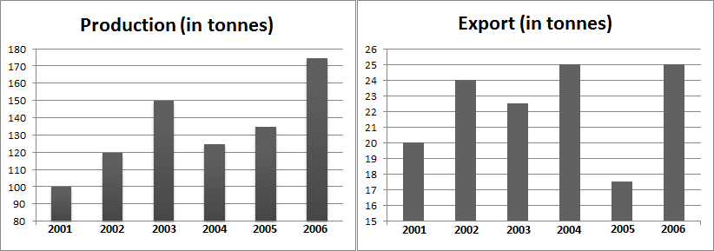

1. In which year is the domestic consumption of steel as a percentage of total production the highest?
2. **2003 (b) 2004 (c) 2005 (d) 2006**
3. In the year 2004, 20% of steel meant for domestic consumption was used in the automobile industry. In the year 2006, 20% of steel meant for domestic consumption was used in the automobile industry. What is the percentage increase in the steel used in automobile industry in 2006 compared to that of 2004?
4. **0 percent (b) 50 percent (c) 33.33 percent (d) 20 percent**
5. Domestic consumption in all the six years put together is approximately what percentage more than the exports in all the six years put together?
6. **400 percent (b) 500 percent (c) 300 percent (d) 280 percent**
7. In 2007, the exports increased by 20% over the previous year. By how many tonnes should the production increase such that domestic consumption is 85% of the production?  
   **(a) 15 tonnes (b) 30 tonnes (c) 50 tonnes (d) 25 tonnes**

**Directions for questions 5 to 8:**

The graph below lists the number of overseas students (percentage-wise split up) from various locations admitted into the Portland University in the years 2007-20012. The total number of students admitted to Portland University from these six locations in the years 2007, 2008, 2009, 2010, 2011 and 2012 are 600, 700, 600, 800, 900 and 1000 respectively.

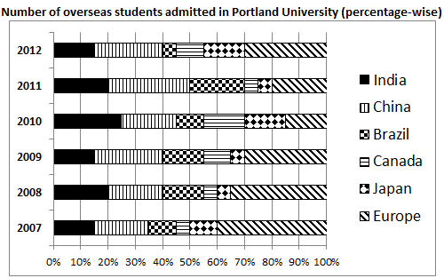

1. What is the total no. of Indian students admitted into Portland University in the 6 years?
2. **850 (b) 825 (c) 805 (d) 750**
3. In which of the following years is the number of Canadian students admitted in Portland University the least?
4. **2009 (b) 2007 (c) 2008 (d) 2011**
5. In 2007, 20% of the European students admitted to Portland University were Germans while in 2012 it was 25%. Find the percentage increase in the number of German students studying in Portland University in 2012 to that of 2007.
6. **27% (b) 43.75% (c) 56.25% (d) 58.83%**
7. In how many years is the number of students from Asian countries (India, China and Japan) admitted into Portland University more than 400?
8. **0 (b) 1 (c) 2 (d) 3**

**Directions for questions 9 to 11:**

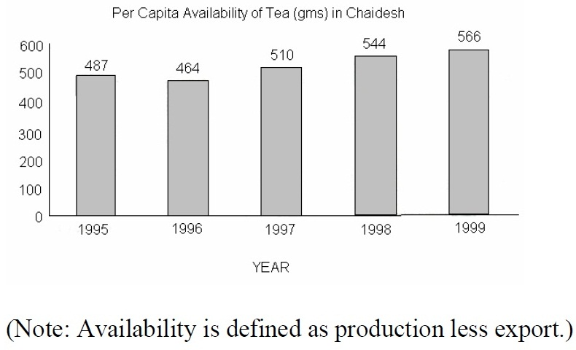

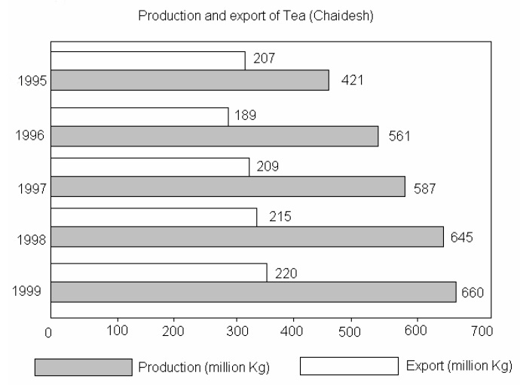

1. In which year during the period 1996-1999 was Chaidesh’s export of tea as a proportion of tea, the highest?

**(a)1996 (b)1997 (c)1998 (d)1999**

1. In which of the following years was the population of Chaidesh the lowest?

**(a)1995 (b)1996 (c)1997 (d)1999**

1. The area under tea cultivation continuously decreased in all four years from 1996 to 1999, 10%, 7%, 4% and 1%, respectively. In which year was tea productivity (production per unit of area) the highest?

**(a)1999 (b)1998 (c)1997 (d)1996**

**Directions for questions 12 to 15:**

Romania produces exactly five agricultural commodities every year. If the production of a particular commodity in a year is more than its requirement then it is exported whereas if the production is less than its requirement then it is imported. The graph given below shows the volume of production (in million tonnes) of the five commodities in Romania from 2001 to 2005.

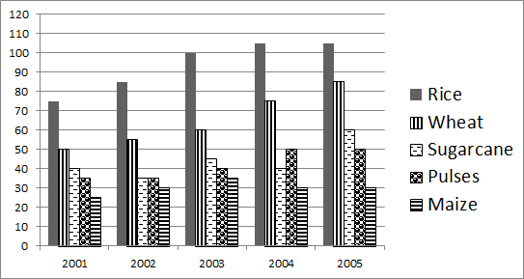

The total requirement of the five commodities together in 2001 was 200 million tonnes; it increased by 25% in 2002 compared to 2001; the requirement in 2003 was same as that of 2002 while the requirement in 2005 was 20% more than 2004. The requirement in 2005 was 360 million tonnes.

The graph given below shows the percentage requirement of each commodity as a part of the total requirement of all commodities in each of the five years.

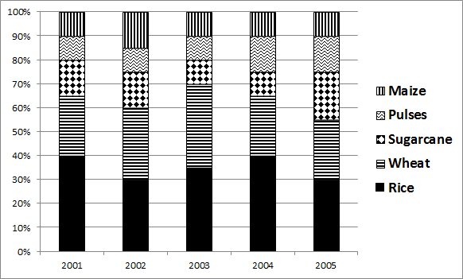

1. In which year did Romania import all the five commodities?

**(a) 2002 (b) 2003 (c) 2004 (d) 2005**

1. How many commodities did Romania export in 2002?
2. **1 (b) 2 (c) 3 (d) 4**
3. The difference between the requirement and production of Maize was the maximum in which year?
4. **2001 (b) 2002 (c) 2003 (d) 2005**
5. What was the total import (in million tonnes) of the five agricultural commodities in the year 2004?
6. **20 (b) 15 (c) 5 (d) 0**

**Directions for questions 16 to 19:**

A management institute was established on January 1, 2000 with 3, 4, 5 and 6 faculty members in the Marketing, Organisational Behaviour (OB), Finance, and Operational Management (OM) areas respectively, to start with. No faculty members retired or joined the institute in the first three months of the year 2000. In the next four years, the institute recruited one faculty member in each of the four areas. All these new faculty members, who joined the institute subsequently over the years, were 25 years old at the time of joining the institute. All of them joined the institute on April 1. During these four years, one of them retired at the age of 60. The following diagram gives the area-wise average age (in terms of number of completed years) of faculty members as of April 1 of 2000, 2001, 2002 and 2003.

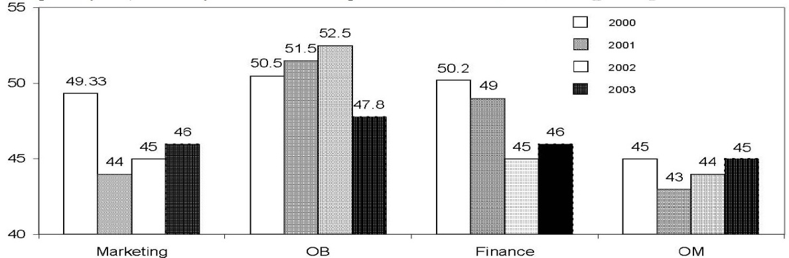

1. From which area did the faculty member retire?

**(a) Finance (b) Marketing (c) OB (4) OM**

1. Professors Naresh and Devesh, two faculty members in the Marketing area, who have been with the institute since its inception, share a birthday which falls on 20th November. One was born in 1947 and the other one in 1950. On April 1 2005, what was the age of the third faculty member, who has been in the same area since inception?

**(a)** **47 (b) 50 (c) 51 (d) 52**

1. In which year did the new faculty member join the finance area?

**(a) 2000 (b) 2001 (c) 2002 (d) 2003**

1. What was the age of the new faculty member, who joined the OM area, as on April 1, 2003?

**(a) 25 (b) 26 (c) 27 (d) 28**

**Directions for questions 20 to 22:**

The bar graph given below shows the data related to the number of people who took CAT, an entrance exam for top B-schools in the country, from the year 2008 to 2012.

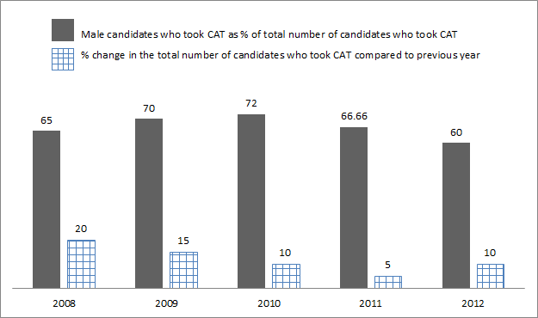

1. If the total number of females who took CAT in 2008 was 84000, find the number of people who took CAT in 2012.
2. **350658 (b) 318780 (c) 363764 (d) 335692**
3. Gender gap is defined as the difference between the number of male and female candidates who took CAT in a particular year. For which of the years from 2008 to 2012 is the ‘Gender Gap’ the highest?
4. **2009 (b) 2010 (c) 2011 (d) Cannot be determined**
5. Which of the following statements is true?
6. **The number of male candidates who wrote CAT in 2012 is less than the number of male candidates who wrote CAT in 2009**
7. **The year in which the highest number of female candidates wrote CAT is not 2012.**
8. **If the number of male candidates who wrote CAT in 2007 is 78% of the total number of candidates who wrote CAT in 2007, then the number of male candidates who wrote CAT in 2007 is the same as the number of the male candidates who wrote CAT in 2008.**
9. **The ratio of number of male candidates who wrote CAT in a particular year to that of the female candidates who wrote CAT in the same year is the highest for 2009.**

**Directions for questions 23 & 24:**The data points in the graph represent the monthly incomes and expenditures of the members belonging to four families – A, B, C and D. Each symbol represents the income and expenditure of a particular family member. Savings = Income – Expenditure

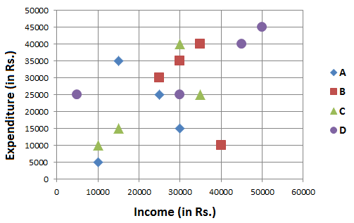

1. Which family has the highest savings?

a) **A b) B c) C d) D**

1. For how many families is the total income more than the total expenditure?

a) **3 b) 2 c) 1 d) 0**

**Directions for questions 25 to 28:**The data points in the figure below represent monthly income and expenditure data of individual members of the Ahuja family (shaded square), the Bose family (unshaded square), the Coomar family (unshaded circle) and the Dubey family (shaded circle)

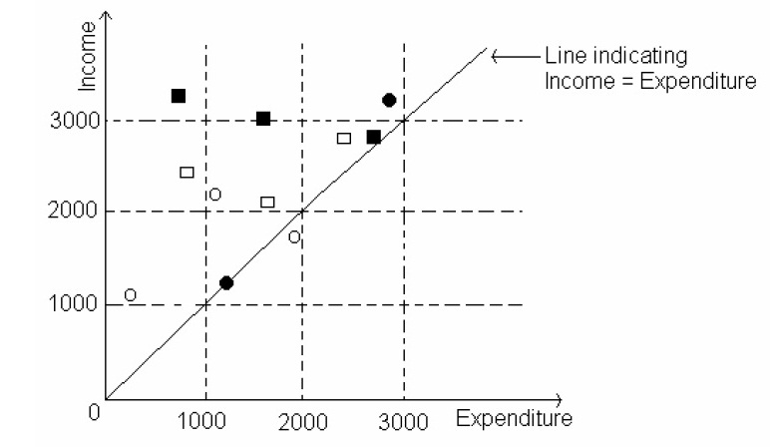

1. Which family has the lowest average income?

**(a)Ahuja (b)Bose (c)Coomar (d)Dubey**

1. Which family has the highest average expenditure?

**(a)Ahuja (b)Bose (c)Coomar (d)Dubey**

1. The highest amount of savings accrues to a member of which family?

**(a)Ahuja (b)Bose (c)Coomar (d)Dubey**

1. Which family has the lowest average savings?

**(a)Ahuja (b)Bose (c)Coomar (d)Dubey**

**Directions for questions 29 to 31:**

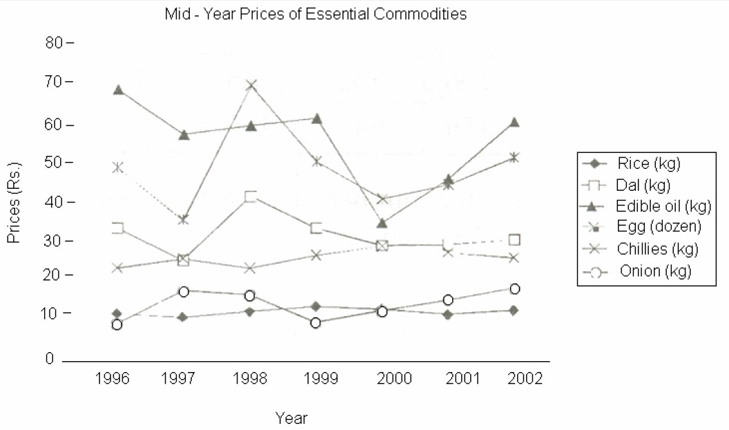

1. From 1996-2002, the number of commodities that exhibited a net overall increase and a net overall decrease, respectively, were

**(a) 3 and 3 (b) 2 and 4 (c) 4 and 2 (d) 5 and 1**

1. The no. of commodities that experienced a price decline for two or more consecutive years is

**(a) 2 (b) 3 (c) 4 (d) 5**

1. For which commodities did a price increase immediately follow a price decline only once?

**(a) Rice, Edible Oil and Dal (b) Egg and Dal**

**(c) Onion only (d) Egg and Onion**

**Directions for questions 32 to 34:**

The line graph below gives details about the production and demand of rice in a particular village in a period of six years. If in a particular year, if production is more than the demand, then the excess rice (production – demand) is sold in the city market. Similarly, if in a particular year, if the demand is more than the production, then the excess demand (demand – production) is met by buying rice in the city market.

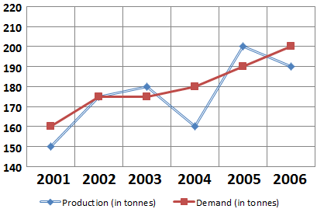

1. From 2001 to 2006, what is the difference between the rice bought and the rice sold in the city market?

**a) 25 tonnes b) 35 tonnes c) 0 tonnes d) 10 tonnes**

1. If the production in 2007 increases by 20% as compared to the previous year, what can be the maximum % increase in demand so that no rice is bought in the city market?

**a) 28% b) 21% c) 14% d) 15%**

1. In 2003, rice was sold in the city market for Rs.10000 per tonne. The selling price of rice increases by 10% year on year. From 2001 to 2006, what was the total income earned by the village by selling rice?

**a) Rs.1,60,000 b) Rs.1,50,000 c) Rs.1,71,000 d) Rs.1,77,000**

**Directions for questions 35 to 38:**

The graph in the next page gives details about the number of televisions of five different brands sold in five months by ABC Electronics Ltd.

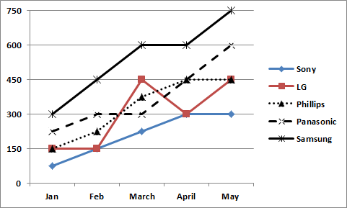

1. Which television brand showed the highest percentage increase in the sales from January to May?

**a) Sony b) Samsung c) Panasonic d) LG**

1. In March, the sales of the given 5 brands contributed 42% of the total sales of TVs by ABC Electronics. The sales of Phillips formed what percentage of the total sales of TVs in the store in that month?

**a) 6% b) 7% c) 8% d) 9%**

1. In June the sales of Panasonic increased by 50% over the previous month. By what percentage should the sales of Samsung increase in June (compared to the previous month) so that sales of Samsung are equal to that of Panasonic in June?

**a) 20% b) 25% c) 15% d) 10%**

1. What is the average increase in the sales of LG from January to May?

**a) 300 b) 75 c) 150 d) 60**

**Directions for questions 39 to 41:**

K-Flo, a kitchen appliance company sells five types of products – fridges, mixers, grinders, water purifiers and coffee makers. The graph in the next page shows the percentage sales of each product that contributed to the total sales of the company in four years from 2001 to 2004.

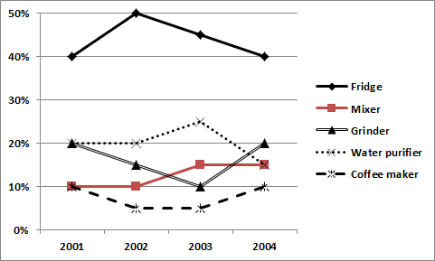

The total sales in 2003 were more than that of 2001. The total sales in 2002 were more than that of 2004 and that of 2003.

1. The sales of at most how may products could have increased continuously from 2001 to 2004?

**a) 1 b) 2 c) 3 d) 4**

1. The ratio of sales of Fridges in 2002 to the sales of Water purifiers in 2001 is not lesser than

**a) 2 b) 2.5 c) 1. 5 d) 0.4**

1. The sales of at least how many products definitely decreased from 2001 to 2003?

**a) 3 b) 2 c) 1 d) 0**

**Directions for questions 42 to 44:**

The pie-chart gives the model-wise distribution of the number of laptops sold by GMM Ltd. in the year 2012. Total number of laptops sold by GMM in 2012 is 16000.

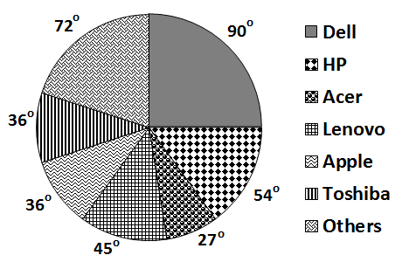

1. The cost of a HP laptop is Rs. 40000 while the cost Lenovo laptop is Rs. 50000. By what percentage is the revenue from sales of HP less than that of the revenue from sales of Lenovo?
2. **1% (b) 2% (c) 3% (d) 4%**
3. By mistake, sales of Dell laptops were over-reported by 25%. If the mistake is corrected, then what are the sales of Apple as a percentage of total number of laptops sold?
4. **10.52% (b) 10% (c) 12.15% (d) 9.8%**
5. From 2012 to 2013, for GMM, the sales of Dell laptops increased by 20%, the sales of HP laptops increased by 20%, the sales of Acer laptops increased by 33.33%, the sales of Lenovo laptops increased by 40%, the sales of Apple laptops and Toshiba laptops increased by 10% each. The sales of Other laptops decreased by 37.5%. If a new pie-chart is drawn for 2013, what is the value of angle made by the sector representing sales of Apple laptops?
6. **35° (b) 36° (c) 53° (d) 54°**

**Directions for questions 45 to 48:**

The following pie-chart gives the break-up of the income of all the five members (Arun, Shilpa, Pradeep, Preeta and Prasad) of a family and the total family expenditure under different heads.

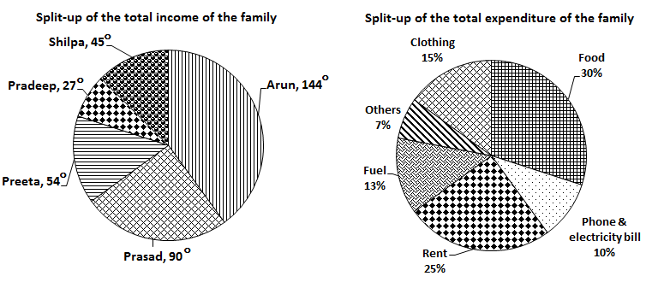

The total income of the family is equal to the total expenditure of the family and the family has no other sources of income.

1. If Prasad did not pay for ‘Others’, then his salary can fully account for the expenses of atmost how many heads?

**a) 1 b) 2 c) 3 d) 4**

1. If Arun does not spend any amount on rent, then his expenditure on food and clothing as a percentage of the total expenditure cannot be less than?

**a) 25% b) 15% c) 10% d) 66.66%**

1. Wherever possible, if all the expenses under one head is paid by a single person, then the number of heads under which more than one person shared the expenses is atleast?

**a) 0 b) 1 c) 2 d) 3**

1. If each person contributes atmost 30% of his income to rent, what is the maximum number of people who would not contribute to rent?

**a) 3 b) 0 c) 2 d) 1**

**Directions for questions 49 to 52:**

Pie-chart 1 lists the income of Mr.Sharma and the break-up of his income under various heads. Pie-chart 2 lists the income of Mrs.Sharma and the break-up of her income under various heads. Pie-chart 3 lists the combined savings of Mr.Sharma and Mrs.Sharma invested across various heads.

Expenditure = Income – Savings.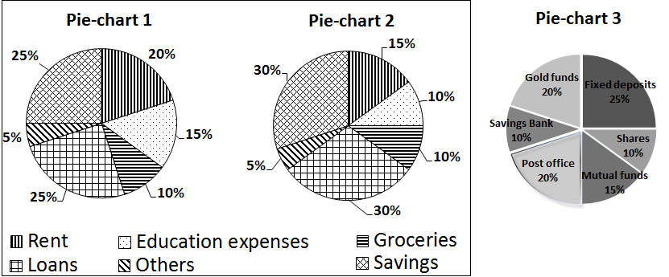

1. The savings of Mr.Sharma is equal to that of Mrs.Sharma. What is the ratio of the total money invested in post office to the total expenditure in ‘Others’ category?
2. **12:11 (b) 6:11 (c) 6:5 (d) 11:6**
3. The total savings of Mr. and Mrs.Sharma is equal to the total expenditure of Mrs.Sharma. The amount invested in Gold funds is what percentage less than the amount spent by Mr.Sharma on groceries?
4. **14% (b) 12.5% (c) 14.28% (d) 12%**
5. Mrs.Sharma deposited her entire savings in Savings bank and Post Office. Mr.Sharma, who earns Rs.70000, did not invest any of his savings in Savings bank or Post Office. What is the difference between the amount spent by Mr.Sharma on ‘Education’ and the amount spent by Mrs.Sharma on ‘Rent’?
6. **Rs.3750 (b) Rs.10500 (c) Rs.6750 (d) Rs.4250**
7. The amount invested in ‘Mutual funds’ is equal to one-third of Mrs.Sharma’s savings. Mrs.Sharma’s income is Rs.45000. 40 percentage of the total expenditure on loans goes to car loan EMI. Find the amount spent on car loan EMI.
8. **Rs.13500 (b) Rs.16500 (c) Rs.15000 (d) Rs.12000**

**Directions for questions 53 to 56:**

MEL Ltd. sells exactly six products – A, B, C, D, E and F. The following pie-chart gives the break-up of the costs and sales value of six products. For a product, Profit = Sales – Cost.

Profit percentage = (Profit/Cost)*100

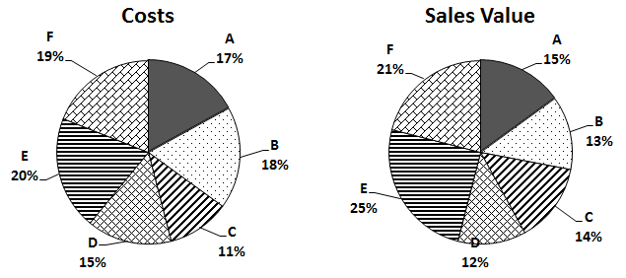

1. If the MEL Ltd. made an overall profit of 20%, then the profit percentage of which product was the highest?
2. **A (b) E (c) C (d) F**
3. If the company made an overall profit, then for at most how many products was the cost more than that of the sales value?
4. **1 (b) 2 (c) 3 (d) 4**
5. If the company did not make a loss on any of the products, the overall profit percentage is atleast?
6. **34% (b) 38.5% (c) 42.5% (d) 47%**
7. If MEL Ltd. made an overall loss, then for at most how many products did it make a profit?
8. **3 (b) 2 (c) 1 (d) 0**

**Directions for questions 57 to 59:**

The following table gives the proportion of male and vegetarian students in a school. The school has a total of 800 students, 80% of whom are in the secondary section, and the remaining are equally divided in Class 11 and Class 12.

|  |  |  |
| --- | --- | --- |
|  | Male | Vegetarian |
| Class 12 | 0.6 |  |
| Class 11 | 0.55 | 0.5 |
| Secondary |  | 0.55 |
| Total | 0.475 | 0.53 |

1. Find the percentage of males in secondary section.

**(a) 40 (b) 45 (c) 50 (d) 55 (e) 60**

1. In class 12, 25% of the vegetarians are males. Find the difference in the number of female vegetarians and male non vegetarians.

**(a) less than 8 (b) 10 (c) 12 (d) 14 (e) 16**

1. Find the percentage of vegetarians in class 12.

**(a) 40 (b) 45 (c) 50 (d) 55 (e) 60**

**Directions for questions 60 to 63:**

Prof. Singh has been tracking the number of visitors to his homepage. His service provider has provided him with the following data on the country of origin of the visitors and the university they belong to:

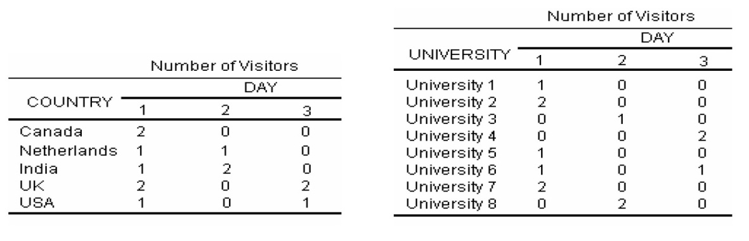

1. To which country does University 5 belong?

**(a) India or Netherlands but not USA (b) India or USA but not Netherlands**

**(c) Netherlands or USA but not India (d) India or USA but not UK**

1. University 1 can belong to

**(a) UK (b) Canada (c) Netherlands (d) USA**

1. Visitors from how many universities from UK visit Prof. Singh’s homepage in the three days?

**(a) 1 (b) 2 (c) 3 (d) 4**

1. Which among the listed countries can possibly host three of the eight listed universities?

**(a) None (b) Only UK (c) Only India (d) Both India and UK**

**Directions for questions 64 to 66:**

The table below indicates the percentage change in production of aluminium as compared to the previous year of the company XYZ Metals.

|  |  |
| --- | --- |
| Year | Percentage change ( in % ) |
| 2001 | -20 |
| 2002 | +20 |
| 2003 | -10 |
| 2004 | +10 |
| 2005 | -10 |

1. In which year was the production the highest?

**a)2000 b)2002 c)2004 d)Cannot be determined**

1. The production in 2004 as compared to 2000 showed:

**a)a decrease of between 5 and 5.5 percent**

**b)a decrease of between 3.5 and 4 percent**

**c)a decrease of between 4 and 4.5 percent**

**d)a decrease of between 4.5 and 5 percent**

1. If the production in 2002 was 6000kgs, what was the production in the year 2001?

**a) 4800 b) 5000 c) 5250 d) Cannot be determined**

**Directions for questions 67 to 69:**

**SALES OF FMCG COMPANIES**

|  |  |  |  |  |  |  |
| --- | --- | --- | --- | --- | --- | --- |
|  | 2006-07 | 2007-08 | 2008-09 | 2009-10 | 2010-11 | 2011-12 |
| HUL | 2387 | 3106 | 3356 | 4318 | 6163 | 9508 |
| PnG | 6884 | 7324 | 7900 | 8536 | 9068 | 9703 |
| ColPal | 4195 | 6361 | 6312 | 6219 | 6912 | 8037 |
| ITC | 3923 | 4984 | 5344 | 6109 | 7022 | 7897 |
| Marico | 4007 | 4219 | 6855 | 7104 | 7355 | 7349 |

1. During the given period, which company showed the maximum percentage increase in sales between two consecutive years?
2. **HUL (b) PnG (c) ColPal** **(d) Marico**
3. What was the approximate average annual growth rate of PnG in the given period?
4. **8.2% (b) 40.95% (c) 6.8% (d) 12.8%**
5. In the year 2008-09, what was the share of ITC as a percentage of all the five companies?

**a)16.95% (b) 17.95% (c) 18.95% (d) 19.95%**

**Directions for questions 70 to 73:**

There are six power plants P, Q, R, S, T and U. There are seven distributing stations A, B, C, D, E, F and G. There are seven cities A1, B1, C1, D1, E1, F1 and G1.

Table 1 shows the cost (in Rs.) of transporting a unit of electricity from a power plant to a distributing station. Table 2 shows the cost (in Rs.) of transporting a unit of electricity from a distributing station to a city.

**Table 1**

|  |  |  |  |  |  |  |
| --- | --- | --- | --- | --- | --- | --- |
|  | P | Q | R | S | T | U |
| A | 619.2 | 978.9 | 337.5 | 198.6 | 602.3 | 126.6 |
| B | 823.2 | 459.6 | 0 | 367.8 | 991.6 | 1356.6 |
| C | 414.9 | 320.9 | 886.7 | 353.9 | 608.7 | 632.3 |
| D | 530.5 | 813.5 | 812.3 | 864.5 | 392.3 | 1108.2 |
| E | 367.8 | 498.6 | 453.2 | 912.3 | 449.8 | 1805.2 |
| F | 456.9 | 772.8 | 111.8 | 658.3 | 0 | 1897.6 |
| G | 345.8 | 116.8 | 983.3 | 487.7 | 754.5 | 983.4 |

**Table 2**

|  |  |  |  |  |  |  |  |
| --- | --- | --- | --- | --- | --- | --- | --- |
|  | A | B | C | D | E | F | G |
| A1 | 835.5 | 688.4 | 950.6 | 870.5 | 1133.6 | 752.6 | 1209.4 |
| B1 | 654.5 | 699.7 | 723.8 | 874.7 | 567.5 | 821.9 | 0 |
| C1 | 436.5 | 368.4 | 512.3 | 710.5 | 133.2 | 658.6 | 239.8 |
| D1 | 639.8 | 466.6 | 109.8 | 653.9 | 871.2 | 458.2 | 488.5 |
| E1 | 567.8 | 367.1 | 220.8 | 438.9 | 753.2 | 702.3 | 631.2 |
| F1 | 319.6 | 0 | 781.5 | 710.2 | 782.6 | 449.8 | 783.2 |
| G1 | 1267.5 | 1788.3 | 1009.5 | 1167.5 | 981.8 | 1420.8 | 1229.6 |

1. In how many ways can a unit of electricity be transported from a particular power plant to any city?

**(a)294 (b) 20 (c) 49 (d) 42**

1. What is minimum cost of transporting a unit of electricity from any power plant to any city?
2. **Rs.0 (b) Rs.331.5 (c) Rs.346.9 (d)Rs. 432.8**
3. What is the maximum cost of transporting a unit of electricity from P to A1?
4. **Rs.1511.6 (b) Rs.1555.2 (c) Rs.1454.7 (d)Rs.1365.5**
5. The minimum cost of transporting a unit of electricity to G1 from any power plant is?
6. **Rs.1346.4 (b) Rs.1349.6 (c) Rs.1466.1 (d)Rs.1330.4**

**Directions for questions 74 to 76:**

The following tables give details about the height and weight of all the 200 students in a class. A taller student always weighs more than a shorter student.

|  |  |  |  |  |
| --- | --- | --- | --- | --- |
| Height not less than (in cms) | No. of students |  | Weight lesser than (in kgs.) | No. of students |
| 125 | 193 |  | 27 | 7 |
| 130 | 178 |  | 30 | 32 |
| 135 | 165 |  | 33 | 69 |
| 140 | 150 |  | 36 | 85 |
| 145 | 132 |  | 39 | 109 |
| 150 | 106 |  | 42 | 127 |
| 155 | 89 |  | 45 | 140 |
| 160 | 65 |  | 48 | 152 |
| 165 | 40 |  | 51 | 169 |
| 170 | 12 |  | 54 | 195 |

1. How many students who are atleast 150 cms tall weigh lesser than 39 kg?
2. **15 (b) 106 (c) 109 (d) 6**
3. How many students who weigh 42 kg or more are not taller than 150 cm?
4. **127 (b) 0 (c) 19 (d) 106**
5. How many students are atleast 155 cm tall and weigh atmost 51 kg?
6. **31 (b) 80 (c) 58 (d) 45**

**Directions for questions 77 to 80:**

The table gives the number of passengers getting in and out of a bus which travels from T.Nagar (starting point) to Tambaram (destination) with four stops Saidapet, Guindy, Chrompet and Pallavaram in between. All the passengers who were in the bus get down at Tambaram. Each passenger travelled at least one stop to the next and no passenger who got out of the bus got in again.

|  |  |  |
| --- | --- | --- |
| Stop | No. of passengers | |
| Getting in | Getting out |
| T.Nagar | 17 |  |
| Saidapet | 15 | 8 |
| Guindy | 10 | 13 |
| Chrompet | 13 | 15 |
| Pallavaram | 11 | 14 |
| Tambaram |  |  |

1. How many passengers got down at Tambaram?
2. **13 (b) 10 (c) 12 (d) 11**
3. Atmost how many passengers who got in at T.Nagar got out at Chrompet?
4. **8 (b) 15 (c) 9 (d) 17**
5. What is the least number of passengers who got in at Guindy and got out at Tambaram?
6. **13 (b) 0 (c) 2 (d) 4**
7. What is the maximum number of passengers who got down at exactly the third stop from where they got in?
8. 9  **(b) 6 (c) 12 (d) 15**

**Directions for questions 81 to 84:**

A die, with numbers 1 to 6 on its six faces, is thrown 150 times. The table below gives details about the number of times each face of the die turned up. It is also observed that no two consecutive throws showed the same number.

|  |  |  |  |  |  |  |
| --- | --- | --- | --- | --- | --- | --- |
| Throws | Number of times each number turned up | | | | | |
| 1 | 2 | 3 | 4 | 5 | 6 |
| First 25 | 6 | 5 | 4 | 5 | 4 | 1 |
| First 50 | 11 | 9 | 8 | 10 | 9 | 3 |
| First 75 | 17 | 15 | 10 | 14 | 13 | 6 |
| First 100 | 17 | 22 | 15 | 18 | 18 | 10 |
| First 125 | 21 | 22 | 22 | 21 | 25 | 14 |
| First 150 | 26 | 35 | 23 | 21 | 28 | 17 |

1. Which of the following numbers definitely did not show up in throw no. 137?
2. **3 (b) 2 (c) 6 (d) 5**
3. Which number turned up the maximum number of times in the first 105 throws?
4. **4 (b) 2 (c) 1 (d) Cannot be determined**
5. What is the minimum number of times number ‘1’ would have turned up in the first 70 throws?
6. **11 (b) 13 (c) 14 (d) 17**
7. Which of the following pairs of numbers could have turned up for an equal number of times in first 120 throws?
8. **‘1’ and ‘2’ (b) ‘4’ and ‘5’ (c) ‘2’ and ‘3’ (d) All the above**

**Directions for questions 85 to 88:**

10 cities A1, A2, A3, A4, A5, A6, A7, A8, A9 and A10 lie in a straight line not necessarily in the same order. The following table gives details about the distance (in km) between the cities.

|  |  |  |  |  |  |
| --- | --- | --- | --- | --- | --- |
|  | A1 | A2 | A3 | A4 | A5 |
| A6 | 320 | 30 | 150 | 220 | 270 |
| A7 | 110 | 240 | 60 | 280 | 60 |
| A8 | 465 | 115 | 295 | 75 | 415 |
| A9 | 500 | 150 | 330 | 110 | 450 |
| A10 | 245 | 105 | 75 | 145 | 195 |

1. What is the shortest distance (in km) that a person should travel if he wants to cover all the cities?
2. **700 (b) 400 (c) 600 (d) 500**
3. What is the distance (in km) between city A2 and A4?
4. **75 (b) 40 (c) 50 (d) 35**
5. If a person starts travelling from A10, what is the shortest distance he/she should travel to cover all the cities?
6. **745 (b) 704 (c) 765 (d) 755**
7. If a person can travel a maximum of 200 km per day what is the maximum number of cities he can visit if it is known that he can start his journey from a city of his choice?
8. **5 (b) 4 (c) 6 (d) 7**

**Directions for questions 89 to 92:**

Students were allotted grades based on the marks they secured in each subject. The maximum mark in each subject is 100. The mark received by each student in each subject is an integer. The tables give the range of marks for each grade and the grades received by the students.

|  |  |
| --- | --- |
| Range marks | Grade |
| 91-100 | A |
| 81-90 | B |
| 71-80 | C |
| 56-70 | D |
| 41-55 | E |
| 0-40 | F |

|  |  |  |  |  |  |
| --- | --- | --- | --- | --- | --- |
| Student | Maths | Physics | Chemistry | Biology | English |
| Arvind | A | B | A | C | B |
| Babu | B | A | A | B | B |
| Chandar | A | C | B | C | B |
| Deepan | C | A | B | C | C |
| Esha | E | E | C | B | D |

1. Which of the following could be the total marks received by Arvind and Babu together?

**a) 844 b) 929 c) 858 d) All the above**

1. If the total marks scored by Arvind is greater than that of Deepan, then atmost how many students could have scored more than Arvind?

**a) 0 b) 1 c) 2 d) 3**

1. If Babu received a score of 460 and Arvind did not get full marks in any subject, then how many students scored less than Babu?

**a) 1 b) 2 c) 3 d) 4**

1. Esha’s total score was 290. What was Esha’s score in Mathematics?

**a) 50 b) 41 c) 42 d) 43**

**Directions for questions 93 to 94:**

50 students are studying in a class. Students are allowed to choose their own subjects. The number of students who study Physics, Chemistry and Maths are 40, 35 and 45 respectively. In the table the first number in a cell represents the number of students who have taken the subject. The numbers in the brackets represent the lowest and the highest mark scored in a subject by a student. For instance, 24 boys have chosen Chemistry and the lowest score by a boy in Chemistry is 41 and the highest score by a boy in Chemistry is 99.

|  |  |  |  |
| --- | --- | --- | --- |
| Subject | Boys | Girls | Total |
| Chemistry | 24(41,99) | 16(45,92) | 40 |
| Physics | 18(48,89) | 17(46, 86) | 35 |
| Maths | 25(40,100) | 20(41, 96) | 45 |

1. What is the maximum number of students in the class who took all the three subjects?

**a) 45 b) 35 c) 34 d) 40**

1. What is the least possible percentage of students of the class scoring 60% to 90% marks in Physics; given that the maximum marks in Physics is 100?

**a) 4% b) 2% c) 6% d) 0%**

**Directions for questions 95 to 98:**

The Consumer Price Index (CPI) of India is based on the prices of four items- Food products, Consumer products, Fuel and Primary products. CPI is calculated once every year and the base year for calculation of CPI is 2000 and the price of each of the four items is indexed to 100 for that year. The CPI in a year is the weighted average of the indexed values of the four items. For each year, the weightage of each item in calculating the index is at least 10%. The table below gives the indexed values of the four items over a period of 10 years.

|  |  |  |  |  |  |  |  |  |  |  |
| --- | --- | --- | --- | --- | --- | --- | --- | --- | --- | --- |
|  | 2001 | 2002 | 2003 | 2004 | 2005 | 2006 | 2007 | 2008 | 2009 | 2010 |
| Food products | 100 | 103.2 | 106.5 | 102.3 | 105.6 | 106.8 | 107.3 | 109.8 | 109.9 | 110.8 |
| Consumer products | 100 | 104.5 | 102.3 | 101.8 | 99.8 | 100.3 | 100.7 | 101.3 | 101.8 | 102.6 |
| Fuel | 100 | 98.3 | 96.3 | 95.3 | 98.6 | 102.3 | 103.6 | 104.7 | 105.6 | 107.3 |
| Primary products | 100 | 101.6 | 99.5 | 97.2 | 100.3 | 100.9 | 101.6 | 102.9 | 103.2 | 103.9 |

1. The CPI in the year 2005 was at-least?

**a) 98.6 b) 99.09 c) 99.59 d) 100.2**

1. In how many of the given years was the CPI of India definitely more than that of 2001?

**a) 8 b) 7 c) 6 d) 5**

1. In which of the given years was the CPI the lowest?

**a) 2002 b) 2003 c) 2004 d) Cannot be determined**

1. What is the lowest possible value of CPI in any of the given years?

**a) 96.74 b) 97.24 c) 96.84 d) None of the above**

**Directions for questions 99 to 101:**

The following table gives details about the model-wise distribution of automobiles sold monthly

|  |  |  |  |  |  |
| --- | --- | --- | --- | --- | --- |
| Model | Jan | Feb | Mar | Apr | May |
| Alto | 39% | 37.50% | 15% | 20% | 42.50% |
| WagonR | 20% | 12.50% | 25% | 16.67% | 37.50% |
| Eeco | 4% | 20% | 25% | 33.33% | 7.50% |
| A-Star | 16% | 10% | 10% | 20% | 6.25% |
| Omni | 21% | 20% | 25% | 10% | 6.25% |
|  | 100% | 100% | 100% | 100% | 100% |

The following table gives details about the month-wise distribution of the various models sold

|  |  |  |  |  |  |
| --- | --- | --- | --- | --- | --- |
| Month | Alto | WagonR | Eeco | A-Star | Omni |
| Jan | 19.50% | 13.33% | 3.33% | 20% | 21% |
| Feb | 22.50% | 10% | 20% | 15% | 24% |
| Mar | 9% | 20% | 25% | 15% | 30% |
| Apr | 15% | 16.67% | 41.67% | 37.50% | 15% |
| May | 34% | 40% | 10% | 12.50% | 10% |
|  | 100% | 100% | 100% | 100% | 100% |

1. What is the difference between the number of Omni cars sold in March and the number of A-Star cars sold in April?

**a)0 b) 50 c) 60 d)Cannot be determined**

1. The ratio of the number of Alto cars sold in March to the WagonR cars sold in January is?

**a) 10:9 b) 5:6 c) 6:5 d) 9:10**

1. If the number of WagonR cars sold in May is 300, what is the total number of cars sold in April and May?

**a)** **800 b) 1600 c) 1550 d) 1500**

**Directions for questions 102 to 104:**

Venkat, a stockbroker, invested a part of his money in the stock of four companies --- A, B, C, and D. Each of these companies belonged to different industries, viz., Cement, Information Technology (IT), Auto, and Steel in no particular order. At the time of investment, the price of each stock was Rs.100.Venkat purchased only one stock of each of these companies. He was expecting a return of 20%, 10%, 30% and 40%, from the stock of companies A, B, C and D respectively. Returns are defined as the change in the value of the stock after one year, expressed as a percentage of the initial value. During the year, two of these companies announced extraordinary good results. One of these two companies belonged to the Cement or the IT industry, while the other one belonged to either the steel or the Auto industry. As a result, the returns on the stocks of these two companies were higher than the initially expected returns. For the company belonging to the Cement or the IT industry with extraordinary good results, the returns were twice that of the initially expected returns. For the company belonging to the steel or the Auto industry, the returns on announcement of extraordinary good results were only one and half times that of the initially expected returns. For the remaining two companies, which did not announce extraordinary good results, the returns realized during the year were the same as initially expected.

102. What is the minimum average return Venkat would have earned during the year?

**(a) 30% (b) 31(1/4)% (c) 32(1/2)% (d) Cannot be determined**

103. If Venkat earned a 35% return on average during the year, then which of these statements

would necessarily be true?

1. Company A belonged either to Auto or to steel industry.
2. Company B did not announce extraordinarily good results.
3. Company A announced extraordinary good results.
4. Company D did not announce extraordinary good results

**(a) I and II only (b) II and III only (c) III and IV only (d) II and IV only**

104. If Venkat earned a 38.75% return on average during the year, then which of these statements would necessarily be true?

* + - 1. Company C belonged either to Auto or Steel Industry.
      2. Company D belonged either to Auto or Steel Industry.
      3. Company A announced extraordinarily good results.
      4. Company B did not announce extraordinarily good results.

(**a)I and II only (b)II and III only (c) I and IV only (d)II and IV only**

**Directions for questions 105 to 108:**

The table below presents the revenue (in millions rupees) of four firms in three states. These firms, Honest Ltd., Aggressive Ltd., Truthful Ltd., and Profitable Ltd. are disguised in the table as A, B, C and D, in no particular order.

|  |  |  |  |  |
| --- | --- | --- | --- | --- |
| **States** | **Firm A** | **Firm B** | **Firm C** | **Firm D** |
| **UP** | 49 | 82 | 80 | 55 |
| **Bihar** | 69 | 72 | 70 | 65 |
| **MP** | 72 | 63 | 72 | 65 |

Further, it is known that:

* In the state of MP, Truthful Ltd. has the highest market share.
* Aggressive Ltd’s aggregate revenue differs from Honest Ltd’s by Rs. 5 million.

105. What can be said regarding the following two statements?

**Statement 1**: Profitable Ltd. has the lowest share in the MP market

**Statement 2**: Honest Ltd’s total revenue is more than Profitable Ltd.

**(a) If statement 1 is true then statement 2 is necessarily true.**

**(b) If statement 1 is true then statement 2 is necessarily false.**

**(c) Both statement 1 and 2 are true.**

**(d) Neither statement 1 and 2 is true.**

106. What can be said regarding the following two statements?

**Statement 1**: Aggressive Ltd. lowest revenue is from MP.

**Statement 2**: Honest Ltd’s lowest revenue is from Bihar.

**(a) If statement 2 is true then statement 1 is necessarily false.**

**(b) If statement 1 is false then statement 2 is necessarily true.**

**(c) If statement 1 is true then statement 2 is necessarily true.**

**(d) None of the above**

107. What can be said regarding the following two statements?

**Statement 1**: Honest Ltd. has the highest share in the UP market.

**Statement 2**: Aggressive Ltd. has the highest share in the Bihar market.

**(a) Both the statements could be true.**

**(b) At least one of the statements must be true.**

**(c) At most one of the statements is true.**

**(d) None of the above.**

108. If Profitable Ltd’s lowest revenue is from UP, then which of the following is true?

**(a)Truthful Ltd’s lowest revenue is from MP.**

**(b)Truthful Ltd’s lowest revenue is from Bihar.**

**(c)Truthful Ltd’s lowest revenue are from UP.**

**(d)No definite conclusion is possible.**

**Directions for questions 109 to 112:**

Twenty one participants from four continents (Africa, Americas, Australasia, and Europe) attended a United Nations conference. Each participant was an expert in one of the four fields, Labour, Health, Population Studies, and Refugee Relocation. The following five facts about the participants are given.

1. The no. of labour experts in the camp was exactly half the no. of experts in each of the three other categories.
2. Africa did not send any labour expert. Otherwise , every continent, including Africa, sent at least one expert for each category
3. None of the continents sent more than three experts in any category.
4. If there had been one less Australasian expert, then the Americas would have have twice as many experts as each of the continents.
5. Mike and Alfanso are leading experts of population studies who attend the conference. They are from Australasia.

109. Alex, an American expert in refugee relocation, was the first keynote speaker in the conference.

What can be inferred about the number of American experts in refugee relocation in conference, excluding Alex?

1. At least one
2. At most two

**(a)Only i and not ii (b) Only ii and not ii (c) Both i and ii (d) Neither i nor ii**

110. Which of the following numbers cannot be determined from the information given?

**(a)Number of labour experts from the Americas**

**(b)Number of health experts from Europe**

**(c)Number of health experts from Australasia.**

**(d)Number of experts in refugee relocation from Africa**

111. Which of the following combinations is NOT possible?

**(a)2 experts in population studies from the Americas and 2 health experts from Africa attended the conference**

**(b)2 experts in population studies from the Americas and 1 health expert from Africa attended the conference**

**(c)3 experts in refugee relocation from the Americas and 1 health expert from Africa attended the conference.**

**(d)Africa and America each had 1 expert in population studies attending the conference.**

112. If Ramos is the lone American expert in population studies, which of the following is NOT true about the number of experts in the conference from the four continents?

**(a)There is one health expert in from Africa.**

**(b)There is one expert in refugee relocation from Africa.**

**(c)There are two experts in health from Americas.**

**(d)There are three experts in refugee relocation from the Americas.**

**Directions for questions 113 to 116 :**

Two traders, Chetan and Michael, were involved in buying and selling of MCS shares over five trading days. At the beginning of the first day, the MCS share was priced at Rs. 100, while at the end of fifth day it was priced at Rs. 110. At the end of each day, the MCS share would either go up by Rs 10, or else, it came down by Rs 10. Both Chetan and Michael took buying and selling decisions at the end of each trading day. The beginning price of the MCS share on a given day was the same as the ending price of the previous day. Chetan and Michael started with the same number of shares and amount of cash, and had enough of both. Below are some additional facts about how Chetan and Michael traded over the five trading days:

* Each day if the price went up, Chetan sold 10 shares of MCS at the closing price. On the other hand, each day if the price went down, he bought 10 shares at the closing price.
* If on any day, the closing price was above Rs 110, the Michael sold 10 shares of MCS, while if it was below Rs 90, he bought 10 , all at the closing price.

113. If Chetan sold 10 shares of MCS on three consecutive days, while Michael sold 10 shares only

once during the five days, what was the price of MCS at the end of day 3?

**a) Rs. 90     b) Rs.100     c) Rs. 110   d) Rs. 120**

114. If Chetan ended up with Rs.1300 more cash than Michael at the end of day 5, what was the

price of MCS share at the end of day 4?

a**) Rs. 90   b) Rs. 100   c) Rs. 110   d) Rs. 120**

115. What could have been the maximum possible increase in the combined cash balance of Chetan

and Michael at the end of fifth day?

**a) Rs. 3700 b) Rs. 4000 c) Rs.4700 d) Rs. 5000**

116. If Michael ended up with 20 more shares than Chetan at the end of day 5, what was the price of

share at the end of day 3?

**a) Rs. 90     b) Rs. 100     c) Rs. 110   d) Rs. 120**

**Directions for questions 117 to 119:**

The bar graph below gives details about the sales and capital employed (in Rs. crore) by the company PVR Ltd. for the years 2001 to 2005.

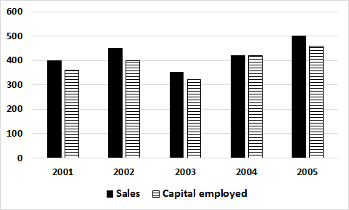

The graph below gives information about the ‘gross profit as a percentage of sales’ and ‘net profit as a percentage of gross profit’.

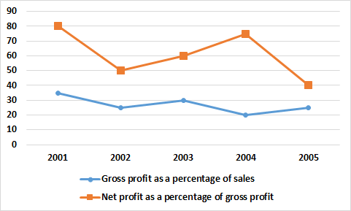

1. ‘Return on capital employed’ is defined as Net profit as a percentage of capital employed. In which of the following years was the return on capital employed the highest?

**(a) 2002 (b) 2003 (c) 2004 (d) 2005**

1. In how many years was the gross profit of the company more than Rs.120 crore?

**(a) 1 (b) 2 (c) 4 (d) 5**

1. In which of the following years were the net profits same?

**(a) 2003 and 2005 (b) 2003 and 2004 (c) 2004 and 2005 (d) 2002 and 2005**

**Directions for questions 120 and 121:**

There are 4 cities A,B,C and D. The ratio of the populations in A,B,C and D is 4:3:2:1 respectively. In A, the ratio of men to women is 3:2. In B the ratio of women to men is 1:2. In C there are an equal number of men and women. Further, in A, the men have a 50% literacy rate, while the women have a 80% literacy rate. In B, the men have a 60% literacy rate while the women have a 40% literacy rate. In C, the men and women both have a 50% literacy rate.

1. If in city D, half the population was females and the number of male literates was 1/29 the total male literates in the other 3 cities combined, then the percentage of male illiterates in D as a percentage of the total population of all the cities combined is

**a)3% b)4% c)5% d)None of the above**

1. Using the data from the above question, the percentage of male literates in D is what % lesser than the female population of D?

**a)400% b)80% c)20% d)None of the above**

**Directions for questions 122 to 126:**

Eight companies sell set-top boxes through their various outlets. The following table gives details about the total number of outlets of each company, the average number of salespersons per outlet, the average number of set top boxes sold by a salesperson in a year, the average monthly expenses for the company and the selling price of a set top box.

|  |  |  |  |  |  |
| --- | --- | --- | --- | --- | --- |
| **Company** | **Total no. of outlets** | **Avg. no. of salespersons per outlet** | **Average no. of set top boxes sold by a salesperson in a year** | **Average monthly expenses (in Rs.crore)** | **Selling price per set top box (in Rs.)** |
| DD Direct | 200 | 3 | 1000 | 7 | 1500 |
| Tata Sky | 402 | 5 | 1345 | 38 | 1800 |
| Dish TV | 345 | 4 | 1420 | 33 | 2000 |
| Videocon | 284 | 6 | 1108 | 41 | 2450 |
| Big TV | 367 | 4 | 1084 | 24 | 1950 |
| Airtel | 478 | 3 | 1503 | 40 | 2200 |
| Hathway | 836 | 2 | 1036 | 23 | 1750 |
| SunDirect | 659 | 3 | 1238 | 42 | 2150 |

For a company, Annual revenue=Number of set-top boxes sold per year*selling price of a set top box

1. How many of the given companies made a loss?
2. **0 b)2 c)3 d)5**
3. Which company made the highest profit?
4. **Tata Sky b)Big TV c)Hathway d)Sun Direct**
5. Gross margin is defined as profit as a percentage of annual revenue. The gross margin of which of the following companies is lesser than 5%?
6. **DD Direct b)Tata Sky c)Hathway d)Sun Direct**
7. Videocon expects a 15% increase in no. of set top box sales and a 12% increase in the annual expenses in the next year. What would be the change in the profit or loss in the next year as compared to the current year?
8. **Losses reduce by approximately Rs.10.35 crore**
9. **Losses reduce by approximately Rs.19.09 crore**
10. **Videocon’s profit increases by Rs.10.35 crore**
11. **Cannot be determined**
12. Which company had the highest profit percentage?

**a)Tata Sky b)Big TV c)Hathway d)Sun Direct**

**Directions for questions 127 to 129:**

**ANNUAL PERCENT CHANGE IN DOLLAR AMOUNT OF SALES  
AT FIVE RETAIL STORES FROM 2006 TO 2008**

| **Store** | **Percent Change from 2006 to 2007** | **Percent Change from 2007 to 2008** |
| --- | --- | --- |
| *P* | 10 | –10 |
| *Q* | –20 | 9 |
| *R* | 5 | 12 |
| *S* | –7 | –15 |
| *T* | 17 | –8 |

1. Which store had the lowest sales for the year 2008?

**a)P b)Q c)S d)Cannot be determined**

1. At Store T, the dollar amount of sales for 2007 was what percent of the dollar amount of sales for 2008?

**a)109 b)108.4 c)108.7 d)Cannot be determined**

1. Which of the following statements must be true?

**a) For 2008, the dollar amount of sales at *R* was greater than at each of the other stores  
b) The dollar amount of sales at Store *S* for 2008 was 22 % less than that for 2006.  
c) The dollar amount of sales at *R* for 2008 was more than 17 % greater than that for 2006.**

**d) More than one of the above**

**Directions for questions 130 to 132:**The bar-graph below gives details about the number of wins and losses. Each team played a total of 20 games and each game ended in a win or a loss or a draw.

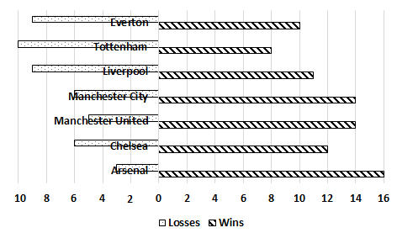

1. A team gets 2 points for a win, 1 point for a draw and -1 point for a loss. What is the total number of points scored by the seven teams?
2. **129 b)148 c)160 d)165**
3. For a team, in a match, . For Tottenham, the goal difference was not lesser than -2 or greater than +2 in any of the matches. Which of the following options could be the goal difference for Tottenham in all the matches put together?
4. **7 b) -12 c)16 d) -20**
5. Neither Liverpool nor Manchester United won more than 4 matches in a row. What is the difference between the maximum number of matches Liverpool could have lost in a row and the maximum number of matches Manchester United could have lost in a row?

**a)2 b)3 c)4 d)None of the above**

**Directions for questions 133 to 136:**

The pie-charts below give the number of matches won by five players Federer, Wawrinka, Nadal, Murray and Djokovic as a percentage of the total number of matches won by them in the years 2010 to 2014. However, certain data elements are missing from the pie-charts.

The total number of matches won by the five players in 2010, 2011, 2012, 2013 and 2014 are 200, 250, 240, 300 and 320 respectively. The following information is also known:

* In each year, no player won less than 5% of the total number of matches won by the five players.
* In 2010, Nadal won more matches than any other player did.
* In 2011, two pairs of players won the same number of matches.
* In 2012, the number of matches won by Murray is the average of the number of matches won by two other players.
* In 2013, the number of matches won by the five players is in Arithmetic progression.
* In 2014, the number of matches won by Djokovic is more than that of exactly 2 players.

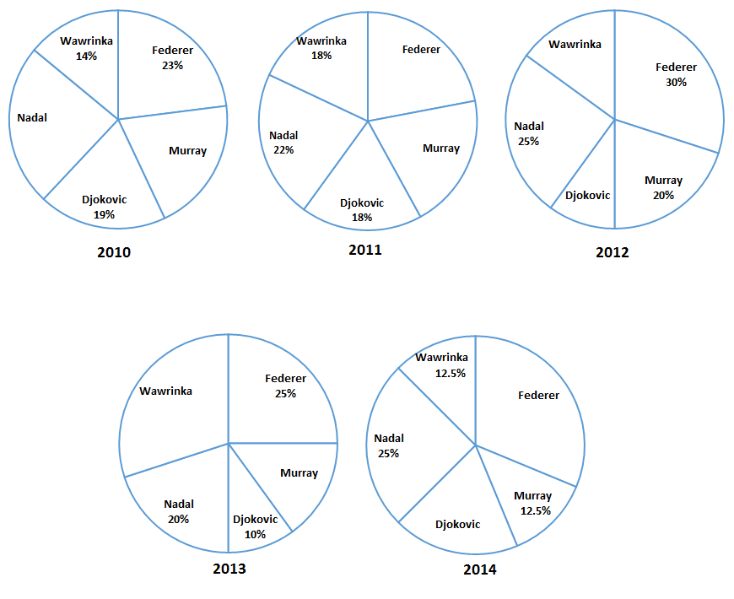

1. Which of the following cannot be the difference between the number of matches won by Nadal in 2010 and by Wawrinka in 2012?
2. **11 b)42 c)54 d)59**
3. How many different values can the number of matches won by Federer in the five years take?
4. **44 b)45 c)53 d)57**
5. Which of the following statements is required to find the number of matches won by Djokovic in the five years?
6. **In 2012 and 2014, the number of matches won by Djokovic as a percentage of total number of matches won is equal.**
7. **Djokovic won the same number of matches as Federer in 2014.**
8. **Of all the five years, Djokovic won the least number of matches in the year 2012.**
9. **The total number of matches won by Djokovic in the five years is lesser than that of Federer but more than that of Wawrinka.**
10. The number of matches won by Nadal in the given period is 303. What is the difference between the maximum number of matches that Murray could have won during the given period and the minimum of no. of matches that Murray could have won during the given period?
11. **5 b)45 c)50 d)None of the above**

**Directions for questions 137 to 140: Answer the questions based on the data given below.**

Nokia produces two types of mobile phones – smart phones and regular phones. The mobile phones produced are either sold domestically or exported. The bar graph gives details about the total no. of phones produced from January to May and the total no. of smart phones exported from Jan to May.

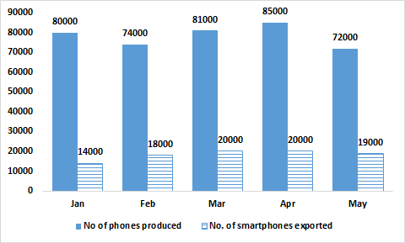

1=Jan , 2=Feb, 3=Mar 4=Apr 5 = May

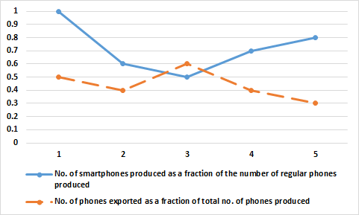

1. Find the ratio of the number of regular phones sold domestically to the number of smartphones exported in the month of April.

**(a) 9:5 (b) 7:10 (c) 10:3 (d) 5:9**

1. Which of the following values is the highest?

**(a) Number of smart phones sold domestically in May.**

**(b) Number of smart phones sold domestically in April.**

**(c) Number of regular phones sold domestically in January.**

**(d) Number of regular phones exported in April.**

1. What is the average number of regular phones exported per month during the given period?

**(a) 16560 (b) 15625 (c) 17350 (d) 18500**

1. In how many of the given months is the number of regular phones sold domestically more than the number of smart phones sold domestically in January?

**(a) 1 (b) 2 (c) 3 (d) 4**

**Directions for questions 141 to 144:**

Out of 4000 people, 40% of the people play chess; 55% play carrom and equal number of people play poker. 15% of the people play none of the three games. 1300 people play Poker and Carrom, 1100 people chess and poker, 1000 people play chess and carrom.

1. If each person who plays exactly two games stops playing one game, what is the minimum number of people who play chess?
2. 1200 (b) 1300 (c) 1100 (d) 1600
3. If 400 people who were playing carrom stop playing carrom, what would be the maximum number of people who played only poker?
4. 1000 (b) 1100 (c) 1200 (d) 900
5. If each person who plays all the three games, stops playing one game, what would be the maximum number of people playing carom and poker only?
6. 1500 (b) 1300 (c) 1100 (d) 800
7. If the number of students who play more than one game stop playing exactly one game, then find the minimum number of people who play chess?
8. 200 (b) 300 (c) 400 (d) 800

**Directions for questions 145 to 148:**

A survey was conducted among the residents of Bangalore and Hyderabad to find how many owned computers and how many owned TV.

* A total of 10000 people participated in the survey.
* For every three persons from Bangalore who participated in the survey, two persons from Hyderabad participated in the survey.
* The number of people of Bangalore who owned both the appliances was twice the number of people of Hyderabad who owned both the appliances.
* The number of people who owned only TV was same in both the cities.
* In Hyderabad, 500 people owned none of the two appliances which was same as the number of people owning both the appliances.
* A total of 5500 people owned TV in both the cities put together.
* In Bangalore, the number of people who owned only Computer was four times the number of people who owned none of the two appliances.

1. In both the cities put together, what is the total number of people who owned only computers?
2. In Hyderabad, how many people own exactly one appliance?
3. In Bangalore, what is the number of people who own none of the two appliances?
4. In both the cities together, the total number of people who owned at least one appliance is

**Directions for questions 149 to 152:**

The line graphs below gives details about the marks scored by five students P, Q, R, S and T in six subjects in two exams- model exam 1 and model exam 2.

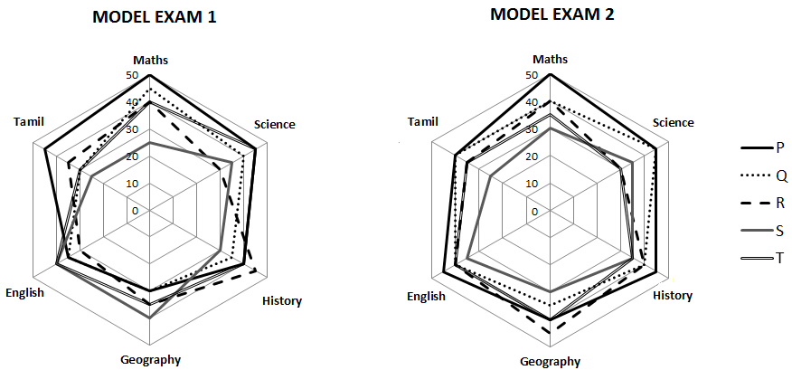

1. For which student is the percentage change in the total marks scored in model exam II when compared to model exam the highest?

(a) Q (b) P (c) T (d) S

1. The total marks scored by the five students in Tamil in both the model exams put together is what percentage lesser than the total marks scored by the five students in English in both the model exams?
2. 11.76% (b) 10.52% (c) 11.15% (d) 11.18%
3. Who among the five students is the second highest scorer in all the subjects in both the model exams put together?
4. P (b) Q (c) R (d) T
5. For which subject is the difference between the marks scored by the five students in model exam I and model exam II the least?
6. Maths (b) History (c) Tamil (d) Both ‘a’ and ‘b’

**Directions for questions 153 to 156:**

In a tournament, 16 football clubs are split into two groups of eight clubs each. Each club plays a match against every other club in the same group exactly once. The winner of each match gets 2 points and the loser gets no points. If the match ends in a draw, both the teams get a point each. At the end of the group stage, the teams are ranked based on points scored. If two teams get the same number of points, then the team that has scored more number of goals in the group stage is ranked higher. The top two teams from each group qualify for the semi-finals. In the semi-finals, the first placed team in group 1 meets the second placed team in group 2 and the second placed team in group 1 meets the first placed team in group 1. The winners of both the semi-finals meet in the final to decide the champion.

1. What is the total number of matches played in the tournament?
2. 59 (b) 57 (c) 60 (d) 58
3. What is the minimum number of wins with which a club can become the champion?
4. 9 (b) 8 (c) 2 (d) 6
5. What is the maximum number of points that a club can score in the group stage and still not qualify for the semi-final?
6. 5 (b) 12 (c) 10 (d) 6
7. If no match in the group stage ends in a draw, then what is the minimum number of wins with which a club can qualify for the semi-final?
8. 6 (b) 5 (c) 4 (d) 3

**Directions for questions 157 to 160:**

The world billiards championship is held among the top eight ranked players in the world. The rank of each player and the points he/she has scored before the beginning of each stage is as follows.

|  |  |  |  |  |  |  |
| --- | --- | --- | --- | --- | --- | --- |
| Player | Rank | Points |  | Player | Rank | Points |
| P | 1 | 165 |  | T | 5 | 146 |
| Q | 2 | 161 |  | U | 6 | 140 |
| R | 3 | 156 |  | V | 7 | 135 |
| S | 4 | 150 |  | W | 8 | 135 |

In the championship, each player plays exactly once with every other player. 2 points are awarded if one beats a player ranked higher than him and 1 point is awarded if one beats a player ranked lower than him. 2 points are deducted if a player loses to someone ranked lower than him and 1 point is deducted if the player loses to someone ranked higher than him. The points are computed after each match and the player with higher number of points is ranked higher. If two players have the same number of points, the player who has played the fewer number of matches till that stage is ranked higher. If two players are still evenly matched, then the player who is ranked higher at the start of the tournament would be ranked higher. After all the matches are over, the player with the highest number of points is ranked first, the next one second and so on. No match ends in a draw and the matches between players can take place in any order.

1. What is the minimum number of points with which player R could finish at the end of the tournament?
2. 142 (b) 144 (c) 143 (d) 141
3. How many of the given players have a chance to get the first rank at the end of the tournament?
4. 3 (b) 4 (c) 5 (d) 6
5. What is the maximum number of points with which player P can finish the tournament?
6. 172 (b)174 (c) 173 (d) 176
7. The points scored by V at the end of all the matches are at least?
8. 128 (b) 127 (c) 129 (d) 126

**Code:MECLR LOGICAL REASONING**

**Directions for questions 1 to 5:**

There are 10 people K,L,M,N,,P,Q,R,S,U,W. A team has to be formed from among these people subject to the following conditions:

A team must include exactly one among P, R, and S.A team must include either M or Q, but not both. If a team includes K, it should also include L and vice versa. If a team includes one among S, U, W it should also include the other two. L and N cannot be members of the same team. L and U cannot be members of the same team.The size of a team is defined as the number of people in it

1. What could be the size of a team that includes K?

**a)2 or 3 b)2 or 4 c)3 or 4 d)only 2 e)only 4**

1. In how many ways can a team be constituted so that the team includes N?

**a)2 b)3 c)4 d)5 e)6**

1. What could be the size of the largest possible team?

**a)8 b)7 c)6 d)5 e)can’t be determined**

1. Who can be a member of a team of size 5?

**a)K b)L c)M d)P e)R**

1. Who cannot be a member of a team of size 3?

**a)L b)M c)N d)P e)Q**

**Directions for questions 6 to 9:**

A group of five students should be selected from five boys A, B, C, D and E and three girls X, Y and Z. Three boys and two girls must be selected in the group. If A is selected in the group, B cannot be selected in the group. If C is selected in the group, D cannot be selected in the group but X must be selected in the group.

1. In how many ways can the members of the group be selected?
2. **4 (b) 6 (c) 10 (d) 12**
3. Who among the following will always be present in the group?
4. **C (b) E (c) X (d) Y**
5. If D is not selected in the group, who among the following must be selected?
6. **A (b) B (c) X (d) Y**
7. If D is selected in the group, which of the following is a valid selection of the remaining four students?
8. **AEXY (b) BEXZ (c) AEYZ (d) All the above**

**Directions for questions 10 to 11:**

In an examination, there are 100 questions divided into three groups A, B and C such that each group contains at least one question. Each question in group A carries 1 mark, each question in group B carries 2 marks and each question in group C carries 3 marks. It is known that the questions in group A together carry at least 60% of the total marks.

1. If group B contains 23 questions, then how many questions are there in group C?

**a) 1 b) 2 c) 3 d) cannot be determined**

1. If group C contains 8 questions and group B carries at least 20% of the total marks, which of the following best describes the number of questions in group B?

**a) 11 or 12 b) 12 or 13 c) 13 or 14 d) 14 or 15**

**Directions for questions 12 to 14:**

In a local pet store, seven puppies wait to be introduced to their new owners. The puppies, named Ashlen, Blakely, Custard, Daffy, Earl, Fala and Gabino, are all kept in two available pens. Pen 1 holds three puppies and Pen 2 holds four puppies.

If Gabino is kept in Pen 1, then Daffy is not kept in Pen 2.

If Daffy is not kept in Pen 2, then Gabino is kept in Pen 1.

If Ashlen is kept in Pen 2, then Blakely is not kept in Pen 2.

If Blakely is kept in Pen 1, then Ashlen is not kept in Pen 1.

1. Which of the following groups of puppies could be in Pen 2?

**a) Gabino, Daffy, Custard, Earl b) Blakely, Gabino, Ashlen, Daffy**

**c) Ashlen, Gabino, Earl, Custard d) Blakely, Custard, Earl, Fala**

1. If Earl shares a pen with Fala, then which of the following MUST be true?

**a) Gabino is in pen 1 with Daffy b) Custard is in pen 2**

**c) Blakely is in pen 2 and Fala is in pen 1 d) Earl is in pen 1**

1. If Earl and Fala are in different pens, then which of the following must NOT be true?

**a) Fala shares a pen with Custard**

**b) Gabino shares a pen with Ashlen**

**c) Earl is a higher numbered pen than Blakely**

**d) Custard is in a higher numbered pen than Fala**

**Directions for questions 15 to 18:**

Seven students A, B, C, D, E, F and G stand in a row, one adjacent to the other. The arrangement is as per the following conditions:

E is to the left of C.

C has as many students to his right as to his left.

D and G are adjacent to each other but neither of them is adjacent to A.

There are exactly two students between A and B.

1. In how many ways can the seven students be arranged?
2. **1 (b) 2 (c) 3 (d) 4**
3. Which of the following students are adjacent to A?

**(a) F and E (b) F and C (c) E & C (d) None of the above**

1. If D is standing to the right of G, who is standing to the immediate right of B?
2. **G (b) D (c) C (d) E**
3. Which student is to the immediate left of C?

**(a)F (b) A (c) E (d) Cannot be determined**

**Directions for questions 19 to 21:**

Six cubical boxes labelled P, Q, R, S, T, and U are arranged one above the other vertically. The boxes are arranged subject to following conditions:

The number of boxes above U is the same as the number of boxes below R.

T is the only box below Q.

P is not the top-most box.

1. In how many ways can the six boxes be arranged?
2. **1 (b) 2 (c) 3 (d) 4**
3. How many boxes are below the box U?
4. **2 (b) 3 (c) 4 (d)Cannot be determined**
5. Which of these boxes is the fifth from bottom?
6. **S (b) R (c) P (d) Q**

**Directions for questions 22 to 25:**

Eight people - Ajay, Bunty, Carol, David, Esha, Farhan, Giri and Harish- are seated around a circular table. Ajay is to the immediate left of Harish who is opposite Esha. David and Farhan are seated opposite to each other. Bunty is seated opposite to Giri who is adjacent to Esha.

1. Who is seated to the immediate left of Esha?
2. **Carol (b) Giri (c) Farhan (d) David**
3. If each person swaps his place with the person seated opposite him, then who would be seated to the immediate left of Bunty?
4. **Farhan (b) Harish (c) Esha (d) David**
5. If Farhan is adjacent to Bunty, who among the following is adjacent to Ajay?
6. **Carol (b) Giri (c) David (d)None of the above**
7. Who are sitting on the either side of Giri?
8. **Esha & Farhan (b) Esha & David (c) David & Carol (d) Either ‘a’ or ‘b’**

**Directions for questions 26 to 28 :**

1. There are three houses on each side of the road.
2. These six houses are labelled as P, Q, R, S,T and U.
3. The houses are of different colours namely, Red, Blue, Green, Orange, Yellow and White.
4. The houses are of different height.
5. T, the tallest house, is exactly opposite to Red coloured house.
6. The shortest house is exactly opposite to the Green coloured house.
7. U, the Orange coloured house, is located between P and S.
8. R, the Yellow coloured house, is exactly opposite to P.
9. Q, the Green coloured house, is exactly opposite to U.
10. P, the White coloured house, is taller than R, but shorter than S and Q.
11. What is the colour of the tallest house?  
    **(a)Red (b) Blue (c) Green (d) Yellow (e)None of these**
12. What is the colour of the house diagonally opposite to Yellow coloured house?

**(a)White (b) Blue (c) Green (d) Red (e)None of these**

1. Which is the second tallest house?

**(a)P (b) S (c) Q (d) R (e)Cannot be determined**

**Directions for questions 29 to 31:**

The heights of five students Ram, Ramesh, Raj, Rajan and Rajat were measured. It was found that Ramesh was taller than Rajan, who was taller than Raj but shorter than Rajat, who was taller than Ram but shorter than Ramesh.

1. Who among the following could have been the shortest person?
2. **Raj (b) Ram (c) Rajan (d)More than one of the above**
3. Who is the tallest person?
4. **Ramesh (b) Rajat (c) Ram (d) Cannot be determined**
5. What is the maximum number of people who can be taller than Ram?
6. **4 (b) 3 (c) 2 (d) 1**

**Directions for questions 32 to 35:**

Prasad, Qureshi, Ram, Sharad, Teena and Umesh were the six students who scored the first six ranks (rank 1 to rank 6, with rank 1 being given to the highest scoring student, rank 2 to the second highest scorer and so on) in both the quarterly exam and the half-yearly exam. No two students scored the same rank in a particular exam. No student scored the same rank in both the exams. The first ranked student in the quarterly exam scored the sixth rank in the half-yearly exam and the sixth ranked student in the quarterly exam scored the first rank in the half-yearly exam. P, who got the second rank in the quarterly exam, dropped two places in the half-yearly exam. T, who got the fifth rank in the quarterly exam, scored lesser than exactly two students in the half-yearly exam. R scored more marks than T in both the exams. S scored the fourth rank in the quarterly exam.

1. What was the rank of S in the half-yearly exam?

**a)4 b) 3 c) 5 d) 2**

1. How many students scored more than U in the quarterly exam as well as the half-yearly exam?

**a)0 b) 4 c) 5 d) Cannot be determined**

1. For how many students is the rank scored in the Quarterly exam numerically lower than the rank scored in the half-yearly exam?

**a)1 b) 2 c) 3 d) 4**

1. What is the difference between the rank scored by Q in the quarterly exam and the rank scored by Q in the half yearly exam?

**a)3 b) 5 c) 4 d) Cannot be determined**

**Directions for questions 36 to 39:**

Four families decided to attend the marriage ceremony of one of their colleagues. One family has no kids, while the others have atleast one kid each. Each family with kids has atleast one kid attending the marriage. Given below is some information about the families, and who reached when to attend the marriage.

* The family with two kids came just before the family with no kids.
* Shanthi who does not have any kids reached just before Sridevi’s family.
* Sunil and his wife reached last with their only kid.
* Anil is not the husband of Joya.
* Anil and Raj are fathers.
* Sridevi’s and Anita’s daughters go to the same school.
* Joya came before Shanthi and met Anita when she reached the venue.
* Raman stays the farthest from the venue.
* Raj said his son could not come because of his exams.

1. Which woman arrives third?

**(a) Shanthi (b) Sridevi (c) Anita (d) Joya**

1. Name the correct pair of husband and wife :

**(a) Raj and Shanthi (b) Sunil and Sridevi (c) Anil and Sridevi (d) Raj and Anita**

1. Of the following pairs, whose daughters go to the same school?

**(a) Anil and Raman (b) Sunil and Raman (c) Sunil and Anil (d) Raj and Anil**

1. Whose family is known to have more than one kid for certain?

**(a) Raman’s (b) Raj’s (c) Anil’s (d) Sunil’s**

**Directions for questions 40 to 43:**Five people- Arya, Bharat, Chavan, Dileep and Emma- play five different games on five different days from Monday to Friday. Arya plays cricket on Tuesday. Bharat plays a game on Friday but it is not Football. Hockey is played on Monday but it is not played by Dileep. Emma plays Chess.

1. Football is played on which of the following days?
2. **Wednesday (b) Thursday (c) Friday (d) Either ‘a’ or ‘b’**
3. What is the game played by Bharat?
4. **Tennis (b) Hockey (c) Cricket (d) Chess**
5. Which of the following statements is required to find the correct combination of person-game-day for each of the five persons?
6. **Football is played on Wednesday**
7. **Dileep plays on Thursday**
8. **Chess is being played on Thursday**
9. **Any of the above**
10. On which of the following days does Chavan play?
11. **Monday (b) Thursday (c) Friday (d) Wednesday**

**Directions for questions 44 to 47:**

Five persons A, B, C, D and E are standing in a row. Each of them is of a different age among 26, 35, 45, 53 and 61 years. Each person belongs to a different profession among Engineer, Doctor, Lawyer, Architect and Actor. The following details are given:

* The youngest person A is standing at the extreme left end of the row.
* The architect is not standing at the extreme ends of the row.
* The difference between the age of the architect and the lawyer is 8 years.
* B, the lawyer, has as many persons to his right as to his left. C and D are adjacent to each other.
* The doctor is standing to the immediate left of B.
* Either C or D is the architect.
* The engineer is 9 years younger than the actor.

1. What is the profession of A?
2. **Doctor (b) Actor (c) Engineer (d)None of the above**
3. Which of the following can definitely not be the age of the architect?
4. **61 (b) 53 (c) 26 (d) 45**
5. Which of the following statements is required to find the correct combination of person-age-profession?
6. **D is the architect**
7. **B is 53 years old**
8. **The doctor is not the oldest person in the group**
9. **All of the above**
10. If the architect is older than exactly two persons, what is the sum of the ages of the lawyer and the doctor?
11. **80 (b) 114 (c) 98 (d) 106**

**Directions for questions 48 to 51:**

Ankit, Biju, Chandra, David and Eshan work in five different organisations AQN, TMB, KDC, LDN and PTC not necessarily in that order. Each person earns a different salary. It is also known that:

* The person working in PTC earns the highest.
* Eshan earns more than David.
* Chandra does not work in LDN and she earns more than Eshan.
* The person working in AQN earns more than the person working in KDC who in turn earns less than the person working in LDN.
* David works in TMB but he does not earn the least salary.
* Biju does not earn the least salary and Eshan does not work in LDN.

1. Who works in KDC?

**a)Ankit b) Biju c) Chandra d) David**

1. If Biju earns more than Eshan, how many people earn more than David?

**a)1 b) 2 c) 3 d) 4**

1. In which bank does Chandra work ?

**a)KDC b) PTC c) LDN d) AQN**

1. Atleast how many people earn more than Eshan?

**a)1 b) 2 c) 3 d) 4**

**Directions for questions 52 to 54:** Four married couples competed in a singing competition. Each couple had a unique team name. Points scored by the teams were 2, 4, 6 and 8. The “Sweet Couple” won 2 points. The “Bindas Singers” won two more points than Laxman’s team. Mukesh’s team won four points more than Lina’s team but Lina’s team din’t score the least amount of points. “Just Singing” won 6 points. Waheda wasn’t on the team called “New Singers”. Sanjeev’s team won 4 points. Divya wasn’t on the “Bindas Singers” team. Tapas and Sania were on the same team, but it wasn’t the “Sweet Couple”

1. Laxman’s teammate and team’s name were:

**a) Divya and Sweet Couple b) Divya and Just Singers**

**c) Waheda and Bindas Singers d) Waheda and Sweet Couple**

1. The teams arranged in the ascending order of points are:

**a) Bindas Singers, Just Singing, New Singers, Sweet Couple**

**b) Sweet Couple, New Singers, Just Singing, Bindas Singers**

**c) New Singers, Sweet Couple, Bindas Singers, Just Singing**

**d) Sweet Couple, Bindas Singers, Just Singing, New Singers**

1. The combination which has the couples rightly paired is:

**a) Mukesh, Lina b) Mukesh, Waheda c) Sanjeev, Divya d) Sanjeev, Lina**

**Directions for questions 55 to 58:**

There are 6 teams in a tournament. Every team plays every other team exactly once. Matches are played in two stages with 3 matches played by each team in stage 1 and 2 matches played by each team in stage 2.There are no ties. Further observations:

**Stage1:** One team won all the three matches while two teams lost all the three matches. D lost to A but won against C and F. E lost to B but won against C and F.B lost at least one match. F did not play against the top team of stage 1.

**Stage 2:** The leader of stage 1 lost the next 2 matches. Of the two teams at the bottom after stage 1, one team won both the matches while the other lost both. One more team lost both the matches.

1. Which is the team with the most wins?

**a) A b)E c)F d)A&C e)B&E**

1. Which are the two teams that defeated the leader of stage 1?

**a)B&D b)E&D c)F&D d)E&F e)B&F**

1. Which team won both the matches in stage 2?

**a)B b)B&F c)E&F d)B,E&F e)A,E&F**

1. Which teams won exactly 2 matches?

**a)D&E b)D&F c)E&F d)D,E&F e)A,D&F**

**Directions for questions 59 to 61:**

Nisha and Isha were playing a game which involved picking up the coins that were left on a table. The players take turns alternately to play the game and in each player, in her turn, can pick up a minimum of one coin and a maximum of six coins. The game continues till all the coins on the table are picked up. Both players play intelligently with the aim of winning the game.

1. The rule of the game is such that whoever picks the last coin is the loser. It is Nisha’s turn to pick up the coins and there are 68 coins on the table. What should be the number of coins that Nisha should pick in order to win the game, no matter what Isha picks?

**a)2 b) 3 c) 4 d) 5**

1. If the rule of the game is that whoever picks the last coin is the loser and Isha started the game by picking up two coins that guaranteed her a win, then which among the following could be the number of coins on the table at the start of the game?

**a)38 b) 59 c) 73 d) All the above**

1. The rule now is such that whoever picks the last coin is the winner. It is Isha’s turn to pick the coins. Which of the following is the number of coins on the table such that Isha can never win the game?

**a)49 b) 41 c)39 d) 71**

**Directions for questions 62 to 64:**

American open is a tennis tournament in which 128 players participate. The tournament is knock-out format in which a player is eliminated even if he loses just one game. The players are seeded from 1 to 128 with the highest ranked player seeded 1 and the lowest ranked player seeded 128. In the first round, seed 1 plays seed 128 in the first match; seed 2 plays seed 127 in the second match and so on. In the second round, the winner of the first match of round 1 plays against the winner of match 64 of round 1; the winner of match 2 of round 1 plays against the winner of match 63 of round of round 1 and so on. The same process is repeated in subsequent rounds till the winner is decided. A match is said to have ended in an upset if a lower ranked player beats a higher ranked player.

1. If a player seeded 15 won the tournament, what is the minimum number of upsets in the American Open?

**a)3 b)4 c)5 d)6**

1. Which seed among the following can seed 2 never have played in the finals, given that seed 2 reached the finals

**a)48 b)61 c)60 d)59**

1. If there were exactly 3 upsets in the tournament, and all happened in different rounds, who can be the lowest ranked player to have won the tournament

**a)7 b)8 c)128 d)None of the above**

**Directions for questions 65 and 66:**

Shownbelow is the layout of a city.Two days (Thursday and Friday) are left for campaigning before a major election, and the city administration has received requests from five potential parties for taking out their processions along the following routes:

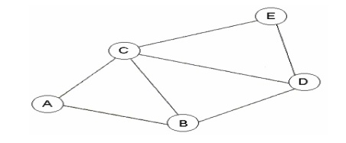

**Congress:**A-C-D-E **SP:** A-B-C-E **BJP:** A-B-D-E **BSP:**B-C-E **CPM:** A-C-D

Street B-D cannot be used for a political procession on Thursday due to a religious procession. The district administration has a policy of not allowing more than one procession to pass along the same Street on the same day. However, the administration must allow all parties to take out their processions during these two days.

1. Congress procession can be allowed:

**(a)Only on Thursday**

**(b)Only on Friday**

**(c)On either day**

**(d)Only if the religious procession is cancelled**

1. Which of the following is NOT true?

**(a)Congress and SP can take out their procession on the same day**

**(b)The CPM procession cannot be allowed on Thursday**

**(c)The BJP procession can only take place on Friday**

**(d)Congress and BSP can take out their processions on the same day.**

**Directions for questions 67 to 68:**

A, B, C, D, E, F, G and H are eight towns inter-connected by roads. Some of the roads are one-way roads where traffic movement is possible in only one direction. Roads from A to G, B to A, B to C, C to D, F to E, D to E and H to D are one-way roads. The other roads connecting A and F, G and H, B and H, H and E are two-way roads where traffic movement is possible in both the directions. No other road exists between the towns.

1. In how many ways can a person travel from town A to town D provided he does not visit any town more than once?

**a)1 b) 2 c) 3 d) 4**

1. What is the maximum number of towns that a person can visit provided that he does not visit each town more than once?
2. **5 b) 8 c) 7 d) 6**

**Directions for questions 69 to 72:**

A significant amount of traffic flows from point S to point T in the one-way street network shown below.

Points A,B,C and D are functions in the network and the arrows mark the direction of traffic flow. The fuel cost in Rupees for travelling along a street is indicated by the number adjacent to the arrow representing the street.

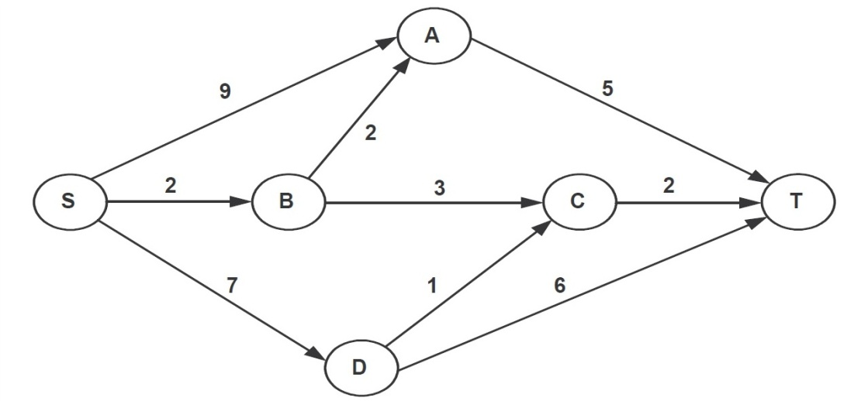

Motorists travelling from Point S to point T would obviously take the route for which the total cost of travelling in the maximum. If 2 or more routes have the same least travel cost, then motorists are indifferent between them. Hence, the traffic gets evenly distributed among all the least cost routes.

The Government can control the flow only by levying appropriate toll at each junction. For example, if a motorist takes the route S-A-T (using junction A alone), then the total cost of travelling would be Rs.14. ( ie, Rs.9 + Rs.5) plus the toll charged at junction A.

1. If the government wants to ensure that all motorists travelling from S to T pay the same amount (fuel cost and toll combined) regardless of the route they choose and the street from B to C is under repairs (and hence unusable), then a feasible set of toll charged (in Rs) at junction A,B,C and D respectively and achieved this goal is:

**(a) 2,5,3,2 (b) 0,5,3,1 (c) 1,5,3,2 (d) 2,3,5,1 (e) 1,3,5,1**

1. If the government wants to ensure that no traffic flows on the street from D to T, while equal amount of traffic flows through junctions A and C, then a feasible set of toll charged (in Rupees) at junction A,B,C and D respectively to achieve this goal is :

**(a) 1,5,3,3 (b) 1,4,4,3 (c) 1,5,4,2 (d) 0,5,2,3 (e) 0,5,2,2**

1. If the government wants to ensure that all routes from S to T get the same amount of traffic, then a feasible set of toll charged (in rupees) at junction A,B,C and D respectively to achieve this goal is:

**(a) 0,5,2,2 (b) 0,5,4,1 (c) 1,5,3,3 (d) 1,5,3,2 (e) 1,5,4,2**

1. If the government wants to ensure that the traffic at S gets evenly distributed along streets from S to A, from S to B, and from S to D, then a feasible set of toll charged (in Rupees) at junctions A,B,C and D respectively to achieve this goal is:

**(a) 0,5,4,1 (b) 0,5,2,2 (c) 1,5,3,3 (d) 1,5,3,2 (e) 0,4,3,2**

**Directions for questions 73 to 75:**The following sketch shows the pipelines carrying water from one location to the other. Each locxation has a demand for water. The demand at P, Q, R, S, T, and U are 600 litres, 1000 litres, 800 litres, 500 litres, 700 litres and 800 litres respectively. Water is supplied in such a way that the total demand of all the six locations is exactly met. The maximum capacity of each pipeline is 3000 litres. Slack in a pipeline is defined as the extra flow required to bring the total flow to maximum capacity. The arrows represent the direction of water flow.

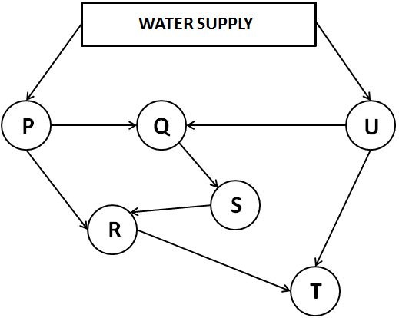

1. What is the minimum possible slack in the pipeline connecting Q and S?
2. **2000 litres (b) 1000 litres (c) 1500 litres (d) 2200 litres**
3. The demand of T alone is increased so that the water supply is maximum possible. What is the minimum quantity of water flow in the pipeline connecting R and T?
4. **1000 litres (b) 0 litres (c) 100 litres (d) 200 litres**
5. 3000 litres of water is supplied to P. Ratio of water flow in the pipeline connecting Q and U and the pipeline connecting T and U is 2:3. If the pipeline connecting R and S is not in use, what is the difference in the quantity of water flowing in the pipe connecting P and Q and the pipe connecting P and R?
6. **200 litres (b) 1400 litres (c) 150 litres (d) 120 litres**

**Directions for questions 76 to 79:**

There are 5 friends. Each of them initially have exactly one fruit bowl from among five fruit bowls- P, Q, R, S, T. Each of the five bowls contained exactly four apples or five bananas or six oranges or seven mangoes or eight guavas ie each bowl contained exactly one variety of fruit only. Q contained six fruits in it initially. Each of the friends now transferred atleast one and atmost two fruits from their respective bowls to each of the other bowls. None of the friends transferred any fruit that they received from another. After all the transfers, it was observed that R has no guavas in it. P has a total of ten fruits, atleast three of which are mangoes. T has six fruits in all, none of which is an apple.

1. How many fruits are there in Q at the end?

**a) 4 b) 5 c) 6 d) 7**

1. How many mangoes are there in P at the end?

**a) 3 b) 4 c) 5 d) Cannot be determined**

1. Which fruit is present in all the bowls at the end?

**a) Orange b) Mango c) Banana d) More than one of the above**

1. How many oranges are there in T at the end?

**a) 0 b) 1 c) 2 d) 3**

**Directions for questions 80 to 82:**

Alex Company has its office at the third floor of a multi-storied building in Mumbai. There are 5 rooms to be allotted to 5 managers (designated M1 to M5), each of whom will occupy one room. Each room has its own advantages and disadvantages. Some have a sea view, while others are closer to either the life or the dining room, while some are more spacious. Each of the five managers was asked to rank the room preferences among the rooms 301, 302, 303, 304 and 305. Their preferences were recorded as follows:

|  |  |  |  |  |  |
| --- | --- | --- | --- | --- | --- |
| Preference | M1 | M2 | M3 | M4 | M5 |
| 1st | 302 | 302 | 303 | 302 | 301 |
| 2nd | 303 | 304 | 301 | 305 | 302 |
| 3rd | 304 | 305 | 304 | 304 | 305 |
| 4th |  | 301 | 305 | 303 |  |
| 5th |  |  | 302 |  |  |

Some managers did not indicate any preference for some rooms, as they did not want to be there under any condition. The company decided to allot rooms to managers in such a way that the managers get rooms as per their best preference or close to that.

1. How many managers would get their rooms as per their best preference?

**a) 1 b) 2 c) 3 d) 4**

1. If manager X gets his/her 1st choice, then his/her preference ranking is 1 and so on. Management decided to allot the rooms so that the sum of the preference ranking of all the managers is minimized. What is the total preference ranking for the rooms allotted to all the managers?

**a) 5 b) 6 c) 7 d) 8**

1. Suppose that Manager M2 decides not to join the new zonal office and Manager M6 takes his place. Manager M6 has the following preference ranking in decreasing order: 301, 302, 303, 304- in this case what would be the sum of the preference ranking allotted to all five managers?

**a) 9 b) 6 c) 7 d) 8**

**Directions for questions 83 to 86:**Among five engineers- Arun, Bimal, Chetan, Das and Eshwar , everyone earns an equal salary every month and saves an equal amount every month. But this month their salary and expenditure varied from their normal salary and expenditure. Arun received Rs. 1000 more than the normal monthly salary and spent Rs. 500 more than the normal monthly expenditure. Bimal received Rs. 500 less than monthly salary and spent Rs. 500 less than monthly expenditure. This month Chetan received Rs. 1500 more than Arun but saved Rs. 1500 less than Arun. Das received Rs. 1000 more than Bimal and saved the same amount as Arun. Eshwar received Rs. 4500 less than what Chetan received this month and could not save any money, since he had to spend the same amount of money he spent the previous month.

1. Who spent the maximum amount of money this month?

**a) Arun b) Bimal c) Chetan d) Cannot be determined**

1. How much money did each of the boys save the last month?

**a) Rs. 3000 b) Rs. 5000 c) Rs. 2000 d) Cannot be determined**

1. How much more money did Chetan spend this month as compared to Eshwar?

**a)Rs 2500 b)Rs 3500 c)Rs 3000 d)Cannot be determined**

1. Das spent how much more money this month as compared to last month?

**a)Rs 0 b)Rs 500 c)Rs 1000 d)Cannot be determined**

**Directions for questions 87 to 90:**Three girls- Asha, Bindu and Chitra and three boys- Ram, Lakhan and Gagan, were participating in a game show, where each of them picked a different card from the six cards available. The number written on the card indicates the number of rupees to be received by that particular person. They are paired in three groups with no two boys in a group. Further

1) The numbers printed on the cards are 30, 40, 60, 80, 100 and 130

2) Asha got less than what her partner got but twice what Bindu got

3) Gagan and his partner got Rs. 200 less than the total amount received by all other pairs

taken together

4) The difference between the amounts received by Bindu and Gagan and that received

by Gagan and Lakhan is the same

5) Ram and his partner together received the same amount as that received by one

among the other persons

1. Who among the following is the partner of Lakhan?

**a) Bindu b) Asha c) Chitra d) Either (a) or (c)**

1. What is the amount that Bindu received?

a**) Rs. 30**  **b) Rs. 40 c) Rs. 60 d) Cannot be determined**

1. What is the total amount received by Bindu, Asha and Gagan?

**a) Rs. 240 b) Rs. 140 c) Rs. 170 d) Rs. 130**

1. Who is Bindu’s partner?

**a)Ram b)Lakhan c)Gagan d)Cannot be determined**

**Directions for questions 91 to 94:**

Four persons A, B, C and D together spent a total of Rs.20000. Each person spent some money on clothes, some on footwear and the remaining on Cosmetics. In total, A spent as much amount as D who in turn spent Rs.500 less than C who in turn spent Rs.1000 less than B. The total money spent on cosmetics is Rs.2000 less than the total money spent on footwear and Rs.3000 less than the total money spent on Clothes. The following is also known:

* B spent Rs.1000 on footwear and thrice that amount on clothes.
* The amount spent by D on cosmetics is Rs.500 less than the amount spent by D on clothes.
* A spends Rs.250 less on cosmetics compared to footwear.
* The amount spent by B on cosmetics is the same as the amount spent by C on clothes which is Rs.500 more than the amount spent by D on footwear.

1. Who spent the least amount on cosmetics?
2. **A (b) B (c) C (d) D**
3. The amount spent by D on clothes is more than the amount spent by A on footwear by
4. **Rs.0 (b) Rs.250 (c) Rs.500 (d) Rs.1000**
5. How much did C spend on footwear?
6. **Rs.250 (b) Rs.2750 (c) Rs.2000 (d) Rs.1000**
7. Which of the following statements is false?

**a)B spent Rs.2000 on cosmetics. b) The total amount on clothes was the highest.**

**c)A spent Rs.1250 on clothes. d) D spent Rs.1750 on cosmetics.**

**Directions for questions 95 to 97:**

A,B,F and T buy one car each and one bike each from the colours yellow, green, pink and blue. The person who owns the green car buys the yellow bike. F owns a pink item. B buys a yellow car. Neither A nor B own a blue item. T owns a green bike. None of them own a car and bike of the same colour.

95. Who buys the blue car?

a)A b)B c)F d)T

96. What is the colour of F’s bike?

a)Blue b)Green c)Yellow d)Pink

97.Who has a pink bike?

a)A b)B c)F d)T

**Directions for questions 98 to 101:**

A,B,C,D,E each have one profession from Doctor, Executive, Advocate, Engineer, Teacher. Each of them like either tea or coffee. A,C and the teacher like coffee. B and the executive like tea. The engineer is C’s brother and both of them like the same drink. The doctor and E like coffee.

98.Who is the doctor?

a)A b)B c)C d)D

99.Who is the engineer?

a)A b)B d)D d)E

100.Who is the executive?

a)A b)C c)D d)E

101.Who like Tea ?

a)Advocate and D b)B and E c)Engineer and Advocate d)A and D

**Directions for questions 102 to 104:**

8 people have to be divided into 2 teams of 4 people each. R and S must be in the same team. T and U cannot be team mates. If V and W are in the same team, U must also be in that team. P and Q are the remaining people.

102.In how many ways can the teams be formed?

a)4 b)5 c)6 d)7

103.If W must be with either V or Q, then in how many ways can the teams be formed?

a)2 b)3 c)4 d)5

104.Which of the following is a possible team?

a)U R S Q b)T U P Q c)R S T V d)R T V W

**Directions for questions 105 to 107:**

Five people A,C,F,R,S each comes from one of the five cities E,G,L,M,Y and pursue one course each from BB, BS, BT, MB, MD. Also,

S and the person from M pursue BS and MD

The person from G is pursuing BT and is not A

Either R or the person pursuing BB is from L

C is from E but is not pursuing MB

A is not doing BS

105.Who is doing BB?

a)A b)C c)F d)R

106.What is the person from L doing?

a)MB b)BB c)BS d)Cannot be determined

107.From where is S?

a)Y b)E c)G d)Cannot be determined

**Directions for questions for 108 to 110:**

7 people D, U,L,P,G,R,S sit in a row such that U is at the extreme left end. P is to the left of G, who is to the immediate left of S. There is exactly one person between R and D. L is two places away to the left of G.

108.Who is at the extreme right end of the row?

a)L b)S c)D d)R

109.Who is at the 6th place from the left end?

a)R b)G c)P d)S

110.Who is at the immediate left of G?

a)S b)R c)D d)Cannot be determined

**Directions for questions 111 to 114:**

There are 7 people in a family A,B,C,D,E,F,G among which there are 2 married couples. G is married and is the grandmother of E. D is the brother of E. B is the uncle of E and has no s no brother. F is A’s son in law.

111.How is C related to E?

a)Mother b)Father c)Aunt d)Uncle

112.How is A related to G?

a)Son b)Brother c)Husband d)Nephew

113.How is B related to A?

a)Son b)Uncle c)Brother d)Nephew

114.How is E related to F?

a)Son b)Nephew c)Daughter d)Niece

**Directions for questions 115 to 117:**

Four people Amar, Bharat, Sanjay and Pankaj are from four places P,Q,R and S. Each of them visit at least 2 and at most 3 of the cities A,B,C,D,E. Every combination of two people have exactly one common city visited by them. Also

Bharat is not from S

Amar and the people from S and Q visited B

Bharat visited E

Sanjay and Pankaj are not from Q

C is visited by the people from P and Q

Pankaj is from P and Sanjay visited by D

Every city is visited by at least one person

115.Which city is visited by the least number of people?

a)A b)C c)D d)E

116.The person from which of these places visited 3 cities?

a)P b)Q c)R d)S

117.Which of the following cities is neither visited by Amar nor by the person from P?

a)A b)B c)D d)E

**Directions for questions 118 to 120:**

Each of 6 people A,Z,P,T,H,J come from each of 6 cities B,C,D,I,K,M and is each one among Athlete, Architect, Doctor, Engineer, Teacher and Professor.

A is a doctor from K

The engineer is from C but is not P

T is not an athlete but comes from M

H is from D

The teacher is from I

J is from B but is not an athlete

118.What is the profession of D’s native?

a)Athlete b)Architect c)Professor d)Cannot be determined

119.Z is from which city?

a)C b)I c)K d)Cannot be determined

120.The professor is from which city?

a)B b)D c)M d)Cannot be determined

**Directions for questions 121 to 124:**

Each of 4 people A,B,C,D bought an item at different costs among Rs 150,225,300,375 and sold them at different profit percentages among 30,40,50,60%.Also

No 2 people obtained the same amount of profit

The person whose profit was 112.5 is not the one with the highest profit

Neither the cost price nor the profit percentage is highest for the person whose profit is the highest

The profit of B is less than that of D and is more than that of A, whose profit is more than that of C

121.What is the highest profit (Rs)?

a)112.5 b)135 c)150 d)180

122.What is the lowest profit (Rs)?

a)45 b)60 c)75 d)90

123.For whom is the profit percentage the least?

a)A b)B c)C d)D

124.What is the cost price of the item for B?

a)225 b)300 c)375 d)Cannot be determined

**Directions for questions 125 to 127:**

6 people A,B,C,D,E, and F visit 6 cities M,N,O,P,J and R on 6 consecutive days starting from Sunday. Each person visited every city only once. No two persons visited the same city on the same day. E visited J one day before C did. R was visited by F on Monday and by A on the following day. D visited O neither on Monday nor on Wednesday. E visited N on Thursday. A visited M on Monday. D and F visited M on Thursday and Tuesday respectively. B’s visit to N, D’s visit to O, A’s visit to P and B’s visit to P were done on four consecutive days respectively. The number of days between E’s visit to J and F’s visit to O is the maximum.

125.On which day did E visit R?

a)Monday b)Wednesday c)Friday d)Cannot be determined

126.If E visited M on Wednesday, when did C visit O?

a)Monday b)Wednesday c)Friday d)Cannot be determined

127.If E visited M on Friday, when did B visit R?

a)Monday b)Wednesday c)Friday d)Cannot be determined

**Directions for questions 128 to 131:**

There are 6 people H,M,D,R,P,S who are performing music, singing and dancing in 6 cities Del,Mum,Kol,Che,Ban,Hyd. In each of the six cities, they perform all the three items one after the other. Each of them has a fixed partner and performs only with their partner. The 6 people in the form of 3 teams, stage three shows in each city and in each show they perform one of music,singing and dancing. Each pair performs only one item in a city.

D sings in Del but does not dance in Ban. R sings in Hyd and H who dances in Del, sings in Che.S plays music in Del and R plays music in Mum. H does not sing in Kol and M does not sing in Hyd but sings in Ban. D plays music in two cities only and H sings in 3 cities. In Che, P is one of the dancers.

128.Which pair dances in Mum?

a)HM b)DP c)RS d)Cannot be determined

129.Which of the following is true?

a)HM dance in Kol b)RS dance only in 2 cities

c)DP play music in Ban d)None of the above

130.If HM play music in Kol, then who plays music in Hyd

a)HM b)DP c)RS d)Cannot be determined

131.Which of the following is required to find the complete schedule?

a)HM dance in Kol b)DP play music in Hyd

c)RS dance in Kol d)HM dance in Hyd

**Directions for questions 132 to 134:**

There are 4 people A,B,C,D to whom 12 tokens numbered 1 to 12 are distributed. Each token is given to only one person. No two people got the same number of tokens. All prime numbers are with B. Both the tokens with A are even numbers. The sum of the numbers on two tokens of C is the same as the sum of the numbers on all tokens of A. C did not get the square of a prime number. B did not get the number 1 or 9. C received the number 12.

132.The maximum possible difference between the sum of numbers on all tokens of any two persons is

a)21 b)22 c)23 d)24

133.The minimum difference between the sum of numbers on all tokens of any two persons is

a)0 b)1 c)5 d)6

134.Which of the following statement is required to find the entire distribution?

a)The sum of all the numbers on all the tokens of one of the person is a perfect cube

b)The sum of all numbers of C is 19

c)Either of the above

d)No further information is required

**Directions for questions 135 to 138:**

10 tokens numbered 1 to 10 are given to 5 boys J,K,L,M,N. K’s tokens have perfect squares. M’s tokens have multiples of 3. L is the only person with 1 token and his number is equal to the sum of N’s numbers. N gets two tokens , both of which are even and one of which is also a multiple of 3.

135.What is the sum of J’s numbers?

a)15 b)20 c)22 d)Cannot be determined

136.Which of the following belongs to L?

a)6 b)8 c)10 d)Either 8 or 10

137.Which of the following is K’s complete set?

a)1,4 b)1,9 c)4,9 d)1,4,9

138.Which of the following is M’s complete set?

a)3,6 b)3,9 c)6,9 d)3,6,9