A knowledge-based AI decision-support model for predicting digital transformation readiness from enterprise innovation data
Short communication
Sai Vignesh Akkineni
Doctor of Business Administration candidate
Corresponding author. Email: saivigneshakkineni2@gmail.com
Institutional affiliation and postal address: to be entered.
Highlights
• Readiness is scored from innovation routines, not digital spend.
• A flexible score outranks six explicit knowledge rules.
• Blending the two probabilities does not improve the score.
• Hold, Develop, and Prioritize separate realized readiness.
• Each band names one missing routine for the next spend.
Abstract
The purpose of this Short Communication is to test whether an enterprise innovation record can support a decision to hold, develop, or prioritize a digital offer. KAID, a knowledge-based AI decision-support model, scores six knowledge routines and uses an AI layer (gradient boosting) to estimate the probability of digital-transformation readiness from the same innovation items. The readiness label is built only from digital markers (a website, an informatics and systems department, and software, hardware, and information and communication technology (ICT) innovation expenditure), and those markers are excluded from the predictors. On the public Latin American innovation surveys, 14,663 firm-years from 12,070 enterprises, logistic regression reaches a holdout area under the receiver-operating curve (AUC) of 0.873, the knowledge layer 0.854, and the AI layer 0.891 (95% enterprise-bootstrap interval 0.879–0.903). The AI layer exceeds the knowledge layer by 0.038 AUC and the logistic model by 0.018 AUC; both intervals exclude zero (p < 0.001). Blending the knowledge probability into the AI-layer probability, with the training weight on the AI layer equal to 0.95, does not improve on the AI layer (difference −0.0002; 95% interval −0.0006 to 0.0001; p = 0.223). On the holdout, 4.0% of Hold firm-years are ready (95% interval 3.1–5.0), 38.4% of Develop firm-years are ready (33.9–42.5), and 64.5% of Prioritize firm-years are ready (60.7–68.2). The missing routine is process innovation in Hold, training in Develop, and knowledge creation in Prioritize.
Keywords: knowledge-based systems; artificial intelligence; enterprise innovation data; digital transformation; decision support; data-centric business models; entrepreneurship
1. Introduction
Digital transformation is a change in how a firm creates value, not a purchase of software [1,2]. A data-centric offer is one a customer will pay for [3], and digital entrepreneurship is the decision to pursue that offer [4]. Big-data analytics capability has been linked to performance through dynamic capabilities rather than through possession of the technology alone [5]. The knowledge-based view treats the firm as an institution that integrates specialist knowledge into a routine that can be used [6]. An artificial-intelligence output is an input to the innovation process [7], and turning that capability into a business model is described as co-evolutionary [8]. Readiness is multidimensional, covering technology, processes, management, human capability, and culture, and it is not settled by one technology indicator [9]. Transformation is also framed as a springboard for product, process, and business-model innovation [10].
Counting those markers as predictors would rediscover the purchase. KAID holds them out as the label, compares a six-rule knowledge score with logistic regression and gradient boosting on an enterprise holdout, and names one missing routine in each band. For Hold and Develop that routine is the common one whose absence most exceeds its absence in Prioritize. For Prioritize it is the common routine most often still absent. The blend weight is chosen on training enterprises and frozen. Section 3 reports which score carries the probability.
2. Methodology
2.1. Readiness label
Let firm-year i have a set Mᵢ of digital markers that the survey asked. The five markers are a website, a formal informatics and systems department, and software, hardware, and ICT innovation expenditure. Each observed marker dᵢₘ equals 1 when the firm reports it and 0 otherwise. The label is
yᵢ = 1{ |Mᵢ| ≥ 3 and (1/|Mᵢ|) Σₘ∈Mᵢ dᵢₘ ≥ 0.5 }. (1)
Firm-years with fewer than three observed markers are excluded. The markers in Mᵢ are not predictors.
2.2. Knowledge-rule layer
The knowledge layer is six production rules, evaluated once per firm-year. A rule fires when any observed item equals 1. If every item for that rule is missing, the rule is left out of the share. In code order the rules are knowledge creation (in-house R&D expenditure or a formal R&D department), external knowledge (external R&D expenditure), training for innovation, organizational innovation, product innovation, and process innovation. The items follow the Oslo Manual [11]. Let fᵢᵣ equal 1 when rule r fires and 0 when it is observed and does not fire, and let Rᵢ be the rules with at least one observed item. In this sample |Rᵢ| = 6 for every retained firm-year. The raw score is
Sᵢ⁰ = (1/|Rᵢ|) Σᵣ∈Rᵢ fᵢᵣ. (2)
A training-only isotonic map g(·) converts the share into a probability Sᵢ = g(Sᵢ⁰), fitted on training enterprises and applied unchanged to the holdout. External R&D fires for 6.0% of the estimation sample. It stays inside the score. It is excluded from the named-routine comparison, because a rule that rare is absent in every band. Two further rules were specified and removed. Innovation cooperation was not asked in 39% of estimation-sample firm-years, and 0.07% of those firm-years were coded ready. The internet as an information source was not asked in 51%, and 2.8% of those firm-years were coded ready.
2.3. AI layer and the decision score
The AI layer is a histogram gradient-boosting classifier [12]. Its inputs are the items inside the six rules, plus marketing innovation, foreign ownership, group membership, log(1 + employment), country, year, and sector. Trees have depth 4, a learning rate of 0.06, at most 400 iterations, an L2 penalty of 1.0, and at least 40 observations in a leaf. Early stopping holds out 15% of the rows inside the fit and stops after 20 rounds without improvement. That internal split is not the enterprise holdout and does not choose w. Missing numeric answers stay missing. Country, year, and sector are one-hot encoded from the current fit only. No class weight is applied. Let Pᵢ be the boosting probability. The KAID score is
Kᵢ = w Pᵢ + (1 − w) Sᵢ, (3)
where w minimizes the Brier score on out-of-fold predictions inside the training sample, on the grid {0, 0.05, …, 1}, and is then frozen. The holdout is not used to pick w. Firms are not classified by maximizing F1. Two cuts are fixed before the holdout is opened. Let π be the training readiness rate. The band is
Hold if Kᵢ < π; Develop if π ≤ Kᵢ < 0.50; Prioritize if Kᵢ ≥ 0.50. (4)
Algorithm 1. A routine is common if it fires for at least 15% of the estimation sample. For Hold and Develop, name the common routine whose absence most exceeds its absence in Prioritize; for Prioritize, name the common routine most often still absent. (1) Drop firm-years with fewer than three observed markers and set yᵢ by Eq. (1). (2) Split by enterprise. (3) On five grouped training folds, fit g and boosting and choose w. (4) Refit on all training enterprises and freeze w. (5) Score the holdout with Eqs. (3)–(4). Seeds: 42 for the split, both fits, and the AUC bootstrap; 43 for band rates.
2.4. Experimental design
The source is the public Harmonized Latin American Innovation Surveys database, LAIS [13]. Eq. (1) keeps 14,663 firm-years and 12,070 enterprises in Ecuador, El Salvador, Panama, Paraguay, and Peru, in 2009 and 2012–2016. The ready share is 23.6%. Software, hardware, and ICT expenditure were asked of every retained firm-year. An informatics department was asked of 90.6%, and a website of 25.8%. Where asked, a website is reported in 50.5% of firm-years, an informatics department in 33.0%, and software, hardware, and ICT expenditure in 18.5%, 16.7%, and 24.1%. The six routines fire at 19.9% (knowledge creation), 6.0% (external R&D), 21.3% (training), 27.9% (organizational innovation), 32.0% (product innovation), and 34.9% (process innovation).
The holdout is 20% of enterprises (country code joined to the firm identifier), so a firm seen in two years stays on one side. Training has 11,731 firm-years (9,656 enterprises). The holdout has 2,932 firm-years (2,414 enterprises) and a ready rate of 23.3%. Logistic regression median-imputes and standardizes numeric inputs and uses an L2 penalty with C = 1; that imputation is not used in the AI layer. F1 cuts maximize training out-of-fold F1 on a grid from 0.05 to 0.95 by 0.025 and are then frozen. AUC, Brier, and the bands do not use them. Uncertainty is 2,000 enterprise bootstrap draws; a single-class draw is dropped. The two-sided p-value is twice the smaller tail, capped at 1, and is reported as p < 0.001 when no draw changes sign.
3. Results
Table 1 is the first use of the holdout. To three decimal places the AI layer and KAID are both 0.891, the figure in the abstract. Brier scores are 0.120, 0.125, 0.110, and 0.110. Mean predicted probability is 0.237 for both the AI layer and KAID, against a ready rate of 0.233, so the Prioritize cut of 0.50 sits above the base rate. The frozen F1 cuts are 0.200, 0.225, 0.300, and 0.350. Both top scores have F1 0.678. KAID’s higher cut raises precision from 0.565 to 0.584 and lowers recall from 0.848 to 0.808.
Table 1. Holdout comparison of readiness scores.
Method | AUC | 95% interval | F1 cut | F1 | Precision | Recall | Brier
Logistic regression | 0.8734 | 0.8596–0.8868 | 0.200 | 0.660 | 0.539 | 0.851 | 0.120
Knowledge layer | 0.8536 | 0.8399–0.8675 | 0.225 | 0.626 | 0.502 | 0.833 | 0.125
AI layer | 0.8914 | 0.8787–0.9033 | 0.300 | 0.678 | 0.565 | 0.848 | 0.110
KAID | 0.8912 | 0.8784–0.9032 | 0.350 | 0.678 | 0.584 | 0.808 | 0.110
Note. n = 2,932 firm-years (2,414 enterprises); ready rate 23.3%. Intervals are 2,000 enterprise bootstraps of the fixed scores (seed 42); models are not refit. Four-decimal AUCs recover Table 2. The abstract rounds AUC to three decimals and rounds 0.0378 and 0.0180 to 0.038 and 0.018.
Table 2 gives the paired contrasts on those scores. The AI layer exceeds the knowledge layer by 0.0378 AUC and logistic regression by 0.0180; both intervals exclude zero and no replicate reverses the sign (p < 0.001). Logistic regression exceeds the knowledge layer by 0.0198 (p < 0.001). Training sets w = 0.95. KAID is 0.0002 below the AI layer (p = 0.223), so the blend does not discriminate better. Most of the holdout discrimination is already linear: chance is 0.50 and the logistic AUC is 0.8734.
Table 2. Paired enterprise-bootstrap contrasts on holdout AUC.
Contrast | Difference in AUC | 95% interval | p
AI layer − knowledge layer | +0.0378 | 0.0291 to 0.0461 | < 0.001
AI layer − logistic regression | +0.0180 | 0.0117 to 0.0247 | < 0.001
Knowledge layer − logistic regression | −0.0198 | −0.0279 to −0.0114 | < 0.001
KAID − AI layer | −0.0002 | −0.0006 to 0.0001 | 0.223
Note. Paired differences on the same 2,932 firm-years, before rounding, from the same 2,000 draws (all retained). A zero difference is counted in both tails.
Of 2,932 holdout firm-years, 1,786 (60.9%) fall in Hold, 487 (16.6%) in Develop, and 659 (22.5%) in Prioritize. Ready counts are 72, 187, and 425, summing to 684. Ready rates are 4.0% (3.1–5.0), 38.4% (33.9–42.5), and 64.5% (60.7–68.2), against a base rate of 23.3%. The intervals do not overlap. Prioritize contains 425 of 684 ready firm-years (62.1%) and 234 firm-years that are not ready (35.5% of the band; 10.4% of the 2,248 firm-years that are not ready). Hold contains 1,714 of those 2,248 (76.2%) and 72 ready firm-years. Process innovation is absent for 93.5% of Hold firm-years and 11.8% of Prioritize firm-years. Training is absent for 98.2% of Hold, 72.9% of Develop, and 29.3% of Prioritize. Knowledge creation is absent in 48.0% of Prioritize.
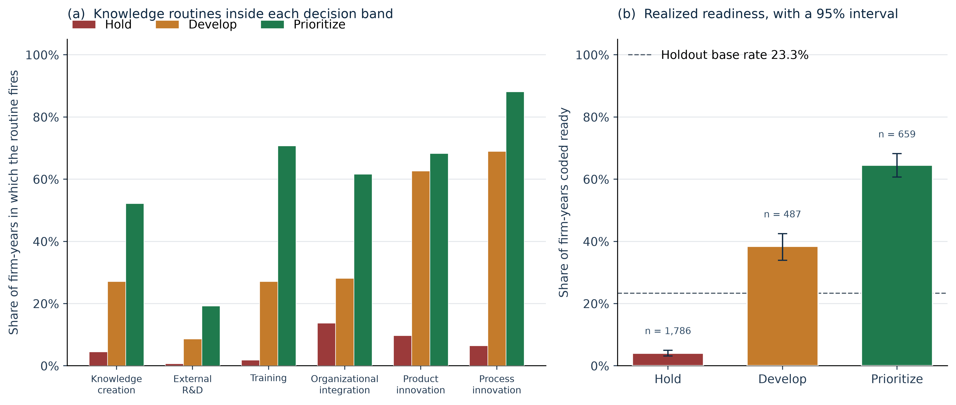 | 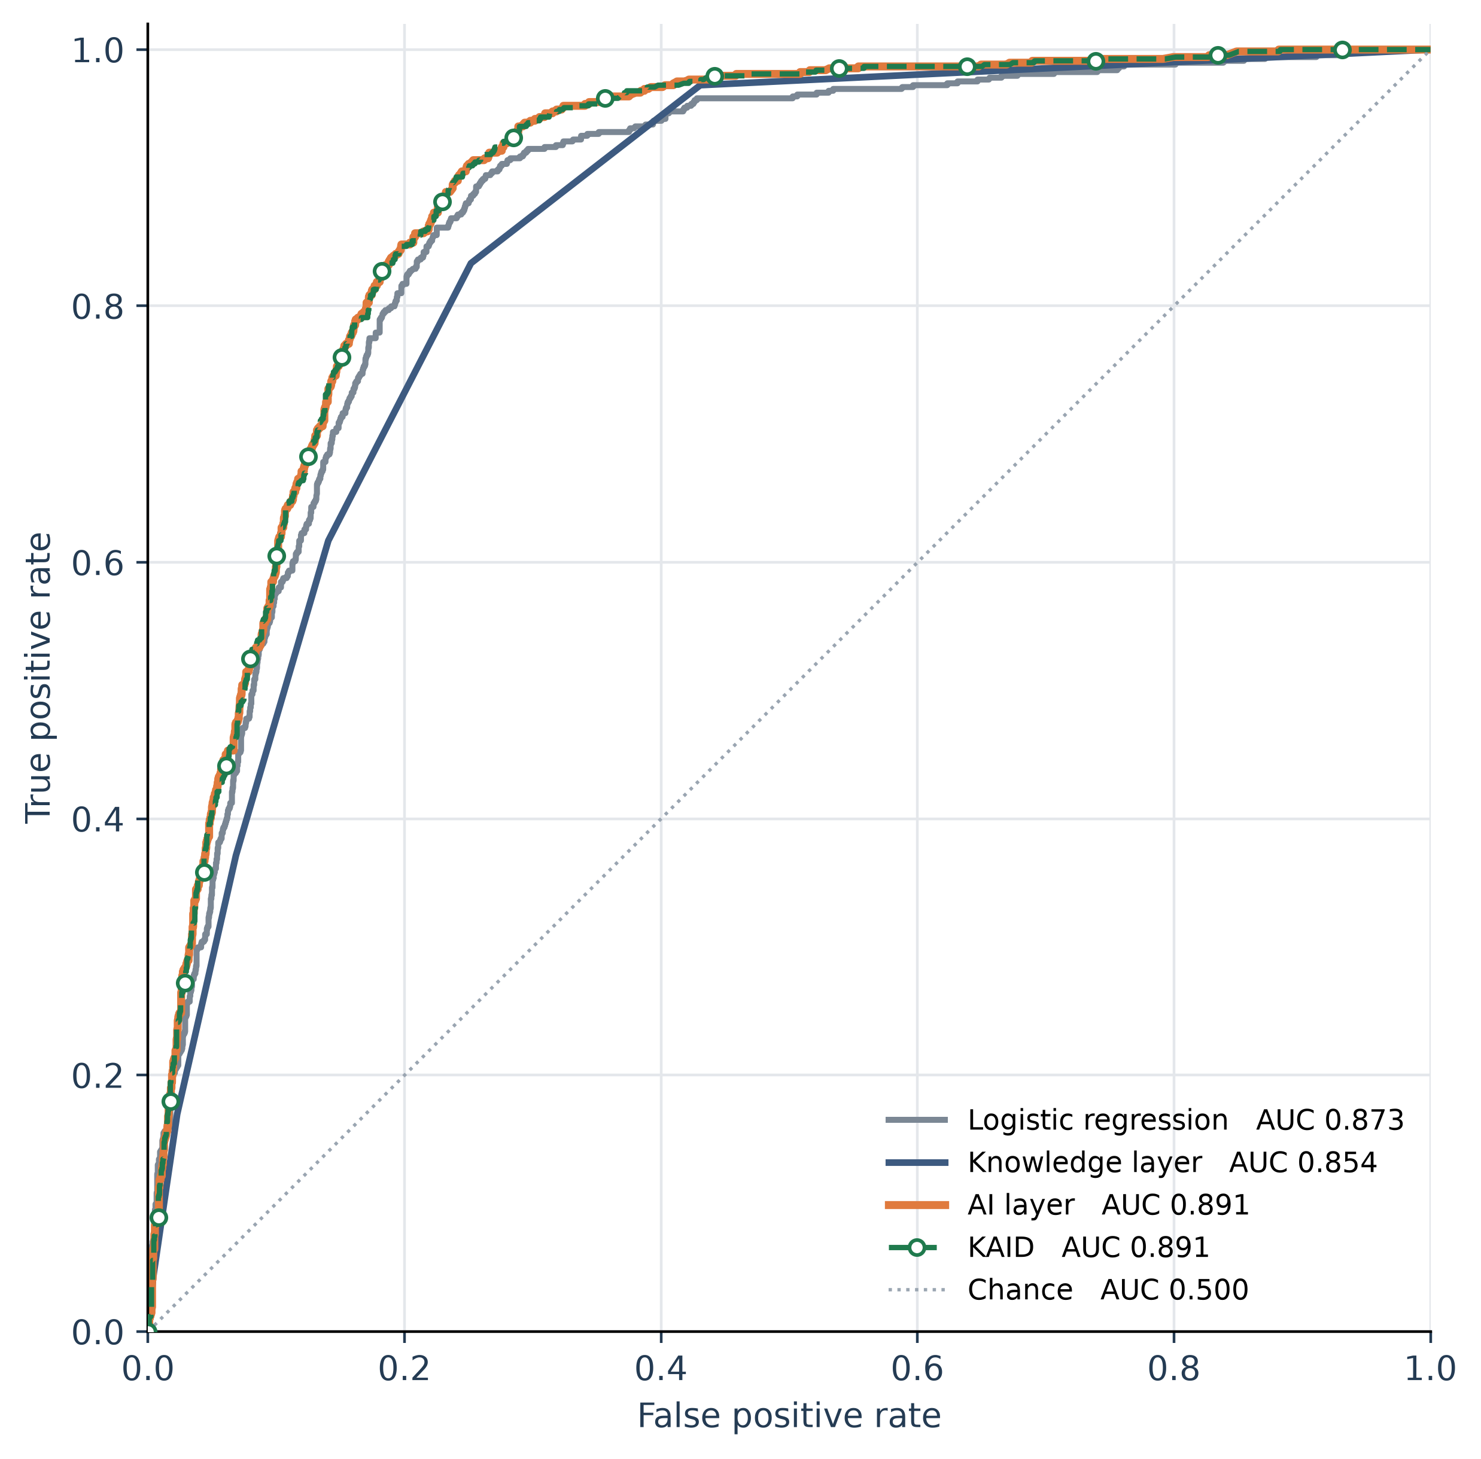
Fig. 1. Holdout bands from K. Panel (a), routine firing rates. Panel (b), share coded ready, with a 95% enterprise-bootstrap interval. The dashed line is the base rate, 23.3%. Fig. 2. Holdout ROC curves. KAID lies on the AI curve (weight 0.95; difference −0.0002, p = 0.223). The diagonal is chance.
Dropping process innovation and refitting the AI layer leaves a holdout AUC of 0.852, beside the knowledge layer at 0.8536 and still above chance. On the 1,782 holdout firm-years where cooperation was asked, 38.3% are ready, against 23.3% in the full holdout. Inside that slice the main AI model has AUC 0.800, cooperation alone has AUC 0.634, and adding the item moves AUC from 0.800 to 0.811. The association is small where the question was fielded. It is not a reason to impute the item where the question was omitted.
4. Discussion
The probability belongs to the AI layer. The budget order belongs to the band and to the routine it is missing. The knowledge layer gives up 0.0198 AUC because it compresses part of the record with equal weights. The AI layer gains 0.0180 by using those items flexibly, with marketing innovation, ownership, size, country, year, and sector. Putting the remaining 5% of the weight on the knowledge probability does not raise AUC (−0.0002; p = 0.223). Once the probability is known, the usable result is the named routine [14]. Hold is the low-readiness group, and its gap is process innovation. Develop sits above the base rate, and its gap is training. Prioritize holds 62.1% of ready firm-years and is still not ready in 35.5% of its firm-years, so it is a shortlist; knowledge creation is absent in 48.0% of it. The screen is not evidence that buying the named routine causes readiness [3,4,10]. Adding cooperation where it was asked moves AUC only from 0.800 to 0.811 [15], which does not justify imputing an unasked item. The contributions are the marker-only label, the negative blend result on an enterprise holdout, and bands that separate readiness and each name one routine.
5. Limitations
The label is a survey proxy, not revenue from a data product. Management, human capability, and culture are part of readiness [9] and are not among the five markers. A website was asked of only a quarter of the estimation sample. Process innovation can include support activities [11], and dropping it leaves an AI-layer AUC of 0.852, so part of the discrimination sits near the label even though the spend items are not predictors. The design is cross-sectional. The blend result concerns items the booster already sees. The bootstrap does not refit the model. LAIS is distributed under CC BY-NC-ND 3.0 IGO and is not redistributed; kaid.py downloads the public file and rebuilds the figures and metrics.
6. Conclusion
Across 2,932 holdout firm-years the probability belongs to the AI layer: logistic regression already reaches AUC 0.8734, the knowledge layer sits 0.0198 below it, and blending does not help (p = 0.223). The bands still separate realized readiness, from 4.0% in Hold to 64.5% in Prioritize, and they point to process innovation, training, or knowledge creation. Prioritize remains a shortlist, with 35.5% of its firm-years not ready. Averaging the probability and the routine does not improve the probability.
CRediT authorship contribution statement
Sai Vignesh Akkineni: Conceptualization, Methodology, Software, Validation, Formal analysis, Investigation, Data curation, Writing – original draft, Writing – review and editing, Visualization.
Declaration of competing interest
The author declares no known competing financial interests or personal relationships that could have appeared to influence the work reported in this paper.
Declaration of generative AI and AI-assisted technologies in the manuscript preparation process
During the preparation of this work the author used Cursor to draft, edit, and format the manuscript and to organize the analysis code. After using this tool, the author reviewed and edited the content as needed and takes full responsibility for the content of the published article.
Funding
This research did not receive any specific grant from funding agencies in the public, commercial, or not-for-profit sectors.
Ethical approval
Ethical approval was not required. The study uses the public LAIS microdata and collected no new data from human participants.
Data availability
The firm microdata are the public LAIS file [13], https://doi.org/10.60966/hbz4-cm10. No identifiable firm record is reported, and the microdata are not redistributed. Running kaid.py downloads that file, refits every model under seed 42, and regenerates the figures and results.json.
References
[1] C. Gong, V. Ribiere, Developing a unified definition of digital transformation, Technovation 102 (2021) 102217. https://doi.org/10.1016/j.technovation.2020.102217
[2] G. Vial, Understanding digital transformation: A review and a research agenda, J. Strateg. Inf. Syst. 28 (2019) 118–144. https://doi.org/10.1016/j.jsis.2019.01.003
[3] P.M. Hartmann, M. Zaki, N. Feldmann, A. Neely, Capturing value from big data – a taxonomy of data-driven business models used by start-up firms, Int. J. Oper. Prod. Manag. 36 (2016) 1382–1406. https://doi.org/10.1108/IJOPM-02-2014-0098
[4] S. Nambisan, Digital entrepreneurship: Toward a digital technology perspective of entrepreneurship, Entrep. Theory Pract. 41 (2017) 1029–1055. https://doi.org/10.1111/etap.12254
[5] S. Fosso Wamba, A. Gunasekaran, S. Akter, S.J.-f. Ren, R. Dubey, S.J. Childe, Big data analytics and firm performance: Effects of dynamic capabilities, J. Bus. Res. 70 (2017) 356–365. https://doi.org/10.1016/j.jbusres.2016.08.009
[6] R.M. Grant, Toward a knowledge-based theory of the firm, Strateg. Manag. J. 17 (S2) (1996) 109–122. https://doi.org/10.1002/smj.4250171110
[7] N. Haefner, J. Wincent, V. Parida, O. Gassmann, Artificial intelligence and innovation management: A review, framework, and research agenda, Technol. Forecast. Soc. Change 162 (2021) 120392. https://doi.org/10.1016/j.techfore.2020.120392
[8] D. Sjödin, V. Parida, M. Palmié, J. Wincent, How AI capabilities enable business model innovation: Scaling AI through co-evolutionary processes and feedback loops, J. Bus. Res. 134 (2021) 574–587. https://doi.org/10.1016/j.jbusres.2021.05.009
[9] F. Michelotto, L.A. Joia, Organizational digital transformation readiness: An exploratory investigation, J. Theor. Appl. Electron. Commer. Res. 19 (2024) 3283–3304. https://doi.org/10.3390/jtaer19040159
[10] S. Bresciani, K.-H. Huarng, A. Malhotra, A. Ferraris, Digital transformation as a springboard for product, process and business model innovation, J. Bus. Res. 128 (2021) 204–210. https://doi.org/10.1016/j.jbusres.2021.02.003
[11] OECD, Eurostat, Oslo Manual 2018: Guidelines for collecting, reporting and using data on innovation, fourth ed., OECD Publishing, 2018. https://doi.org/10.1787/9789264304604-en
[12] J.H. Friedman, Greedy function approximation: A gradient boosting machine, Ann. Stat. 29 (2001) 1189–1232. https://doi.org/10.1214/aos/1013203451
[13] G. Crespi, C. Guillard, M. Salazar, F. Vargas, Harmonized Latin American innovation surveys database (LAIS): Firm-level microdata for the study of innovation: 2007–2017 [dataset], Inter-American Development Bank, 2022. https://doi.org/10.60966/hbz4-cm10
[14] Y.K. Dwivedi, et al., Artificial intelligence (AI): Multidisciplinary perspectives on emerging challenges, opportunities, and agenda for research, practice and policy, Int. J. Inf. Manag. 57 (2021) 101994. https://doi.org/10.1016/j.ijinfomgt.2019.08.002
[15] T. Liu, J. Leng, S. Zhu, R. Fu, Digital transformation and enterprise innovation capability: From the perspectives of enterprise cooperative culture and innovative culture, J. Theor. Appl. Electron. Commer. Res. 20 (2025) 136. https://doi.org/10.3390/jtaer20020136

