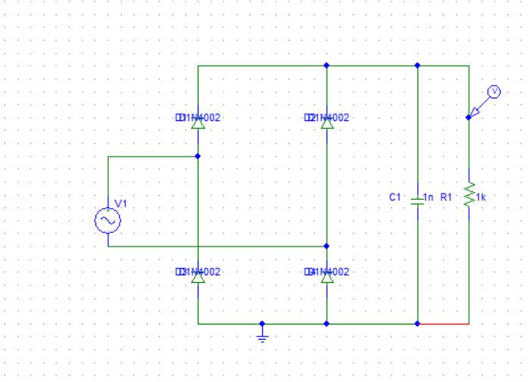

FULLWAVE RECTIFIER CIRCUIT DIAGRAM

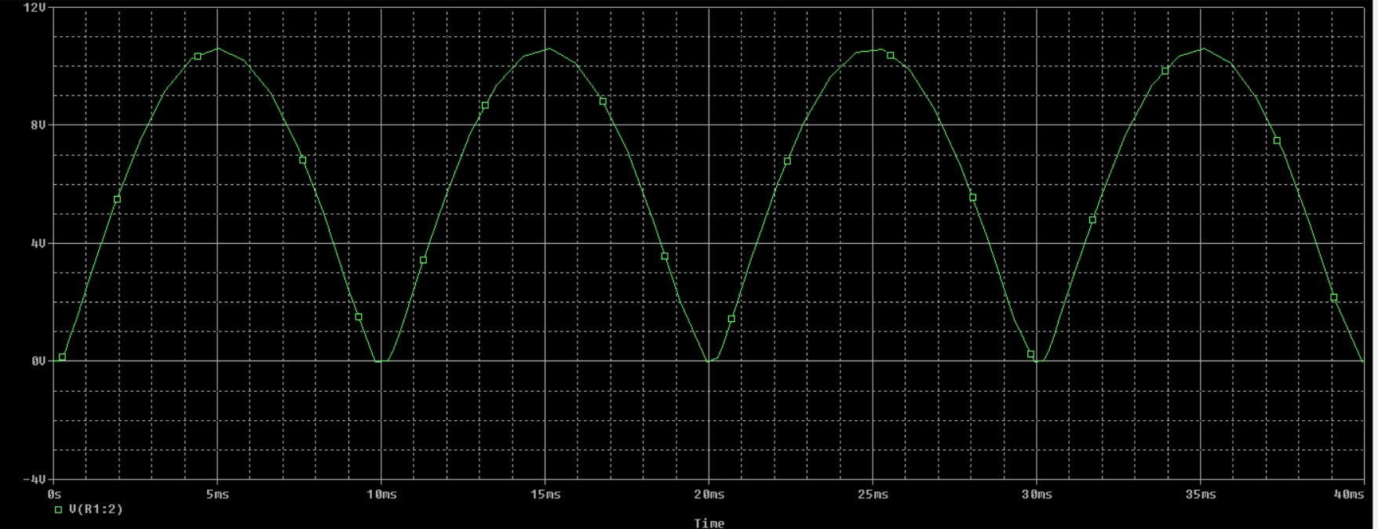

FULLWAVE RECTIFIER WAVEFORM