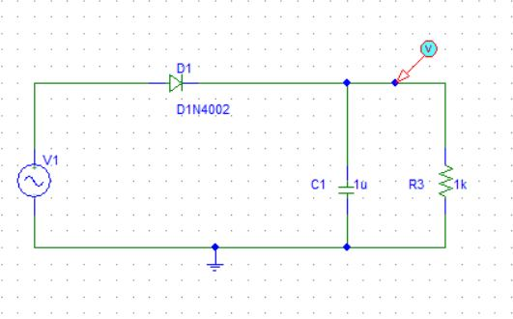

HALFWAVE RECTIFIER CIRCUIT DIAGRAM

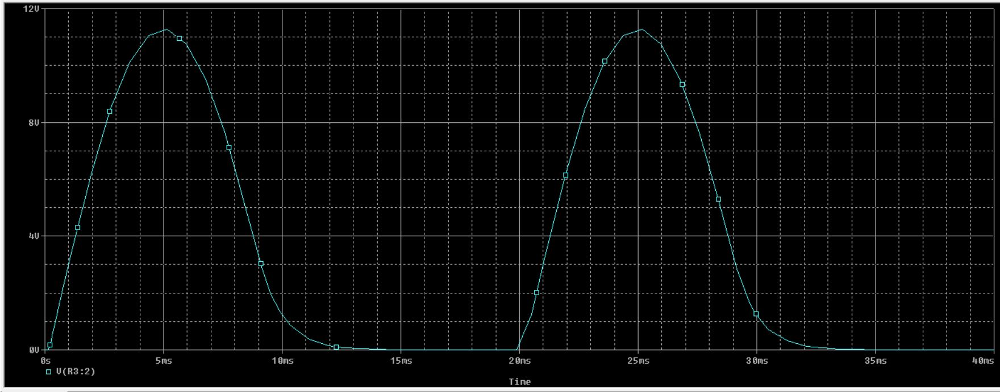

HALFWAVE RECTIFIER WAVE FORM