***DIGITAL FUNDAMENTALS***

***AND***

***COMPUTER ORGANIZATION***

***DIGITAL HEADS OR TAILS***

|  |  |
| --- | --- |
| T. UMAR AHMED  2018103075  CSE ‘Q’ BATCH | G. VIGNESH 2018103078  CSE ‘Q’ BATCH |

***DIGITAL HEADS OR TAILS***

Digital Heads or Tails is a circuit designed in order to choose between two alternatives. It can be used as a substitute for coin tossing. Coin tossing is generally used in order to choose between two options or used to resolve a dispute between two parties. The party who calls for the side wins. This is the purpose of this digital circuit too.

***This digital circuit works in the following way:***

When the circuit is switched ON, the two LEDs present start to blink. One LED can be used to represent one option while the other one is used to represent the other option. When the push button provided is pressed, one among the two LEDs stays ON while the other one switches OFF. The switching ON and OFF of the LEDs is completely random and depends upon the clock pulse at that instant. By this the user can choose the option represented by the LED which is ON. The 7-segment display provided displays the chosen option.

***COMPONENTS REQUIRED***:

* IC 555 Timer
* IC 4017 Decade Counter
* IC 7408 (AND Gate)
* IC 7404 (NOT Gate)
* IC 7400 (NAND Gate)
* 7-Segment Display
* Resistors- 1KΩ (3), 10KΩ (1)
* Capacitor- 1µF
* Battery(9V)
* Push-button
* Patch Cords
* Bread Board

***CIRCUIT DIAGRAM***

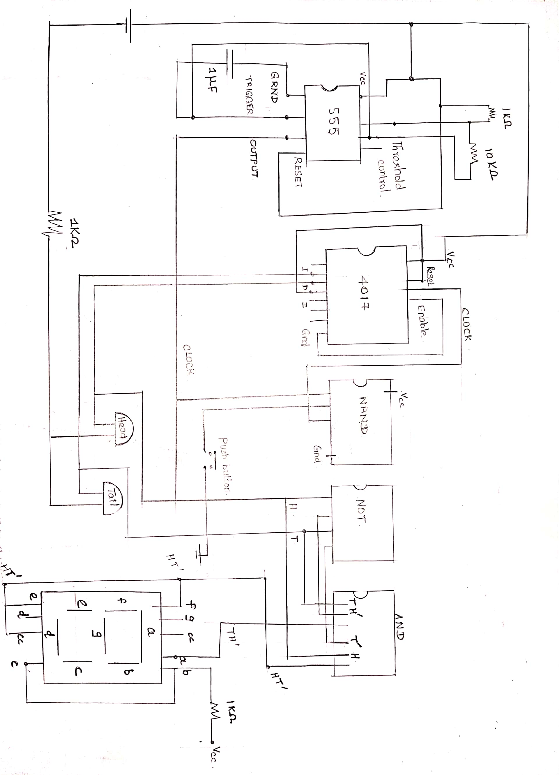

***CIRCUIT EXPLANATION:***

When the circuit is switched ON, the IC 555 timer produces a clock wave pulse. The frequency of the clock wave pulse is controlled by the resistor placed across the trigger and threshold port of the IC 555 timer. The clock output wave pulse is given to one of the inputs of a NAND gate and the another input is connected to the output of the push button. When the push button is not pressed, the NAND gate’s output seems to be an inverted clock pulse, because if no input is given to the second input of the NAND gate it is considered as 1 (according to the truth table of NAND gate).

***(Truth Table of NAND Gate)***

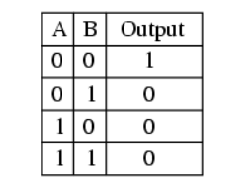

***(Inverted Clock Pulse)***

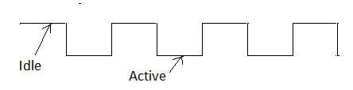

When the push button is pressed, the input of the push button which is ground (0), is given as its output, so that the NAND gate which is connected to push button’s output gives out one (1) instead of the inverted clock pulse at that instant. This output of the NAND gate is given to the clock of IC 4017- decade counter.

When the push button is not pressed, the decade counter counts between its inputs in ports 1,2 and since the third input port is given to RESET of the IC 4017, it acts like a mod-3 counter which counts 1,2 and goes back to 1. When the push button is pressed, 1 is given instead of clock so that the counting of the counter stops at that second between any two states of inputs in 1 and 2, and this is completely random and only depends upon the clock pulse frequency.

Decade counter’s outputs are given to two LEDs and also to a 7-segment display to represent H or T. In order to obtain H in 7-segment display, we need to get 1, in pins b, c, e, f, g of the 7-segment display and in order to get T, we need to get 1, in pins a, b, c. Since b and c are common for both H and T, we have connected it directly to the ground (0). When H part of the 7-segment display glows, T should be OFF, so HT’ is given to e, f, g and when T part glows, H should be OFF so TH’ is given to a. Here H and T denote the outputs of the decade counter 1, 2. So randomly either H or T is displayed on the 7-segment display.

***APPLICATIONS:***

* This circuit can be used as a substitute for coin-tossing to choose between two alternatives.
* In a [game theoretic](https://en.wikipedia.org/wiki/Game_theory) analysis it provides even odds to both sides involved, requiring little effort and preventing the dispute from escalating into a struggle.
* This circuit can be used to resolve dispute between two parties.

***CONCLUSION:***

Thus the circuit has been successfully designed and implemented using the necessary logic components.