ReviveAI - AI-Powered Photo and Audio Denoising and Restoration – Deep Learning – Diffusion Models

Project Description:
ReviveAI is a local web application that removes noise from photographs and audio recordings and restores faded old prints. A user drops in a photo or a recording and presses one button; ReviveAI measures the problem, chooses the right clean-up automatically and shows the result next to the original so the improvement can be judged immediately. Grain, high-ISO noise, speckle, salt-and-pepper “snow”, colour noise, black-and-white photos, faded and scratched prints, and tape hiss in recordings are all handled through the same simple interface, which makes the tool useful for photographers, archivists, families digitising old albums and anyone cleaning up a noisy recording.
The project combines three layers of intelligence. A classical engine — BM3D (Studio mode) and non-local means (Fast mode), with the noise level measured automatically — is the dependable default. An optional AI mode uses SCUNet, a pretrained blind denoising network that needs no noise level, and a built-in training pipeline lets you train your own denoiser on 1,000 or more photos and use it as the “Mine” option. For research extension, the project also includes ControlNet and SGMSE+ (diffusion-based) training scripts for photo restoration and audio enhancement. Everything runs on the user’s own computer: uploads sit in a temporary folder and are deleted after an hour, and results are reported with honest, reproducible PSNR and SSIM measurements rather than unverified claims.

Scenarios
Scenario 1: A family wants to rescue a faded, stained print covered in dust and scratches. They select the “Faded print” sample (or upload their own scan), press Clean up photo, and ReviveAI applies its old-photo restoration — contrast, dust and scratch repair, sharpening and colour tone. They drag the comparison handle to check the result and download it as a PNG.
Scenario 2: A photographer has a high-ISO picture full of sensor noise, such as the “High-ISO cat” sample. ReviveAI measures the noise level, picks the clean-up and removes the grain; if the result looks too smooth or still too noisy, the Gentler and Stronger buttons re-run it with less or more strength, and Fine-tune exposes every slider.
Scenario 3: A user has a photo damaged by salt-and-pepper speckle, snow specks or colour noise. ReviveAI finds the damaged pixels one by one, repairs them from clean neighbours and then removes the remaining grain, so bright specks and colour blotches disappear while edges stay sharp.
Scenario 4: A user uploads a short recording with steady tape hiss, such as tape-hiss.wav. ReviveAI removes the hiss and hum while keeping the bass, reports how much quieter the hiss is in the quiet passages, and lets the user switch between Original and Denoised while viewing the waveform or spectrogram.
Scenario 5: A student whose project must use a model they trained themselves collects 1,000 or more clean photos and runs the training script. ReviveAI then shows a “Mine” option under Quality, and its hint reports how many images the model was trained on and its held-out score — letting the student compare their own network with Studio, Fast and AI modes using PSNR and SSIM.

Technical Architecture:
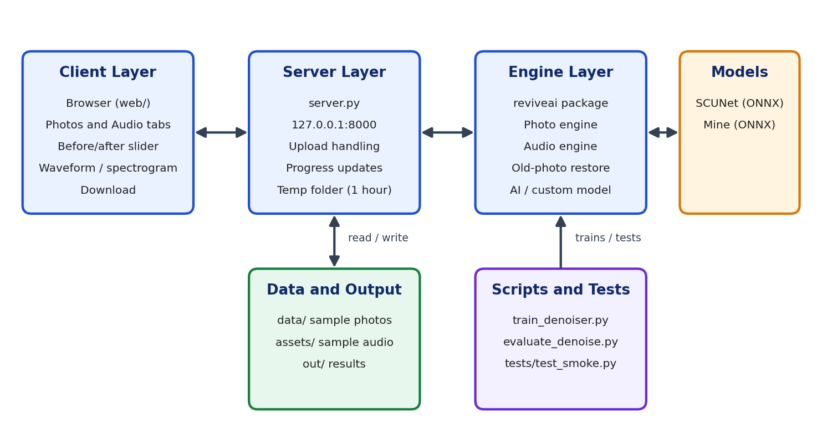
Description: The application follows a four-layer flow. The client layer is the browser interface served from the web folder, with Photos and Audio tabs, a before/after comparison slider, a waveform and spectrogram view and a Download button. The server layer, server.py, runs at 127.0.0.1:8000, receives uploads, reports progress and returns results, keeping files in a temporary folder that is cleared after an hour. The engine layer is the reviveai package, which contains the photo engine, the audio engine, the old-photo restoration mode and the optional AI and custom-model denoisers. The model layer holds the ONNX files — the downloaded SCUNet model and the user’s own custom_denoiser.onnx. Sample data, results, training and evaluation scripts, and tests sit alongside in the data, out, scripts and tests folders.
Flow Diagram:
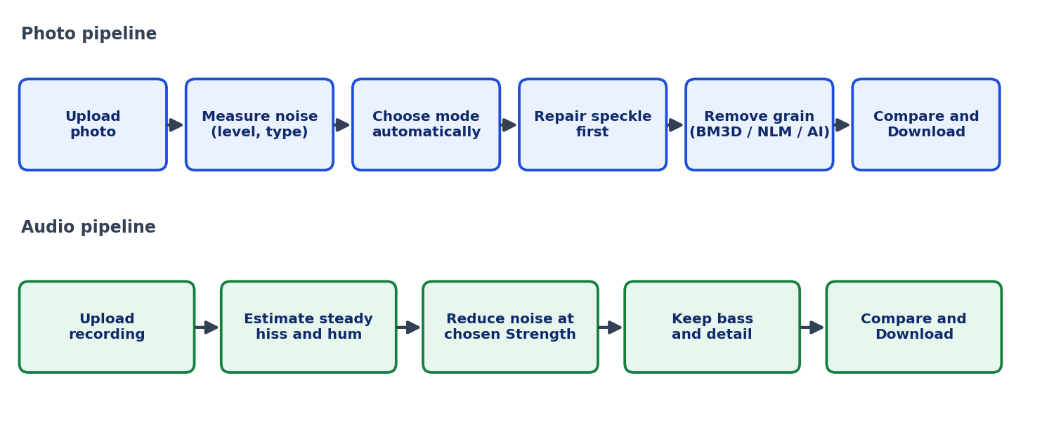
Description: ReviveAI does not use a database, so instead of an ER diagram this diagram shows how a file moves through the system. A photo is uploaded, its noise level and type are measured, the mode is chosen automatically, speckle is repaired first and the remaining grain is then removed using Studio, Fast, AI or Mine, after which the user compares and downloads the result. A recording is uploaded, its steady hiss and hum are estimated and reduced at the chosen Strength while the bass and detail are preserved, and the user compares Original and Denoised before downloading.

Pre-requisites:
- Python Programming Proficiency: Python Documentation
- Image Processing with OpenCV and NumPy: OpenCV Documentation
- Numerical Computing with NumPy: NumPy Documentation
- Audio and Signal Processing Basics: Familiarity with waveforms, spectrograms, sample rates, noise and the signal-to-noise ratio.
- Deep Learning with PyTorch (for training): PyTorch Documentation
- ONNX Runtime (for AI mode): ONNX Runtime Documentation
- HTML, CSS and JavaScript Skills: MDN Web Docs
- Version Control with Git: Git Documentation

Project Workflow:

Activity 1: Model Selection and Architecture
- Activity 1.1: Analyse the noise types the tool must handle and decide on the clean-up strategy for each.
- Activity 1.2: Select the denoising methods — BM3D, non-local means, SCUNet and a custom-trained network.
- Activity 1.3: Define the architecture across the web interface, server.py and the reviveai package.
- Activity 1.4: Set up the environment, install the requirements and start the server.

Activity 2: Core Functionalities Development
- Activity 2.1: Build the photo denoising engine with automatic noise measurement and mode selection.
- Activity 2.2: Build the “Restore old photo” mode for faded, soft and scratched prints.
- Activity 2.3: Build the audio denoising engine that removes hiss and hum while keeping the bass.
- Activity 2.4: Add the optional AI mode using the pretrained SCUNet network.
- Activity 2.5: Add the training pipeline for a custom denoiser and the “Mine” option.
- Activity 2.6: Evaluate the results with PSNR, SSIM and audio measurements.

Activity 3: Server Development
- Activity 3.1: Build server.py to serve the interface and accept photo and audio uploads.
- Activity 3.2: Add progress reporting, Gentler and Stronger re-runs, and downloads.
- Activity 3.3: Add temporary file handling, input limits and automated tests.

Activity 4: Frontend Development
- Activity 4.1: Design the dark, responsive interface with Photos and Audio tabs and sample photos.
- Activity 4.2: Build the comparison slider, zoom controls, waveform and spectrogram player and the action bar.

Activity 5: Deployment
- Activity 5.1: Prepare the application and run it locally with python server.py.
- Activity 5.2: Test and verify every photo and audio feature path.

Activity 6: Conclusion
- Activity 6.1: Summarise what ReviveAI achieves for photographs and recordings.
- Activity 6.2: Report the measured results honestly and state the limits of each method.
- Activity 6.3: Highlight that all processing stays on the user’s computer.
- Activity 6.4: Outline future work such as GPU-trained diffusion models, video support and further audio models.

Milestone 1: Model Selection and Architecture
In this milestone the focus is on choosing the methods that power ReviveAI and on defining how the application is structured around them. Because no single denoiser is perfect on every file, the project is built around a reliable classical engine, an optional neural network for harder cases and a way to train and measure a custom model — all behind one simple interface.

Activity 1.1: Analyse the Noise Types and Plan the Clean-up
Before choosing models, list the kinds of damage the tool must handle and decide how each will be treated:
- Grain, sensor and high-ISO noise: Removed with BM3D (Studio) or non-local means (Fast), with the noise level measured automatically.
- Speckle, salt-and-pepper and “snow”: Detected pixel by pixel and repaired from clean neighbours, after which the remaining grain is removed.
- Colour (chroma) noise: The colour channels are smoothed strongly while brightness and detail are left alone.
- Black-and-white photos: Detected automatically and processed as a single channel.
- Mixtures of the above: Speckle is removed first, then grain.
- Faded, soft or stained old prints: Handled by a dedicated “Restore old photo” mode.
- Audio hiss and hum: Reduced by the audio engine while the bass is preserved.

Activity 1.2: Research and Select the Appropriate Models
- Studio mode (BM3D): The highest-quality classical denoiser in the project, at the cost of about one minute per megapixel on a single CPU core.
- Fast mode (non-local means): A much quicker classical method that is several dB weaker than Studio.
- AI mode (SCUNet): A pretrained blind denoising network that needs no noise level and was trained on many mixed noise types. It is used through a community ONNX export (Apache-2.0) and runs on the CPU through ONNX Runtime.
- Mine (custom DnCNN-style network): A denoiser the user trains on their own photos; the script writes models/custom_denoiser.onnx, which ReviveAI picks up automatically.
- Diffusion extension: ControlNet (photo restoration) and SGMSE+ (audio enhancement) training scripts are included for GPU experiments.
- Choose Measurable Methods: Every mode is judged with PSNR and SSIM on held-out photos, because “100% accuracy” is not meaningful for denoising — there is no single correct answer to match.

Activity 1.3: Define the Architecture of the Application
- Draft an Architectural Diagram: Show the browser interface, server.py, the reviveai engines, the ONNX models and the supporting folders, as in the Technical Architecture section.
- Separate Responsibilities: Keep the interface in the web folder, request handling in server.py and all image and audio processing in the reviveai package.
- Keep Everything Local: Process files on the user’s computer, store uploads in a temporary folder and delete them after an hour.
- Plan Optional Components: Make AI mode and the “Mine” model optional, so the application works fully with the classical engine alone.

Activity 1.4: Set Up the Development Environment
- Install Python and Pip: Ensure a recent version of Python is installed along with pip.
- Install the Requirements: From the project folder, install the dependencies listed in requirements.txt:
pip install -r requirements.txt
- Install Training Requirements (Optional): Training your own model uses requirements-train.txt, which needs PyTorch; a free Colab or Kaggle GPU is enough.
- Install ONNX Runtime for AI Mode (Optional): Run pip install onnxruntime and restart ReviveAI.
- Confirm the Project Structure: The project folder contains the assets, data, models, out, reviveai, scripts, tests and web folders, together with app.py, server.py, README.md, requirements.txt and requirements-train.txt.
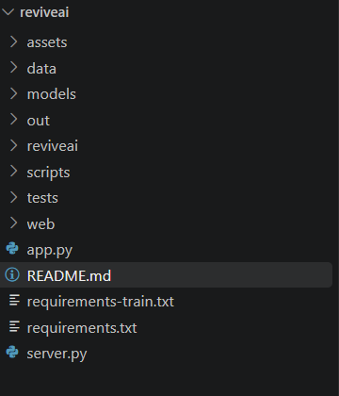

Milestone 2: Core Functionalities Development
Milestone 2 builds the processing engines that sit beneath every screen of the application: the photo denoiser, the old-photo restoration mode, the audio denoiser, the optional AI mode, the training pipeline and the evaluation that measures them.

Activity 2.1: Build the Photo Denoising Engine
- Measure the Noise Automatically: The engine estimates the noise level and recognises what is in the image, so the user never has to enter a noise value.
- Choose the Mode from What Is Found: Grain, speckle, colour noise, black-and-white content or a mixture each trigger the appropriate steps.
- Repair Speckle First: Salt-and-pepper and snow specks are located pixel by pixel and replaced from clean neighbours before any smoothing, so they are not smeared into the picture.
- Remove the Remaining Grain: BM3D (Studio) or non-local means (Fast) removes the grain, and chroma noise is smoothed hard in the colour channels only.
- Control the Strength: A Strength setting also controls how hard stubborn speckle is chased, while “Keep film grain” adds a natural texture back to very smooth results.
- Leave Clean Photos Untouched: A clean photo passes through unchanged (60.0 dB in, 60.0 dB out in the evaluation).

Activity 2.2: Build the “Restore Old Photo” Mode
- Restore Contrast: Faded prints regain their tonal range.
- Repair Dust and Scratches: Bright specks and scratch lines are detected and filled from their surroundings.
- Sharpen and Correct Tone: Soft prints are sharpened and the colour tone of the print is corrected.
- Set Honest Expectations: This mode is classical image processing judged by eye, with no accuracy score, and it cannot recover detail that was never captured.

Activity 2.3: Build the Audio Denoising Engine
- Support Common Formats: WAV, MP3, FLAC and OGG files, mono or stereo, at any sample rate and up to 5 minutes.
- Remove Steady Hiss and Hum: The engine reduces steady background noise at a default strength of 0.4.
- Protect the Bass: Bass stays within about 0.5 dB of the original at every setting; the cost of removing more hiss is softer treble, so Strength should be raised only as far as needed.
- Report the Improvement: After processing, the interface states how much quieter the hiss is in the quiet parts (for example, 6.6 dB lower for tape-hiss.wav).

Activity 2.4: Add the Optional AI Mode (SCUNet)
- Install ONNX Runtime: Run pip install onnxruntime and restart ReviveAI.
- Install the Model: In the app choose Photos → Quality → AI → “Install the AI model” (one time, about 75 MB, internet needed), or run the download command from the terminal:
python -m reviveai.ai_denoise --download
- Combine with Speckle Repair: Speckle is removed first because the network was not trained for salt-and-pepper noise; the network then handles the remaining noise.
- Be Aware of the Cost: AI mode runs on the CPU, so it is slower than Fast and large photos can take minutes.
- Know the Status: The surrounding code (download, tiling, odd sizes, blending, errors, one-click installer) was tested with a stand-in model; the real SCUNet quality is unmeasured, so check your first result yourself.

Activity 2.5: Train Your Own Denoiser
- Prepare the Data: Put 1,000 or more varied clean photos in one folder (free sets include DIV2K, Flickr2K and BSD500; check the licences).
- Run the Training Script: The script builds noisy/clean pairs on the fly, keeps 3% of the photos aside for testing, trains a DnCNN-style network and writes models/custom_denoiser.onnx:

pip install torch opencv-python-headless numpy onnxruntime
python scripts/train_denoiser.py --data path/to/your_clean_photos --iters 20000

- Use the Result: After restarting ReviveAI a “Mine” option appears under Quality, and its hint shows how many images it was trained on and its held-out score.
- Pipeline Test Result: A small CPU-only test run (tiny network, 800 iterations, about 3 minutes, 1,009 crops of only 6 photos) raised PSNR on 31 held-out photos from 24.9 to 29.9 dB at noise level 15, from 20.6 to 28.0 dB at level 25 and from 15.1 to 23.9 dB at level 50. This proves the pipeline works; on a fresh photo at level 25 it reached 29.1 dB, below Studio at 32.2 dB, so a full GPU run on varied photos is still needed before quoting a score.

Activity 2.6: Evaluate the Results
Run python scripts/evaluate_denoise.py to reproduce the measurements below. The test noise is synthetic, the noise level is found automatically, and “removed” is calculated as 1 − 10^(−gain/10), so a 10 dB gain equals 90%.
Photos — Studio mode (6 different photographs per row):
Noise type | PSNR in → out (dB) | SSIM in → out | Noise removed
None (clean photo) | 60.0 → 60.0 | 1.00 → 1.00 | Untouched
Grain, sigma 25 | 20.6 → 32.0 | 0.34 → 0.88 | 93%
Salt & pepper 5% | 17.9 → 25.5 | 0.38 → 0.87 | 83%
Salt & pepper 20% | 11.9 → 24.1 | 0.12 → 0.77 | 94%
Snow specks 8% | 15.4 → 25.5 | 0.45 → 0.87 | 90%
Grain 15 + speckle 5% | 17.2 → 27.2 | 0.28 → 0.83 | 90%
Colour noise | 30.4 → 37.8 | 0.79 → 0.97 | 82%
Multiplicative speckle | 19.3 → 24.3 | 0.43 → 0.69 | 68%
B&W + grain 25 | 20.5 → 32.0 | 0.38 → 0.89 | 93%
B&W + very heavy grain 50 | 14.9 → 26.7 | 0.17 → 0.71 | 93% (detail lost)
B&W + salt & pepper 10% | 15.1 → 24.9 | 0.24 → 0.82 | 90%

Most noise types reach about 90%; light speckle, colour noise and signal-dependent speckle fall short, and Fast mode is several dB weaker than Studio.
Audio — default strength 0.4 (48 kHz stereo music with strong bass):
Case | SI-SDR gain | Bass change | Treble change | Hiss in quiet intro
Quiet intro, hiss 15 dB below music | +2.3 dB | -0.2 dB | -6.2 dB | -13 dB
Quiet intro, hiss 10 dB below music | +5.2 dB | -0.4 dB | -4.2 dB | -12 dB
Continuous music, hiss 15 dB below | +2.0 dB | -0.4 dB | -3.7 dB | —
Continuous music, hiss 10 dB below | +5.2 dB | -0.5 dB | -4.2 dB | —

For 16 kHz mono music, 56–76% of the added noise energy is removed. Audio does not reach 90%, but the bass is kept at every setting.

Milestone 3: Server Development
Milestone 3 focuses on server.py, the file that connects the browser interface to the processing engines. In this milestone you serve the interface, accept uploads safely, run the clean-up and return results the user can compare and download.

Activity 3.1: Build the Local Server
- Serve the Interface: Start a local server at 127.0.0.1:8000 that serves the web interface, so ReviveAI opens in the browser with one command.
- Accept Photo Uploads: Accept JPG, PNG or WebP photos up to 60 MB, either chosen from disk or loaded from the built-in samples.
- Accept Audio Uploads: Accept WAV, MP3, FLAC and OGG recordings of up to 5 minutes.
- Provide Samples: Offer four sample photos (Faded print, Grainy café, Night shot and High-ISO cat) and a sample recording so the tool can be tried instantly.

Activity 3.2: Run the Clean-up and Return Results
- Call the Engines: Pass each upload to the photo or audio engine in the reviveai package and return the cleaned file.
- Report Progress: Large photos are processed in sections, and the Clean up button shows live progress such as “Denoising, section 0 of 1”.
- Support Gentler and Stronger Re-runs: Re-process the original with a lower or higher strength without uploading again.
- Name Downloads Clearly: Results are downloaded as a PNG for photos and a WAV for audio, named after the original file — for example faded-print-denoised.png and tape-hiss-denoised.wav.

Activity 3.3: Handle Files, Limits and Testing
- Use a Temporary Folder: Uploads are stored in a temp folder and deleted after an hour, so nothing accumulates on disk.
- Enforce Limits: Reject files that are too large, too long or in an unsupported format with a clear message.
- Run the Automated Tests: Use the smoke test for the engines and the interface test, which drives the real interface against the live server:

python tests/test_smoke.py
python server.py & node tests/ui.test.js

- Optional Gradio Demo: The project also includes a Gradio demo (app.py) from the earlier restoration toolkit, started with python app.py.

Milestone 4: Frontend Development
Milestone 4 focuses on a clear, calm interface that makes a technical tool feel simple. The design hides complexity behind one big button and exposes every slider only when the user opens Fine-tune.

Activity 4.1: Designing and Developing the User Interface
- Create the Header: The ReviveAI logo and wordmark, Photos and Audio tabs, a “Runs on this computer” badge that reinforces privacy, and a theme toggle.
- Design the Drop Zone: A large dashed area with the headline “Drop an old or noisy photograph”, a short description of supported damage and formats, a Choose a photo button and “Or try a sample” thumbnails.
- Use a Dark, Focused Theme: A dark background with a soft blue accent keeps attention on the image or waveform.
- Keep Controls Simple: The action bar offers one main button (Clean up photo or Clean up recording), Gentler and Stronger re-runs, Download, and a Fine-tune panel for advanced settings.
- Show Status in Plain Language: Messages such as “Add a photo and ReviveAI chooses the right clean-up for it” and “Done. Drag the handle to compare, or try Gentler or Stronger” guide the user at each step.

Activity 4.2: Building the Comparison and Playback Components
- Before/After Slider: A draggable handle reveals the Original on one side and the Denoised result on the other, with labels in each corner.
- Zoom Controls: Minus, Fit, 100% and plus buttons let the user inspect fine detail, and “Hold to see original” temporarily shows the untouched photo.
- Progress on the Button: While the clean-up runs, the main button fills like a progress bar and shows the current section.
- Audio Player: A large waveform (or spectrogram) with a play button, a time slider and an Original/Denoised switch for instant A/B comparison.
- Waveform and Spectrogram Toggle: The user can switch the audio view to see the hiss disappear from the spectrogram.
- Download and New File: A Download button saves the result, and New photo or New recording resets the screen.

Milestone 5: Deployment
In Milestone 5 the focus is on running ReviveAI on a local computer and verifying every feature. Because everything runs locally, no cloud hosting or external service is needed.

Activity 5.1: Preparing the Application for Local Deployment
- Open the Project Folder: In a terminal, move into the reviveai folder.
- Install the Dependencies: Run pip install -r requirements.txt if you have not already done so.
- Optional Models: Install ONNX Runtime and download the SCUNet model for AI mode, or place a trained custom_denoiser.onnx in the models folder for the Mine option.

Activity 5.2: Local Testing and Verification
- Start the Server: From the project folder, run the following command; ReviveAI then opens at http://127.0.0.1:8000:
python server.py
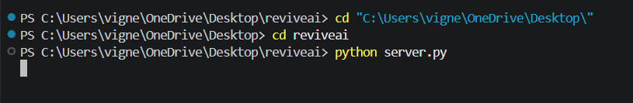
- Verify Every Feature Path: Work through each workflow before sharing the application:
- Photos: load each sample, press Clean up photo and compare with the slider; try Gentler, Stronger and Download.
- Old print: confirm the Faded print sample has its dust and most scratches reduced.
- Audio: load the tape-hiss sample, clean it, switch between Original and Denoised and download the WAV.
- AI and Mine: if installed, confirm the AI and Mine options appear under Quality.
- Tests: run the smoke test and the interface test and confirm they pass.
- Mind Processing Time: Studio takes about one minute per megapixel on one CPU core (less on multi-core, and about three times faster for black-and-white photos).

Exploring the Website’s Web Pages:

Photos Page (Home):
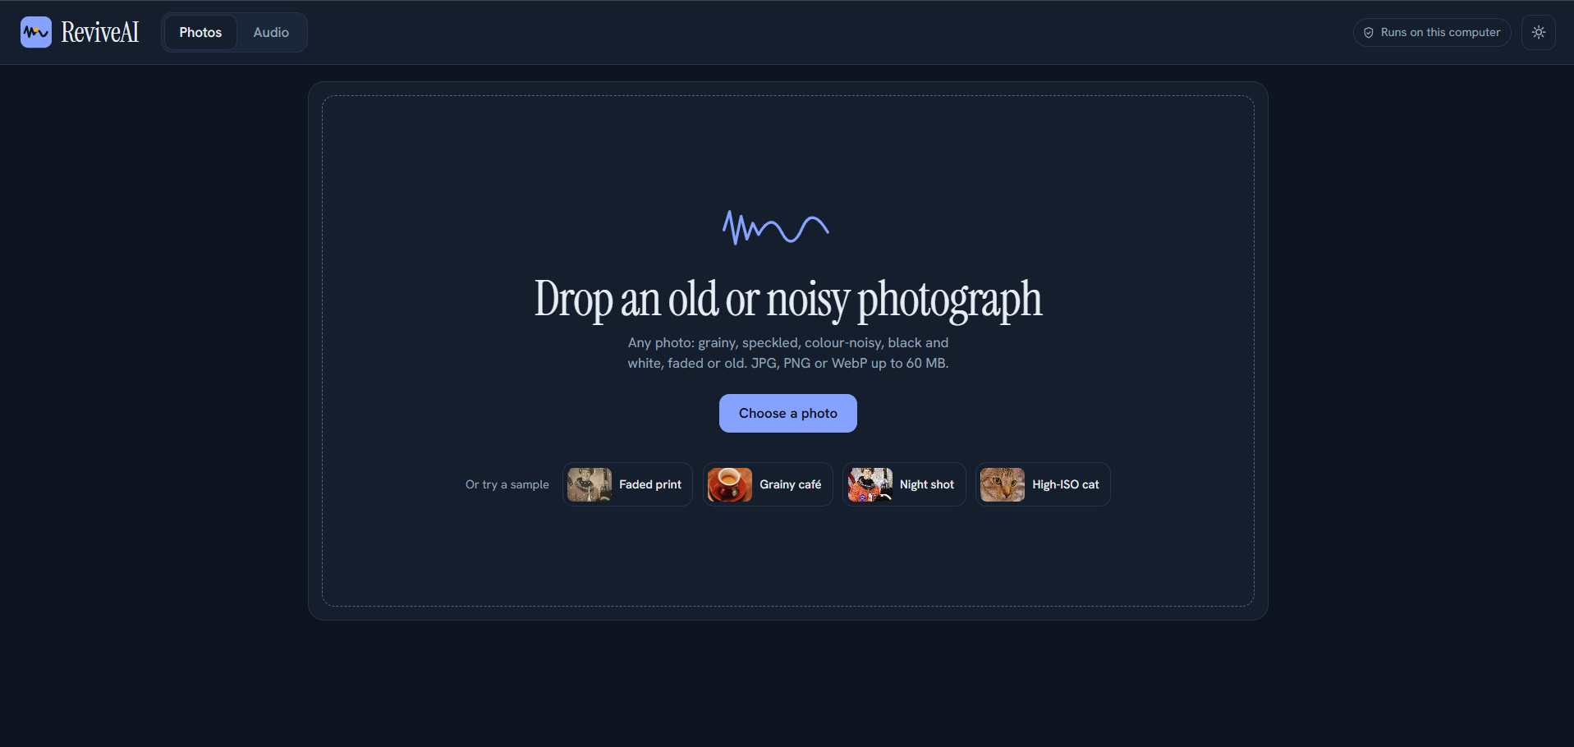
Description: The first screen of ReviveAI. The header carries the logo, the Photos and Audio tabs, the “Runs on this computer” badge and a theme toggle. The large drop zone invites the user to “Drop an old or noisy photograph”, explains that grainy, speckled, colour-noisy, black-and-white, faded or old photos are supported (JPG, PNG or WebP up to 60 MB) and offers a Choose a photo button. Below it, four sample thumbnails — Faded print, Grainy café, Night shot and High-ISO cat — let anyone try the tool without a file.

Photo Loaded:
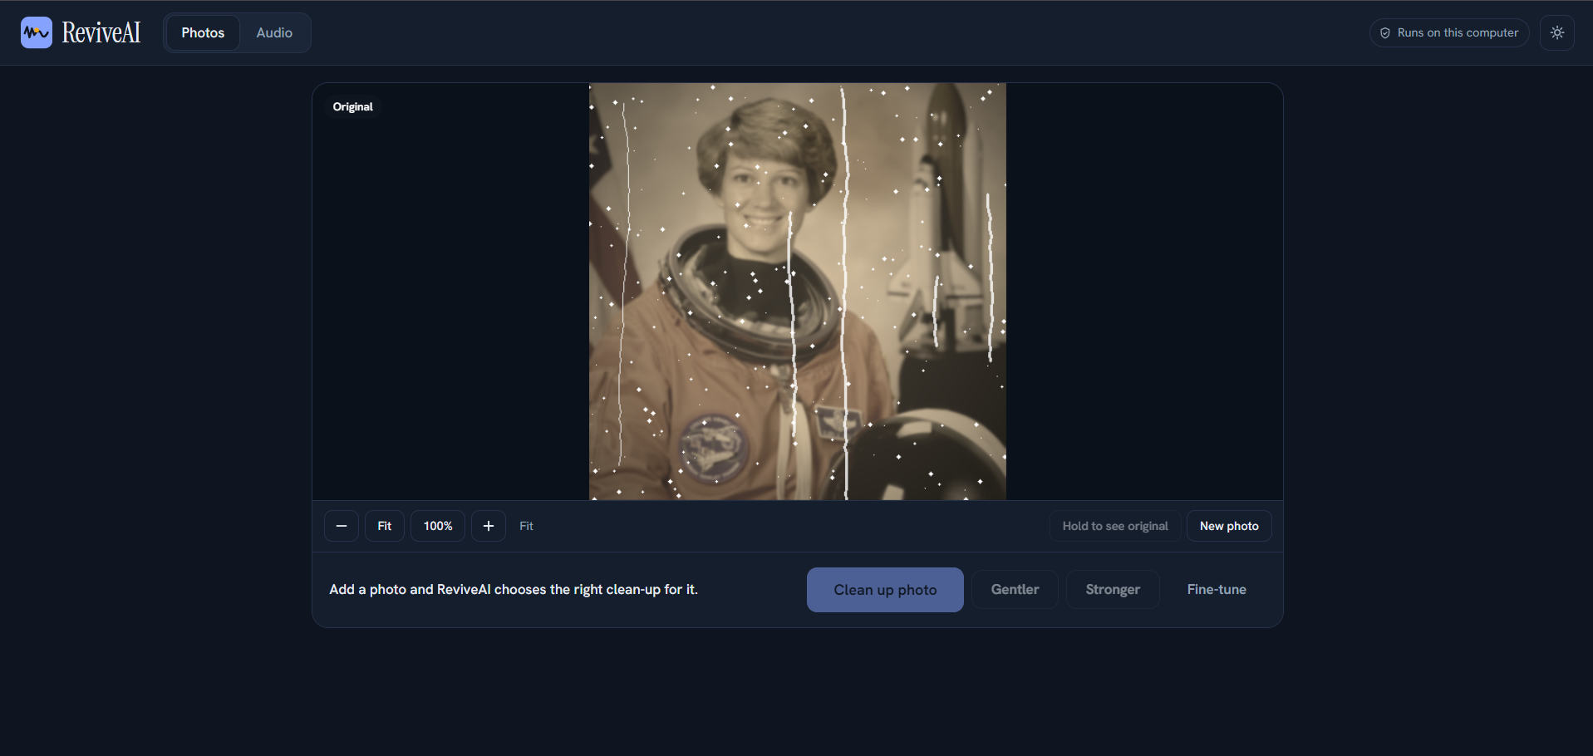
Description: After a photo is chosen (here the Faded print sample), it appears on the canvas labelled Original, covered with dust specks and long vertical scratches. Zoom controls (minus, Fit, 100% and plus) and a “Hold to see original” button sit below the image, and the status line reads “Add a photo and ReviveAI chooses the right clean-up for it.” The Clean up photo button is ready, with Gentler, Stronger and Fine-tune beside it.

Restoration Result:
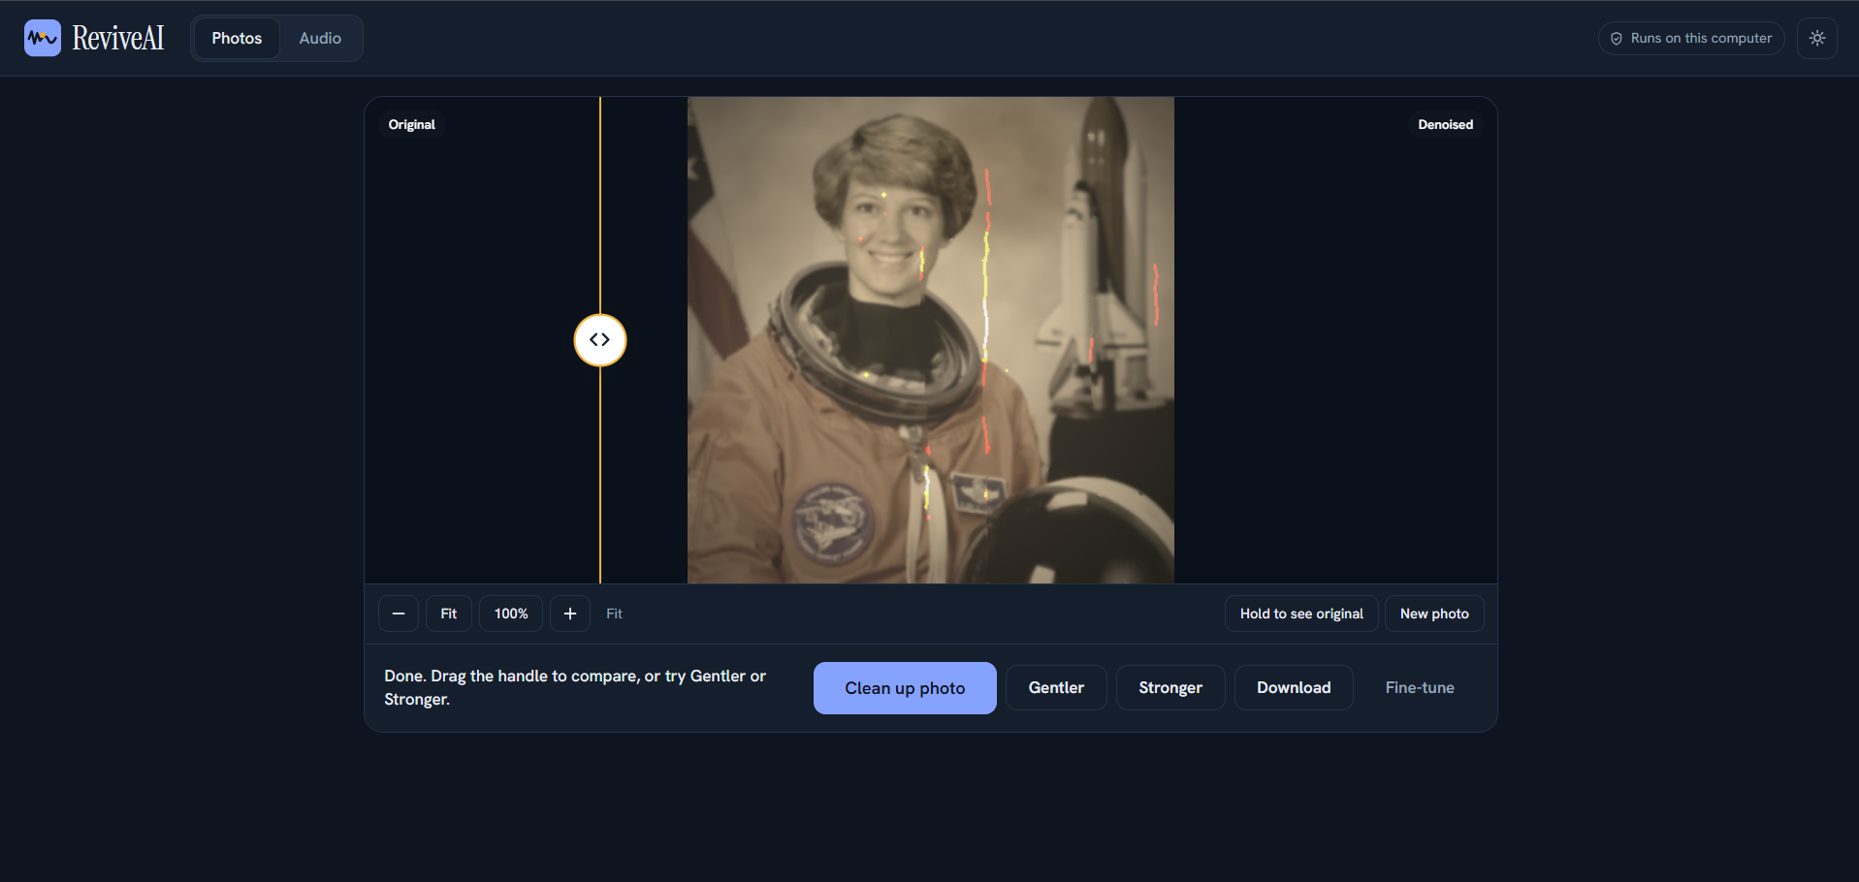
Description: After the clean-up, a comparison slider appears with the Original on one side and the Denoised photo on the other. Most dust specks have been removed and the faded print looks cleaner and clearer, although traces of the longest scratches remain and are visible as thin coloured streaks. The status line explains that the user can drag the handle to compare or try Gentler or Stronger, and a Download button is now available.

Downloading:
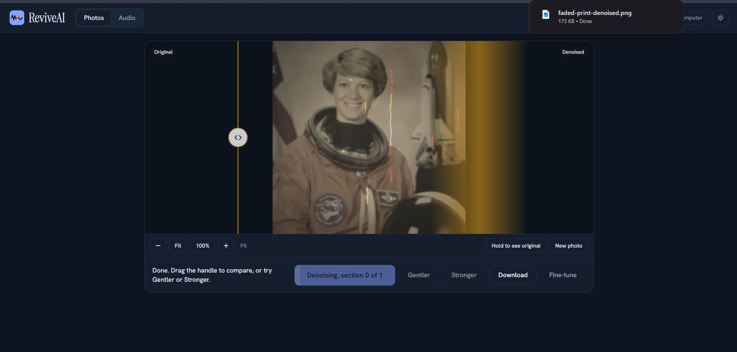
Description: Pressing Gentler or Stronger re-runs the clean-up on the same photo. The main button fills as a progress bar and shows “Denoising, section 0 of 1” while the result is refreshed, and a sweep of colour passes across the picture as the new version is drawn. The browser’s download panel confirms that faded-print-denoised.png (173 KB) was saved when the user pressed Download.

High-ISO Photo Result:
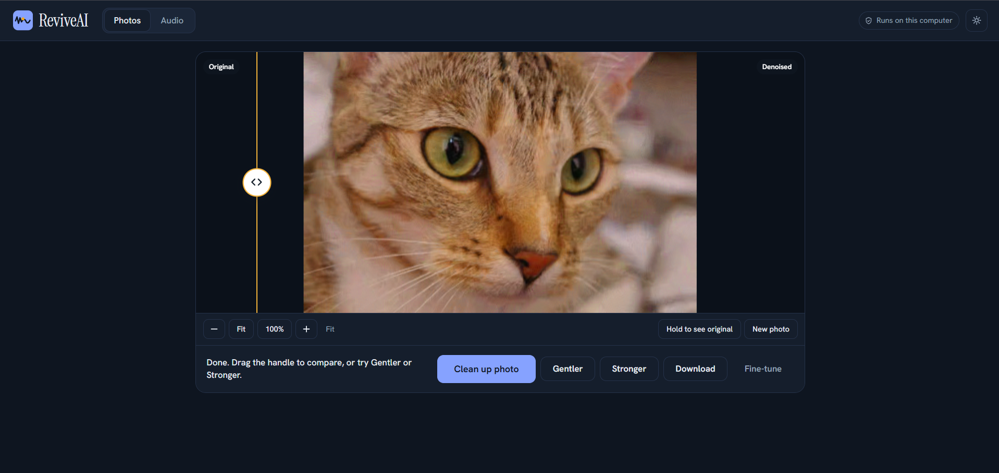
Description: The High-ISO cat sample after clean-up. The grain that was visible in the original has been removed, giving smooth fur and clear eyes. This illustrates the effect described in the project notes: at heavy noise levels the fine detail is buried under the noise, so the result looks smooth, and the Strength and Keep film grain settings under Fine-tune let the user trade smoothness against texture.

Audio Page — Original Recording:
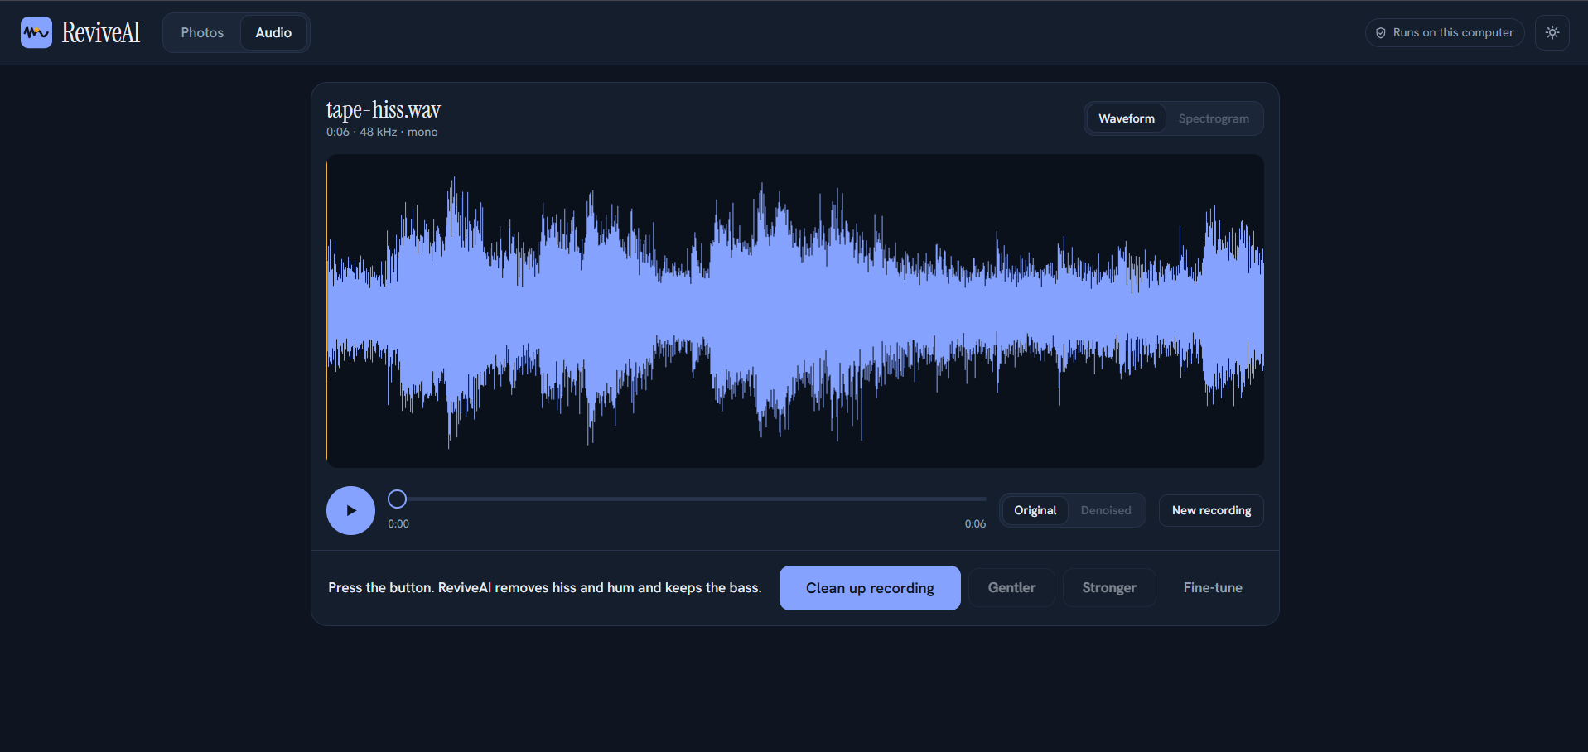
Description: The Audio tab shows the loaded recording, tape-hiss.wav (0:06, 48 kHz, mono), as a large waveform with a Waveform/Spectrogram toggle. A play button, a time slider and an Original/Denoised switch sit below, together with a New recording button. The action bar explains “Press the button. ReviveAI removes hiss and hum and keeps the bass.” and offers Clean up recording, Gentler, Stronger and Fine-tune.

Audio Page — Denoised Result:
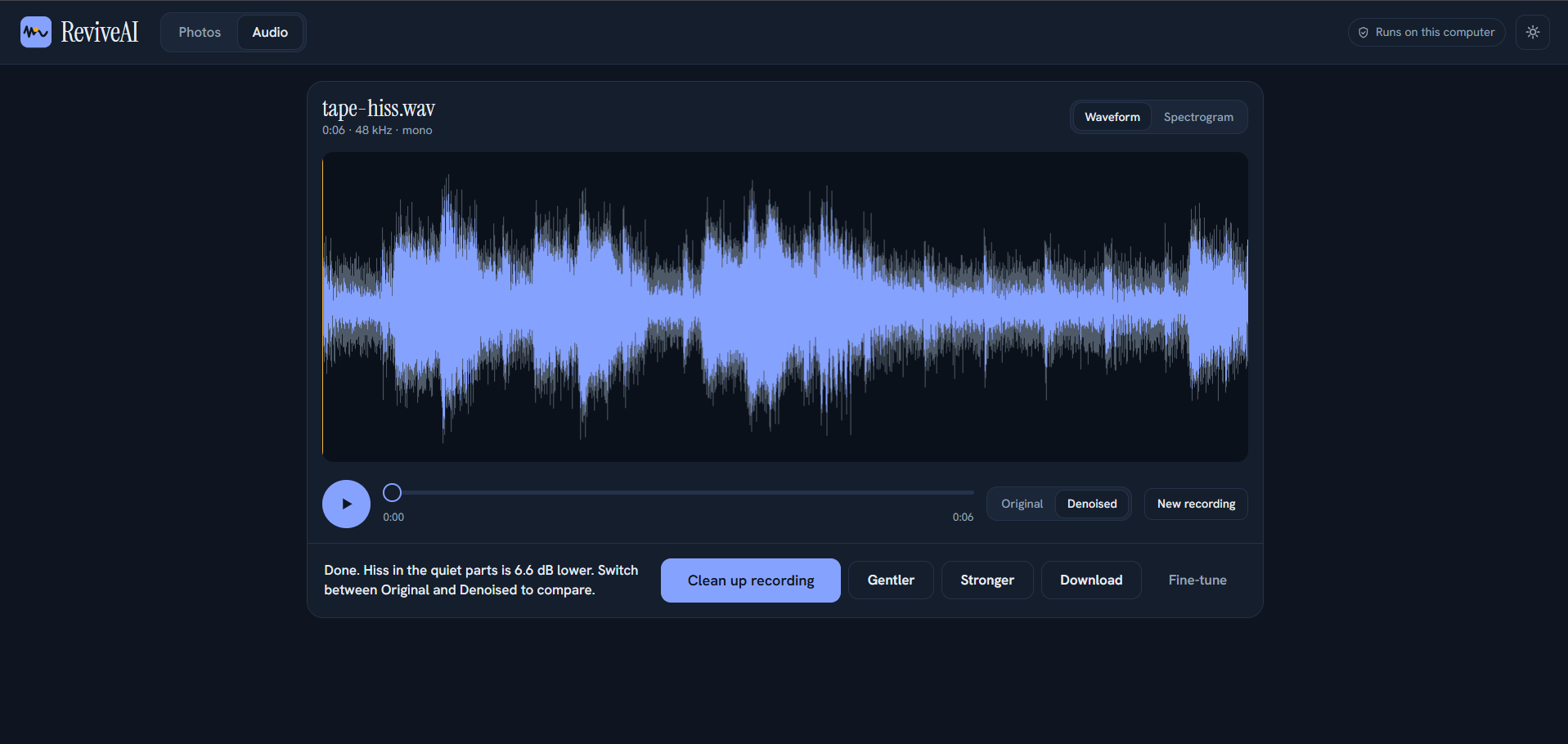
Description: After the clean-up, the waveform shows the original in grey behind the cleaned signal in blue, making the removed hiss visible, especially in the quiet passages. The status line reports “Done. Hiss in the quiet parts is 6.6 dB lower. Switch between Original and Denoised to compare.” and the Denoised view is now active, with Gentler, Stronger and Download available.

Audio Download:
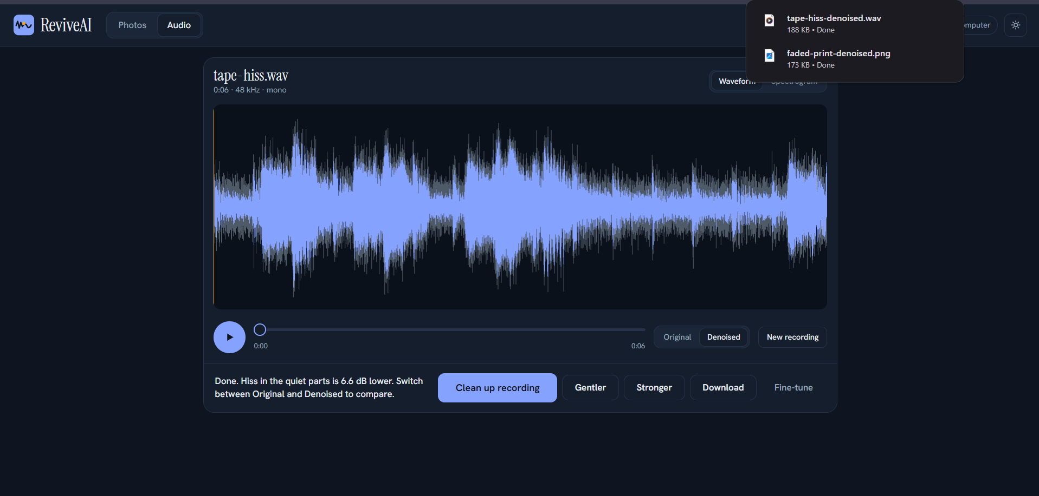
Description: Pressing Download saves the cleaned recording, and the browser’s download panel confirms tape-hiss-denoised.wav (188 KB) next to the earlier faded-print-denoised.png. The files are named after the original upload with “-denoised” added, so results are easy to match to their sources.

Conclusion:
ReviveAI is a local web application, built with Python, that removes noise from photographs and audio recordings and restores faded old prints. Instead of asking the user to understand noise levels and filter settings, it measures the problem, chooses the right clean-up and presents the result beside the original, with Gentler and Stronger buttons for quick adjustment and a Fine-tune panel for those who want every slider.
The core of the project is its layered approach. A classical engine — BM3D in Studio mode and non-local means in Fast mode — handles grain, speckle, colour noise and black-and-white photos reliably. An optional AI mode adds the pretrained SCUNet network for a wider range of real-world noise, and a training pipeline lets the user build a custom denoiser on 1,000 or more photos and measure it on held-out images. The project also includes ControlNet and SGMSE+ diffusion training scripts as a path for future GPU experiments, and a dedicated old-photo mode repairs contrast, dust, scratches and colour tone.
A major objective of ReviveAI is honest measurement. Results are reported as PSNR and SSIM on photos and as SI-SDR, bass and treble change on audio, and can be reproduced with the evaluation script. Most photo noise types reach about 90% noise removal in Studio mode, while audio removes 56–76% of the added noise and does not reach 90%. The limits are stated plainly: the test noise is synthetic, very heavy noise leaves a smooth, painterly result, AI-mode quality is not yet measured, and the old-photo mode cannot recover detail that was never captured.
Privacy is built in: everything runs on the user’s own computer, uploads are kept in a temporary folder and deleted after an hour, and no photo or recording is sent to an online service.
The project can be extended with GPU-trained diffusion models for photo restoration, speech and music enhancement models, video denoising and further evaluation on real-world noise. In its present form, ReviveAI is a practical, transparent and private tool for cleaning up photographs and recordings.

