Medium Questions:

1. Write a C# program to input the basic salary of an employee and calculate his annual Gross salary and take-home salary according to the following:  
   Basic Salary <= 10000 : HRA = 20%, DA = 80%   
   Basic Salary <= 20000 : HRA = 25%, DA = 90%   
   Basic Salary > 20000 : HRA = 30%, DA = 95%  
     
   **Deductions**Taxes: 6% per annum.  
   Insurance: 1% per annum.
2. The tiles on the ground in front of an apartment building **need changing**. The ground has a **square shape with a side of N meters**. The tiles are "**W**" **meters wide** and "**L**" **meters long**. There is one bench on the ground with a **width of "M" meters and a length of "O" meters**. The tiles under it do not need to be replaced. Each tile is replaced for **0.2 minutes**.  
     
   Write a program that **reads the size of the ground, the tiles, and the bench from the console**, and calculates how many tiles are needed to cover the ground and what **is the total time for replacing the tiles.  
     
   Input Data**

The input data comes as **5 numbers**, which are read from the console:   
**N** – **length** of a **side** of the **ground** within the range of **[1 … 100].**

**W** – **width** per **tile** within the range of **[0.1 … 10.00].**  
**L** – **length** per **tile** within the range of **[0.1 … 10.00**].   
**М** – **width** of the **bench** within the range of **[0 … 10].**   
**О** – **length** of the **bench** within the range of **[0 … 10].  
  
Output Data**

Print on the console **two numbers**:   
The **number of tiles needed** for the repair and the **total time for changing them**, each on a new line.

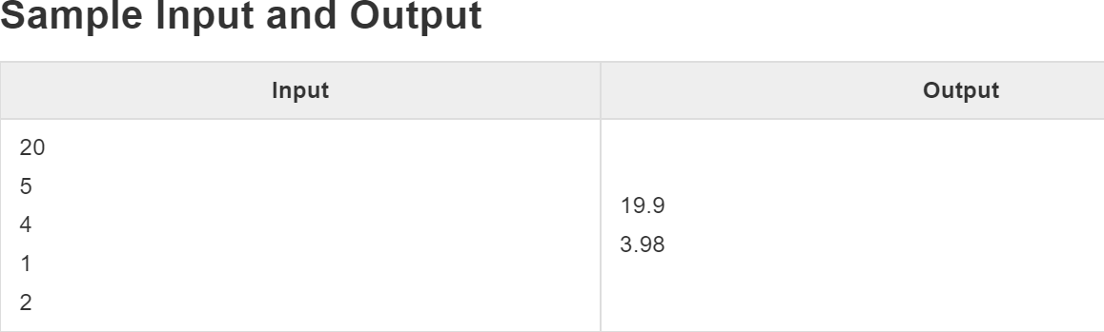

1. C# program to print all leap years from 1 to N.

**Sample Input and Output:**

**Input:** Enter the value of N: 2000

**Output:** Leap years from 1 to 2000:

……128 132 136 140 144 148 152 156 160 164 168 172 176 180 184 188 192 196 204 208......

1. Write a C# program to print all Armstrong numbers between 1 to n.

**Armstrong number examples:**  
2 -> 21  = 2 it is an Armstrong number.  
153 -> 13 + 53 + 33 = 153 it is an Armstrong number.

23 -> 22 + 32 =13 it is **not** an Armstrong number.

**Sample Input and Output:**

**Input**:

Enter the lower limit: 1

Enter the upper limit: 1000

**Output**:

Armstrong numbers in the given range are: 1 2 3 4 5 6 7 8 9 153 370 371 407…

1. Write a program to find the sum of the Arithmetic Progression series.

# Sample Input and Output:

**Input**:   
starting number = 5,   
difference = 2,   
number of elements = 10

**Output**:   
Output Series: 5 7 9 11 13 15 17 19 21 23  
The sum is: 140

1. Draw the following hollow rectangle in the console:

******************

* *

* *

* *

* *

******************

1. Write a program to get the time of each day from the given array of date-time values.  
     
   Array of DateTime: { DateTime.Now,

new DateTime(2016, 8, 16, 9, 28, 0),

new DateTime(2011, 5, 28, 10, 35, 0),

new DateTime(1979, 12, 25, 14, 30, 0) };

1. Write a program in C# Sharp to create a function to find the factorial of a given number.  
     
   **Sample Input and Output:**  
   Enter a number: 5  
   The factorial of 5 is 120

1. Write a C# Sharp program to get a date and the number of months from the user and print the resultant date after adding the mentioned number of months to the given date.  
     
   **Requirements**:  
    1. Calculation part must be done in another method.

2. Printing the output must be in another method.  
  
**Input**:  
Enter the date: 01/01/2022  
Enter the number of months: 12  
  
**Output**:  
Given date: 01/01/2022  
End date: 01/01/2023

1. Write a program in C# Sharp to count the total number of alphabets, digits, and special characters in a string.  
     
   **Requirements**:  
    1. Calculating the alphabet must be done in a separate method.

2. Calculating the digits must be done in a separate method.  
 3. Calculating the Special characters must be done in a separate method.  
  
**Sample Input and Output:**  
  
Enter a string: Welcome 2 Syncfusion!  
  
The number of Alphabets in the string is: 17

The number of Digits in the string is: 1

The number of Special characters in the string is: 3