Simple Questions

1. Write a program to **convert money from one currency into another**. Accept the value of INR as input from the user and display the equivalent value of USD, EUR, and CNY. Use the following fixed currency rates:  
     
   100 Rs = 1.22 USD  
   100 Rs = 1.27 EUR  
   100 Rs = 8.79 CNY
2. Find the salary of a person whose basic salary is 10,000 and add DA as 10% and HRA as 10 %. The taxes deducted from the annual salary is 5%. Find his annual income.
3. Write a program that **inputs a password** (one line with random text) and checks if the input **matches** the phrase "**s3cr3t!P@ssw0rd**". If it matches, print "**Welcome**", otherwise "**Wrong password!**

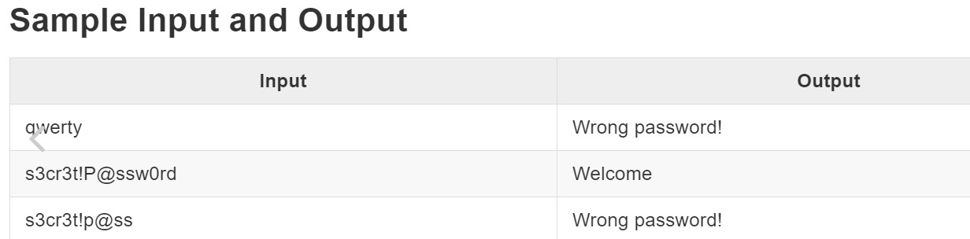

1. Write a program that **inputs an integer** and checks if it is **below 100**, **between 100 and 200,** or **over 200**. Print the appropriate message as in the examples below.

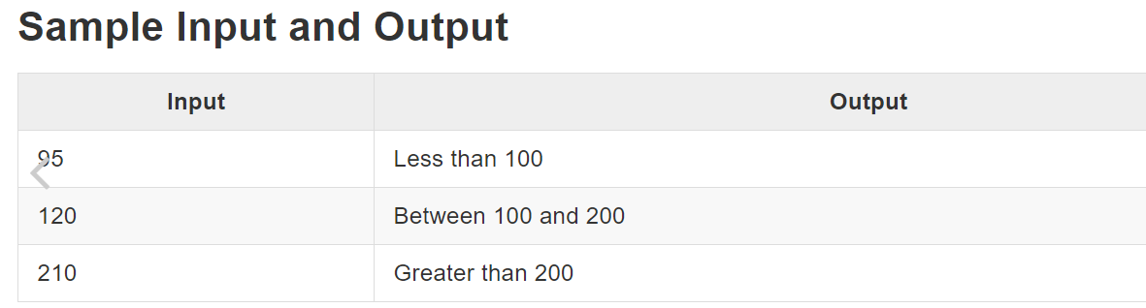

1. Write a program that **inputs the speed** (decimal number) and prints **speed information**. For speed **up to 10** (inclusive), print "**slow**". For speed **over 10** and **up to 50**, print "**average**". For speed **over 50 and up to 150**, print "**fast**". For speeds **over 150 and up to 1000**, print "**ultra fast**". For higher speed, print "**extremely fast**".

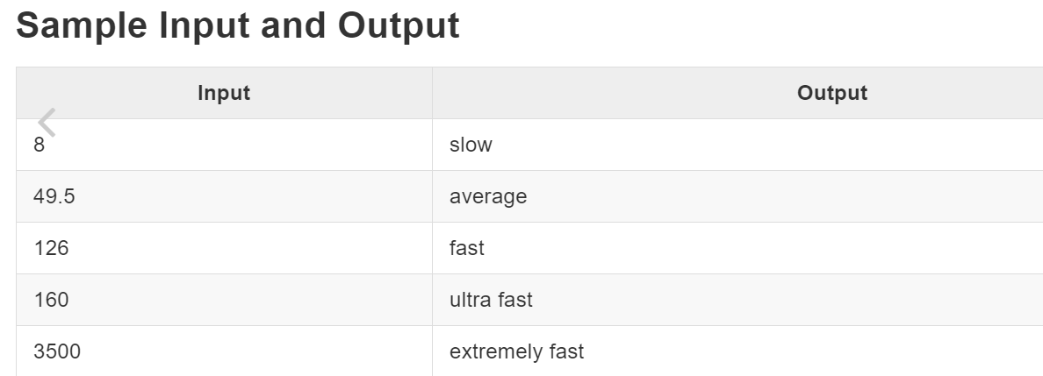

1. Get a character by asking the user to enter it and find whether it is a vowel or not. Show “It is a vowel” or “It is not a vowel”.
2. Find XY by asking the user to enter the value of X and Y. (Don’t use library functions)
3. Find the sum of the square of given odd values ranges 1- 99.
4. Generate the multiplication table of a number entered by the user from 1 to 20. Ex: 12*1=12 12*2=24 12*3=36….
5. Write a program to print the following 1

22

333

4444

55555

666666

1. Write a program to check given number is prime or not. Input: 3

Output: It is a prime number

1. Write a program to get the day of the week for a specified date.  
     
   **Sample Input and output:**Enter the date in the format(MM/dd/yyyy): 07/11/2022  
   The day of the week for 7/11/2022 is Monday.
2. Write a program to print individual characters of the string in reverse order.  
     
   **Sample Input and output:**Input the string: syncfusion software  
   The characters of the string in reverse are:  
   erawtfos noisufcnys
3. Write a program to count the total number of vowels in a string.  
     
   **Sample Input and output:**Input the string: Syncfusion  
   The total number of vowels in the string is: 3
4. Write a program to prompt the user to get the name and print the welcome message.  
     
   **Requirements:**
   * Getting the name from the user should be in the main method.
   * Printing the message “Welcome Name” in another method.
   * Print the message “Have a nice day!” in another method.

**Sample input and output:**Enter the name: Baskaran  
  
Welcome Baskaran  
Have a nice day!