

GroupRM

Holiday Management

Table of Contents
1. Purpose 3
2. Holiday Management 3
3. Holiday Management Process Flow 3
4. Creating Holiday list 4
5. Example Scenario 7

Purpose
The purpose of this document is to briefly explain the creation and workflow of holiday management.

Holiday Management
Holiday management policy allows the user to save the holidays and non-business days in the application. By using this feature, the approver will be notified, if any of the validities expires on the holiday or non-business days. The application will throw an alert pop-up, when the airline administrator approves the group request which has the fare validity or name list validity expires on holiday or non-business days, so that the airline user can change the time-limit matrix according to the holidays.

Holiday Management Process Flow
The holiday management flow process is provided in the below section.
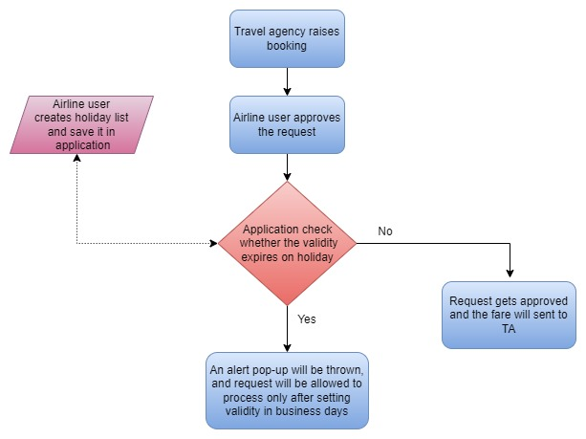
- Airline user creates the holiday list based on the holidays of the country and the city.
- When travel agent raise a group booking request, the request will be sent to airline user for processing.
- When the airline user approves the request, the application will check, whether the validities expire on the holiday dates or in business days.
- If the validity expires on holiday dates, the application will block the user by throwing an alert pop-up, requesting to change the validity date from contract manager.
- You can edit the time limit matrix from the contract manager and can set the validities to business days based on needs, the modified time limit is applicable only for the particular request, and it won’t get applied for the future group requests.
- Once after changing the expiry date of validity to business dates, the application allows the user to approve the request.
- In the case of the autopilot policy, if one of the validities expires on a holiday, the application will change the validity to the following working day or, if the departure occurs on the next day, it will change the validity to the prior day.
- The application will show no error if the fare validity doesn’t expire on business days.

Creating Holiday list
Follow the steps given below to create an appropriate holiday list in the GRM application.
- On the menu bar point to Admin and click Holiday Management.
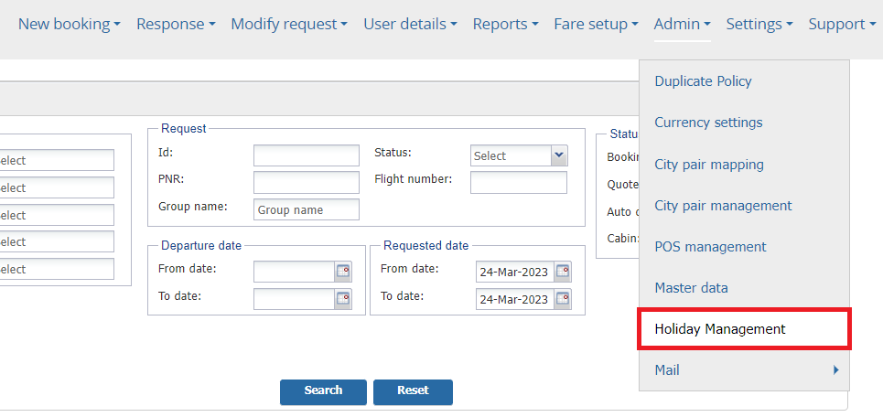
- Click Create Holiday.
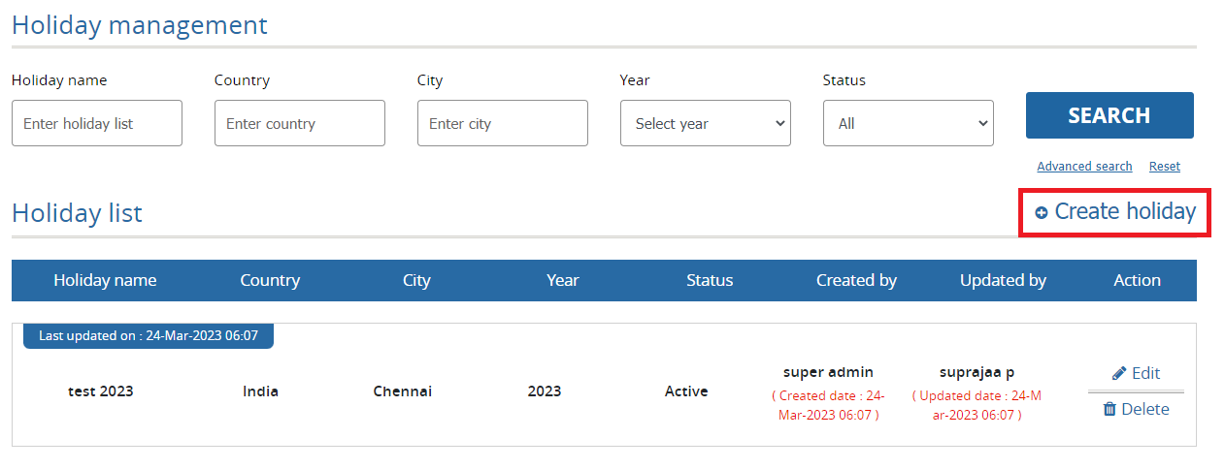
- Enter the Holiday name (Name for holiday list), Country, City, Year, and status.
- Click Rolling for next year check-box, if the holiday list needs to be followed for next year.
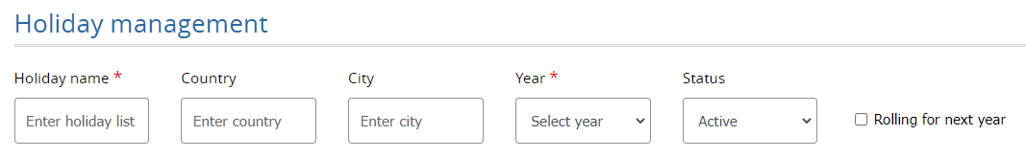
- In the Calendar select the date and enter the Holiday name and click .
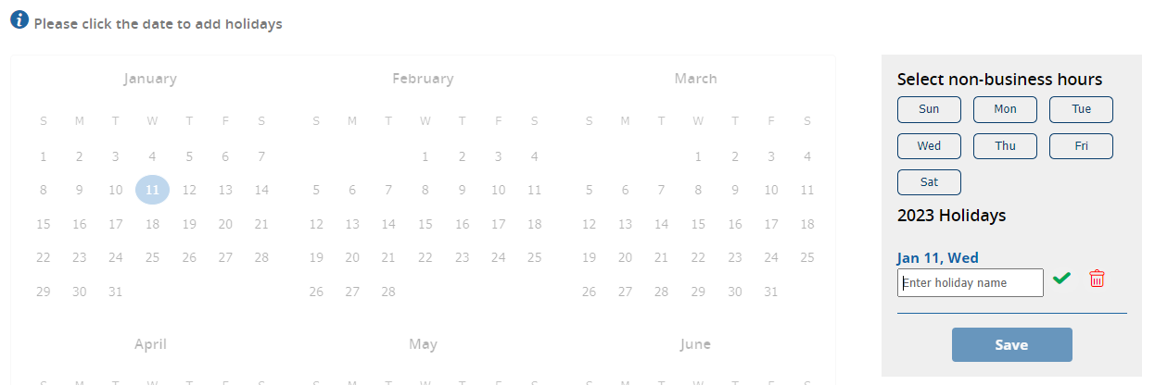
- Select the non-business hours of week.
- After entering the entire holiday list, click Save, and holiday list gets created.
- You can use the edit option to modify the entered holiday name. Click option to delete the entered the holiday name.
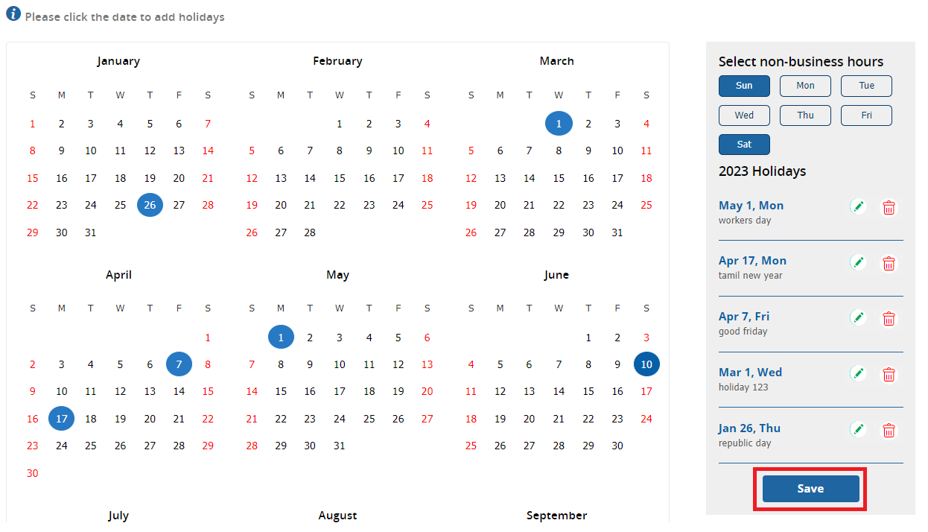
- You can modify and delete the created holiday management policy by using edit and delete option from the listing page.
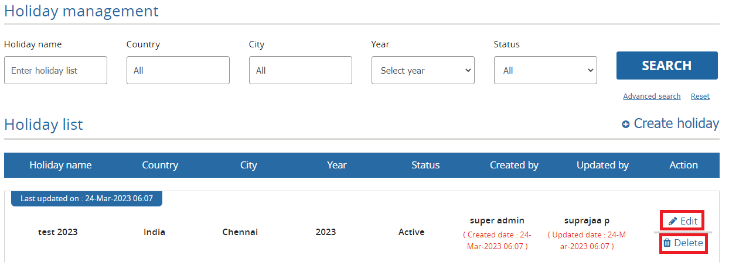

Example Scenario
Below is the sample scenario in which it is been explained how the holiday list feature is applied to a request when the time limit falls on holidays.
The scenario for holiday management is checked for the trip MAA-BOM, after setting the holidays accordingly.
Trip: MAA – BOM
Requested Date: 24-03-23.
Departure date: 01-04-23
Fare Validity: 25-03-23
Payment Validity: 28-03-23
Name List Validity: 29-03-23
Holiday date: 28-03-23
In this scenario when the airline user approves the request, the application will block the user by throwing the alert pop-up as shown below.
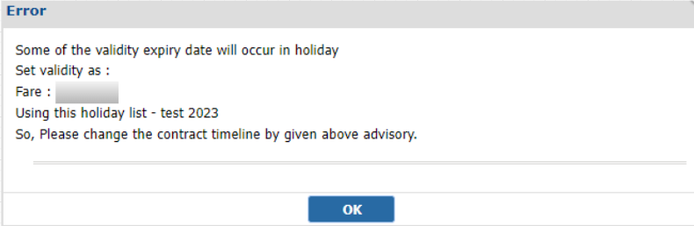
The application will allow the user to approve the request only after changing the validity to business days by using the edit option in contract manager.

