**EXPLORTATORY DATA ANALYSIS**

**ASSIGMENT 2**

**By-**

**IPBLGCET TEAM -4**

**Countries with high purchases**

. 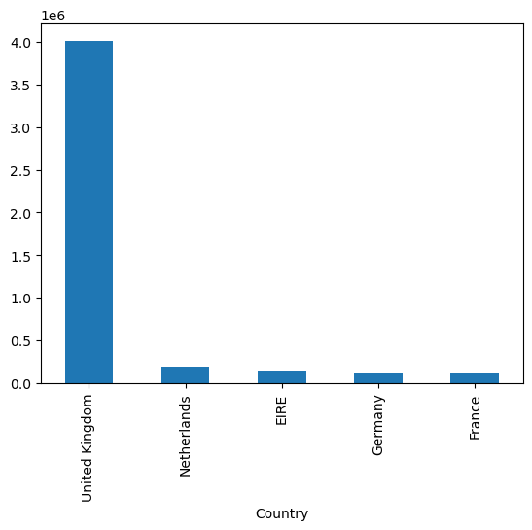

1. **Observation :** 
   * As the above graph says that united kingdom has the most number of purchases among the all the countries which is more than 400$thousand dollars

**2 countries with least number of purchases**

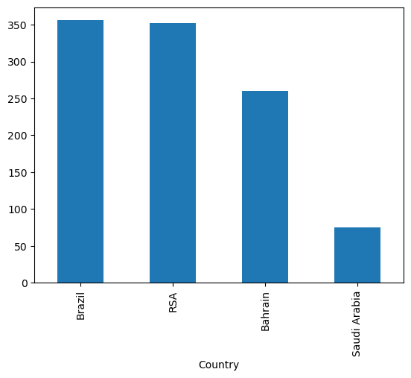

**Observation:**

* As we can see in the above graph that least number of purchases are done by the Saudi Arabia and Brazil,RSA,Bahrain are next least purchases by the wholesalers from these countries

**Total sales for different years**

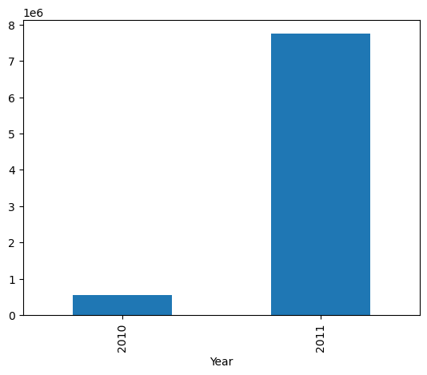

**Observation:**

**>Total sales accros different year**

* As depicted in the graph, the number of purchases in the year 2010 is notably lower compared to 2011. This difference can be attributed to the fact that our dataset only includes data for the month of December in 2010, while encompassing all 12 months in 2011**.**

**4. Total sales across the different months**

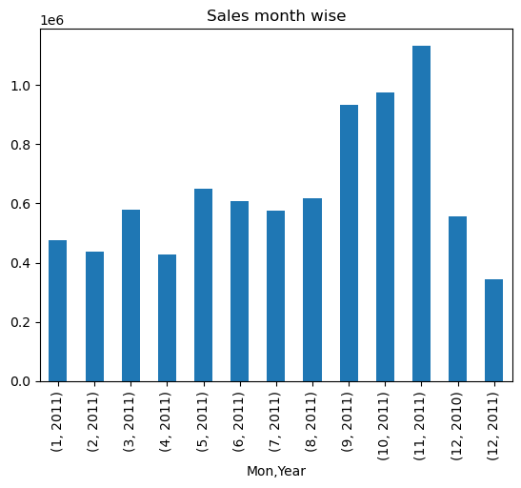

**Observation:**

* We could see that DEC 2010 we have sales of 748957 and in DEC 2011 we have sales of 433668 which is a huge drop when analyzed further found out that We have only data upto 9th on dec 2011, so we find a sales drop in the month of dec 2011
* We can see that from September to November we have very good sales
* Month
* April 426047.851
* August 616368.000
* December 897110.400
* February 436546.150
* January 475074.380
* July 574238.481
* June 608013.160
* March 579964.610
* May 648251.080
* November 1132407.740
* October 974603.590
* September 931440.372

**5. Top customers by Total Spending**

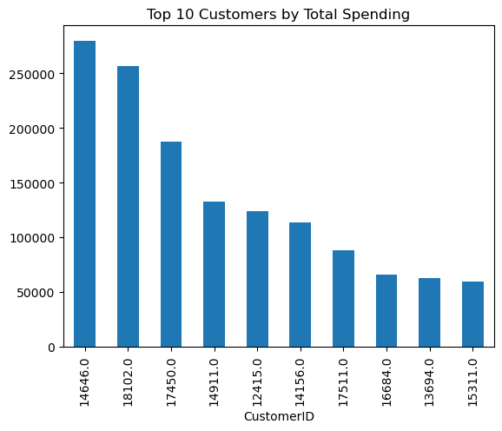

**Observation**

* Upon reviewing the graph, it is evident that customer ID 14646, representing a wholesaler from the Netherlands, spent the highest amount, exceeding 25,000, on 20-12-2010, a date with relatively lower sales for that year.

**6.top 10 products that are sold**

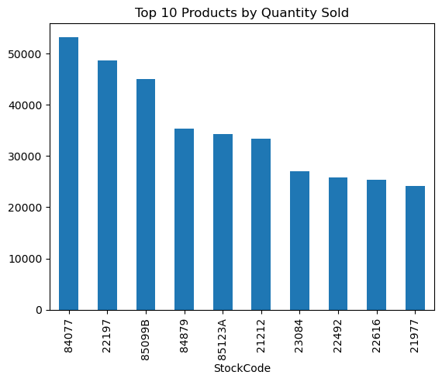

**Observation:**

1. Upon analyzing the graph, it is evident that the product with stock code 84077, titled WORLD WAR 2 GLIDERS ASSTD DESIGNS, has recorded the highest number of purchases, surpassing 50,000 units.

2. Furthermore, stock code 22197, representing SMALL POPCORN HOLDER, has also witnessed substantial sales, exceeding 50,000 units. This increased demand could be attributed to a popular choice for gifting purposes.