Spark:
- Spark is a software framework for processing Big Data.
- It uses in-memory processing for processing Big Data which makes it highly faster. It is also a distributed data processing engine.
- It does not have its own storage system like Hadoop has, so it requires a storage platform like HDFS. It can be run on local mode (Windows or UNIX based system) or cluster mode.
- It supports programming languages like Java, Scala, Python, and R.

Spark Architecture:
- Spark also follows master-slave architecture.
- Apart from the master node and slave node, it has a cluster manager that acquires and allocates resources required to run a task.
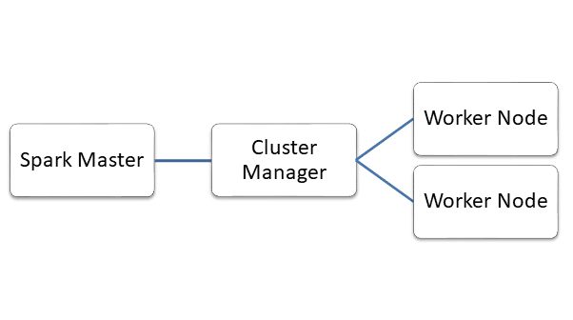
- In master node, there is a ‘driver program’ which is responsible for creating ‘Spark Context’.
Spark Context acts as a gateway for the execution of Spark application.
- The Spark Context breaks a job into multiple tasks and distributes them to slave nodes called ‘Worker Nodes’.
- Inside the worker nodes, there are executors who execute the tasks.
- The driver program and cluster manager communicate with each other for the allocation of resources. The cluster manager launches the executors. Then the driver sends the tasks to executors and monitors their end to end execution.
- If we increase the number of worker nodes, the job will be divided into more partitions and hence execution will be faster.
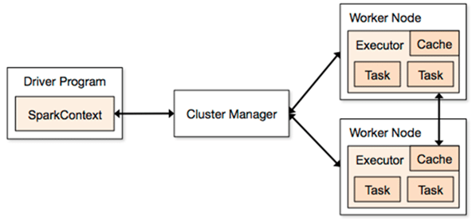

Data Representations in Spark : RDD / Dataframe / Dataset:
- Data can be represented in three ways in Spark which are RDD, Dataframe, and Dataset. For each of them, there is a different API.

1. Resilient Distributed Dataset (RDD)
- RDD is a collection of partitioned data.
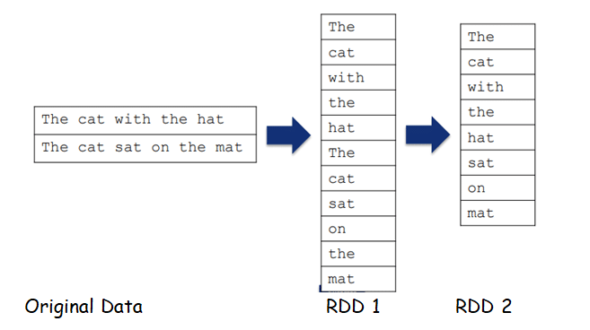

- The data in an RDD is split into chunks that may be computed among multiple nodes in a cluster.
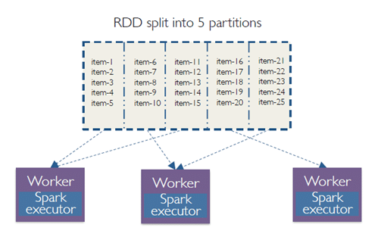
- If a node fails, the cluster manager will assign that task to another node, thus, making RDD’s fault tolerant.
- Once an RDD is created, its state cannot be modified, thus it is immutable. But we can apply various transformations on an RDD to create another RDD.
- Also, we can apply actions that perform computations and send the result back to the driver.

2. Dataframe
- It can be termed as dataset organized in named columns. It is similar to a table in a relational database.
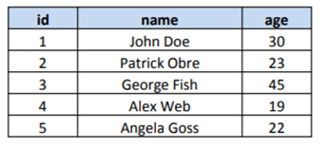
- It is also immutable like RDD. Its rows have a particular schema. We can perform SQL like queries on a data frame. It can be used only for structured or semi-structured data.

3. Dataset
- It is a combination of RDD and dataframe.
- It is an extension of data frame API, a major difference is that datasets are strongly typed. It can be created from JVM objects and can be manipulated using transformations.
- It can be used on both structured and unstructured data.

Spark Ecosystem
- Apache Spark has some components which make it more powerful. They are explained further.

1. Spark Core
- It contains the basic functionality of Spark. All other libraries in Spark are built on top of it.
- It supports RDD as its data representation. Its responsibilities include task scheduling, fault recovery, memory management, and distribution of jobs across worker nodes, etc.

2. Spark Streaming
- It is used to process data which streams in real time. Eg: You search for a product and immediately start getting advertisements about it on social media platforms.

3. Spark SQL
- It supports using SQL queries. It supports data to be represented in the form of data frames and dataset.

4. Spark MLlib
- It is used to perform machine learning algorithms on the data.

5. Spark GraphX
- It allows data visualization in the form of the graph. It also provides various operators for manipulating graphs, combine graphs with RDDs and a library for common graph algorithms..
Difference between Hadoop, Spark and MapReduce

Hadoop | Spark | MapReduce
- Hadoop is an open source framework which uses a MapReduce algorithm.  - Hadoop’s MapReduce model reads and writes from a disk, thus slow down the processing speed.  - Hadoop is designed to handle batch processing efficiently.  - Hadoop is a high latency computing framework, which does not have an interactive mode.  - With Hadoop MapReduce, a developer can only process data in batch mode only.  - Hadoop is a cheaper option available while comparing it in terms of cost | - Spark is lightning fast cluster computing technology, which extends the MapReduce model to efficiently use with more type of computations.  - Spark reduces the number of read/write cycles to disk and store intermediate data in-memory, hence faster-processing speed.  - Spark is designed to handle real-time data efficiently.  - Spark is a low latency computing and can process data interactively.  - Spark can process real-time data, from real time events like twitter, facebook.  - Spark requires a lot of RAM to run in-memory, thus increasing the cluster and hence cost. | - It is a framework that is open-source which is used for writing data into the Hadoop Distributed File System.  - It is having a very slow speed as compared to Apache Spark.  - It is unable to handle real-time processing.  - It is difficult to program as you required code for every process.  - It supports more security projects.  - For performing the task, It is unable to cache in memory.  - Its scalability is good as you can add up to n different nodes.  - It actually needs other queries to perform the task.

