| **Command** | **Purpose** |
| --- | --- |
| $ vi <filename> | Open or edit a file. |
| i | Switch to Insert mode. |
| **Esc** | Switch to Command mode. |
| :w | Save and continue editing. |
| :wq or ZZ | Save and quit/exit vi. |
| :q! | Quit vi and do not save changes. |
| yy | Yank (copy a line of text). |
| p | Paste a line of yanked text below the current line. |
| o | Open a new line under the current line. |
| O | Open a new line above the current line. |
| A | Append to the end of the line. |
|  |  |
| a | Append after the cursor's current position. |
| I | Insert text at the beginning of the current line. |
| b | Go to the beginning of the word. |
| e | Go to the end of the word. |
| x | Delete a single character. |
| dd | Delete an entire line. |
| Xdd | Delete X number of lines. |
| Xyy | Yank X number of lines. |
| G | Go to the last line in a file. |
| XG | Go to line X in a file. |
| gg | Go to the first line in a file. |
| :num | Display the current line's line number. |
| h | Move left one character. |
| j | Move down one line. |
| k | Move up one line. |
| l | Move right one character. |

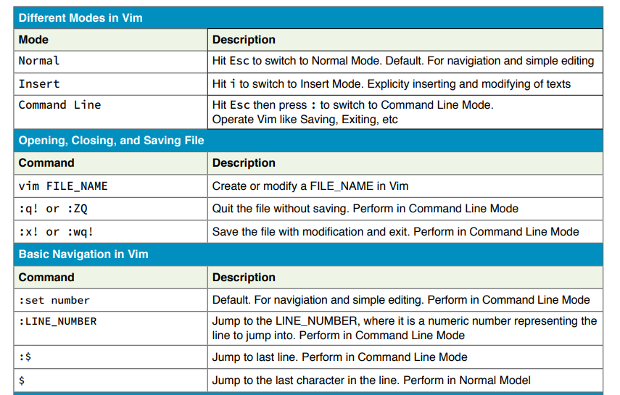

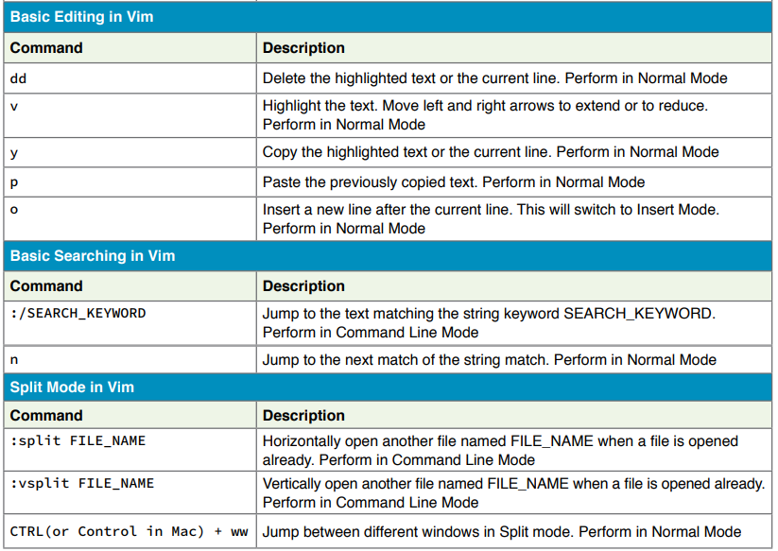

Don't forget it is a hidden file inside your home directory (you would not be the first to do a ls -l and thinking it is not there).

Do a:

ls -la ~/ | more

There should be a .bashrc on the first page. If not just create it with:

vi ~/.bashrc

and add in the lines you need to add into it.

Permissions of my .bashrc are:

-rw-r--r-- 1 discworld discworld 3330 Mar 10 16:03 .bashrc

(chmod 644 .bashrc to make it rw r r).

<https://askubuntu.com/questions/127056/where-is-bashrc>