Tirupati Surface-Water & Monitoring — Project Report
Site: Tirupati district & surrounds, Andhra Pradesh, India Sensor: Sentinel-1 C-band SAR (RTC GRD, amplitude) Date: 2026-07-16 · Status: Operational — implemented, verified, run end-to-end

Abstract
This report presents a near-real-time surface-water, drought, and flood change-detection analysis for the Tirupati district using Sentinel-1 Synthetic Aperture Radar (SAR) amplitude imagery. Because radar images through cloud and darkness, the workflow keeps operating through the South-West monsoon, when optical sensors fail. A 16-date Sentinel-1 time series (2026-01-06 → 2026-06-30) is processed by a single deterministic pipeline that classifies open water from backscatter and detects new inundation against a dry-season baseline, using three
complementary detectors: a fixed decibel threshold, a per-scene adaptive Otsu threshold, and a self-supervised deep change detector (SAFNet). Detection is made dual-polarization (VV ∧ VH) to reject dry smooth surfaces, and outputs are exported as georeferenced GeoTIFFs. Over the analysis window the pipeline resolves the district's hydrological cycle — confident open water falling from ~1.4 km² in January to a ~0.5 km² minimum by late June, then rebounding to ~2.4 km² at monsoon onset — a directly usable drought/drawdown signal.

Area of Interest

Parameter | Value
Location | Tirupati district & coastal Andhra Pradesh
Bounding box (W,S,E,N) | 79.298, 13.498, 79.552, 13.752 (EPSG:4326)
Extent | ~27 × 28 km tile centered on Tirupati city
Projection | EPSG:32644 (UTM zone 44N)
Terrain / hydrology | Semi-arid plateau; irrigation tanks and reservoirs subject to strong seasonal drawdown

The AOI is deliberately compact, so the full multi-detector pipeline (including the CNN) runs at district scale in minutes.

Pre-processing and Auxiliary Data

Component | Detail
Product | Sentinel-1 RTC GRD (Radiometrically Terrain-Corrected γ⁰, linear backscatter), IW mode.
Source | Microsoft Planetary Computer (sentinel-1-rtc collection), signed access.
Scenes | 16 acquisitions, 2026-01-06 → 2026-06-30, ~12-day cadence (dry winter → pre-monsoon → monsoon onset).
Polarizations | Dual-pol VV + VH (~823 MB total in data/Tirupati/).
Native grid | 10 m pixels; nodata = −32768.
Grid alignment | Every scene (VV and paired VH) is warped onto one common ~40 m reference grid (WarpedVRT, downsample ×4), co-registering all dates and guarding array stacking against footprint drift.
Radiometric prep | Average resampling on read (cheap speckle reduction); linear γ⁰ → decibels (10·log₁); nodata / non-positive samples masked to NaN so invalid pixels are never counted as water.

No DEM or external mask is required for the amplitude workflow; the reference-grid transform is retained so all raster outputs are georeferenced (EPSG:32644).

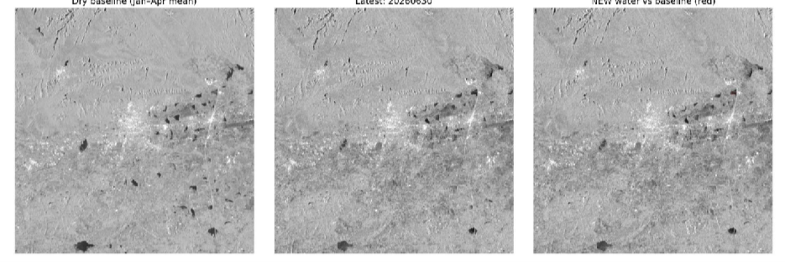

Figure 1: Tirupati Region SAR Images over the period of January- April [post winter seasion]

Figure 2: Latest SAR image of the Tirupati area ; Figure 3:Combine and give variation of Data

Methodology and Techniques
Dual-polarization water primitive. A pixel is classed open water only when dark in both polarizations
- VV < −17 dB and VH < −24 dB. Requiring co- and cross-pol darkness rejects smooth dry surfaces (roads, runways, dry sand) that fool a VV-only test, cutting false positives.

Three complementary detectors:

  - Fixed −17 dB VV threshold — the classical, well-understood baseline.
  - Per-scene adaptive Otsu — Otsu computed on the dark tail of each scene's histogram (open water is
~0.1 % of pixels, so whole-histogram Otsu would over-detect), clamped to ±3 dB around −17 dB so noise cannot drift the cut.
  - SAFNet — Siamese Adaptive Fusion Network (self-supervised, no labels): a shared-weight multi-scale encoder embeds both dates; per-scale absolute difference features are combined by a
learned per-pixel softmax attention into a change probability. Trained on reconstruction (learn SAR texture) + synthetic copy-paste change (pasted content = change, added speckle = no change), so it learns SAR-noise invariance rather than the −17 dB rule.

Change detection. New water = open water now (dual-pol) and dry in the baseline. Both the threshold and SAFNet change masks are speckle-cleaned (morphological opening + removal of connected components < 5 px).
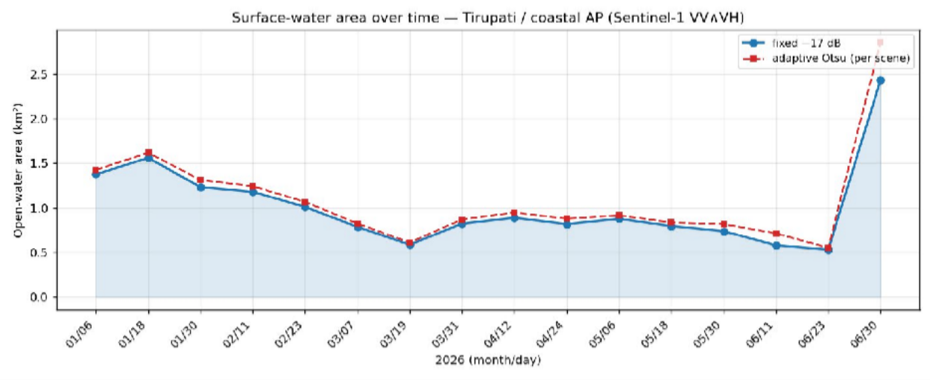
Figure : The Graph representation of water surface changes over the period of January – June [16 acquisitions]

Core SAR Processing Chain
(This track uses SAR amplitude (GRD), so there is no interferometric phase — the "core chain" is amplitude classification + change detection, the amplitude analogue of an InSAR chain.)
Discover glob VV scenes, parse YYYYMMDD, sort chronologically

│
Align + dB WarpedVRT → common ~40 m grid → to_db → nodata/NaN (VV and VH)
│
Water mask dual-pol: VV < −17 dB ∧ VH < −24 dB (per scene)
│
Time series count water px → km² (fixed cut + adaptive Otsu) → figure 1
│
Baseline mean dB of first ~8 (dry) scenes vs latest scene
│
New water (A) water now (dual-pol) ∧ dry in baseline → despeckle → figure 2 + GeoTIFF
│
SAFNet (B) self-supervised train → change probability → Otsu cut
→ changed ∧ water now → despeckle → figure 3 + GeoTIFFs
│
Validate SAFNet scored vs threshold (PROXY) or vs REF_WATER (ground truth)

SAFNet architecture: multi-scale Siamese encoder (channels 1→16→32→64, max-pool between scales); a decoder used only for reconstruction pre-training; and an adaptive-fusion head that projects each scale's |fA − fB|, upsamples, and combines them via per-pixel softmax attention into a change logit. Losses: reconstruction (MSE) + synthetic-change (BCE), optimised jointly.
Water-area conversion uses px_area = (10·DS)² / 1e6 km² per pixel; the whole chain is a pure function of the input scenes and the tunable constants.

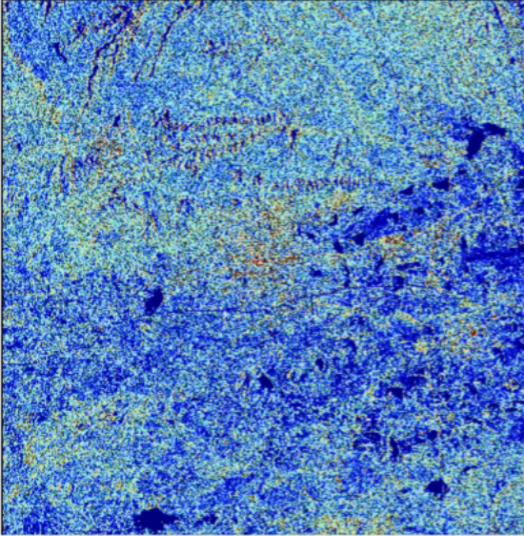

Figure: The SAR Image of Tirupati & Around Area

Implementation
SAR/
├── stac.py # download: query Planetary Computer STAC, clip to bbox, save GeoTIFFs
├── analyze_water.py # analyse: 3 detectors → figures + georeferenced GeoTIFFs
├── data/Tirupati/ # 16 RTC GRD scenes (VV + VH) (~823 MB)
├── outputs/ # generated PNGs + GeoTIFFs
└── venv/ # Python 3.9.6

- Environment: venv (Python 3.9.6) — pystac-client, planetary-computer, rasterio, numpy, matplotlib, scipy (speckle cleanup), torch (SAFNet, optional).
- Deterministic: SEED = 0 → identical reruns; a changed result means the code or data changed.
- Headless: Matplotlib Agg backend (safe over SSH / CI).
- Graceful degradation: guarded imports — without torch the two threshold figures still emit; without scipy speckle cleanup is skipped.
- Configuration-driven: all tunables are module-level constants at the top of analyze_water.py; behaviour is changed there, not in the body.
- Runtime: ≈ 6 minutes, dominated by SAFNet training on CPU.

Result and Outcome
Surface-water area — the hydrological cycle (dual-pol "confident open water"):

Epoch | Open water
2026-01-06 | ~1.4 km²
spring (drawdown) | declining
2026-06-23 (minimum) | ~0.5 km²
2026-06-30 (monsoon onset) | ~2.4 km² (sharp rebound)

The January→June drawdown as tanks and reservoirs dry, followed by a monsoon-onset refill on the final pass, is itself a drought-monitoring signal: a flat or continued decline into June would flag water stress for the district.
New-water (flood) vs dry baseline: ~0 km² (16 px by threshold, 25 px by SAFNet). This is correct for the window — June water overlaps the permanent reservoirs, so almost nothing is newly inundated; this is a drawdown period, not a flood event. The dual-pol gate keeps the estimate conservative.
SAFNet vs threshold — scored as a labelled PROXY (not ground truth): precision 0.64 · recall 1.00 · F1
0.78 · IoU 0.64 (SAFNet's 25 px is a superset of the threshold's 16 px).

Outputs (outputs/): water_area_timeseries.png, flood_change_map.png, safnet_change_map.png, plus georeferenced
GeoTIFFs new_water_threshold.tif, new_water_safnet.tif, safnet_change_prob.tif (EPSG:32644, QGIS-ready).
Outcome: an operational, reproducible surface-water and flood change-detection capability at ~40 m district scale, with three complementary detectors and GIS-ready products; the 2026 run cleanly captures the district's reservoir drawdown and monsoon-onset refill.

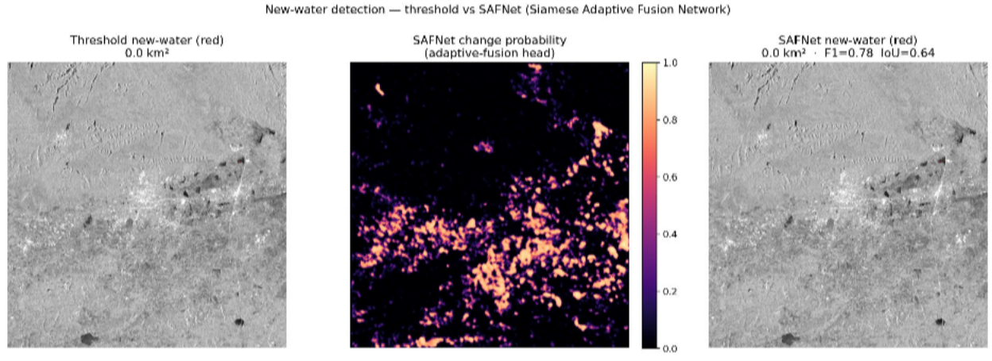

Figure 1 : Threshold of new water around Tirupati; Figure 2: Adaptive SAFNet to change Probability Figure 3: Discovery of the new water surface on the Tirupati that represent red color


Figure 4: This is Water Surface on the Tirupati based on the Analysis from January - June

Limitation
- Dual-pol is deliberately conservative — reported km² are confident open water, not a maximal estimate; thin or wind-roughened water may be undercounted.
- SAFNet is unsupervised and unvalidated on ground truth — its precision/ recall/F1/IoU are
a proxy against the threshold method until a real mask is supplied via REF_WATER; synthetic copy-paste change only approximates real hydrology.
- The fixed −17 dB cut can be biased by wind-roughened water and very smooth dry surfaces; the adaptive Otsu curve mitigates this partially, but a DEM/HAND or permanent-water mask would further exclude terrain that cannot hold water.
- Amplitude-only. GRD carries no phase, so no interferometric deformation or fine-scale coherence information is available on this track.

References
- Microsoft Planetary Computer — Sentinel-1 RTC (sentinel-1-rtc) collection.
- Sentinel-1 mission — ESA / Copernicus Programme.
- Otsu, N. (1979) — A threshold selection method from gray-level histograms, IEEE TSMC.
- Siamese / attention-fusion change-detection networks for remote sensing (SAFNet design lineage).
- Bonafilia, D. et al. (2020) — Sen1Floods11: a georeferenced dataset for Sentinel-1 flood mapping (ground-truth / future validation).
- Radiometric Terrain Correction (RTC) γ⁰ processing background.

